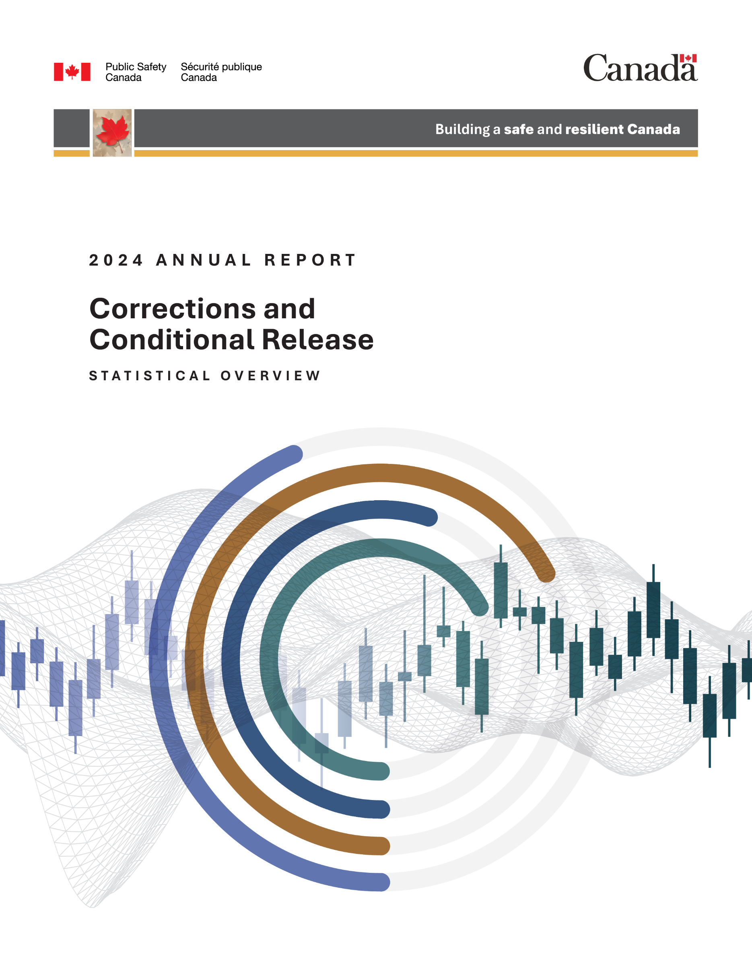

Read this publication online at:
https://www.publicsafety.gc.ca/cnt/rsrcs/pblctns/ccrso-2024/index-en.aspx
The purpose of the Corrections and Conditional Release Statistical Overview (CCRSO) is to assist the public in understanding statistical information on corrections and conditional release.
Aussi disponible en français sous le titre : L’Aperçu statistique : Le système correctionnel et la mise en liberté sous condition
To obtain permission to reproduce Public Safety Canada materials for commercial purposes or to obtain additional information concerning copyright ownership and restrictions, please contact:
Public Safety Canada, Communications
269 Laurier Ave. W
Ottawa Canada K1A 0P8

Communications@ps-sp.gc.ca
www.PublicSafety.gc.ca
© His Majesty the King in Right of Canada, as represented by the Ministers of Public Safety and Emergency Preparedness, 2026.
Publication date: 2026-05
Catalogue Number: PSI-3E-PDF
ISSN: 1713-1073

Corrections and Conditional Release Statistical Overview 2024
This document was produced by the Public Safety Canada Portfolio Corrections Statistics Committee which is composed of representatives of Public Safety Canada, Correctional Service of Canada, Parole Board of Canada, the Office of the Correctional Investigator and the Canadian Centre for Justice and Community Safety Statistics (Statistics Canada).

Preface
The Corrections and Conditional Release Statistical Overview (CCRSO) has been published annually since 1998. The purpose of the CCRSO is to assist the public in understanding statistical information on corrections and conditional release. A primary consideration in producing the CCRSO was to present general statistical information in a user-friendly way that will facilitate understanding by a broad audience. There are several features of this document that make it different from typical statistical reports:
- The visual representation of the statistics is simple and uncluttered, and under each chart, a few key points assist the reader in extracting relevant information from the chart.
- For each chart, a table of numbers corresponds to the visual representation. In some instances, the table includes additional numbers (e.g., a 5-year series), even though the chart depicts the data for the most recent year (e.g., Figure A2).
The data used in the CCRSO reflects the most recent data available at the time of preparation. For much of the report, data are available from the 2024 calendar year or for the April 1, 2023 - March 31, 2024 fiscal year. There are a few figures for which the cycle of data collection is more infrequent – for example, the General Social Survey on Canadians’ Safety (Victimization) is administered on a 5-year cycle with the most recent available data being from 2019.
Much of the data reported for 2020-21 was collected during the COVID-19 pandemic. As such, some trends observed between 2019–20 and 2020–21 should be interpreted with caution. The impacts of the pandemic may also be reflected in the data reported for 2021–22 and 2022–23.
The CCRSO includes data from partners that have different measures and methods for assessing gender and sex, and use different labels for these terms. For consistency across reporting, in the CCRSO, when sex was measured, the terms Male, Female, and Another sex were used; when gender was measured, the terms Men and Women and Boys and Girls were used.
In addition, beginning with the 2021 CCRSO, some data that was previously labelled as measuring ethnicity has been changed to race to more accurately reflect the identity concepts used by partners. As research measures pertaining to racialized groups advance, these terms and identity concepts may change in future years.
This report reflects terminology used in the source data, including the term “offender”. We recognize that this term may not align with person-first language and can be perceived as stigmatizing.
Considering the different types of crime statistics and terminology presented in the CCRSO, a certain level of data literacy is essential for accurate interpretation of the data. For example, some figures and tables in the CCRSO display frequencies, while others display rates; frequency and rate data answer different questions and inform responses to crime in different ways. To optimize the public’s ability to form an accurate, informed, and critical interpretation of different crime statistics and terminology presented in the CCRSO, a data literacy focused companion product was published along with the 2022 CCRSO and is available on https://www.publicsafety.gc.ca/cnt/rsrcs/pblctns/ccrso-2022-dt-ltrcy/index-en.aspx.
To continually improve this annual publication, we welcome your comments. Any correspondence regarding this report, including permission to use tables and figures should be directed to horizontalpolicy-politiqueshorizontales@ps-sp.gc.ca.

Table of contents
Preface 4
Contributing Partners 10
Section A: Crime and the Criminal Justice System 12
- Police-reported crime rate 13
- Police-reported crime rate by province/territory 17
- Crime Severity Index: 10-year trend 19
- Police-reported hate crimes: 10-year trend 22
- Police-reported homicide: 10-year trend 24
- Self-reported victimization rate 28
- Self-reported violent victimization rate by type, gender, and age 31
- Self-reported victimization reported to police 35
- The rate of adults charged 38
- Criminal Code and other Federal Statute charges among adults: 5-year trend 41
- Decisions in adult criminal court 46
- Length of adult custodial sentences 49
- The rate of youth charged 53
- Criminal Code and other Federal Statute charges among youth: 5-year trend 57
- Youth criminal court sentences: 5-year trend 61
- Youth criminal court sentences for most serious sentence: 5-year trend 65
- International incarceration rates 69
- International incarceration rates: 10-year trend 72
Section B: Corrections Administration 75
- Costs of federal and provincial/territorial corrections 76
- Number of CSC employees by location 82
- Cost of incarceration in a federal institution: 5-year trend 85
- The number of Parole Board of Canada employees 88
- The number of employees in the Office of the Correctional Investigator 90
- Most common offender complaints to the Office of the Correctional Investigator 92
Section C: Federal Offender and Registered Victims Populations 96
- Offenders under the responsibility of CSC 97
- Number of registered victims and number of offenders with a registered victim: 5-year trend 101
- The number of in-custody offenders: 10-year trend 104
- Number of admissions to CSC facilities by sex 108
- Warrant of committal admissions to CSC facilities by sex: 10-year trend 114
- Number of registered victims by gender: 5-year trend 116
- CSC total offender population by sentence length 119
- Offences of victimization among registered victims 122
- Warrant of committal admissions to a CSC facility by age 125
- Number of registered victims by age 128
- Warrant of committal admissions to a CSC facility for Indigenous and non-Indigenous offenders by age 131
- Age distribution of the CSC offender population 134
- CSC offender population by self-reported race 137
- Number of registered victims by self-reported race 141
- CSC offender population by religion 145
- CSC offenders by Indigenous and non-Indigenous self-identification 149
- Offenders in custody at a CSC facility by security risk classification 155
- Admissions to federal jurisdiction with a life and/or indeterminate sentence* by sex and Indigenous self-identification: 10-year trend 158
- Proportion of offenders with life and/or indeterminate sentences 165
- Percentage of total offender population serving a sentence for a violent offence 171
- Indigenous offenders under the responsibility of CSC 175
- Number of authorizations for transfer to Structured Intervention Units in federal institutions: 5-year trend 180
- Percentage of successful transfers out of Structured Intervention Units in federal institutions 182
- Structured Intervention Units: Time Outside of Cell 184
- Structured Intervention Units: Duration of Stay 187
- Characteristics of Offenders in Structured Intervention Unit Cells by Indigenous and non-Indigenous 189
- Reasons for Transfer to Structured Intervention Units 192
- Number of offender deaths while in custody: 10-year trend 195
- Number of escapees and escape incidents from federal institutions or Healing Lodges: 10-year trend 199
- CSC offenders in community under supervision by sex: 10-year trend 201
- Offenders under provincial/territorial supervision on probation or conditional sentence: 10-year trend 206
- Population of offenders on provincial parole*: 10-year trend 208
Section D: Conditional Release 211
- Number of CSC offenders granted temporary absences: 10-year trend 212
- Offenders released from federal institutions, including Healing Lodges, on parole: 10-year trend 215
- Federal day and full parole grant rates by gender: 10-year trend 222
- Federal day and full parole grant rates by Indigenous and non-Indigenous offenders: 10-year trend 228
- Number of Culturally Responsive Hearings: 10-year trend 233
- Proportion of sentence served prior to being released on parole: 10-year trend 236
- Proportion of sentence served by Indigenous and non-Indigenous offenders prior to being released on parole: 10-year trend 239
- Outcome of federal day parole supervision periods 243
- Outcome of federal full parole supervision periods 246
- Offenders released from federal institutions including Healing Lodges on statutory release: 10-year trend 249
- Outcome of federal statutory release supervision periods 253
- Rates of violent offence convictions for offenders on federal conditional release: 10-year trend 255
Section E: Special Applications of Criminal Justice 258
- Number of initial detention reviews: 10-year trend 259
- Annual judicial review hearings 262
- Number of Dangerous Offender designations 266
- Number of long-term supervision orders imposed 270
- Record suspensions and pardons: 5-year trend 274
Section F: Federal Services to Registered Victims 279
- Number of contacts with registered victims: 5-year trend 280
- Number of victim statements received for consideration in release decisions: 5-year trend 283
- Requests for financial assistance to attend parole hearings: 5-year trend 285
- Number of Parole Board of Canada contacts with victims: 10-year trend 287
- Victim presentations at PBC Hearings: 10-year trend 289
- Number of decisions sent from PBC decision registry: 5-year trend 291

Contributing Partners

Public Safety Canada
Public Safety Canada (PS) is Canada’s lead federal department for public safety, which includes emergency management, national security and community safety. Its many responsibilities include developing legislation and policies that govern corrections, implementing innovative approaches to community justice, and providing research expertise and resources to the corrections community.

Correctional Service Canada
The Correctional Service of Canada (CSC) is the federal government department responsible for administering custodial sentences of a term of 2 years or more, as imposed by the courts. CSC is responsible for managing institutions of various security levels and supervising offenders under conditional release in the community.

Parole Board of Canada
The Parole Board of Canada (PBC) is an independent administrative tribunal responsible for making decisions about the timing and conditions of release of offenders into the community on various forms of conditional release. The Board also makes pardon, record suspension and expungement decisions and recommendations respecting clemency through the Royal Prerogative of Mercy.

Office of the Correctional Investigator
The Correctional Investigator is the Ombudsperson for federal offenders. The Office of the Correctional Investigator (OCI) conducts investigations into the problems of offenders related to decisions, recommendations, acts or omissions of the Correctional Service of Canada that affect offenders individually or as a group.

Canadian Centre for Justice and Community Safety Statistics (Statistics Canada)
The Canadian Centre for Justice and Community Safety Statistics (CCJCSS) is a division of Statistics Canada. The CCJCSS is the focal point of a federal-provincial-territorial partnership, known as the National Justice Statistics Initiative, for the collection of information on the nature and extent of crime and the administration of civil and criminal justice in Canada.

Section A:
Crime and the Criminal Justice System



Police-reported crime rate

Figure A1. Police-reported crime rate. Rate per 100,000
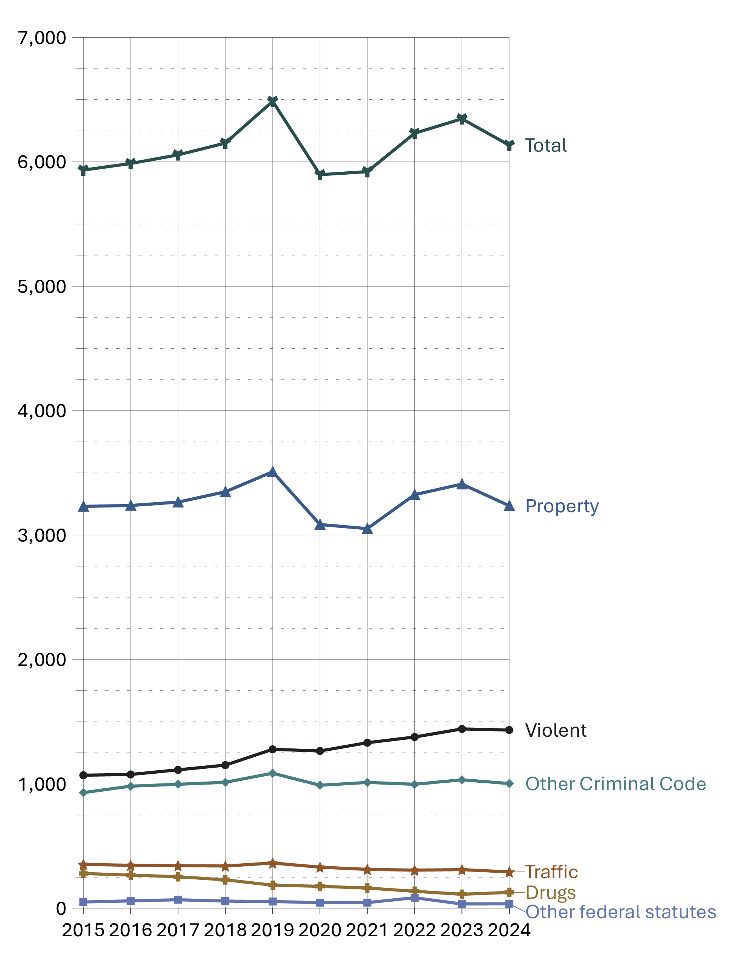
Source: Statistics Canada. Table 35-10-0177-01, Incident-based crime statistics, by detailed violations, Canada, provinces, territories, Census Metropolitan Areas and Canadian Forces Military Police.
- The police-reported crime rate increased by 9.3% from 2015 to 2019, then decreased by 9.1% from 2019 to 2020. From 2020 to 2023, the rate rose by 7.6%, followed by a 3.3% decrease from 2023 to 2024. Fluctuations in the total police-reported crime rate between 2019 and 2022 may be due to the imposition and cessation of the COVID-19 pandemic lockdown restrictions.
- Despite fluctuations in the 10-year period between 2015 and 2024, the total police-reported crime rate slightly increased (+3.4%) from 2015 (5,934) to 2024 (6,134).
- The only type of offence that meaningfully increased from 2020 to 2024 was violent crime (+13.3%); though, over the past year (from 2023 to 2024) there was a minor decrease in violent crime (-0.6%).
- The offence types that meaningfully decreased from 2020 to 2024 were drug offences
(-27.7%) and other federal statutes (-19.6%).
- Notably, the police-reported crime rate is lower in 2024 (6,134) than it was at the inception of the survey in 1998 (8,915) — a decrease of 31.2%.

Table A1. Police-reported crime rate. Rate per 100,000
Year | Violent | Property | Traffic | Other CC | Drugs | Other federal statutes | Total charged
1998 | 1,345 | 5,696 | 469 | 1,051 | 235 | 40 | 8,915
1999 | 1,440 | 5,345 | 388 | 910 | 264 | 44 | 8,474
2000 | 1,494 | 5,189 | 370 | 924 | 287 | 43 | 8,376
2001 | 1,473 | 5,124 | 393 | 989 | 288 | 62 | 8,390
2002 | 1,441 | 5,080 | 379 | 991 | 296 | 54 | 8,315
2003 | 1,435 | 5,299 | 373 | 1,037 | 274 | 46 | 8,532
2004 | 1,404 | 5,123 | 379 | 1,072 | 306 | 50 | 8,391
2005 | 1,389 | 4,884 | 378 | 1,052 | 290 | 60 | 8,090
2006 | 1,387 | 4,809 | 376 | 1,050 | 295 | 57 | 8,004
2007 | 1,354 | 4,525 | 402 | 1,029 | 308 | 59 | 7,707
2008 | 1,334 | 4,258 | 437 | 1,039 | 308 | 67 | 7,475
2009 | 1,322 | 4,122 | 435 | 1,017 | 291 | 57 | 7,281
2010 | 1,292 | 3,838 | 420 | 1,029 | 321 | 61 | 6,996
2011 | 1,236 | 3,536 | 424 | 1,008 | 330 | 60 | 6,628
2012 | 1,199 | 3,438 | 407 | 1,001 | 317 | 67 | 6,466
2013 | 1,096 | 3,154 | 387 | 956 | 311 | 52 | 5,982
2014 | 1,044 | 3,100 | 365 | 918 | 295 | 49 | 5,793
2015 | 1,070 | 3,231 | 353 | 930 | 280 | 51 | 5,934
2016 | 1,076 | 3,238 | 346 | 982 | 267 | 60 | 5,987
2017 | 1,113 | 3,265 | 343 | 997 | 254 | 69 | 6,056
2018 | 1,151 | 3,348 | 340 | 1,013 | 229 | 58 | 6,151
2019 | 1,278 | 3,509 | 364 | 1,086 | 186 | 55 | 6,487
2020 | 1,265 | 3,085 | 331 | 989 | 177 | 45 | 5,897
2021 | 1,331 | 3,052 | 313 | 1,012 | 163 | 46 | 5,921
2022 | 1,377 | 3,325 | 307 | 997 | 137 | 85 | 6,230
2023 | 1,442 | 3,410 | 311 | 1,033 | 113 | 35 | 6,346
2024 | 1,433 | 3,236 | 293 | 1,003 | 128 | 36 | 6,134
Source: Statistics Canada. Table 35-10-0177-01, Incident-based crime statistics, by detailed violations, Canada, provinces, territories, Census Metropolitan Areas and Canadian Forces Military Police.
Notes
Other Criminal Code offences (Other CC) includes administration of justice violations, weapons/firearms violations, counterfeit, possession of, accessing, making or distribution of child pornography and prostitution.
Other federal statute offences refer to offences against Canadian federal statutes, such as Customs Act, Employment Insurance Act, Firearms Act, Food and Drugs Act (FDA), Income Tax Act, Controlled Drugs and Substances Act (CDSA) and Narcotic Control Act (NCA). This offence category excludes Criminal Code of Canada offences.
These crime statistics are based on crimes that are reported to the police. Since not all crimes are reported to the police, these figures underestimate actual crime statistics. See Sections A6 to A8 for self-reported rates based on Statistics Canada’s General Social Survey (GSS) on Canadians’ Safety surveys (victimization), an alternative method of measuring crime. GSS data is complementary to police-reported crime data, as many individuals who are victimized do not report their victimization to police; therefore, GSS data contributes to a more holistic representation of actual crime statistics.

Police-reported crime rate by province/territory

Figure A2. Police-reported crime rate (2024). Rate per 100,000
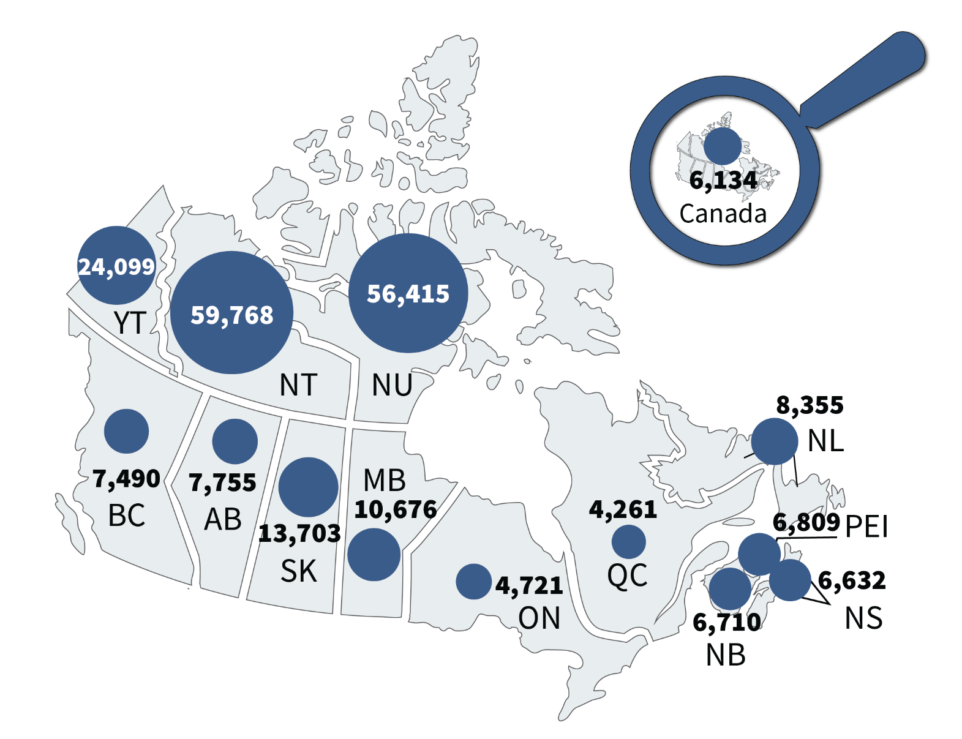
Source: Statistics Canada. Table 35-10-0177-01, Incident-based crime statistics, by detailed violations, Canada, provinces, territories, Census Metropolitan Areas and Canadian Forces Military Police.
- Crime rates were highest in the territories and elevated in central Canada. This general pattern has been stable over time.
- At the national level, the police-reported crime rate increased 7.6% from 2020 to 2023 and then decreased 3.3% from 2023 to 2024.
- In the 5-year period between 2020 and 2024, the crime rate in most provinces and territories increased. The three largest increases were observed in Newfoundland and Labrador (+24.7%), Prince Edward Island (+21.9%), and Quebec (+18.1%). In contrast, British Columbia (-13.7%) and Alberta (-12.2%) experienced the largest decreases in crime rate over this period.

Table A2. Police-reported crime rate. Rate per 100,000
Province/territory | 2020 | 2021 | 2022 | 2023 | 2024
Newfoundland and Labrador | 6,698 | 7,224 | 7,449 | 7,929 | 8,355
Prince Edward Island | 5,588 | 5,407 | 5,926 | 6,998 | 6,809
Nova Scotia | 5,811 | 6,009 | 6,440 | 6,467 | 6,632
New Brunswick | 6,777 | 7,200 | 7,120 | 7,258 | 6,710
Quebec | 3,607 | 3,770 | 4,302 | 4,295 | 4,261
Ontario | 4,034 | 4,183 | 4,440 | 4,772 | 4,721
Manitoba | 10,148 | 10,001 | 11,210 | 11,148 | 10,676
Saskatchewan | 12,391 | 12,897 | 13,345 | 13,959 | 13,703
Alberta | 8,832 | 8,380 | 8,775 | 8,474 | 7,755
British Columbia | 8,681 | 8,303 | 8,124 | 7,991 | 7,490
Yukon | 25,945 | 25,435 | 23,982 | 24,369 | 24,099
Northwest Territories | 61,383 | 60,013 | 59,356 | 60,784 | 59,768
Nunavut | 53,502 | 54,939 | 53,084 | 58,872 | 56,415
Canada | 5,897 | 5,921 | 6,230 | 6,346 | 6,134
Source: Statistics Canada. Table 35-10-0177-01, Incident-based crime statistics, by detailed violations, Canada, provinces, territories, Census Metropolitan Areas and Canadian Forces Military Police.
Notes
These crime statistics are based on crimes that are reported to the police. Since not all crimes are reported to the police, these figures underestimate actual crime statistics. See Tables A6 to A8 for self-reported rates based on General Social Survey (GSS) on Canadians’ Safety surveys (victimization), an alternative method of measuring crime. GSS data is complementary to police-reported crime data, as many individuals who are victimized do not report their victimization to police; therefore, GSS data contributes to a more holistic representation of actual crime statistics.

Crime Severity Index: 10-year trend

Figure A3. Crime Severity Index* (CSI) – 10-year trend
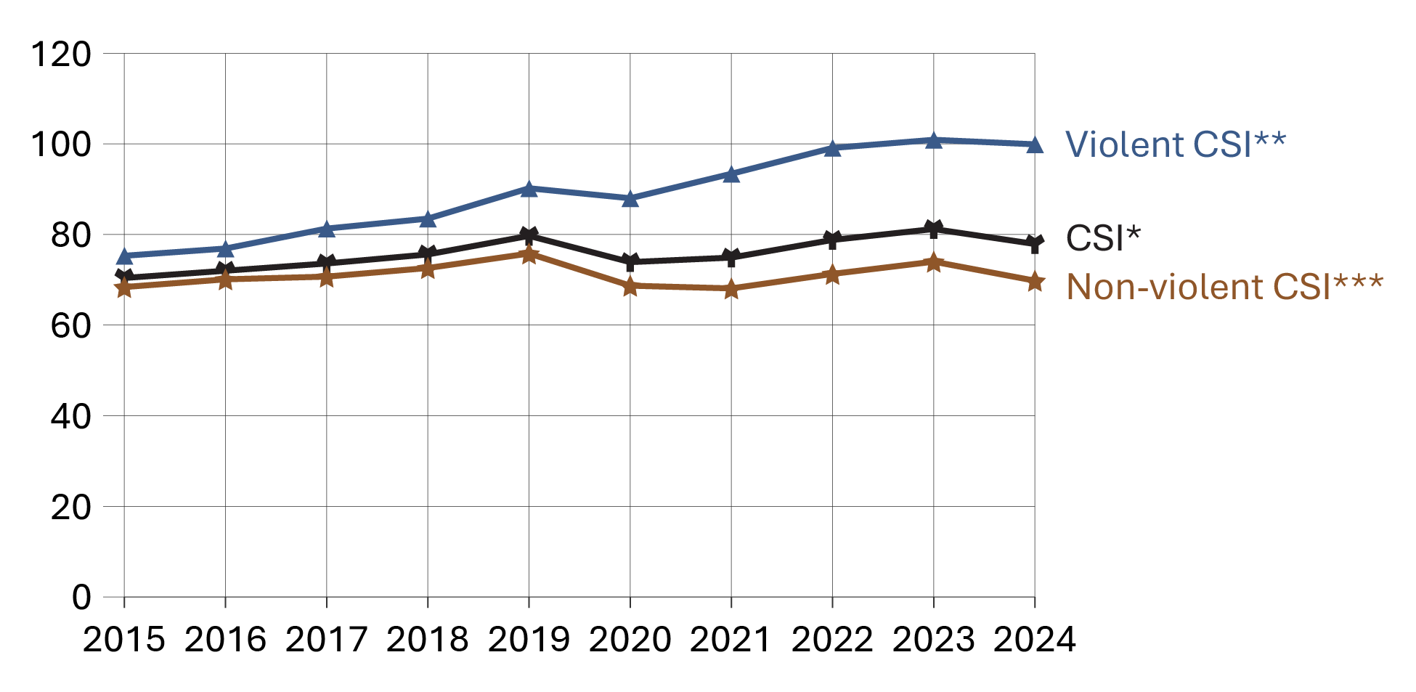
Source: Statistics Canada. Table 35-10-0026-01, Crime severity index and weighted clearance rates, Canada, provinces, territories and Census Metropolitan Areas.
- From 2015 to 2019, the Crime Severity Index* (CSI) increased steadily. Violent CSI** rose from 75.3 to 90.2, non-violent CSI*** from 68.4 to 75.8, and the overall CSI from 70.4 to 79.7.
- Between 2019 and 2023, violent CSI** increased from 90.2 to 100.9, while non-violent CSI*** decreased from 75.8 to 74.0. The overall CSI remained relatively stable, slightly increasing from 79.7 in 2019 to 81.2 in 2023. Fluctuations observed between 2019 and 2022 may be due to the imposition and cessation of the COVID-19 pandemic lockdown restrictions.
- Over the past year (from 2023 to 2024), the violent**, non-violent***, and overall CSI decreased slightly.

Notes
*The Crime Severity Index (CSI) measures changes in the level of severity of crime in Canada from year to year. In the index, all crimes are assigned a weight based on their seriousness. The level of seriousness is based on actual sentences handed down by the courts in all provinces and territories. More serious crimes are assigned higher weights, less serious offences lower weights. As a result, more serious offences have a greater impact on changes in the index. The CSI is standardized to 100 in base year 2006. CSI weights are updated using data from the Integrated Criminal Courts Survey (ICCS) every 5 years. 2022 marks the third update to the CSI weights since 1998. 2021 revised and 2022 CSI data are presented here using the updated weights and may have a marginal impact on the CSI data itself.
The crime severity index includes all Criminal Code violations including traffic, as well as drug violations and all Federal Statutes.
**The violent crime severity index includes all Incident-based Uniform Crime Reporting Survey violent violations, some of which were not previously included in the aggregate violent crime category, including uttering threats, criminal harassment and forcible confinement.
***The non-violent crime severity index includes all non-violent Criminal Code violations including traffic, as well as drug violations and all Federal Statutes.

Table A3. Crime Severity Index* (CSI) from 2015 to 2024
Year | Violent CSI** | Non-violent CSI*** | Total CSI*
2015 | 75.3 | 68.4 | 70.4
2016 | 76.9 | 70.1 | 72.0
2017 | 81.3 | 70.7 | 73.6
2018 | 83.5 | 72.6 | 75.6
2019 | 90.2 | 75.8 | 79.7
2020 | 88.0 | 68.7 | 73.9
2021 | 93.4 | 68.1 | 74.9
2022 | 99.1 | 71.3 | 78.8
2023 | 100.9 | 74.0 | 81.2
2024 | 99.9 | 69.8 | 77.9
Source: Statistics Canada. Table 35-10-0026-01, Crime severity index and weighted clearance rates, Canada, provinces, territories and Census Metropolitan Areas.
Notes
*The Crime Severity Index (CSI) measures changes in the level of severity of crime in Canada from year to year. In the index, all crimes are assigned a weight based on their seriousness. The level of seriousness is based on actual sentences handed down by the courts in all provinces and territories. More serious crimes are assigned higher weights, less serious offences lower weights. As a result, more serious offences have a greater impact on changes in the index. The PRCSI is standardized to 100 in base year 2006. CSI weights are updated using data from the Integrated Criminal Courts Survey (ICCS) every 5 years. 2022 marks the third update to the CSI weights since 1998. 2021 revised and 2022 CSI data are presented here using the updated weights and may have a marginal impact on the CSI data itself.
The crime severity index includes all Criminal Code violations including traffic, as well as drug violations and all Federal Statutes.
**The violent crime severity index includes all Incident-based Uniform Crime Reporting Survey violent violations, some of which were not previously included in the aggregate violent crime category, including uttering threats, criminal harassment and forcible confinement.
***The non-violent crime severity index includes all non-violent Criminal Code violations including traffic, as well as drug violations and all Federal Statutes.

Police-reported hate crimes: 10-year trend

Figure A4. Number of police-reported hate crimes by motivation type – 10-year trend
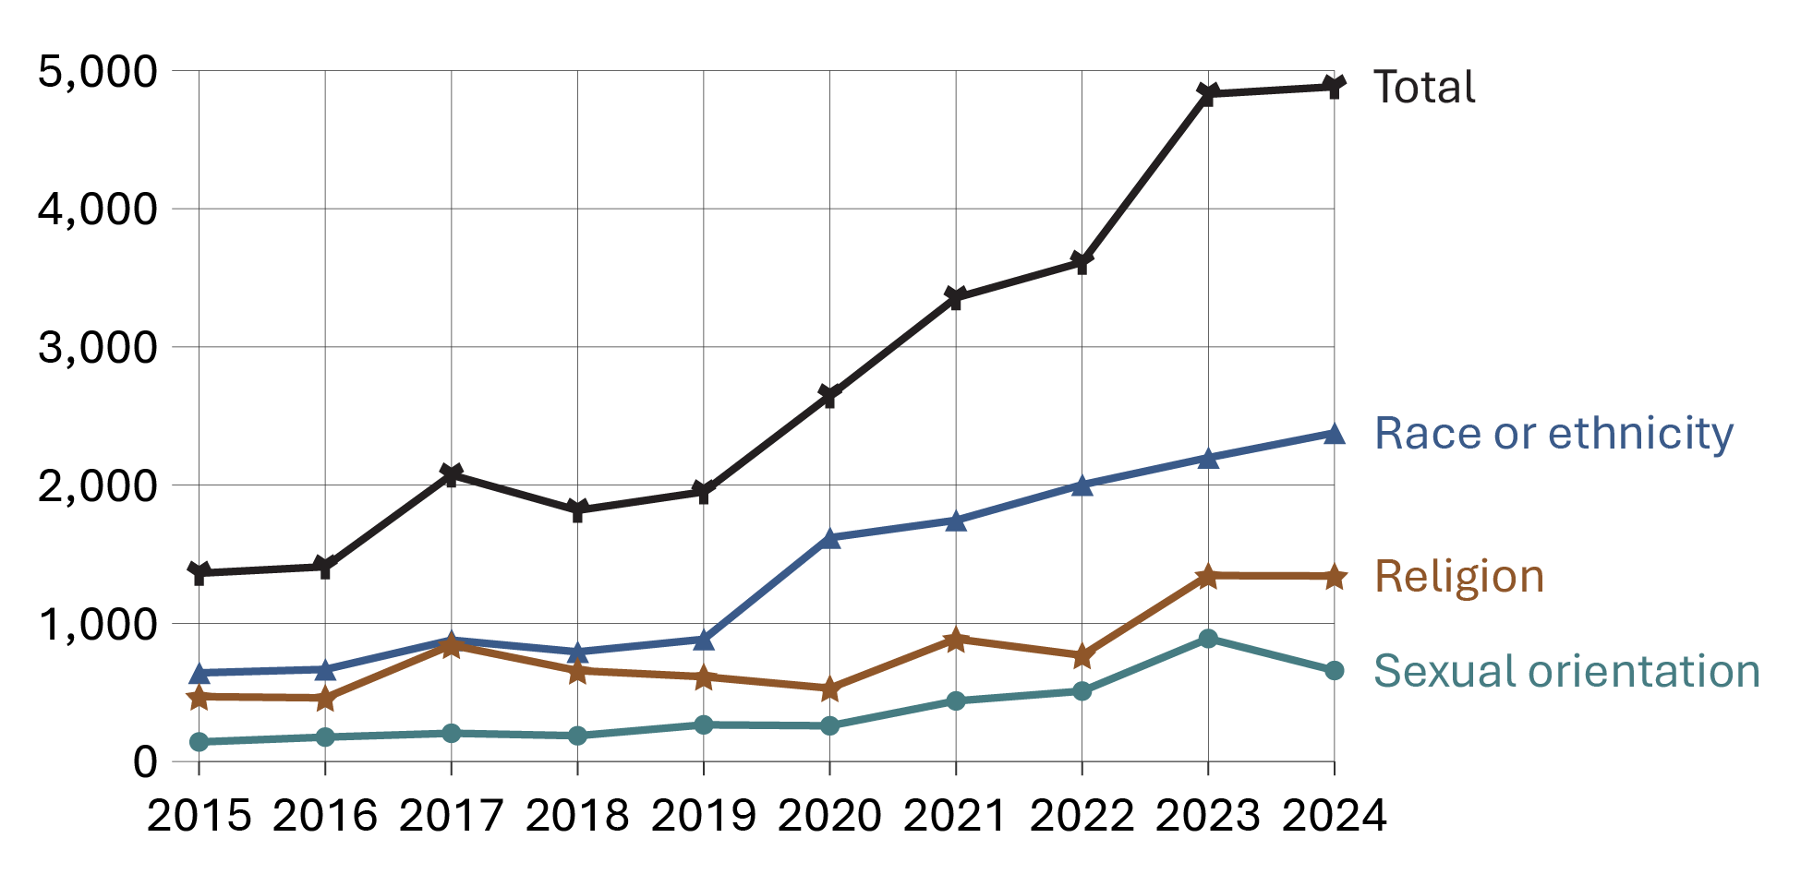
Source: Statistics Canada. Table 35-10-0066-01, Police-reported hate crime, by type of motivation, selected regions and Canada (selected police services).
- The total number of police-reported hate crimes has significantly increased* in the past 10 years, with an overall increase of 258.4% from 2015 to 2024.
- From 2015 to 2019, the total number of police-reported hate crimes increased* by 43.2%. From 2019 to 2024, the number of police-reported hate crimes has more than doubled, representing a 150.2% increase (from 1,951 in 2019 to 4,882 in 2024).
- Categorized by motivation, the greatest type of hate crime to increase between 2019 and 2024 were hate crimes targeting race or ethnicity (+1,493 incidents), followed by religion (+729 incidents), and sexual orientation (+393 incidents).
Notes
*Higher rates of police-reported hate crimes may reflect changes in the recognition, reporting, and investigation of these incidents by police and community members. An October 2020 publication by The Ontario Association of Chiefs of Police stated that there have been increased efforts (e.g., training) on the part of police services across Canada to facilitate the reporting of hate motivated crimes.
Table A4. Number of police-reported hate crimes by motivation type from 2015 to 2024
Year | Race or ethnicity | Religion | Sexual orientation | Total
2015 | 641 | 469 | 141 | 1,362
2016 | 666 | 460 | 176 | 1,409
2017 | 878 | 842 | 204 | 2,073
2018 | 793 | 657 | 186 | 1,817
2019 | 884 | 613 | 265 | 1,951
2020 | 1,619 | 530 | 258 | 2,646
2021 | 1,745 | 886 | 438 | 3,355
2022 | 2,002 | 768 | 509 | 3,612
2023 | 2,198 | 1,345 | 889 | 4,828
2024 | 2,377 | 1,342 | 658 | 4,882
Source: Statistics Canada. Table 35-10-0066-01, Police-reported hate crime, by type of motivation, selected regions and Canada (selected police services).
Notes
Higher rates of police-reported hate crimes may reflect changes in the recognition, reporting, and investigation of these incidents by police and community members. An October 2020 publication by The Ontario Association of Chiefs of Police stated that there have been increased efforts (e.g., training) on the part of police services across Canada to facilitate the reporting of hate motivated crimes.
Total includes all motivation types for which data is collected. The three motivation types displayed in the table represent the greatest three categories reported by Statistics Canada.

Police-reported homicide: 10-year trend

Figure A5a. Number of police-reported homicide victims by Indigenous identity
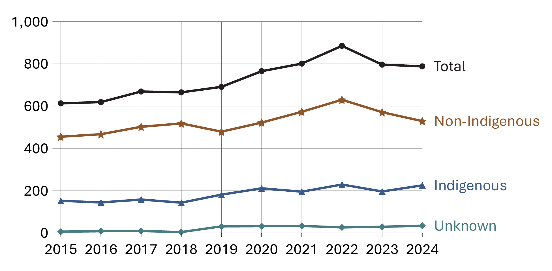
Source: Statistics Canada. Table 35-10-0060-01, Number of homicide victims and persons accused of homicide, by Indigenous identity, age group and gender.

Figure A5b. Number of police-reported homicide victims by sex
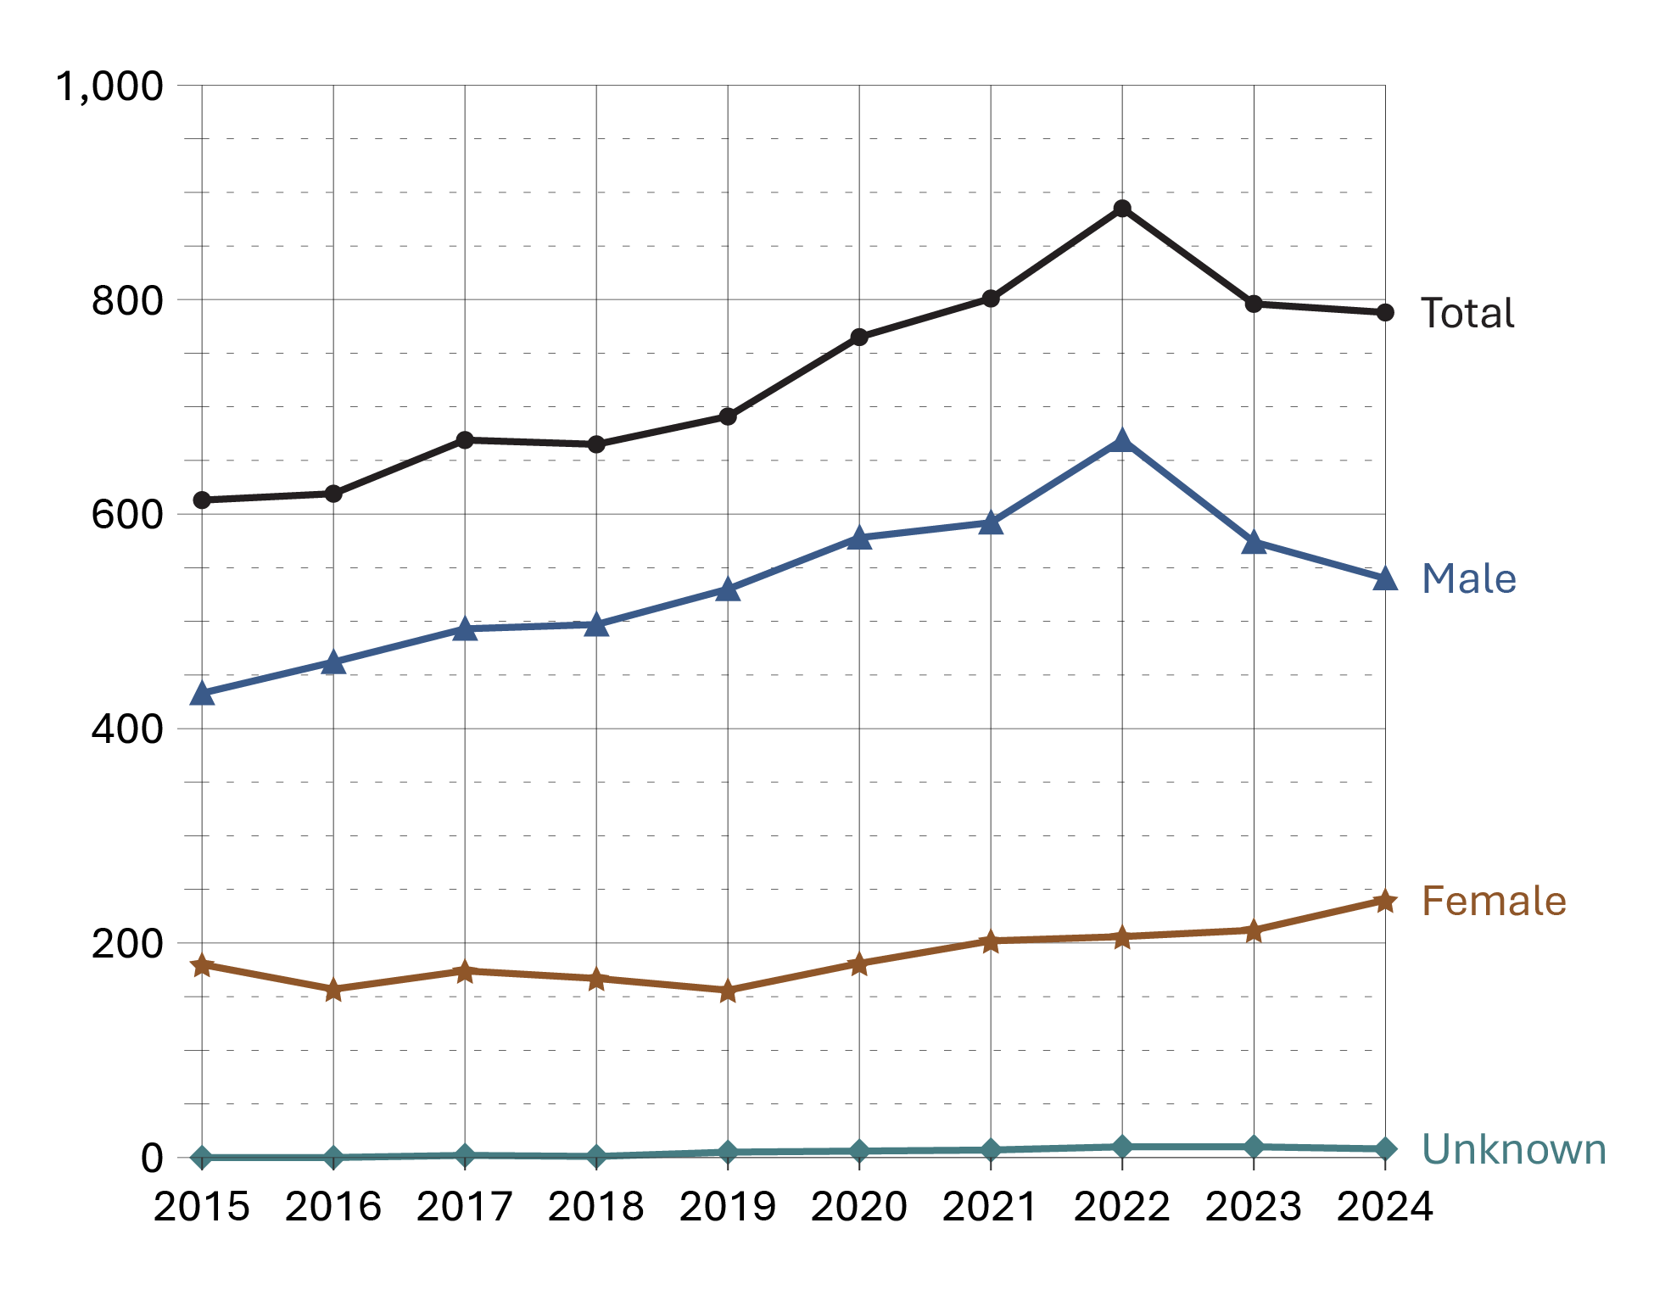
Source: Statistics Canada. Table 35-10-0060-01, Number of homicide victims and persons accused of homicide, by Indigenous identity, age group and gender.
- The total number of police-reported homicide victims in Canada has increased by 28.5% over the past 10 years (from 613 in 2015 to 788 in 2024). There was a 15.7% increase from 2020 to 2022 (from 765 in 2020 to 885 in 2022), followed by an 11.0% decrease between 2022 and 2024 (from 885 in 2022 to 788 in 2024).
- The total number of police-reported homicide victims remained stable (-1.0%) from 2023 to 2024.
- Indigenous homicide victims increased by 48.0% from 2015 to 2024 (from 152 to 225), whereas non-Indigenous homicide victims increased by 16.3% (from 455 to 529) in the same time period.
- The number of female homicide victims increased by 33.3% over the past 10 years (from 180 in 2015 to 240 in 2024), with a 13.2% increase between 2023 and 2024. Similarly, male victims increased 24.7% over the past 10 years (from 433 in 2015 to 540 in 2024), though there was a 5.9% decline from 2023 to 2024.

Table A5a. Number of police-reported homicide victims by Indigenous identity
Year | Indigenous | Non-Indigenous | Unknown | Total
2015 | 152 | 455 | 6 | 613
2016 | 144 | 467 | 8 | 619
2017 | 158 | 502 | 9 | 669
2018 | 143 | 518 | 4 | 665
2019 | 181 | 479 | 31 | 691
2020 | 211 | 522 | 32 | 765
2021 | 195 | 573 | 33 | 801
2022 | 229 | 630 | 26 | 885
2023 | 196 | 571 | 29 | 796
2024 | 225 | 529 | 34 | 788
Source: Statistics Canada. Table 35-10-0060-01, Number of homicide victims and persons accused of homicide, by Indigenous identity, age group and gender.

Table A5b. Number of police-reported homicide victims by sex
Year | Female | Male | Unknown | Total
2015 | 180 | 433 | 0 | 613
2016 | 157 | 462 | 0 | 619
2017 | 174 | 493 | 2 | 669
2018 | 167 | 497 | 1 | 665
2019 | 156 | 530 | 5 | 691
2020 | 181 | 578 | 6 | 765
2021 | 202 | 592 | 7 | 801
2022 | 206 | 669 | 10 | 885
2023 | 212 | 574 | 10 | 796
2024 | 240 | 540 | 8 | 788
Source: Statistics Canada. Table 35-10-0060-01, Number of homicide victims and persons accused of homicide, by Indigenous identity, age group and gender.
Notes
The Homicide Survey represents a complete count of the number of homicides known and reported by police services in Canada. Homicides are scored according to the year that they are reported by police to the Homicide Survey. In most cases the year in which the homicide occurred is the same as the reporting year; however, because some homicides become known to police long after they occur, there are typically some homicides included in a given year's total that actually occurred in previous years.
Source: Statistics Canada (2025). Data accuracy, Homicide Survey.

Self-reported victimization rate

Figure A6. Victims of self-reported crime by type (2019). Rate per 100,000
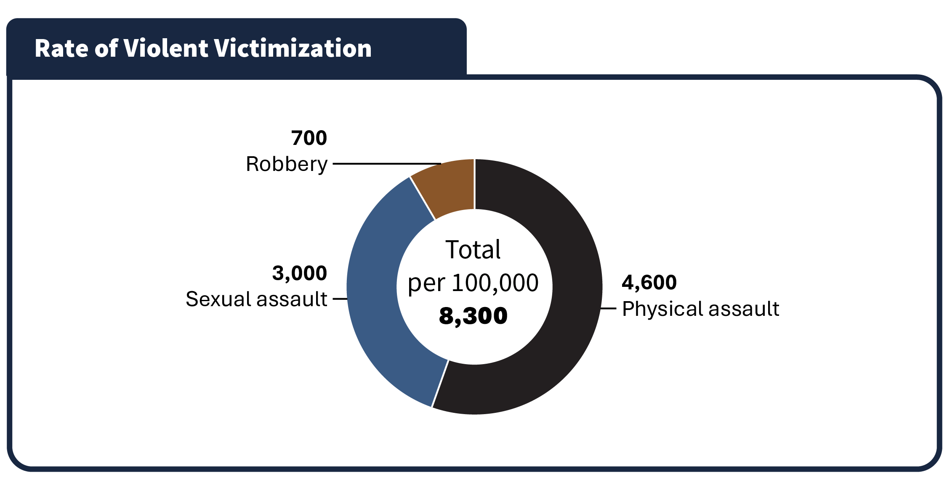
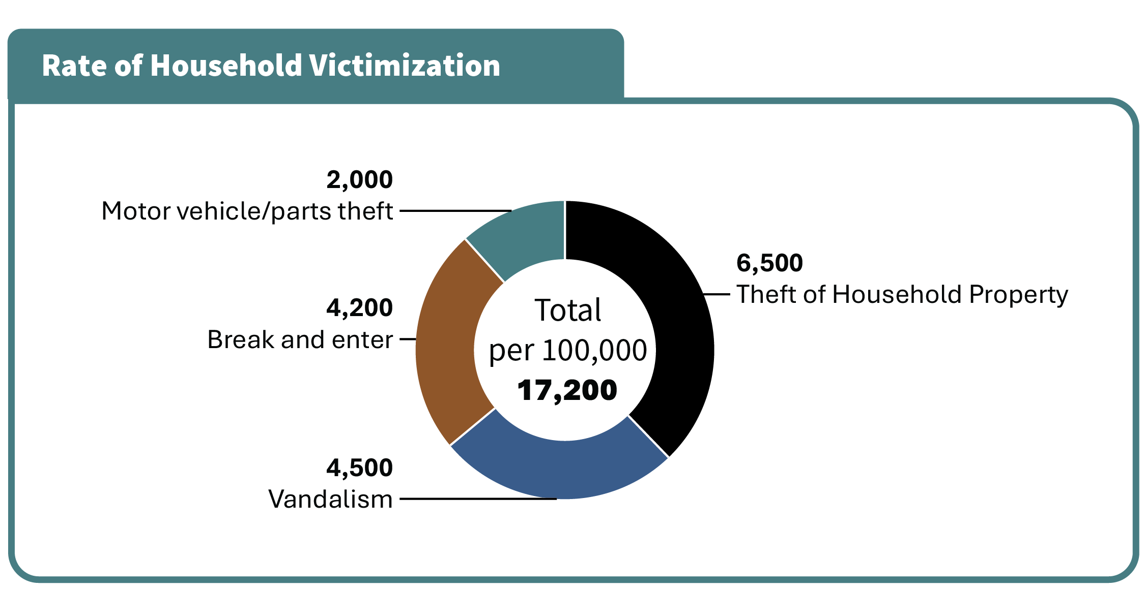
Source: Statistics Canada. General Social Survey (GSS).
- Assault was the third most common self-reported crime and the most common form of violent victimization.
- In 2019, theft of personal property was the most common self-reported form of victimization followed by theft of household property.

Table A6. Victims of self-reported crime by type (2019). Rate per 100,000
Type of violent victimization | Rate
Theft of personal property | 9,800
Household victimization total | 17,200
Theft of household property | 6,500
Vandalism | 4,500
Break and enter | 4,200
Motor vehicle/parts theft | 2,000
Violent victimization total | 8,300
Physical assault | 4,600
Sexual assault | 3,000
Robbery | 700
Source: Statistics Canada. General Social Survey (GSS).
Notes
General Social Survey (GSS) Canadians’ Safety data are reported per 1,000 population, which are converted to per 100,000 in the CCRSO for ease of comparison with police-reported rates.
Police-reported rates are based on crimes that are reported to the police. Since not all crimes are reported to the police, these figures underestimate actual crime statistics. GSS data is complementary to police-reported crime data, as many individuals who are victimized do not report their victimization to police; therefore, GSS data contributes to a more holistic representation of actual crime statistics.
Total household victimization includes the following categories contained in the General Social Survey: motor vehicle/parts theft, break and enter, vandalism, theft of household property.
Total violent victimization includes the following categories contained in the General Social Survey: physical assault, sexual assault, and robbery.
The GSS Canadians’ Safety is conducted every 5 years, and the most recent data available are from 2019. A new cycle of GSS Victimization data was in collection at the time of report preparation and will be included in a future CCRSO report once publicly available. The GSS excludes those under age 15.

Self-reported violent victimization rate by type, gender, and age

Figure A7a. Self-reported violent victimization rate by type and gender (2019). Rate per 100,000
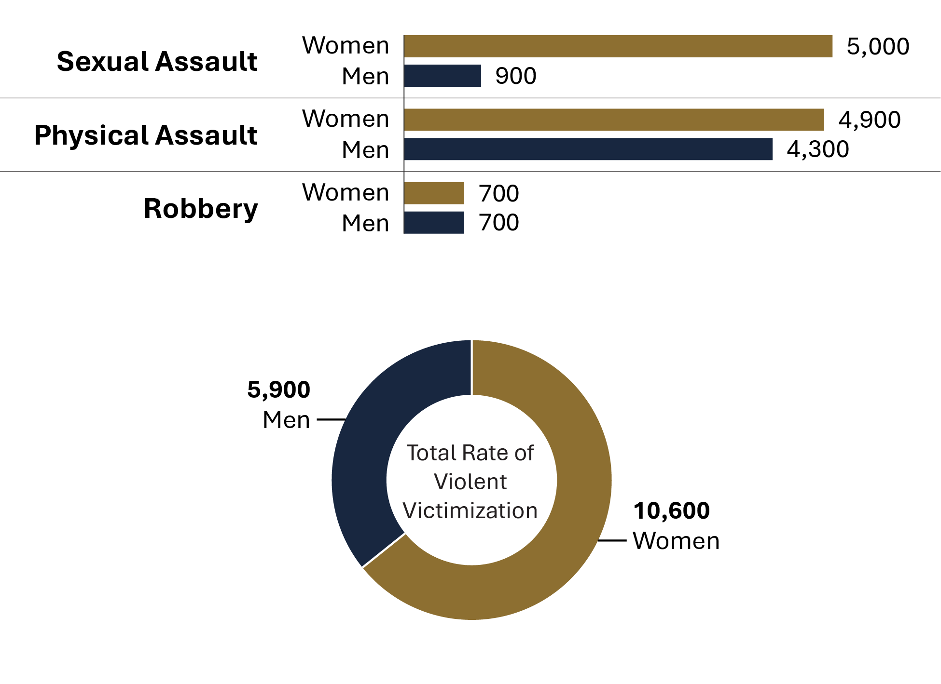
Source: Statistics Canada. General Social Survey (GSS).

Figure A7b. Self-reported violent victimization rate by age and gender (2019). Rate per 100,000
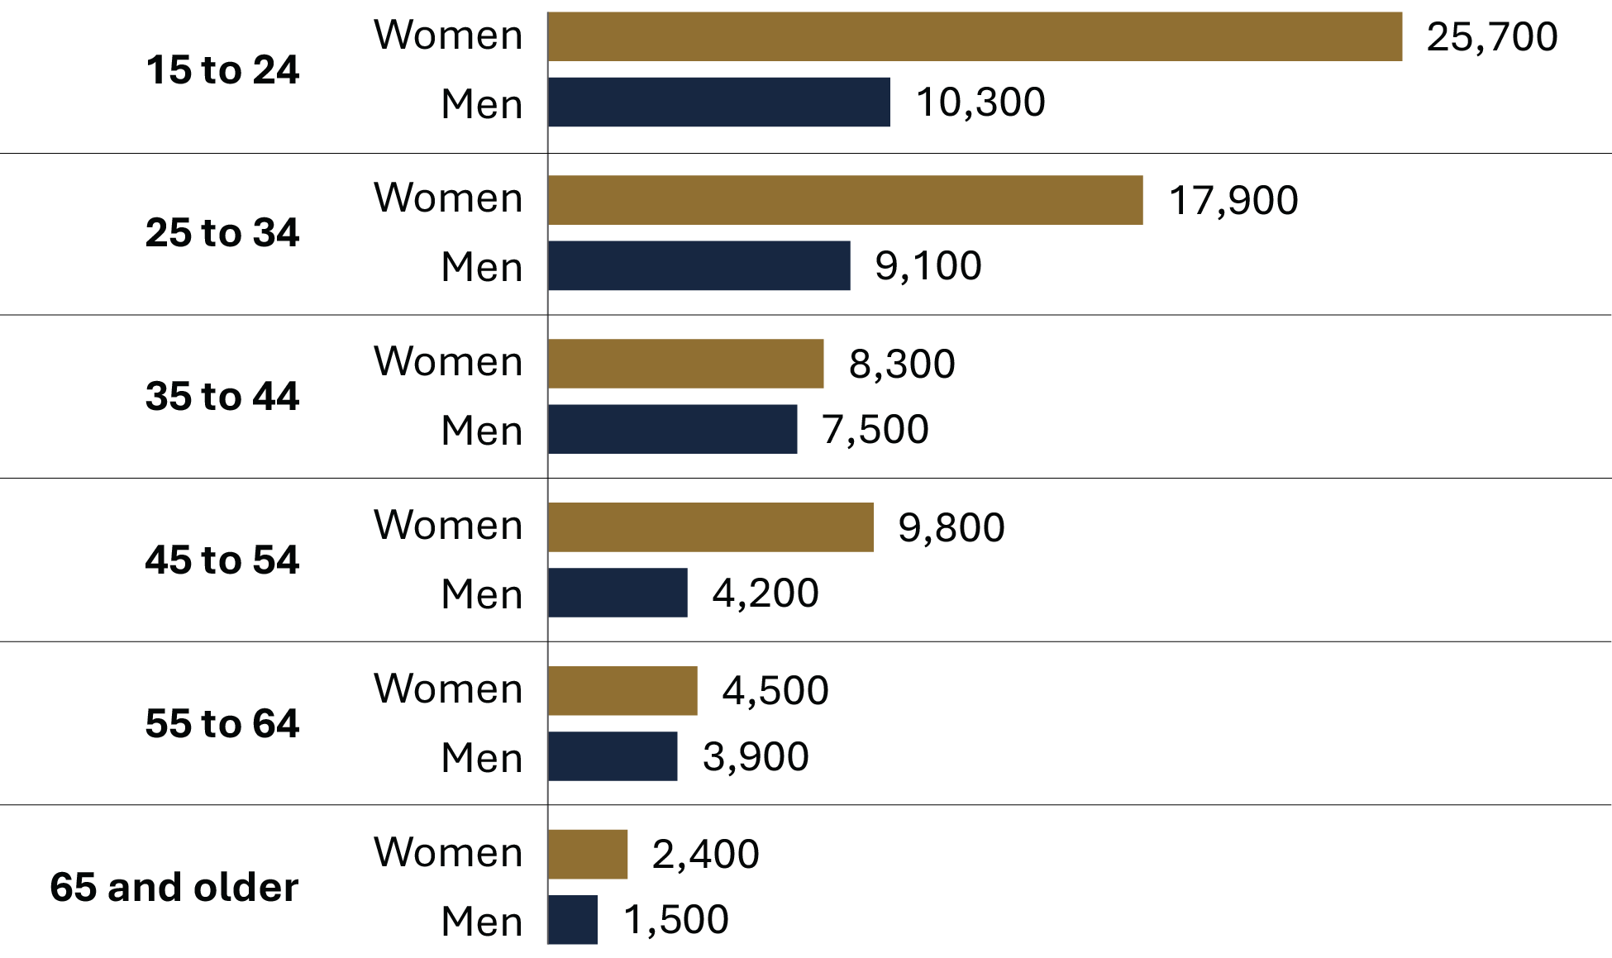
Source: Statistics Canada. General Social Survey (GSS).
- Women were more likely to experience violent victimization than men. When broken down by types of crime, the gender difference is largely due to the substantially higher number of women who self-report sexual assault.
- The gender difference in self-reported crime was greatest at ages 15 to 24 (with a difference of 15,400 per 100,000), followed by ages 25 to 34 (with a difference of 8,800 per 100,000).

Table A7a. Self-reported violent victimization rate by type and gender (2019). Rate per 100,000
Type of violent victimization | Women | Men
Sexual assault | 5,000 | 900
Robbery | 700 | 700
Physical assault | 4,900 | 4,300
Total violent victimization | 10,600 | 5,900

Table A7b. Self-reported violent victimization rate by age (2019). Rate per 100,000
Age group | Women | Men
15 to 24 | 25,700 | 10,300
25 to 34 | 17,900 | 9,100
35 to 44 | 8,300 | 7,500
45 to 54 | 9,800 | 4,200
55 to 64 | 4,500 | 3,900
65 and older | 2,400 | 1,500
Source: Statistics Canada. General Social Survey (GSS).
Notes
General Social Survey (GSS) Canadians’ Safety data are reported per 1,000 population, which are converted to per 100,000 in the CCRSO for ease of comparison with police-reported rates.
Police-reported rates are based on crimes that are reported to the police. Since not all crimes are reported to the police, these figures underestimate actual crime statistics. GSS data is complementary to police-reported crime data, as many individuals who are victimized do not report their victimization to police; therefore, GSS data contributes to a more holistic representation of actual crime statistics.
Total household victimization includes the following categories contained in the General Social Survey: motor vehicle/parts theft, break and enter, vandalism, theft of household property.
Total violent victimization includes the following categories contained in the General Social Survey: physical assault, sexual assault, and robbery.
The GSS Canadians’ Safety is conducted every 5 years, and the most recent data available are from 2019. A new cycle of GSS Victimization data was in collection at the time of report preparation and will be included in a future CCRSO report once publicly available. The GSS excludes those under age 15.

Self-reported victimization reported to police

Figure A8. Percentage of self-reported victimization reported to police (2019)
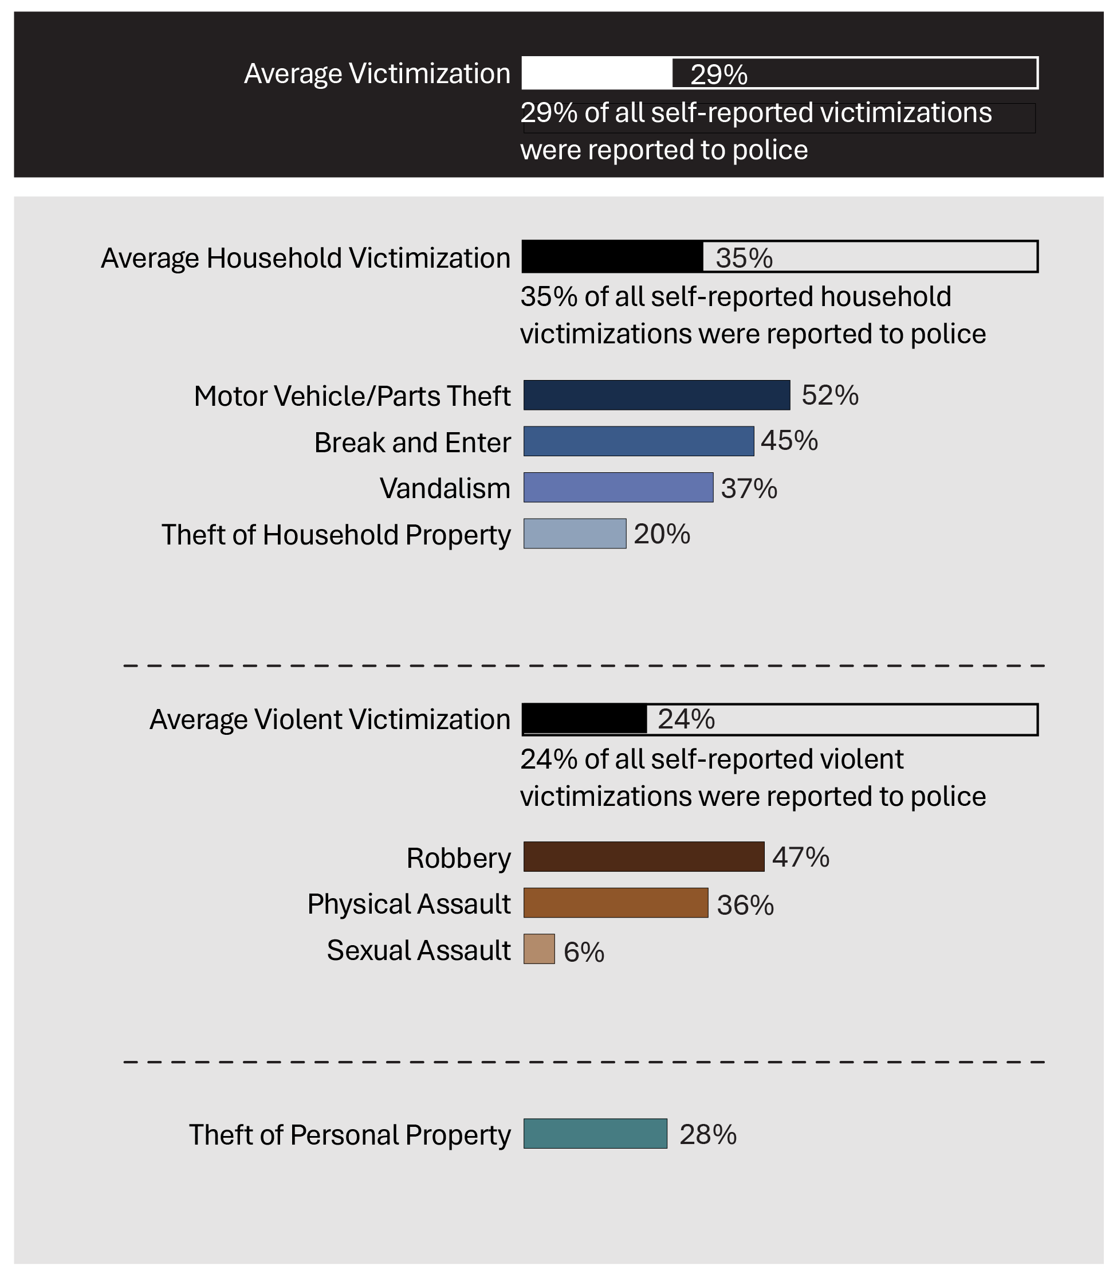
Source: Statistics Canada. General Social Survey (GSS).
Note: The percentages for each crime category indicate the proportion of that specific type of crime reported to the police, compared to the overall incidence of that type of crime reported under the GSS. For example, out of 100% of the self-reported thefts of personal property, only 28% were reported to police.
- Among all self-reported victims of motor vehicle/parts theft in 2019, 52% of these crimes were reported to police. This was the most frequently self-reported crime type that was reported police. Among all self-reported victims of sexual assault, only 6% were reported to police. This was the least frequently self-reported crime type that was reported to police.
- On average, self-reported household victimization crimes were more commonly reported to police than self-reported violent victimization crimes.
Table A8. Percentage of self-reported victimization reported to police (2019)
Type of victimization | Percent reported to police
Theft of personal property | 28
Household victimization average | 35
Motor vehicle/parts theft | 52
Break and enter | 45
Vandalism | 37
Theft of household property | 20
Violent victimization average | 24
Robbery | 47
Physical assault | 36
Sexual assault | 6
Average overall victimization | 29
Source: Statistics Canada. General Social Survey (GSS).
Notes
General Social Survey (GSS) Canadians’ Safety data are reported per 1,000 population, which are converted to per 100,000 in the CCRSO for ease of comparison with police-reported rates.
Police-reported rates are based on crimes that are reported to the police. Since not all crimes are reported to the police, these figures underestimate actual crime statistics. GSS data is complementary to police-reported crime data, as many individuals who are victimized do not report their victimization to police; therefore, GSS data contributes to a more holistic representation of actual crime statistics.
Total household victimization includes the following categories contained in the General Social Survey: motor vehicle/parts theft, break and enter, vandalism, theft of household property.
Total violent victimization includes the following categories contained in the General Social Survey: physical assault, sexual assault, and robbery.
Theft of personal property is not captured under household victimization or violent victimization; it is therefore presented separately. Theft of personal property is included in the total average victimization.
The GSS Canadians’ Safety is conducted every 5 years, and the most recent data available are from 2019. A new cycle of GSS Victimization data was in collection at the time of report preparation and will be included in a future CCRSO report once publicly available. The GSS excludes those under age 15.

The rate of adults charged

Figure A9. Rate of adults charged. Rate per 100,000
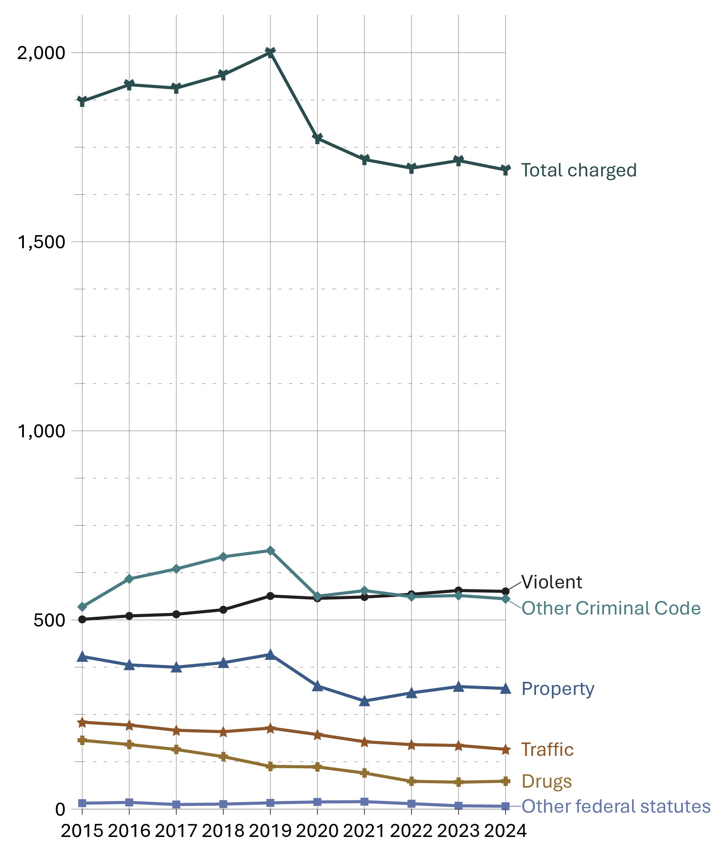
Source: Statistics Canada. Table 35-10-0177-01, Incident-based crime statistics, by detailed violations, Canada, provinces, territories, Census Metropolitan Areas and Canadian Forces Military Police.
- The overall rate of adults charged in 2024 was 9.7% lower than the rate recorded in 2015. From 2015 to 2019 there was a 6.8% increase, followed by a 14.2% decrease from 2019 to 2023.
- Notably, the overall rate of adults charged was 24.4% lower in 2024 (1,690) than it was at the inception of the survey in 1998 (2,236).
- The rate of adults charged with violent crimes slightly increased from 2020 to 2024 (+3.3%). The 2024 rate is 14.8% higher than in 2015.
- The rate of adults charged with drug offences has consistently decreased, with a total decrease of 59.5% over the 10-year period from 2015 and 2024.

Table A9. Rate of adults charged. Rate per 100,000
Year | Violent | Property | Traffic | Other CC | Drugs | Other federal statutes | Total charged
1998 | 563 | 677 | 374 | 430 | 168 | 12 | 2,236
1999 | 590 | 632 | 371 | 396 | 185 | 18 | 2,203
2000 | 615 | 591 | 349 | 411 | 198 | 16 | 2,190
2001 | 641 | 584 | 349 | 451 | 202 | 18 | 2,256
2002 | 617 | 569 | 336 | 460 | 199 | 18 | 2,211
2003 | 598 | 573 | 326 | 476 | 172 | 15 | 2,168
2004 | 584 | 573 | 314 | 490 | 187 | 22 | 2,180
2005 | 589 | 550 | 299 | 479 | 185 | 22 | 2,131
2006 | 594 | 533 | 300 | 498 | 198 | 20 | 2,150
2007 | 577 | 499 | 298 | 521 | 208 | 20 | 2,132
2008 | 576 | 487 | 307 | 540 | 207 | 22 | 2,149
2009 | 585 | 490 | 311 | 532 | 201 | 20 | 2,152
2010 | 576 | 473 | 295 | 545 | 211 | 22 | 2,132
2011 | 548 | 441 | 271 | 527 | 213 | 23 | 2,034
2012 | 541 | 434 | 269 | 536 | 203 | 25 | 2,020
2013 | 505 | 417 | 242 | 519 | 200 | 18 | 1,910
2014 | 489 | 399 | 233 | 520 | 191 | 13 | 1,849
2015 | 501 | 403 | 230 | 535 | 182 | 15 | 1,872
2016 | 511 | 381 | 222 | 609 | 171 | 18 | 1,915
2017 | 515 | 375 | 208 | 635 | 157 | 12 | 1,906
2018 | 527 | 387 | 205 | 667 | 138 | 13 | 1,942
2019 | 563 | 409 | 214 | 683 | 113 | 16 | 2,000
2020 | 557 | 325 | 197 | 563 | 111 | 19 | 1,773
2021 | 561 | 286 | 178 | 578 | 95 | 20 | 1,717
2022 | 568 | 307 | 170 | 561 | 73 | 14 | 1,695
2023 | 578 | 324 | 168 | 565 | 71 | 9 | 1,715
2024 | 576 | 319 | 158 | 556 | 74 | 7 | 1,690
Source: Statistics Canada. Table 35-10-0177-01, Incident-based crime statistics, by detailed violations, Canada, provinces, territories, Census Metropolitan Areas and Canadian Forces Military Police.
Notes
Other Criminal Code offences (Other CC) includes administration of justice offences, counterfeit, weapons/firearms violations, possession of, accessing, making or distribution of child pornography and prostitution.
Other federal statute offences refer to offences against Canadian federal statutes, such as Customs Act, Employment Insurance Act, Firearms Act, Food and Drugs Act (FDA), Income Tax Act, Controlled Drugs and Substances Act (CDSA) and Narcotic Control Act (NCA). This offence category excludes Criminal Code of Canada offences.
Violent crimes include homicide, attempted murder, assault, sexual offences, abduction, extortion, robbery, firearms, and other violent offences such as uttering threats and criminal harassment. Property crimes include break and enter, motor vehicle theft, other theft, possession of stolen property, fraud, mischief and arson.
Due to rounding, rates may not add up to totals.

Criminal Code and other Federal Statute charges among adults: 5-year trend

Figure A10. Percentage of All Charges, by Type of Charge
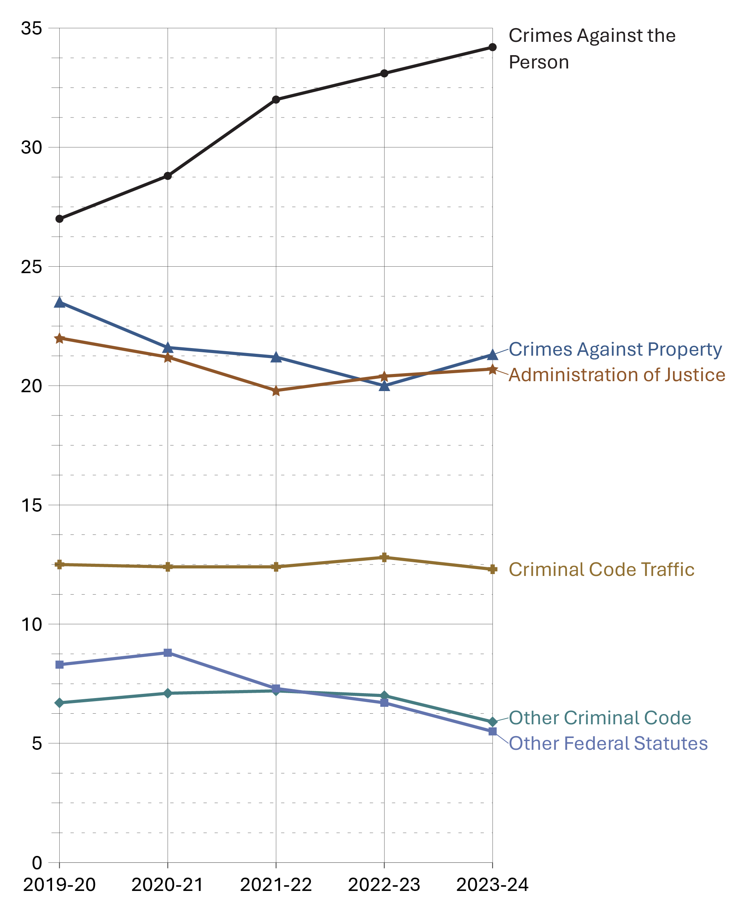
Source: Statistics Canada. Table 35-10-0027-01, Adult criminal courts, number of cases and charges by type of decision.
- From 2019-20 to 2022-24, crimes against the person increased from 27.0% to 34.2% of all charges among adults. In the same time period, the proportions of all other categories either decreased or remained stable.
- The most frequent charges in adult courts in 2023-24 were common assault (Level 1) (12.3%), failure to comply with order (10.2%), major assault (Level 2 and 3) (9.7%), and impaired driving (8.9%). These charges are captured in categories “Crimes against the person”, “Administration of justice”, and “Criminal Code traffic”, respectively.

Table A10. Type of charge
Type of charge | 2019-20 | 2020-21 | 2021-22 | 2022-23 | 2023-24
Crimes against the person | 85,831 | 68,393 | 70,887 | 72,503 | 78,119
Homicide | 330 | 314 | 274 | 334 | 301
Attempted murder | 184 | 180 | 169 | 162 | 162
Robbery | 3,244 | 2,633 | 2,464 | 2,337 | 2,317
Sexual assault | 3,607 | 2,704 | 3,163 | 3,576 | 3,992
Other sexual offences | 4,081 | 2,896 | 3,380 | 3,841 | 3,845
Major assault (levels 2 & 3) | 20,778 | 17,520 | 18,813 | 20,139 | 22,122
Common assault (level 1) | 32,360 | 24,845 | 26,526 | 25,975 | 28,011
Uttering threats | 13,782 | 11,152 | 10,331 | 9,848 | 10,663
Criminal harassment | 3,702 | 3,067 | 2,727 | 2,865 | 3,110
Other crimes against persons | 3,325 | 2,889 | 2,840 | 3,246 | 3,427
Crimes against property | 74,640 | 51,230 | 47,015 | 43,744 | 48,730
Theft | 28,278 | 16,564 | 13,342 | 12,191 | 14,809
Break and enter | 10,026 | 7,950 | 7,618 | 7,748 | 8,415
Fraud | 11,362 | 7,496 | 6,223 | 5,608 | 5,701
Mischief | 11,873 | 9,505 | 10,931 | 10,228 | 10,996
Possession of stolen property | 10,689 | 7,892 | 7,245 | 6,796 | 7,448
Other property crimes | 2,412 | 1,823 | 1,656 | 1,173 | 1,361
Administration of justice | 69,668 | 50,416 | 43,732 | 44,771 | 47,243
Fail to appear | 4,280 | 3,146 | 3,429 | 4,277 | 3,951
Breach of probation | 28,265 | 19,063 | 12,768 | 12,618 | 13,905
Unlawfully at large | 2,715 | 1,349 | 521 | 461 | 565
Fail to comply with order | 27,460 | 21,889 | 22,127 | 22,548 | 23,387
Other admin. justice | 6,948 | 4,969 | 4,887 | 4,867 | 5,435
Other Criminal Code | 21,242 | 16,893 | 16,010 | 15,351 | 13,561
Weapons/firearms | 11,170 | 9,819 | 10,228 | 9,892 | 10,310
Prostitution | 11 | 32 | 7 | 26 | 22
Disturbing the peace | 633 | 409 | 353 | 334 | 343
Residual Criminal Code | 9,428 | 6,633 | 5,422 | 5,099 | 2,886
Criminal Code traffic | 39,797 | 29,534 | 27,472 | 28,055 | 28,167
Impaired driving | 31,264 | 22,758 | 19,517 | 20,247 | 20,260
Other CC traffic | 8,533 | 6,776 | 7,955 | 7,808 | 7,907
Other federal statutes | 26,189 | 20,898 | 16,201 | 14,730 | 12,605
Drug possession | 6,165 | 6,683 | 4,982 | 4,399 | 3,330
Other drug offences | 6,909 | 6,156 | 7,059 | 6,809 | 6,498
Residual federal statutes | 12,450 | 7,675 | 3,944 | 3,382 | 2,611
Total offences | 317,367 | 237,364 | 221,317 | 219,154 | 228,425
Source: Statistics Canada. Table 35-10-0027-01, Adult criminal courts, number of cases and charges by type of decision.
Notes
Assault is a violent offence classified into 3 levels: level 1 or common assault, the least serious form including behaviours such as pushing, slapping, punching and face-to-face threats; level 2 assault, defined as assault with a weapon or causing bodily harm; and level 3 aggravated assault, defined as assault that wounds, maims, disfigures or endangers the life of the victim.
Administration of justice includes the offences failure to appear, breach of probation, and unlawfully at large.
Other Criminal Code offences (Other CC) includes administration of justice violations, weapons/firearms violations, counterfeit, possession of, accessing, making or distribution of child pornography and prostitution.
Other federal statute offences refer to offences against Canadian federal statutes, such as Customs Act, Employment Insurance Act, Firearms Act, Food and Drugs Act (FDA), Income Tax Act, Controlled Drugs and Substances Act (CDSA) and Narcotic Control Act (NCA). This offence category excludes Criminal Code of Canada offences.
The concept of a case has changed to more closely reflect court processing. Statistics from the Integrated Criminal Court Survey used in this report should not be compared to editions of the Corrections and Conditional Release Statistical Overview prior to 2007. A case is 1 or more charges against an accused person or corporation, processed by the courts at the same time, and where all of the charges in the case received a final disposition. Where a case has more than 1 charge, it is necessary to select a charge to represent the case. An offence is selected by applying 2 rules. First, the most serious decision rule is applied. In cases where 2 or more offences have the same decision, the most serious offence rule is applied. All charges are ranked according to an offence seriousness scale. Superior Court data are not reported to the Integrated Criminal Court Survey for Prince Edward Island, Quebec, Ontario, Manitoba and Saskatchewan. In addition, information from Quebec's municipal courts is not collected.
The Canadian Centre for Justice and Community Safety Statistics continues to make updates to the offence library used to classify offence data sent by the provinces and territories. These improvements have resulted in minor changes in the counts of charges and cases as well as the distributions by type of offence. Data presented have been revised to account for these updates.
Due to rounding, percentages may not add up to 100 percent.
Reported year periods reflect fiscal years. A fiscal year runs from April 1 to March 31 of the following year.

Decisions in adult criminal court

Figure A11. Number of cases in adult criminal court and admissions to custody (2023-24)
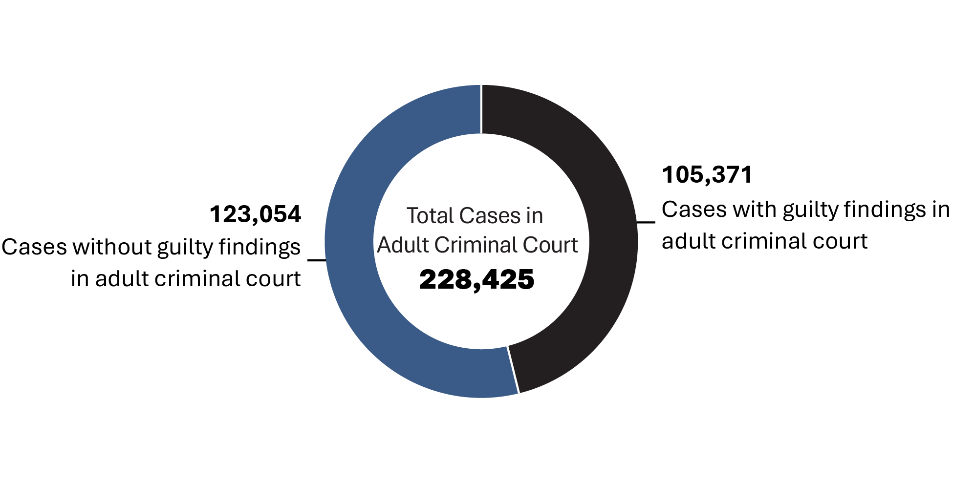
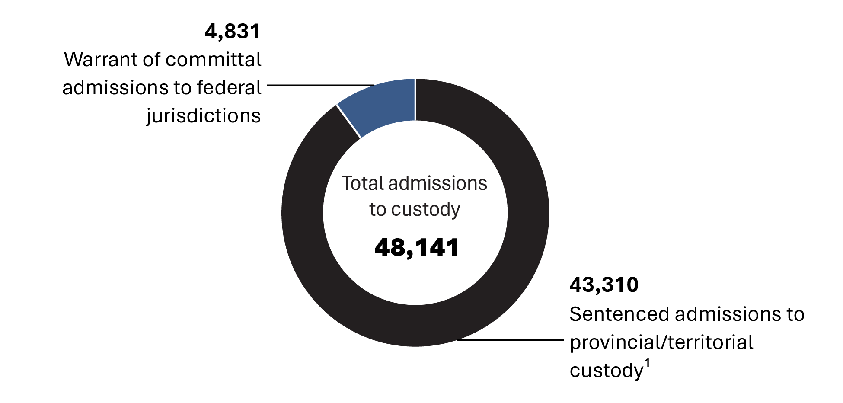
Sources:
¹Statistics Canada. Table 35-10-0018-01, Adult sentenced custody admissions to correctional services by sex and sentence length ordered;
Statistics Canada. Table 35-10-0027-01, Adult criminal courts, number of cases and charges by type of decision;
Correctional Service of Canada.
- In 2023-24, there were 105,371 cases with guilty findings in adult criminal court.
- Between 2019-20 and 2023-24, the total number of cases in adult criminal court decreased 28.0%. Over the same time period, the total number of sentenced admissions to provincial/territorial custody decreased 33.3%.
- In 2023-24, there were 4,831 warrant of committal admissions to a federal institution or Healing Lodge.
- In 2023-24, there were 43,310 sentenced admissions to provincial/territorial custody.

Table A11. Cases in adult criminal court and admissions to custody
Case type |  | 2019-20 |  | 2020-21 |  | 2021-22 |  | 2022-23 |  | 2023-24
Total cases without guilty findings in criminal court¹ | 124,597 |  | 118,223 |  | 116,126 |  | 117,072 |  | 123,054
Acquitted¹ | 9,811 |  | 7,147 |  | 2,012 |  | 2,300 |  | 2,442
Stayed or withdrawn¹ | 111,079 |  | 108,234 |  | 112,317 |  | 112,612 |  | 118,265
Other decisions¹ | 3,707 |  | 2,842 |  | 1,797 |  | 2,160 |  | 2,347
Total case decisions* in adult criminal court¹ | 317,367 |  | 237,364 |  | 221,317 |  | 219,154 |  | 228,425
Cases with guilty findings in adult criminal court¹ | 192,770 |  | 119,141 |  | 105,191 |  | 102,082 |  | 105,371
Sentenced admissions to provincial/territorial custody² | 64,964 |  | 35,566 |  | 37,932 |  | 40,900 |  | 43,310
Warrant of committal —admission to FED (CSC)³ | 4,642 |  | 3,228 |  | 4,007 |  | 4,729 |  | 4,831
Sources
¹ Statistics Canada. Table 35-10-0027-01, Adult criminal courts, number of cases and charges by type of decision;
² Statistics Canada. Table 35-10-0018-01, Adult sentenced custody admissions to correctional services by sex and sentence length ordered;
³ Correctional Service of Canada.
Notes
Warrant of Committal is a new admission to federal jurisdiction from the courts.
*The concept of a case changed to more closely reflect court processing. Statistics from the Integrated Criminal Court Survey used in this report should not be compared to editions of the Corrections and Conditional Release Statistical Overview prior to 2007. A case is one or more charges against an accused person or corporation, processed by the courts at the same time, and where all of the charges in the case received a final disposition.
The decision type guilty includes guilty of the offence, of an included offence, of an attempt of the offence, or of an attempt of an included offence. This category also includes cases where an absolute or conditional discharge has been imposed. This figure only includes cases convicted in provincial court and partial data from Superior Court. Superior Court data are not reported to the Integrated Criminal Court Survey for Prince Edward Island, Quebec, Ontario, Manitoba and Saskatchewan. Information from Quebec's municipal courts is not collected.
Police data are reported on a calendar year basis whereas court and correctional services data are reported on a fiscal year basis (April 1 through March 31).
These numbers refer to the total number of admissions to a federal institution or Healing Lodge during each fiscal year and may be greater than the actual number of offenders admitted, since an individual offender may be admitted more than once in a given year.
Individuals found guilty in adult criminal court in a given year period are not always admitted to custody in the same year period.
There is a lag in the data entry of admissions into CSC's Offender Management System. The admission figures for the most recent year are under-reported by 200-400 admissions at the time of year end data extraction. More accurate figures will be available in the next year's publication. Please use caution when including the most recent year in any trend analysis.

Length of adult custodial sentences

Figure A12. Length of prison sentence ordered by the court (2023-24)
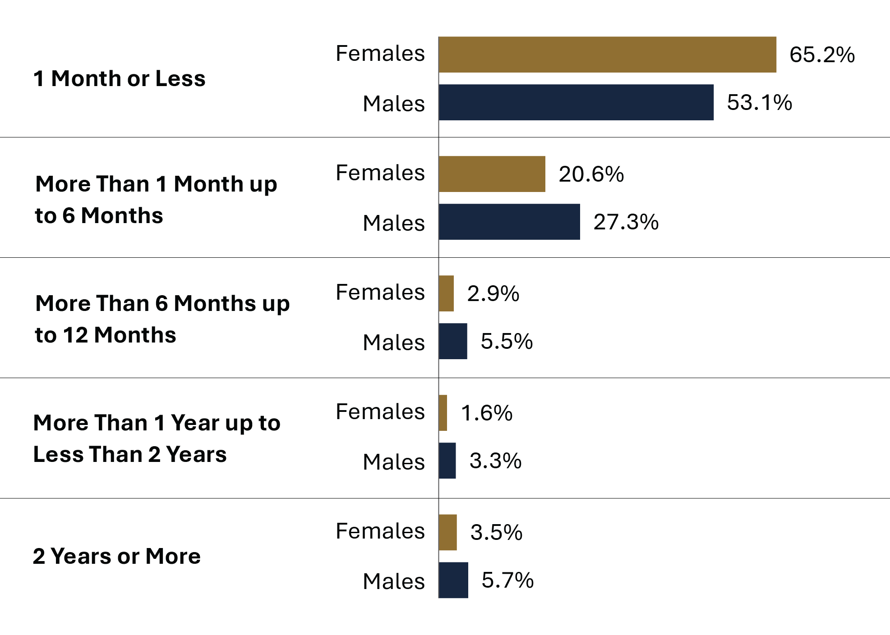
Source: Statistics Canada. Table 35-10-0032-01, Adult criminal courts, guilty cases by length of custody.
- Just under half (49.8%) of all custodial sentences imposed by adult criminal courts were 1 month or less in fiscal year 2023-24.
- Prison sentences for males tended to be longer than for females, with the exception of sentences of 1 month or less.
- 65.2% of females and 53.1% of males who were incarcerated following a guilty* finding received a sentence of 1 month or less, and 85.8% of females and 80.4% of males received a sentence of 6 months or less.
Notes
*The decision type guilty includes guilty of the offence, of an included offence, of an attempt of the offence, or of an attempt of an included offence. This category also includes cases where an absolute or conditional discharge has been imposed.

Table A12. Length of prison sentence ordered by the court

Sentence of 1 month or less (%) between fiscal year 2019-20 and 2023-24
Sex | 2019-20 | 2020-21 | 2021-22 | 2022-23 | 2023-24
Females | 54.8 | 51.9 | 61.9 | 63.4 | 65.2
Males | 46.6 | 43.4 | 51.5 | 51.8 | 53.1
Total | 44.6 | 41.0 | 47.8 | 48.1 | 49.8

Sentence of 1 month up to 6 months (%) between fiscal year 2019-20 and 2023-24
Sex | 2019-20 | 2020-21 | 2021-22 | 2022-23 | 2023-24
Females | 26.0 | 27.1 | 21.9 | 20.2 | 20.6
Males | 31.0 | 31.7 | 28.0 | 27.4 | 27.3
Total | 28.4 | 28.8 | 24.7 | 23.9 | 24.1

Sentence of more than 6 months up to 12 months (%) between fiscal year 2019-20 and 2023-24
Sex | 2019-20 | 2020-21 | 2021-22 | 2022-23 | 2023-24
Females | 3.9 | 4.5 | 3.7 | 3.5 | 2.9
Males | 5.9 | 6.8 | 6.1 | 5.7 | 5.5
Total | 5.3 | 6.0 | 5.3 | 4.9 | 4.8

Sentence of more than 1 year up to less than 2 years (%) between fiscal year 2019-20 and 2023-24
Sex | 2019-20 | 2020-21 | 2021-22 | 2022-23 | 2023-24
Females | 1.9 | 2.2 | 1.5 | 1.5 | 1.6
Males | 3.4 | 3.9 | 3.4 | 3.4 | 3.3
Total | 3.0 | 3.4 | 2.9 | 2.9 | 2.8

Sentence of 2 years or more (%) between fiscal year 2019-20 and 2023-24
Sex | 2019-20 | 2020-21 | 2021-22 | 2022-23 | 2023-24
Females | 1.9 | 2.7 | 3.2 | 3.4 | 3.5
Males | 3.6 | 4.2 | 4.8 | 5.4 | 5.7
Total | 3.2 | 3.7 | 4.2 | 4.6 | 4.9

Sentence length unknown (%) between fiscal year 2019-20 and 2023-24
Sex | 2019-20 | 2020-21 | 2021-22 | 2022-23 | 2023-24
Females | 11.5 | 11.7 | 7.9 | 8.0 | 6.2
Males | 9.6 | 10.1 | 6.2 | 6.3 | 5.1
Total | 15.6 | 17.1 | 15.1 | 15.6 | 13.6
Source: Statistics Canada. Table 35-10-0032-01, Adult criminal courts, guilty cases by length of custody.
Notes
Total includes the following categories: males, females, sex unknown, and any registered companies.
Length unknown includes indeterminate custody sentences. In some provinces/territories, particularly British Columbia, Saskatchewan, Quebec and New Brunswick, the unknown category may include guilty cases with custody where the custodial sentence ordered has already been served and the time remaining is equal to zero.
The concept of a case has changed to more closely reflect court processing. Statistics from the Integrated Criminal Court Survey used in this report should not be compared to editions of the Corrections and Conditional Release Statistical Overview prior to 2007.
Superior Court data are not reported to the Integrated Criminal Court Survey for Prince Edward Island, Quebec, Ontario, Manitoba and Saskatchewan. In addition, information from Quebec's municipal courts is not collected.
The Canadian Centre for Justice and Community Safety Statistics continues to make updates to the offence library used to classify offence data sent by the provinces and territories. These improvements have resulted in minor changes in the counts of charges and cases as well as the distributions by type of offence. Data presented have been revised to account for these updates.
Due to rounding, totals may not add up to 100 percent.
Reported year periods reflect fiscal years. A fiscal year runs from April 1 to March 31 of the following year.

The rate of youth charged

Figure A13. Rate of youth charged. Rate per 100,000
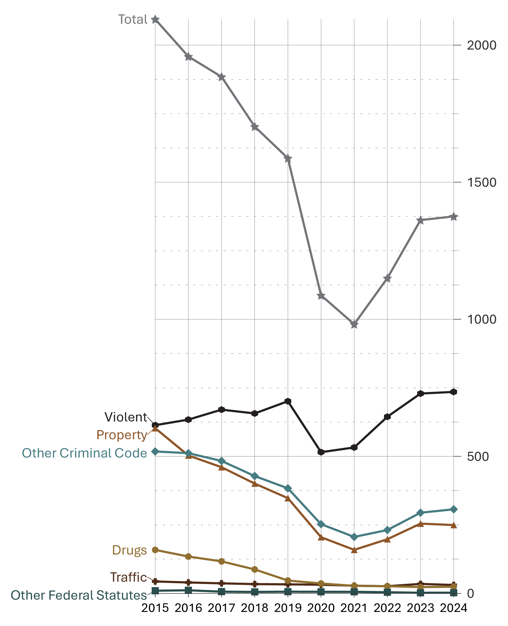
Source: Statistics Canada. Table 35-10-0177-01, Incident-based crime statistics, by detailed violations, Canada, provinces, territories, Census Metropolitan Areas and Canadian Forces Military Police.
- From 2015 to 2021, the rate of youth charged decreased substantially (-53.1%). The sharp decrease (-38.1%) seen between 2019 and 2021 may be due to lockdown restrictions resulting from the COVID-19 pandemic. From 2021 to 2024, after most lockdown restrictions had ended, there was an increase of 40.0%.
- Between 2015 to 2019 there was a 14.2% increase in the rate of youth charged with a violent crime, followed by a 24.0% decrease between 2019 to 2021, perhaps due to COVID-19 pandemic lockdown restrictions. The sharp increase (+38.1%) observed between 2021 and 2024 may be due to the lifting of many COVID-19 lockdown restrictions.
- In the 10-year period between 2015 and 2024, the rate of youth charged with drug offences decreased by 84.6%.

Table A13. Rate of youth charged. Rate per 100,000
Year | Violent | Property | Traffic | Other CC | Drugs | Other federal statutes | Total charged
1998 | 994 | 2,500 | 0 | 870 | 226 | 4 | 4,775
1999 | 1,060 | 2,237 | 0 | 728 | 266 | 2 | 4,500
2000 | 1,136 | 2,177 | 2 | 760 | 317 | 4 | 4,589
2001 | 1,157 | 2,119 | 1 | 840 | 343 | 6 | 4,656
2002 | 1,102 | 2,009 | 0 | 793 | 337 | 6 | 4,476
2003 | 953 | 1,570 | 0 | 726 | 208 | 5 | 3,662
2004 | 918 | 1,395 | 1 | 691 | 230 | 5 | 3,457
2005 | 924 | 1,276 | 0 | 660 | 214 | 10 | 3,287
2006 | 917 | 1,216 | 0 | 680 | 240 | 16 | 3,269
2007 | 943 | 1,211 | 75 | 732 | 260 | 17 | 3,461
2008 | 909 | 1,130 | 74 | 730 | 267 | 19 | 3,369
2009 | 888 | 1,143 | 68 | 698 | 238 | 30 | 3,294
2010 | 860 | 1,035 | 62 | 669 | 255 | 31 | 3,147
2011 | 806 | 904 | 58 | 636 | 263 | 31 | 2,918
2012 | 765 | 842 | 58 | 629 | 240 | 20 | 2,771
2013 | 692 | 722 | 45 | 554 | 229 | 10 | 2,435
2014 | 625 | 625 | 42 | 526 | 198 | 6 | 2,184
2015 | 614 | 603 | 44 | 518 | 159 | 10 | 2,094
2016 | 634 | 503 | 40 | 512 | 135 | 11 | 1,959
2017 | 670 | 460 | 37 | 483 | 117 | 6 | 1,884
2018 | 656 | 401 | 34 | 428 | 87 | 5 | 1,703
2019 | 701 | 348 | 33 | 383 | 47 | 6 | 1,587
2020 | 515 | 205 | 32 | 253 | 36 | 6 | 1,087
2021 | 532 | 159 | 28 | 206 | 27 | 6 | 982
2022 | 644 | 198 | 26 | 231 | 26 | 4 | 1,150
2023 | 729 | 255 | 35 | 294 | 23 | 2 | 1,362
2024 | 735 | 249 | 31 | 307 | 24 | 3 | 1,375
Source: Statistics Canada. Table 35-10-0177-01, Incident-based crime statistics, by detailed violations, Canada, provinces, territories, Census Metropolitan Areas and Canadian Forces Military Police.
Notes
Other Criminal Code offences (Other CC) includes administration of justice violations; weapons/firearms violations; counterfeit; possession of, accessing, making or distribution of child pornography; and prostitution.
Other federal statute offences refer to offences against Canadian federal statutes, such as Customs Act, Employment Insurance Act, Firearms Act, Food and Drugs Act (FDA), Income Tax Act, Controlled Drugs and Substances Act (CDSA) and Narcotic Control Act (NCA). This offence category excludes Criminal Code of Canada offences.
For criminal justice purposes, youth are defined under Canadian law as persons age 12 to 17.
Rates are based on 100,000 youth population (12 to 17 years old). Violent crimes include homicide, attempted murder, assault, sexual offences, abduction, extortion, robbery, firearms, and other violent offences such as uttering threats and criminal harassment. Property crimes include break and enter, motor vehicle theft, other theft, possession of stolen property, fraud, mischief and arson.

Criminal Code and other Federal Statute charges among youth: 5-year trend

Figure A14. Percentage of all Criminal Code and other federal statute charges among youth
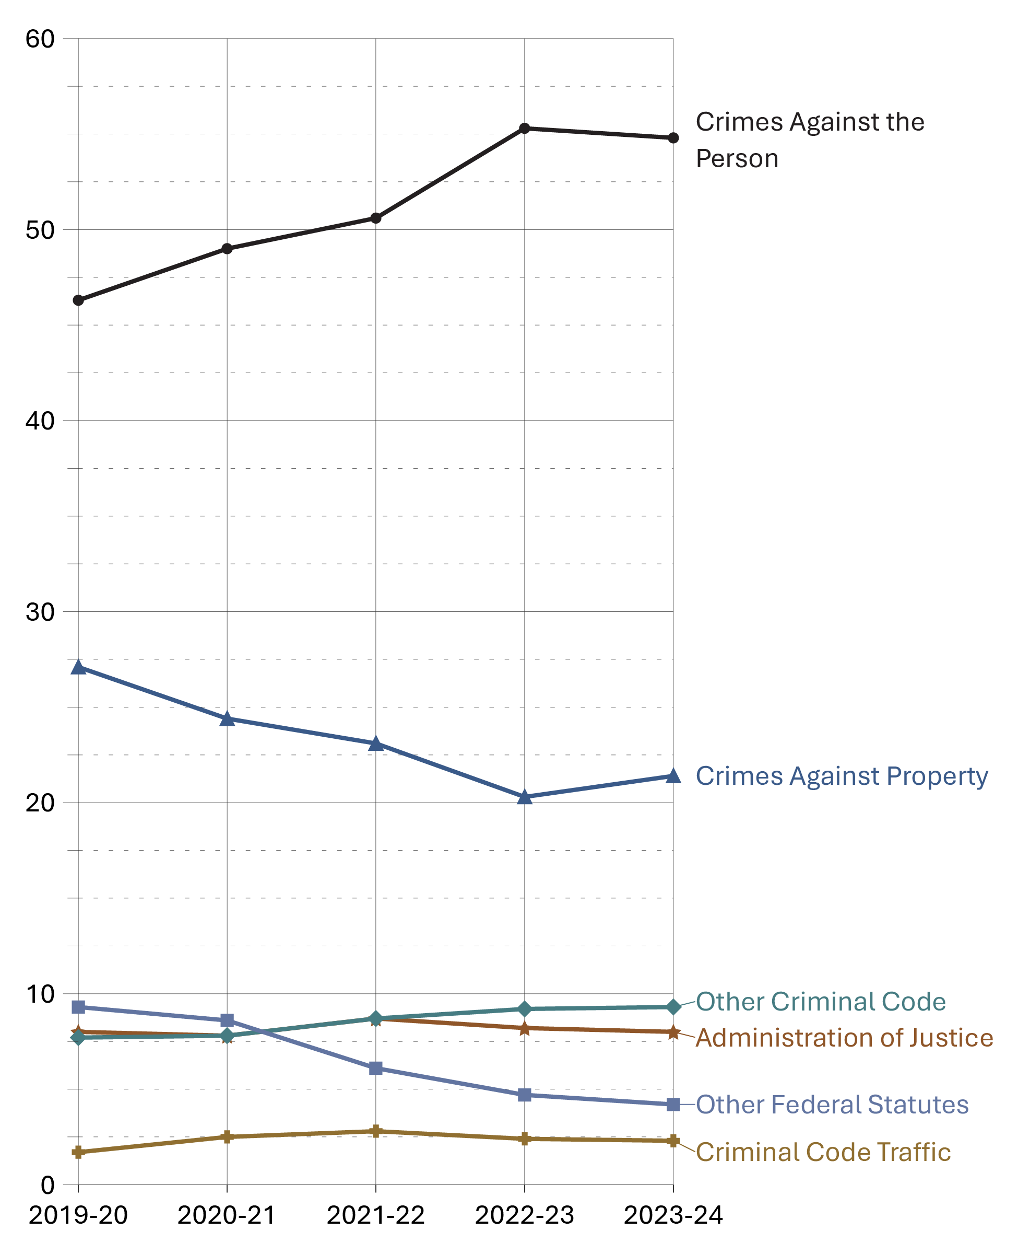
Source: Statistics Canada. Table 35-10-0038-01, Youth courts, number of cases and charges by type of decision.
- In 2023-24, crimes against the person accounted for approximately half (54.8%) of all charges among youth (increasing from 46.3% in 2019-20).
- In the 5-year period between 2019-20 and 2023-24, crimes against property and other federal statute charges decreased among youth, while crimes against the person and Other Criminal Code charges increased. Criminal Code traffic and administration of justice charges remained relatively stable.
- Common assault (included in “Crimes against the person”) has consistently been the most frequent charge in youth court in the 5-year period from 2019-20 to 2023-24.

Table A14. Number of all Criminal Code and other federal statute charges among youth
Type of charge | 2019-20 | 2020-21 | 2021-22 | 2022-23 | 2023-24
Crimes against the person | 10,379 | 7,345 | 5,769 | 6,713 | 8,539
Homicide and Attempted Murder | 41 | 37 | 40 | 39 | 48
Robbery | 1,502 | 1,082 | 787 | 692 | 1,087
Sexual Assault/Other Sexual Offences | 1,821 | 1,486 | 1,322 | 1,467 | 1,558
Major Assault | 2,145 | 1,579 | 1,358 | 1,625 | 2,185
Common Assault | 2,828 | 1,825 | 1,522 | 2,049 | 2,585
Other Crimes Against the Person | 2,026 | 1,322 | 738 | 839 | 1,069
Crimes against property | 6,087 | 3,659 | 2,633 | 2,460 | 3,335
Theft | 1,588 | 812 | 430 | 451 | 728
Break and Enter | 1,165 | 781 | 619 | 555 | 723
Fraud | 382 | 257 | 123 | 92 | 117
Mischief | 1,278 | 889 | 802 | 804 | 981
Possession of Stolen Property | 1,060 | 533 | 392 | 314 | 450
Other Crimes Against Property | 237 | 161 | 119 | 93 | 138
Administration of justice | 1,788 | 1,164 | 988 | 998 | 1,240
Failure to comply with order | 1,064 | 725 | 648 | 654 | 828
Other administration of justice | 626 | 378 | 291 | 315 | 368
Other Criminal Code | 1,718 | 1,170 | 988 | 1,113 | 1,444
Weapons/Firearms | 1,381 | 922 | 816 | 960 | 1294
Prostitution | 1 | 2 | 1 | 0 | 1
Disturbing the Peace | 33 | 23 | 32 | 28 | 17
Residual Criminal Code | 303 | 223 | 139 | 125 | 132
Criminal Code traffic | 379 | 373 | 320 | 287 | 358
Other federal statutes | 2,088 | 1,290 | 695 | 567 | 657
Drug Possession | 272 | 164 | 41 | 65 | 41
Other Drug Offences | 338 | 242 | 183 | 189 | 175
Youth Criminal Justice Act | 1,382 | 775 | 454 | 302 | 410
Residual Federal Statutes | 96 | 109 | 17 | 11 | 31
Total | 22,439 | 15,001 | 11,393 | 12,138 | 15,573
Source: Statistics Canada. Table 35-10-0038-01, Youth courts, number of cases and charges by type of decision.
Notes
Administration of justice includes the offences failure to appear, breach of probation, and unlawfully at large.
Other Criminal Code (Other CC) offences includes administration of justice violations, weapons/firearms violations, counterfeit, possession of, accessing, making or distribution of child pornography and prostitution.
Other federal statute offences refer to offences against Canadian federal statutes, such as Customs Act, Employment Insurance Act, Firearms Act, Food and Drugs Act (FDA), Income Tax Act, Controlled Drugs and Substances Act (CDSA) and Narcotic Control Act (NCA). This offence category excludes Criminal Code of Canada offences.
Youth Criminal Justice Act offences include failure to comply with a disposition or undertaking, contempt against youth court, assisting a youth to leave a place of custody and harbouring a youth unlawfully at large. Also included are similar offences under the Young Offenders Act, which preceded the Youth Criminal Justice Act.
The concept of a case has changed to more closely reflect court processing. Statistics from the Integrated Criminal Court Survey used in this report should not be compared to editions of the Corrections and Conditional Release Statistical Overview prior to 2007. A case is 1 or more charges against an accused person or corporation, processed by the courts at the same time, and where all of the charges in the case received a final disposition. Where a case has more than 1 charge, it is necessary to select a charge to represent the case. An offence is selected by applying 2 rules. First, the most serious decision rule is applied. In cases where 2 or more offences have the same decision, the most serious offence rule is applied. All charges are ranked according to an offence seriousness scale.
The Canadian Centre for Justice and Community Safety Statistics continues to make updates to the offence library used to classify offence data sent by the provinces and territories. These improvements have resulted in minor changes in the counts of charges and cases as well as the distributions by type of offence. Data presented have been revised to account for these updates.
The table includes data from the most recent year available at the time of preparation.
Reported year periods reflect fiscal years. A fiscal year runs from April 1 to March 31 of the following year.

Youth criminal court sentences: 5-year trend

Figure A15. Percentage of sentence type received in youth criminal court
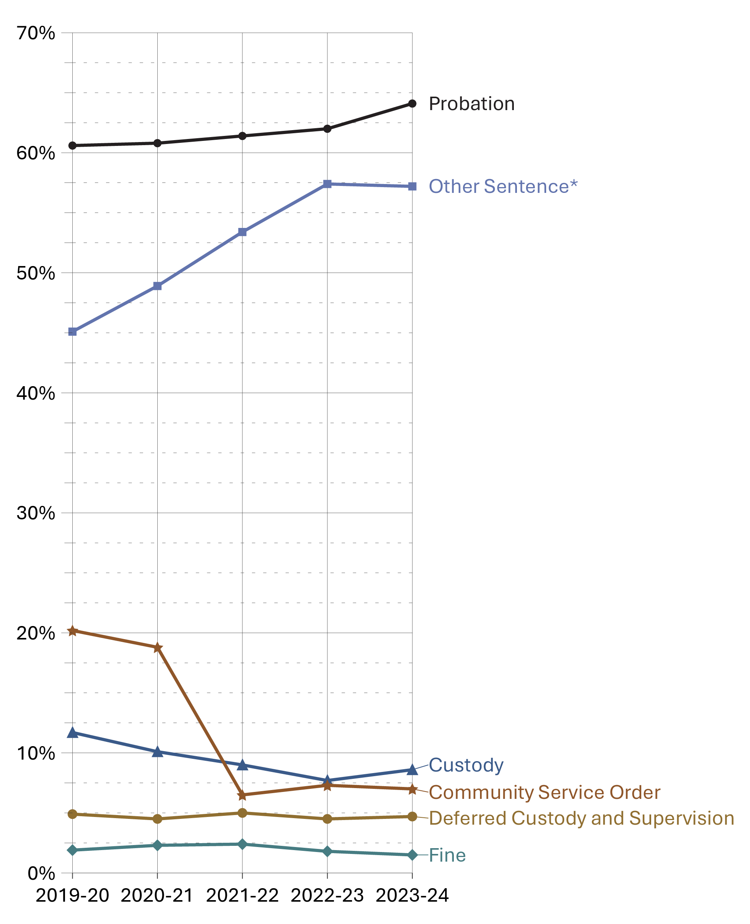
Source: Statistics Canada. Table 35-10-0041-01, Youth courts, guilty cases by type of sentence.
- Probation has consistently been the most common sentence in youth criminal court. In fiscal year 2023-24, 64.1% of all youth found guilty were sentenced to probation. By sex, 60.7% of females and 64.8% of males were sentenced to probation in 2023-24.
- Community service orders steadily declined from 2019-20 to 2020-21, then had a sharp decline between 2020-21 and 2023-24 (from 18.8% to 7.0%). Fluctuations between 2019 and 2022 may be due to the imposition and cessation of the COVID-19 pandemic lockdown restrictions.
- In the 5-year period from 2019-20 to 2023-24, other sentences* increased from 45.1% to 57.2%.
Notes
*Other sentence includes absolute discharge, restitution, prohibition, seizure, forfeiture, compensation, pay purchaser, essays, apologies, counselling programs and conditional discharge, conditional sentence, intensive support and supervision, attendance at non-residential program(s), and reprimand. This category also includes intensive support and supervision, attendance at non-residential program(s) and reprimand where sentencing data under the Youth Criminal Justice Act are not available.

Table A15. Percentage of sentence type received in youth criminal court

Probation (%) between fiscal year 2019-20 and 2023-24
Sex | 2019-20 | 2020-21 | 2021-22 | 2022-23 | 2023-24
Female | 53.9 | 51.9 | 55.3 | 57.1 | 60.7
Male | 62.2 | 63.3 | 62.7 | 62.4 | 64.8
Total | 60.6 | 60.8 | 61.4 | 62.0 | 64.1

Custody (%) between fiscal year 2019-20 and 2023-24
Sex | 2019-20 | 2020-21 | 2021-22 | 2022-23 | 2023-24
Female | 4.7 | 4.4 | 4.6 | 3.0 | 4.0
Male | 12.8 | 10.9 | 9.7 | 8.4 | 9.6
Total | 11.7 | 10.1 | 9.0 | 7.7 | 8.6

Community service order (%) between fiscal year 2019-20 and 2023-24
Sex | 2019-20 | 2020-21 | 2021-22 | 2022-23 | 2023-24
Female | 18.9 | 19.0 | 6.5 | 6.7 | 6.6
Male | 21.8 | 20.5 | 5.8 | 7.2 | 7.0
Total | 20.2 | 18.8 | 6.5 | 7.3 | 7.0

Deferred custody and supervision (%) between fiscal year 2019-20 and 2023-24
Sex | 2019-20 | 2020-21 | 2021-22 | 2022-23 | 2023-24
Female | 3.7 | 3.4 | 3.9 | 3.8 | 3.0
Male | 5.3 | 4.7 | 5.3 | 5.1 | 5.3
Total | 4.9 | 4.5 | 5.0 | 4.5 | 4.7

Fine (%) between fiscal year 2019-20 and 2023-24
Sex | 2019-20 | 2020-21 | 2021-22 | 2022-23 | 2023-24
Female | 1.6 | 2.0 | 1.7 | 0.8 | 1.0
Male | 1.9 | 2.2 | 2.5 | 1.9 | 1.5
Total | 1.9 | 2.3 | 2.4 | 1.8 | 1.5

Other sentence* (%) between fiscal year 2019-20 and 2023-24
Sex | 2019-20 | 2020-21 | 2021-22 | 2022-23 | 2023-24
Female | 43.7 | 49.9 | 52.5 | 55.4 | 57.8
Male | 46.4 | 48.7 | 54.5 | 59.0 | 57.3
Total | 45.1 | 48.9 | 53.4 | 57.4 | 57.2
Source: Statistics Canada. Table 35-10-0041-01, Youth courts, guilty cases by type of sentence.
Notes
*Other sentence includes absolute discharge, restitution, prohibition, seizure, forfeiture, compensation, pay purchaser, essays, apologies, counselling programs and conditional discharge, conditional sentence, intensive support and supervision, attendance at non-residential program(s), and reprimand. This category also includes intensive support and supervision, attendance at non-residential program(s) and reprimand where sentencing data under the Youth Criminal Justice Act are not available.
Cases can have more than one sentence. Therefore, sanctions are not mutually exclusive and will not add to 100%. For all sentencing tables, data are for cases with a guilty finding only. Sentencing information is not available for a small proportion of guilty cases (i.e., approximately 3%, overall). For all sentencing tables, data are for cases with a guilty finding only and for which sentencing information is reported.
The concept of a case has changed to more closely reflect court processing. Statistics from the Integrated Criminal Court Survey used in this report should not be compared to editions of the Corrections and Conditional Release Statistical Overview prior to 2007.
The table includes data from the most recent year available at the time of preparation.
Reported year periods reflect fiscal years. A fiscal year runs from April 1 to March 31 of the following year.

Youth criminal court sentences for most serious sentence: 5-year trend

Figure A16. Percentage of youth criminal court sentence for most serious sentence
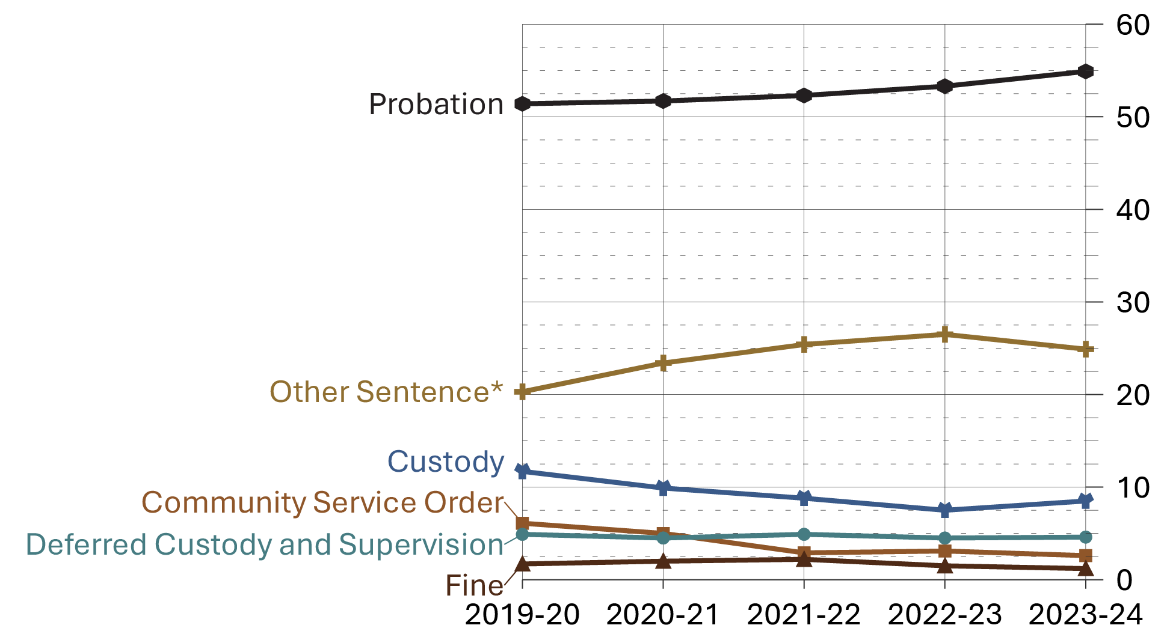
Source: Statistics Canada. Table 35-10-0042-01, Youth courts, guilty cases by most serious sentence.
- In 2023-24, 54.9% of youth found guilty were given probation as the most serious sentence. This rate has remained relatively stable since the implementation of the Youth Criminal Justice Act in April 2003.
- Of the Youth Criminal Justice Act sentences in 2023-24, fine orders were the least frequent sentences (1.2%), followed by community service orders (2.6%).
Notes
*Other sentence includes absolute discharge, restitution, prohibition, seizure, forfeiture, compensation, pay purchaser, essays, apologies, counselling programs and conditional discharge, conditional sentence, intensive support and supervision, attendance at non-residential program(s), and reprimand. This category also includes intensive support and supervision, attendance at non-residential program(s) and reprimand where sentencing data under the Youth Criminal Justice Act are not available.

Table A16. Percentage of youth criminal court sentence for most serious sentence

Probation (%) between fiscal year 2019-20 and 2023-24
Sex | 2019-20 | 2020-21 | 2021-22 | 2022-23 | 2023-24
Female | 49.2 | 47.1 | 49.9 | 53.1 | 54.9
Male | 51.6 | 53.2 | 52.6 | 52.5 | 54.2
Total | 51.4 | 51.7 | 52.3 | 53.3 | 54.9

Custody (%) between fiscal year 2019-20 and 2023-24
Sex | 2019-20 | 2020-21 | 2021-22 | 2022-23 | 2023-24
Female | 4.7 | 4.3 | 4.2 | 2.9 | 4.0
Male | 12.8 | 10.6 | 9.5 | 8.1 | 9.4
Total | 11.7 | 9.9 | 8.8 | 7.5 | 8.5

Community service order (%) between fiscal year 2019-20 and 2023-24
Sex | 2019-20 | 2020-21 | 2021-22 | 2022-23 | 2023-24
Female | 7.5 | 6.9 | 3.8 | 3.6 | 2.1
Male | 5.3 | 4.7 | 1.9 | 2.6 | 2.4
Total | 6.1 | 5.0 | 2.9 | 3.1 | 2.6

Deferred custody and supervision (%) between fiscal year 2019-20 and 2023-24
Sex | 2019-20 | 2020-21 | 2021-22 | 2022-23 | 2023-24
Female | 3.7 | 3.4 | 3.9 | 3.8 | 3.0
Male | 5.3 | 4.7 | 5.2 | 5.0 | 5.3
Total | 4.9 | 4.5 | 4.9 | 4.5 | 4.6

Fine (%) between fiscal year 2019-20 and 2023-24
Sex | 2019-20 | 2020-21 | 2021-22 | 2022-23 | 2023-24
Female | 1.3 | 2.0 | 1.4 | 0.5 | 0.7
Male | 1.6 | 1.9 | 2.2 | 1.7 | 1.3
Total | 1.7 | 2.0 | 2.2 | 1.5 | 1.2

Other sentence* (%) between fiscal year 2019-20 and 2023-24
Sex | 2019-20 | 2020-21 | 2021-22 | 2022-23 | 2023-24
Female | 27.3 | 31.2 | 31.1 | 31.9 | 31.3
Male | 19.6 | 21.6 | 25.3 | 26.5 | 24.0
Total | 20.3 | 23.4 | 25.4 | 26.5 | 24.9
Source: Statistics Canada. Table 35-10-0042-01, Youth courts, guilty cases by most serious sentence.
Notes
It is possible to receive more than one sentence type in relation to a guilty charge in a case. For the current figure, when a youth received multiple sentences, only the most serious sentence is represented. Sentence types are ranked from most to least serious as follows: Intensive rehabilitative custody and supervision; custody and supervision - presumptive, murder; custody and supervision - presumptive, excluding murder; custody and supervision; custody (supervision type) not specified, youth custodial sentence under the Young Offenders Act, or adult custody; conditional sentence, deferred custody and supervision; Intensive support and supervision; probation; prohibition, seizure, forfeiture; community service; personal service/compensation in kind; pay purchaser; restitution; compensation; fine; conditional discharge; absolute discharge; reprimand; and other.
*Other sentence includes absolute discharge, restitution, prohibition, seizure, forfeiture, compensation, pay purchaser, essays, apologies, counselling programs and conditional discharge, conditional sentence, intensive support and supervision, attendance at non-residential program(s), and reprimand. This category also includes intensive support and supervision, attendance at non-residential program(s) and reprimand where sentencing data under the Youth Criminal Justice Act are not available.
The concept of a case has changed to more closely reflect court processing. Statistics from the Integrated Criminal Court Survey used in this report should not be compared to editions of the Corrections and Conditional Release Statistical Overview prior to 2007.
The table includes data from the most recent year available at the time of preparation.
Reported year periods reflect fiscal years. A fiscal year runs from April 1 to March 31 of the following year.

International incarceration rates

Figure A17. Prison population (2024). Rate per 100,000
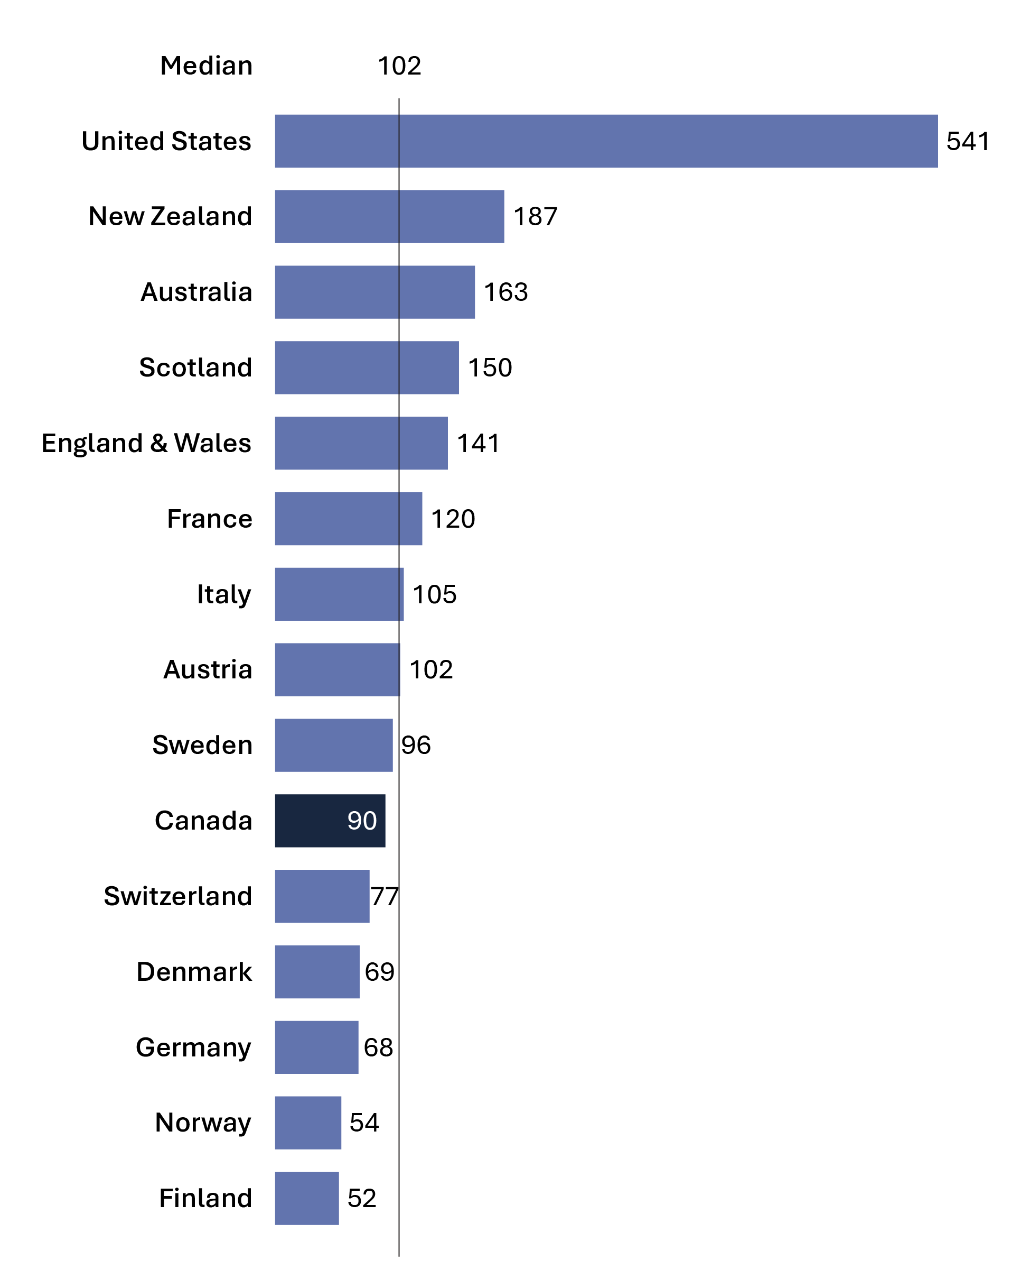
Source: World Prison Brief, Institute for Crime & Justice Policy Research (ICPR) (www.prisonstudies.org/highest-to-lowest/prison-population-total).
- In 2024, Canada's incarceration rate was 90 per 100,000. When ranked from highest incarceration rate (i.e., 1) to lowest (i.e., 224), Canada's prison population rate was ranked 163 of 224 countries. Canada's incarceration rate is lower than the median of Western and European countries, and much lower than the United States where the incarceration rate was 541 per 100,000 in 2024.
- Finland’s incarceration rate was 52 per 100,000, the lowest incarceration rate among western European countries.

Notes
The median is the middle value where half the values fall below the median and the other half above. The median is the preferred way to measure the average when there is an extreme outlier in the data.

Table A17. Prison population. Rate per 100,000
Country | 2015 | 2016 | 2017 | 2018 | 2019 | 2020 | 2021 | 2022 | 2023 | 2024
United States | 698 | 693 | 666 | 655 | 655 | 639 | 629 | 505 | 531 | 541
New Zealand | 190 | 203 | 214 | 214 | 201 | 188 | 150 | 157 | 173 | 187
Australia | 151 | 152 | 168 | 172 | 170 | 160 | 165 | 165 | 158 | 163
Scotland | 144 | 142 | 138 | 143 | 149 | 136 | 138 | 136 | 144 | 150
England & Wales | 148 | 147 | 146 | 140 | 140 | 131 | 132 | 139 | 146 | 141
France | 100 | 103 | 103 | 100 | 105 | 90 | 103 | 106 | 109 | 120
Italy | 86 | 90 | 95 | 98 | 101 | 89 | 92 | 96 | 104 | 105
Austria | 95 | 93 | 94 | 98 | 98 | 95 | 90 | 97 | 99 | 102
Sweden | 60 | 53 | 57 | 59 | 61 | 68 | 73 | 74 | 82 | 96
Canada | 106 | 114 | 114 | 114 | 107 | 104 | 104 | 85 | 88 | 90
Switzerland | 84 | 83 | 82 | 81 | 81 | 80 | 73 | 72 | 73 | 77
Denmark | 61 | 58 | 59 | 63 | 63 | 68 | 72 | 72 | 69 | 69
Germany | 78 | 78 | 77 | 75 | 77 | 69 | 71 | 67 | 67 | 68
Norway | 71 | 74 | 74 | 63 | 60 | 49 | 57 | 56 | 54 | 54
Finland | 57 | 55 | 57 | 51 | 53 | 53 | 50 | 51 | 51 | 52
Source: World Prison Brief, Institute for Crime & Justice Policy Research (ICPR) (www.prisonstudies.org/highest-to-lowest/prison-population-total ).
Notes
Table A17 and A18 display the same data for ease of reference and accessibility purposes.
The incarceration rate presented here is a measure of the number of people (i.e., adults and youth) in custody per 100,000 people in the general population. Incarceration rates from the World Prison Brief hosted by the Institute for Crime & Justice Policy Research (ICPR) are based on the most recently available data at the time the list was compiled. The data were retrieved online on April 2nd, 2025 from http://www.prisonstudies.org, which contains the most up-to-date information available. Additionally, different practices and variations in measurement in different countries limit the comparability of these figures.

International incarceration rates: 10-year trend

Figure A18. Prison population. Rate per 100,000
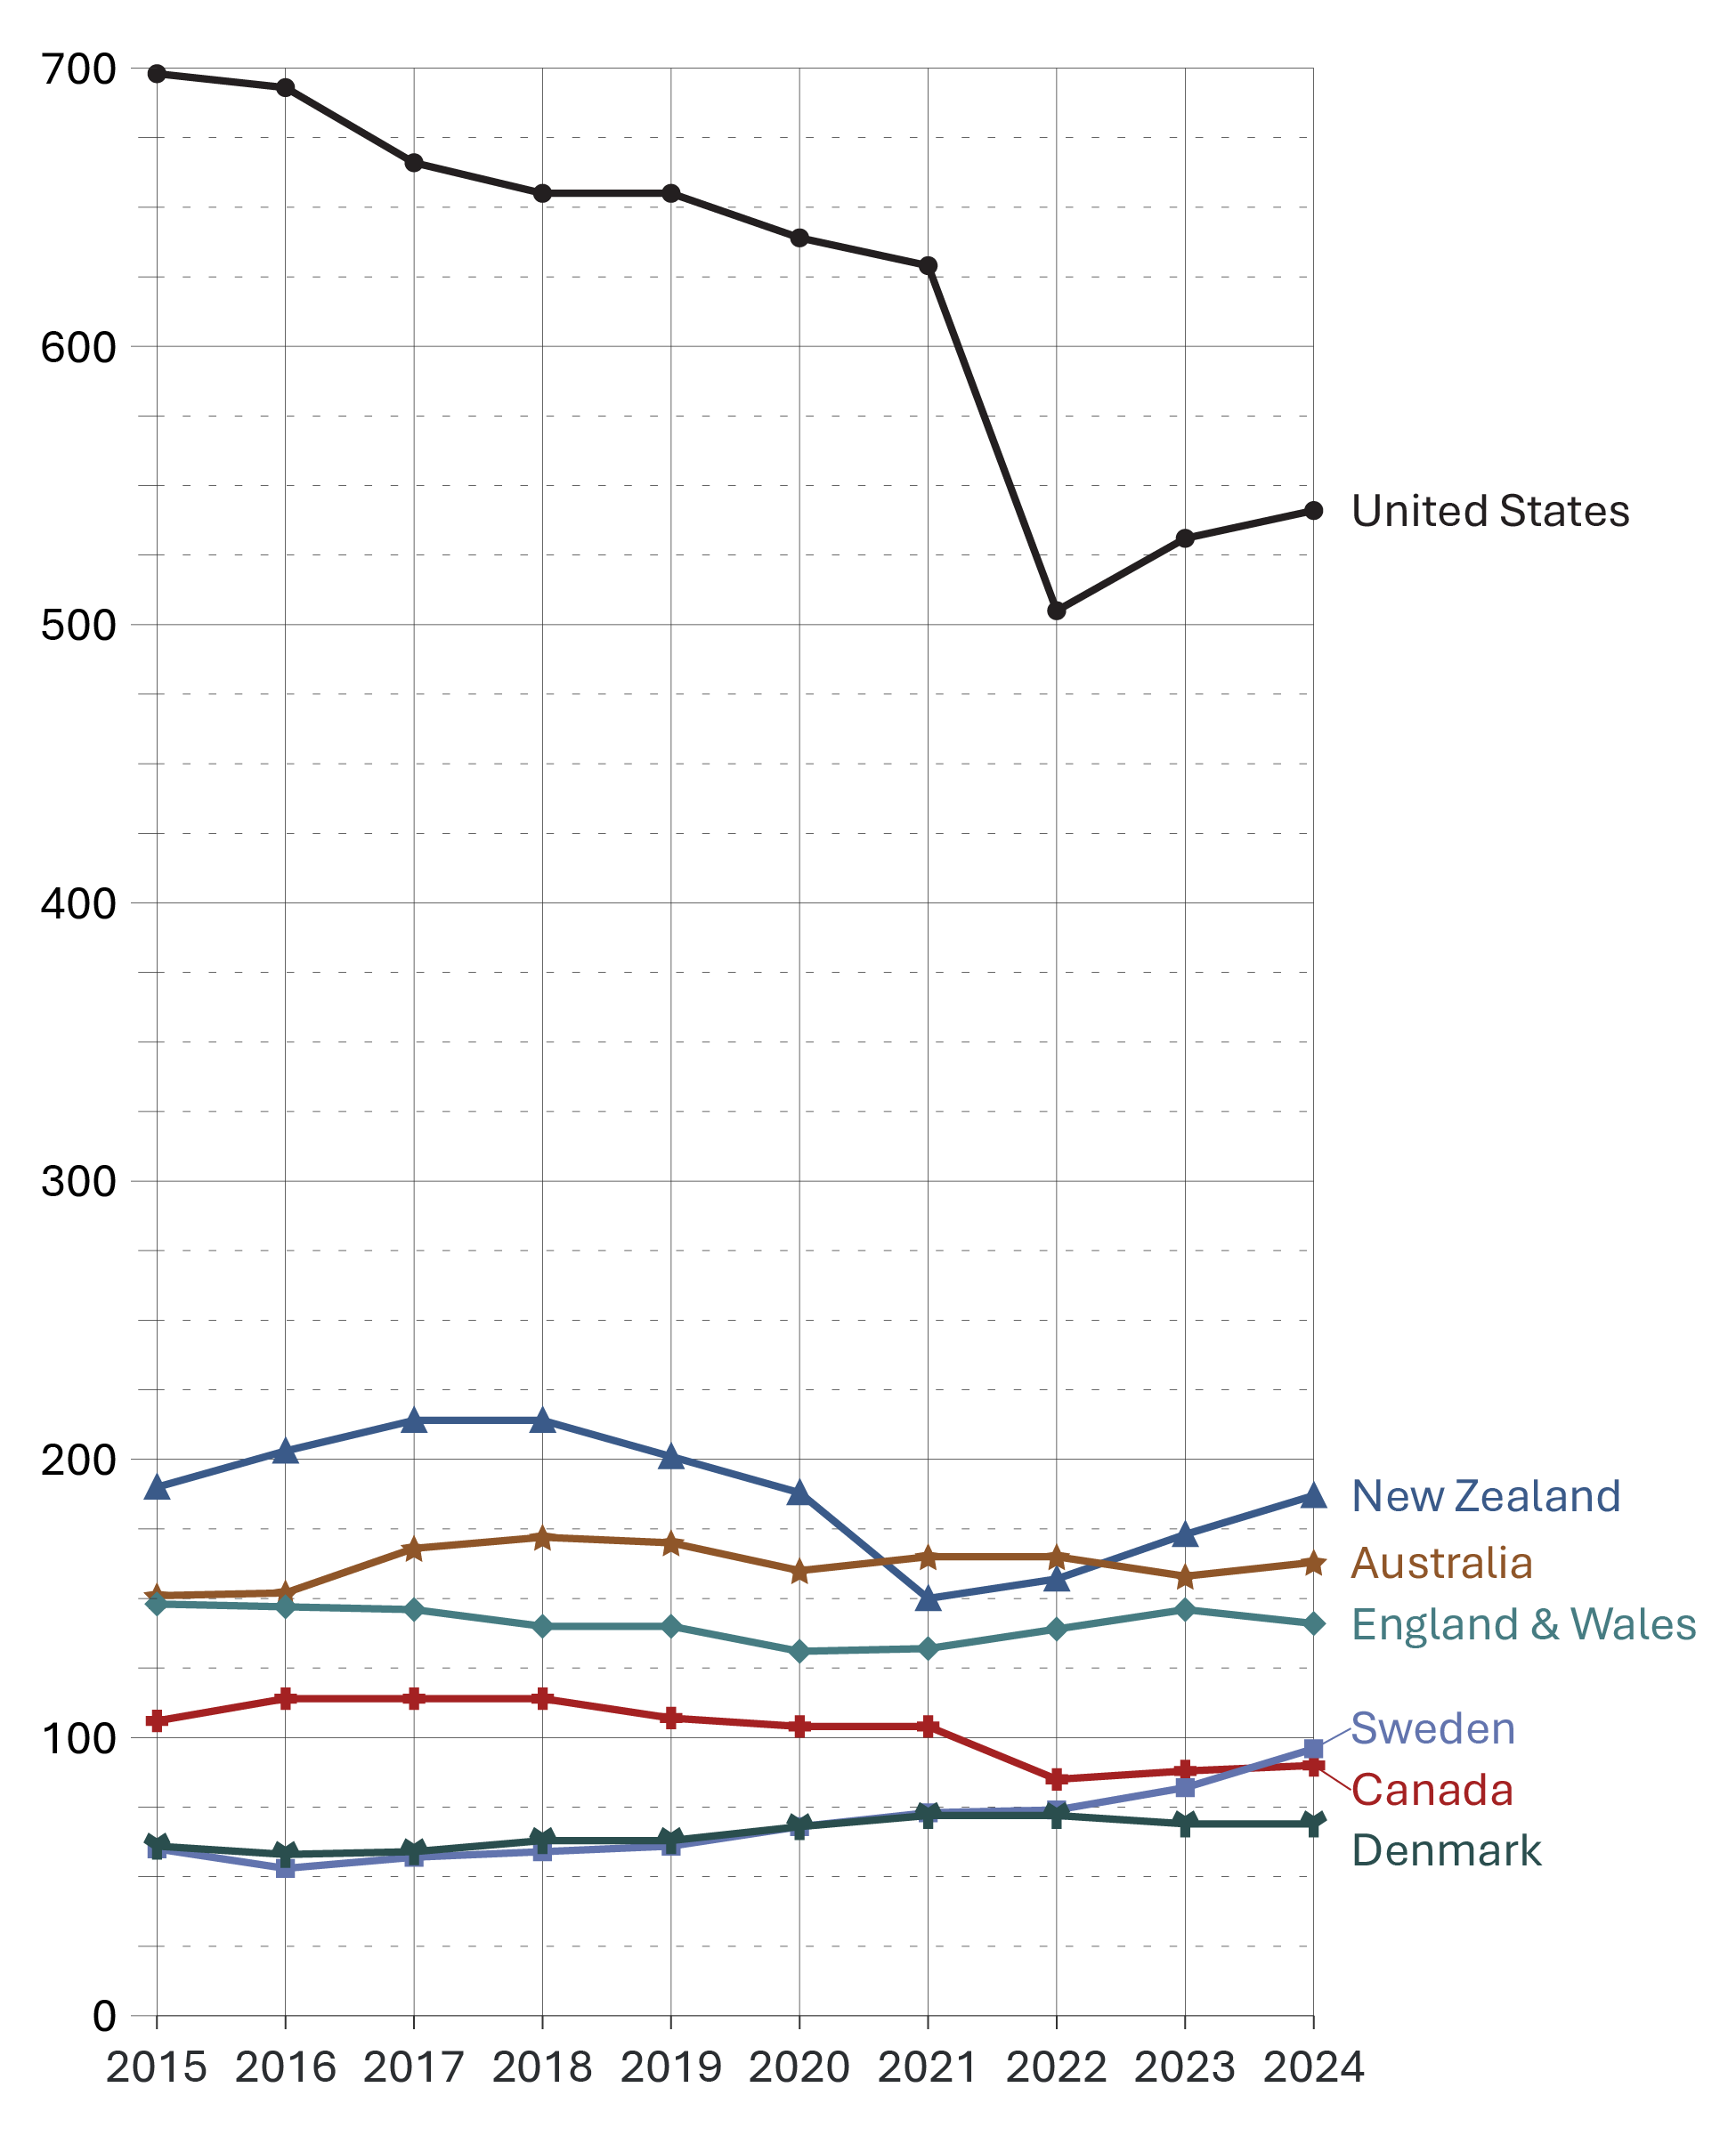
Source: World Prison Brief, Institute for Crime & Justice Policy Research (ICPR) (www.prisonstudies.org/highest-to-lowest/prison-population-total ).
- In the past 10 years (from 2015 to 2024), Canada’s incarceration rate declined 15.1%.
- From 2015 to 2023, incarceration rates declined in 8 of the 15 countries presented in the table below, while the remaining 7 countries increased. Notable decreases were the United States and Norway, with both countries reporting decreases of 23.9% between 2015 to 2023. Notable increases in the incarceration rate over the same time period were Sweden (+36.7%) and Italy (+20.9%).
- From 2023 to 2024, incarceration rates either remained stable or increased. The greatest increases were in Sweden (+17.1%) and France (+10.1%). The only country reporting a decrease in the incarceration rate between 2023 to 2024 was England & Wales (-3.4%).

Table A18. Prison population. Rate per 100,000
Country | 2015 | 2016 | 2017 | 2018 | 2019 | 2020 | 2021 | 2022 | 2023 | 2024
United States | 698 | 693 | 666 | 655 | 655 | 639 | 629 | 505 | 531 | 541
New Zealand | 190 | 203 | 214 | 214 | 201 | 188 | 150 | 157 | 173 | 187
Australia | 151 | 152 | 168 | 172 | 170 | 160 | 165 | 165 | 158 | 163
Scotland | 144 | 142 | 138 | 143 | 149 | 136 | 138 | 136 | 144 | 150
England & Wales | 148 | 147 | 146 | 140 | 140 | 131 | 132 | 139 | 146 | 141
France | 100 | 103 | 103 | 100 | 105 | 90 | 103 | 106 | 109 | 120
Italy | 86 | 90 | 95 | 98 | 101 | 89 | 92 | 96 | 104 | 105
Austria | 95 | 93 | 94 | 98 | 98 | 95 | 90 | 97 | 99 | 102
Sweden | 60 | 53 | 57 | 59 | 61 | 68 | 73 | 74 | 82 | 96
Canada | 106 | 114 | 114 | 114 | 107 | 104 | 104 | 85 | 88 | 90
Switzerland | 84 | 83 | 82 | 81 | 81 | 80 | 73 | 72 | 73 | 77
Denmark | 61 | 58 | 59 | 63 | 63 | 68 | 72 | 72 | 69 | 69
Germany | 78 | 78 | 77 | 75 | 77 | 69 | 71 | 67 | 67 | 68
Norway | 71 | 74 | 74 | 63 | 60 | 49 | 57 | 56 | 54 | 54
Finland | 57 | 55 | 57 | 51 | 53 | 53 | 50 | 51 | 51 | 52
Source: World Prison Brief, Institute for Crime & Justice Policy Research (ICPR) (www.prisonstudies.org/highest-to-lowest/prison-population-total ).
Notes
Table A17 and A18 display the same data for ease of reference and accessibility purposes.
The incarceration rate presented here is a measure of the number of people (i.e., adults and youth) in custody per 100,000 people in the general population. Incarceration rates from the World Prison Brief are based on the most recently available data at the time the list was compiled. The data were retrieved online on April 2nd, 2025 at www.prisonstudies.org, which contains the most up to date information available. Additionally, different practices and variations in measurement in different countries limit the comparability of these figures.

Section B:
Corrections Administration



Costs of federal and provincial/territorial corrections

Figure B1a. Costs of federal corrections¹
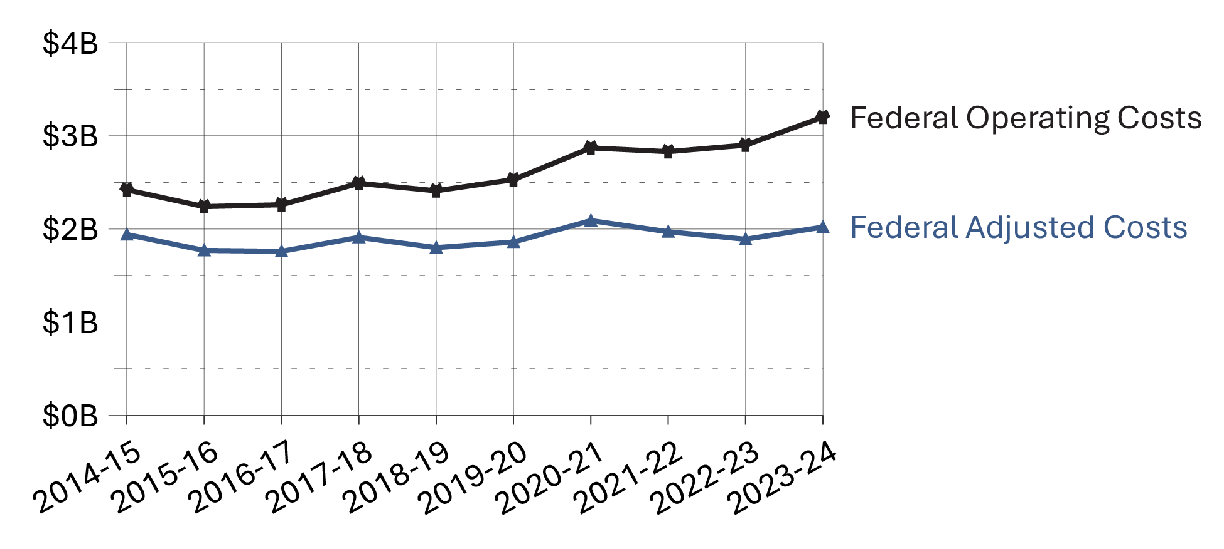

Figure B1b. Costs of provincial/territorial corrections²
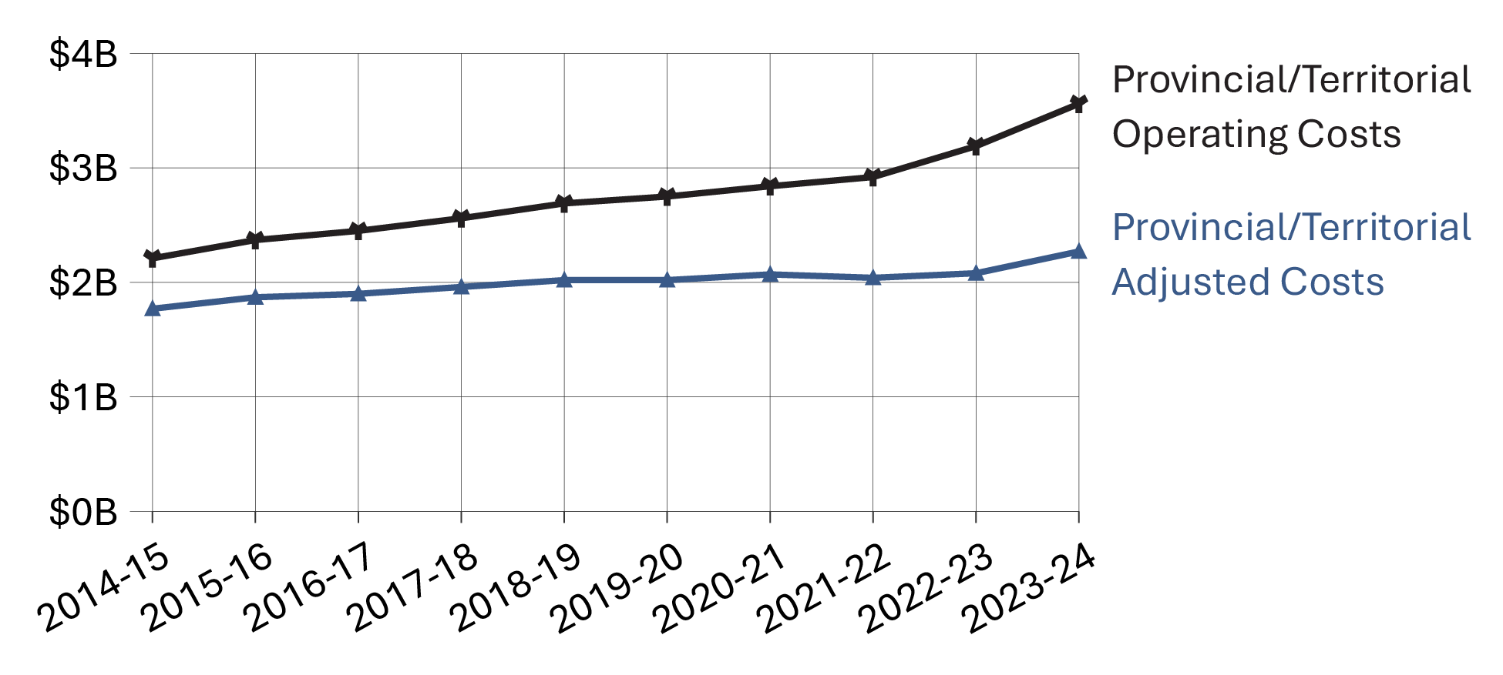
Sources:
¹Correctional Service Canada; Office of the Correctional Investigator; Parole Board of Canada. ²Statistics Canada. Table 35-10-0013-01, Operating expenditures for adult correctional services.
- Costs of federal corrections were about $3.2 billion in 2023-24. This was a 10.4% increase compared to the prior year and 32.0% higher than 2014-15. When considering adjusted costs, there was a 4.4% increase in spending between 2014-15 to 2023-24.
- Costs of provincial/territorial corrections were about $3.6 billion in 2023-24. This represented an 11.5% increase from 2022-23, and a 60.9% increase since 2014-15. When considering adjusted costs, there was a 28.2% increase in spending between 2014-15 to 2023-24.

Table B1a. Federal corrections costs in current dollars

Fiscal year 2019-20
Organization | Operating ($’000) | Capital ($’000) | Total ($’000) | Per capita* ($)
CSC | 2,477,237 | 164,643 | 2,641,879 | 70.28
PBC | 51,489 | NA | 51,489 | 1.37
OCI | 5,441 | NA | 5,441 | 0.14
Total | 2,534,167 | 164,643 | 2,698,809 | 71.79

Fiscal year 2020-21
Organization | Operating ($’000) | Capital ($’000) | Total ($’000) | Per capita* ($)
CSC | 2,811,113 | 121,987 | 2,933,100 | 77.17
PBC | 57,745 | NA | 57,745 | 1.52
OCI | 5,304 | NA | 5,304 | 0.14
Total | 2,874,162 | 121,987 | 2,996,149 | 78.83

Fiscal year 2021-22
Organization | Operating ($’000) | Capital ($’000) | Total ($’000) | Per capita* ($)
CSC | 2,764,000 | 146,976 | 2,910,977 | 76.12
PBC | 58,753 | NA | 58,753 | 1.54
OCI | 5,467 | NA | 5,467 | 0.14
Total | 2,828,220 | 146,976 | 2,975,197 | 77.80

Fiscal year 2022-23
Organization | Operating ($’000) | Capital ($’000) | Total ($’000) | Per capita* ($)
CSC | 2,824,285 | 199,357 | 3,023,642 | 77.66
PBC | 68,776 | NA | 68,776 | 1.77
OCI | 5,478 | NA | 5,478 | 0.14
Total | 2,898,539 | 199,357 | 3,097,896 | 79.56

Fiscal year 2023-24
Organization | Operating ($’000) | Capital ($’000) | Total ($’000) | Per capita* ($)
CSC | 3,116,475 | 256,363 | 3,372,838 | 84.15
PBC | 77,448 | NA | 77,448 | 1.93
OCI | 5,575 | NA | 5,575 | 0.14
Total | 3,199,498 | 256,363 | 3,455,861 | 86.22
Sources: Federal costs are from Correctional Service Canada; Office of the Correctional Investigator; Parole Board of Canada.

Table B1b. Federal corrections costs in constant 2002 dollars

Fiscal year 2019-20
Organization | Operating ($’000) | Capital ($’000) | Total ($’000) | Per capita* ($)
CSC | 1,821,498 | 121,061 | 1,942,558 | 51.67
PBC | 37,860 | NA | 37,860 | 1.01
OCI | 4,001 | NA | 4,001 | 0.11
Total | 1,863,358 | 121,061 | 1,984,418 | 52.79

Fiscal year 2020-21
Organization | Operating ($’000) | Capital ($’000) | Total ($’000) | Per capita* ($)
CSC | 2,044,446 | 88,718 | 2,133,164 | 56.13
PBC | 41,996 | NA | 41,996 | 1.10
OCI | 3,857 | NA | 3,857 | 0.10
Total | 2,090,300 | 88,718 | 2,179,017 | 57.33

Fiscal year 2021-22
Organization | Operating ($’000) | Capital ($’000) | Total ($’000) | Per capita* ($)
CSC | 1,924,344 | 102,327 | 2,026,672 | 53.00
PBC | 40,905 | NA | 40,905 | 1.07
OCI | 3,806 | NA | 3,806 | 0.10
Total | 1,969,055 | 102,327 | 2,071,383 | 54.17

Fiscal year 2022-23
Organization | Operating ($’000) | Capital ($’000) | Total ($’000) | Per capita* ($)
CSC | 1,844,431 | 130,192 | 1,974,623 | 50.71
PBC | 44,915 | NA | 44,915 | 1.15
OCI | 3,577 | NA | 3,577 | 0.09
Total | 1,892,923 | 130,192 | 2,023,116 | 51.96

Fiscal year 2023-24
Organization | Operating ($’000) | Capital ($’000) | Total ($’000) | Per capita* ($)
CSC | 1,969,834 | 162,040 | 2,131,874 | 53.19
PBC | 48,953 | NA | 48,953 | 1.22
OCI | 3,524 | NA | 3,524 | 0.09
Total | 2,022,311 | 162,040 | 2,184,351 | 54.50
Sources: Correctional Service Canada; Office of the Correctional Investigator; Parole Board of Canada.
Notes
“Not applicable” is abbreviated to “NA” in this table due to formatting.
Total expenditures represent gross expenditures (including revenues netted against expenditures for the provision of internal support services) and exclude revenues (i.e., Foreign Exchange Gains and refund of previous year revenue). Operating costs include Employee Benefit Plan expenditures. CSC expenditures exclude CORCAN (a Special Operating Agency that conducts industrial operations within penitentiaries), remissions on service fees as well as spending of amounts equivalent to the proceeds from disposal of surplus moveable Crown assets.
*Per capita cost is calculated by dividing the total expenditures by the total Canadian population and represents the cost per Canadian for federal correctional services. The 2022 CCRSO used population estimates from July within the fiscal year. For example, the 2020-21 fiscal year used July 2020. This change was implemented in the 2020 CCRSO, and therefore, some values might vary from prior reports.
Due to rounding, constant dollar amounts may not add up to Total.
Constant dollars represent dollar amounts calculated on a 1-year base (2002) that adjusts for inflation allowing the yearly amounts to be directly comparable. Changes in the Consumer Price Index (CPI) were used to calculate constant dollars. Beginning in the 2020 CCRSO, the CPI rate is based on an average of the monthly CPI for the fiscal year rather than calendar year. This limits comparability of the current data to that reported prior to the 2020 CCRSO.
Federal expenditures on corrections include spending by Correctional Service Canada (CSC), the Parole Board of Canada (PBC), and the Office of the Correctional Investigator (OCI).
Costs are rounded to the thousands.
The table includes data from the most recent year available at the time of preparation.
Reported year periods reflect fiscal years. A fiscal year runs from April 1 to March 31 of the following year.

Number of CSC employees by location

Figure B2. CSC employees at the end of fiscal year (2023-24)
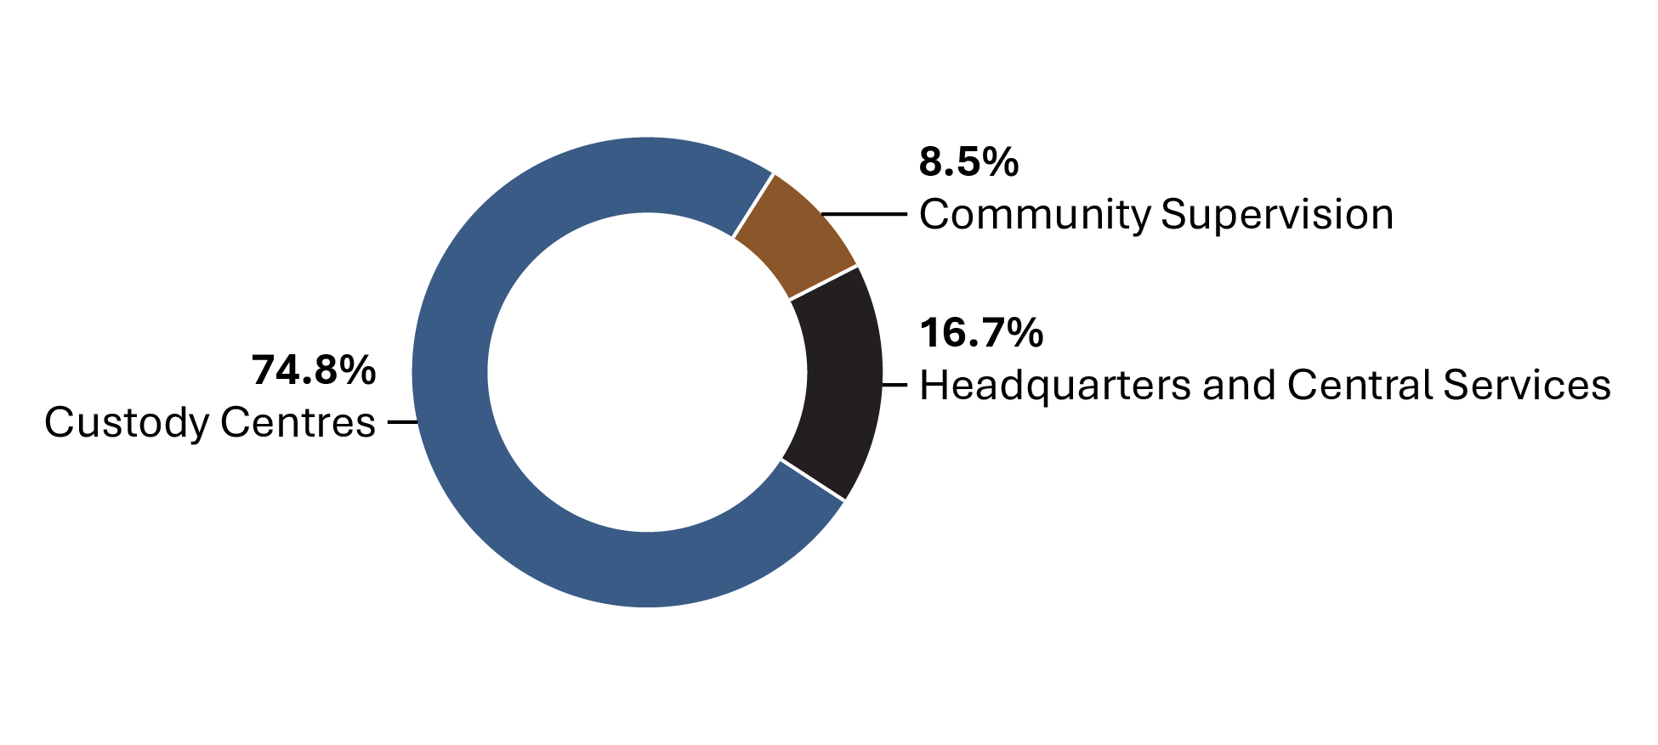
Source: Correctional Service of Canada.
- The Correctional Service of Canada (CSC) has a total staff of 18,605.
- 74.8% of CSC staff work in institutions.
- Staff employed in community supervision account for 8.5% of the total number of CSC employees.

Table B2. CSC employees at the end of fiscal year
Service area | March 31, 2015 | % | March 31, 2024 | %
Headquarters and central services total | 2,641 | 15.0 | 3,106 | 16.7
Administration | 2,256 | 12.8 | 2,209 | 11.9
Program staff | 71 | 0.4 | 66 | 0.4
Health care | 95 | 0.5 | 92 | 0.5
Correctional officers | 29 | 0.2 | 44 | 0.2
Instructors/supervisors | 9 | 0.1 | 15 | 0.1
Parole officers/parole supervisors* | 2 | 0.0 | 1 | 0.0
Other** | 179 | 1.0 | 679 | 3.6
Custody centres total | 13,510 | 76.9 | 13,925 | 74.8
Administration | 1,838 | 10.5 | 1,800 | 9.7
Program staff | 888 | 5.1 | 1,094 | 5.9
Health care | 882 | 5.0 | 1,121 | 6.0
Correctional officers | 7,730 | 44.0 | 7,299 | 39.2
Instructors/supervisors | 369 | 2.1 | 430 | 2.3
Parole officers/parole supervisors* | 665 | 3.8 | 589 | 3.2
Other** | 1,138 | 6.5 | 1,592 | 8.6
Community supervision total | 1,408 | 8.0 | 1,574 | 8.5
Administration | 367 | 2.1 | 371 | 2.0
Program staff | 280 | 1.6 | 268 | 1.4
Health care | 74 | 0.4 | 86 | 0.5
Correctional officers | 0 | 0.0 | NA | NA
Parole officers/parole supervisors | 686 | 3.9 | 816 | 4.4
Other** | 1 | 0.0 | 33 | 0.2
Total | 17,559 | 100.0 | 18,605 | 100.0
Source: Correctional Service of Canada.
Notes
“NA” refers to non-applicable. Due to changes in policy, Correctional Officers no longer occupy positions in the community.
The “Instructors/supervisors” category is not applicable to community supervision and is thus not included in the community supervision total.
*These parole officers work within institutions, with the responsibility of preparing offenders for release.
**The "Other" category represents job classifications such as trades and food services.
These numbers represent indeterminate and terms equal to or more than 3 months substantive employment; and employee status of active and paid leave current up to March 31, 2024.
Due to rounding, percentage may not add to 100.
Reported year periods reflect fiscal years. A fiscal year runs from April 1 to March 31 of the following year.

Cost of incarceration in a federal institution: 5-year trend

Figure B3. Federal average daily cost per inmate (current $)
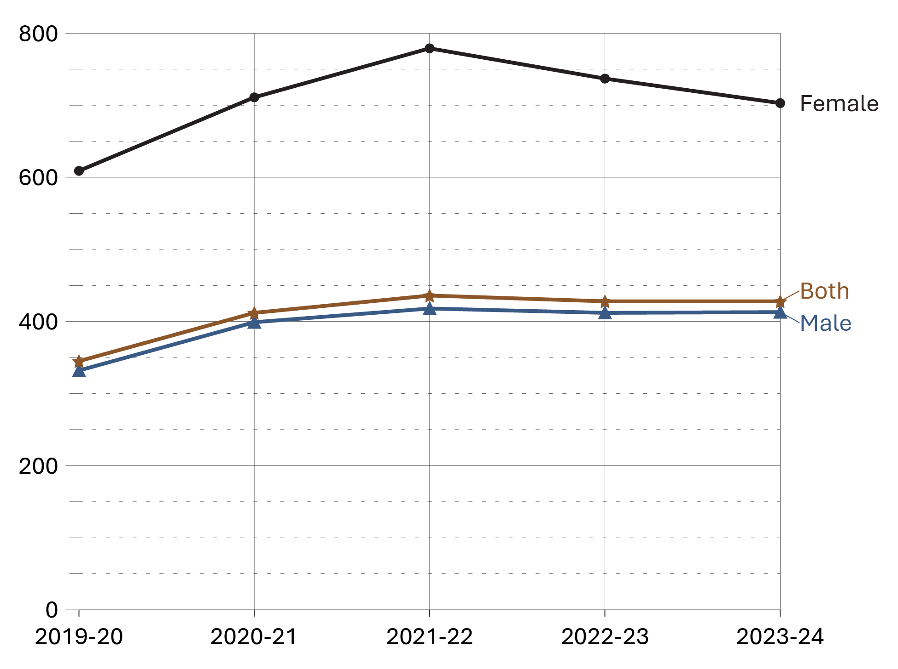
Source: Correctional Service of Canada.
- The federal average daily inmate cost has increased from $345 in 2019-20 to $428 in 2023-24. In 2023-24, the annual average cost of keeping an inmate incarcerated was $156,744 per year, an increase from $126,253 per year in 2019-20. In 2023-24, the annual average cost of keeping a male incarcerated was $150,666 per year, whereas the annual average cost for incarcerating a female was $256,682.
- The cost associated with maintaining an offender in the community is 69.7% less than what it costs to maintain an offender in custody ($47,522 per year versus $156,744 per year).
Table B3. Annual average cost per offender (current $)
Categories | 2019-20 | 2020-21 | 2021-22 | 2022-23 | 2023-24
Maximum security (men’s facilities) | 174,939 | 204,048 | 221,993 | 223,071 | 214,426
Medium security (men’s facilities) | 111,243 | 131,533 | 135,676 | 134,281 | 136,263
Minimum security (men’s facilities) | 92,877 | 121,898 | 128,889 | 118,601 | 121,617
Women’s facilities | 222,942 | 259,654 | 284,157 | 268,829 | 256,682
Exchange of services agreements* (males and females) | 131,322 | 130,729 | 174,218 | 169,164 | 182,033
Incarcerated average | 126,253 | 150,505 | 159,115 | 156,366 | 156,744
Offenders in the community | 34,214 | 38,418 | 41,519 | 42,691 | 47,522
Total incarcerated and in community | 104,963 | 119,735 | 128,478 | 131,423 | 137,248
Source: Correctional Service of Canada.
Notes
In 2022-23, the methodology was changed to exclude class action settlements as they are not part of the direct costs of maintaining an offender. As the change in methodology was minor, past years have not been recalculated retroactively.
The average daily inmate cost includes those costs associated with the operation of the institutions such as salaries and employee benefit plan contributions but excludes non-operating expenditures such as Capital and CORCAN expenditures (a Special Operating Agency that conducts industrial operations within federal institutions). Furthermore, it excludes expenditures related to retroactive salary payments (for prior years) and expenditures related to the Vote netted Revenues.
*The intent of an Exchange of Service Agreement is to detail the roles and responsibilities of each jurisdiction and include specific protocols regarding per diem rates, offender information sharing, and invoicing pertaining to the reciprocal exchange of offenders between jurisdictions.
The total cost for maintaining offenders includes additional NHQ & RHQ administrative costs which are not part of the Institutional and/or Community calculations.
Offenders in the Community include Offenders on conditional release, statutory release or with Long-Term Supervision Order, under CSC supervision.
Figures may not add due to rounding.
Reported year periods reflect fiscal years. A fiscal year runs from April 1 to March 31 of the following year.

The number of Parole Board of Canada employees

Figure B4. Full-time equivalents – 10-year trend
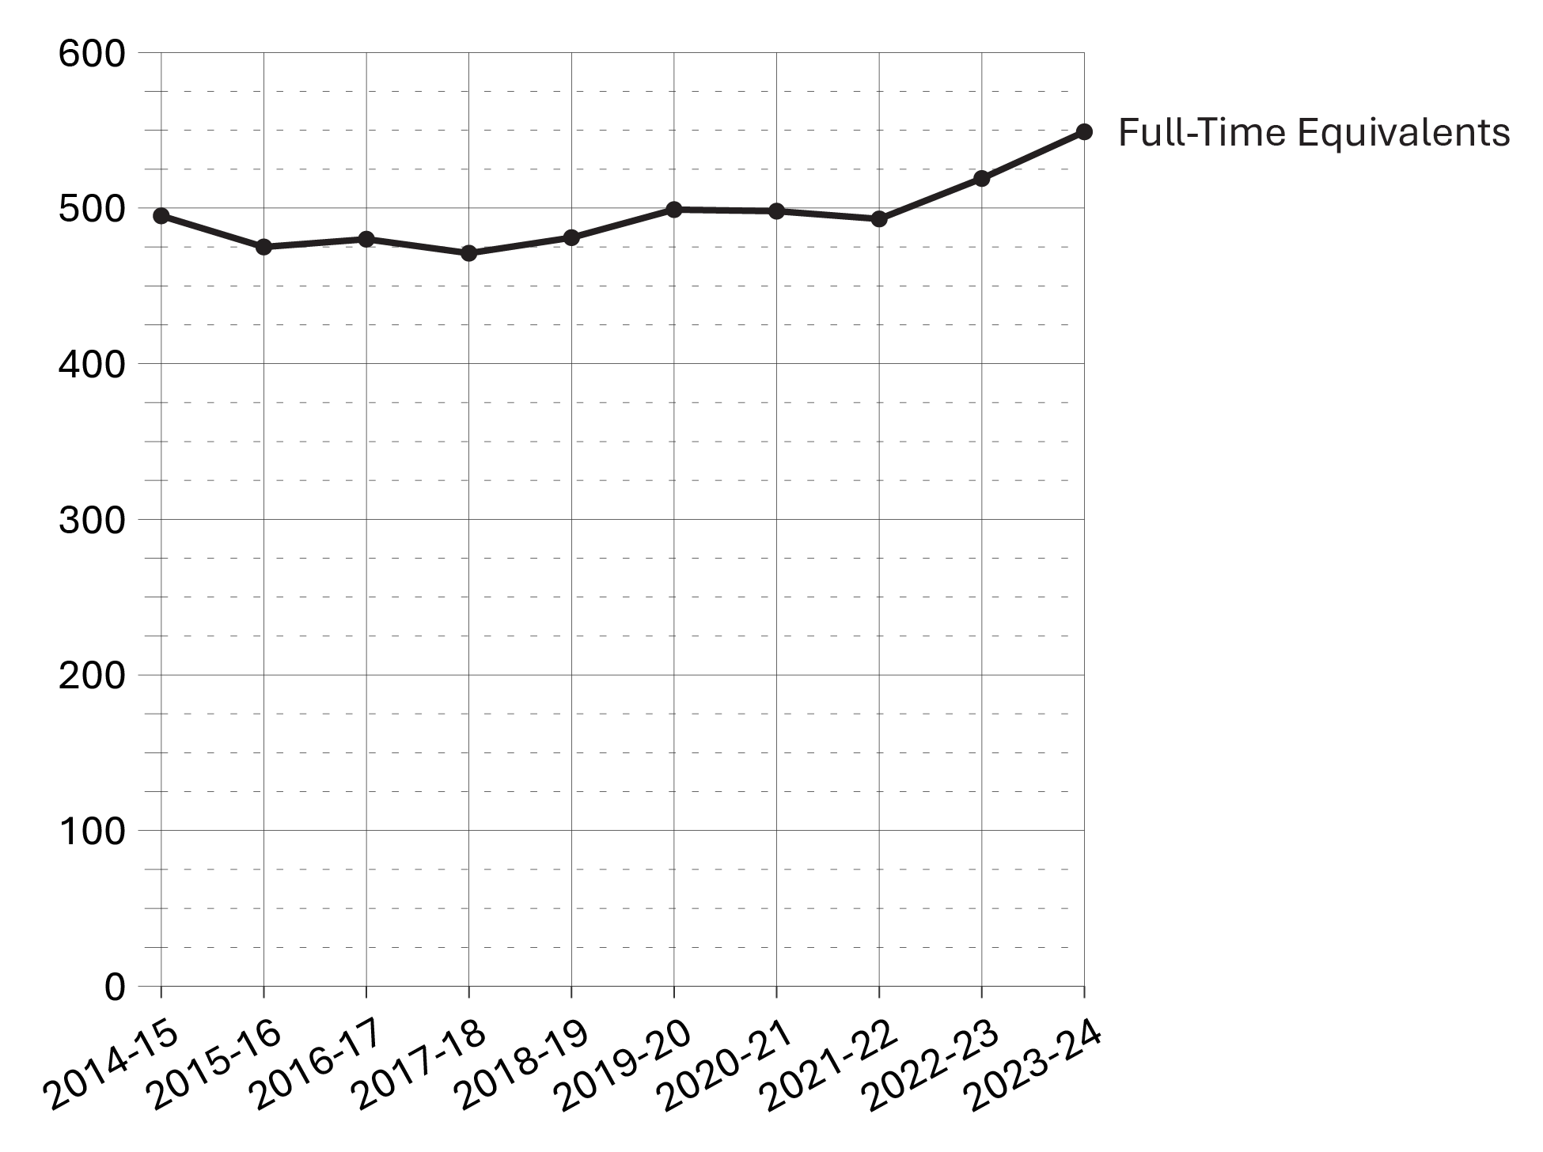
Source: Parole Board of Canada.
- In 2023-24, the full-time equivalents employed by the Parole Board of Canada increased by 5.8% to 549 (30 more) compared to 2022-23.
- Over the past 10 fiscal years (from 2014-15 to 2023-24), there has been a 10.9% increase (from 495 to 549) in the number of full-time equivalents employed by the Parole Board of Canada.

Table B4. Full-time equivalents
Parole Board of Canada employees | 2019-20 | 2020-21 | 2021-22 | 2022-23 | 2023-24
Total program activity | 499 | 498 | 493 | 519 | 549
Conditional release decisions | 320 | 323 | 320 | 329 | 345
Conditional release openness and accountability | 45 | 45 | 49 | 49 | 52
Record suspension and clemency recommendations | 72 | 62 | 57 | 65 | 70
Internal services | 62 | 68 | 67 | 76 | 82
Total types of employees | 499 | 498 | 493 | 519 | 549
Full-time board members | 40 | 36 | 40 | 39 | 42
Part-time board members | 20 | 20 | 19 | 18 | 19
Staff | 439 | 442 | 434 | 462 | 488
Source: Parole Board of Canada.
Notes
A full-time equivalent is a measure of the extent to which an employee represents a full person-year charge against a departmental budget. Section 103 of the Corrections and Conditional Release Act limits the Parole Board of Canada to 60 full-time members.
Reported year periods reflect fiscal years. A fiscal year runs from April 1 to March 31 of the following year.

The number of employees in the Office of the Correctional Investigator

Figure B5. Full-time equivalents
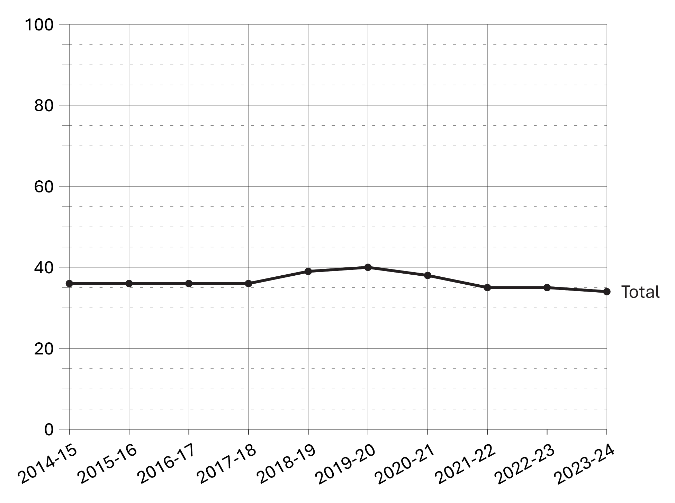
Source: Office of the Correctional Investigator.
- In 2023-24, the total number of full-time equivalents at the Office of the Correctional Investigator was 34, which is 1 less than the year prior.
- In the 10 year period between 2014-15 to 2023-24, the total number of full-time equivalents at the Office of the Correctional Investigator has remained relatively stable.

Table B5. Full time equivalents
Types of employees | 2019-20 | 2020-21 | 2021-22 | 2022-23 | 2023-24
Correctional investigator | 1 | 1 | 1 | 1 | 1
Senior management and investigative services | 28 | 26 | 24 | 22 | 20
Internal services | 5 | 5 | 5 | 8 | 8
Policy and research | 6 | 6 | 5 | 4 | 5
Total | 40 | 38 | 35 | 35 | 34
Source: Office of the Correctional Investigator.
Notes
The Office of the Correctional Investigator (OCI) may commence an investigation on receipt of a complaint by or on behalf of an offender or on its own initiative. Complaints are made by telephone, letter and during interviews with the OCI's investigative staff at federal correctional facilities. The dispositions in response to complaints involve a combination of internal responses (where the information or assistance sought by the offender can generally be provided by the OCI's investigative staff) and investigations (where, further to a review/analysis of law, policies and documentation, OCI investigative staff make an inquiry or several interventions with Correctional Service Canada and submit recommendations to address the complaint). Investigations vary considerably in terms of scope, complexity, duration, and resources required.
Reported year periods reflect fiscal years. A fiscal year runs from April 1 to March 31 of the following year.

Most common offender complaints to the Office of the Correctional Investigator

Figure B6a. Top 10 offender complaints at the end of fiscal year 2023-24
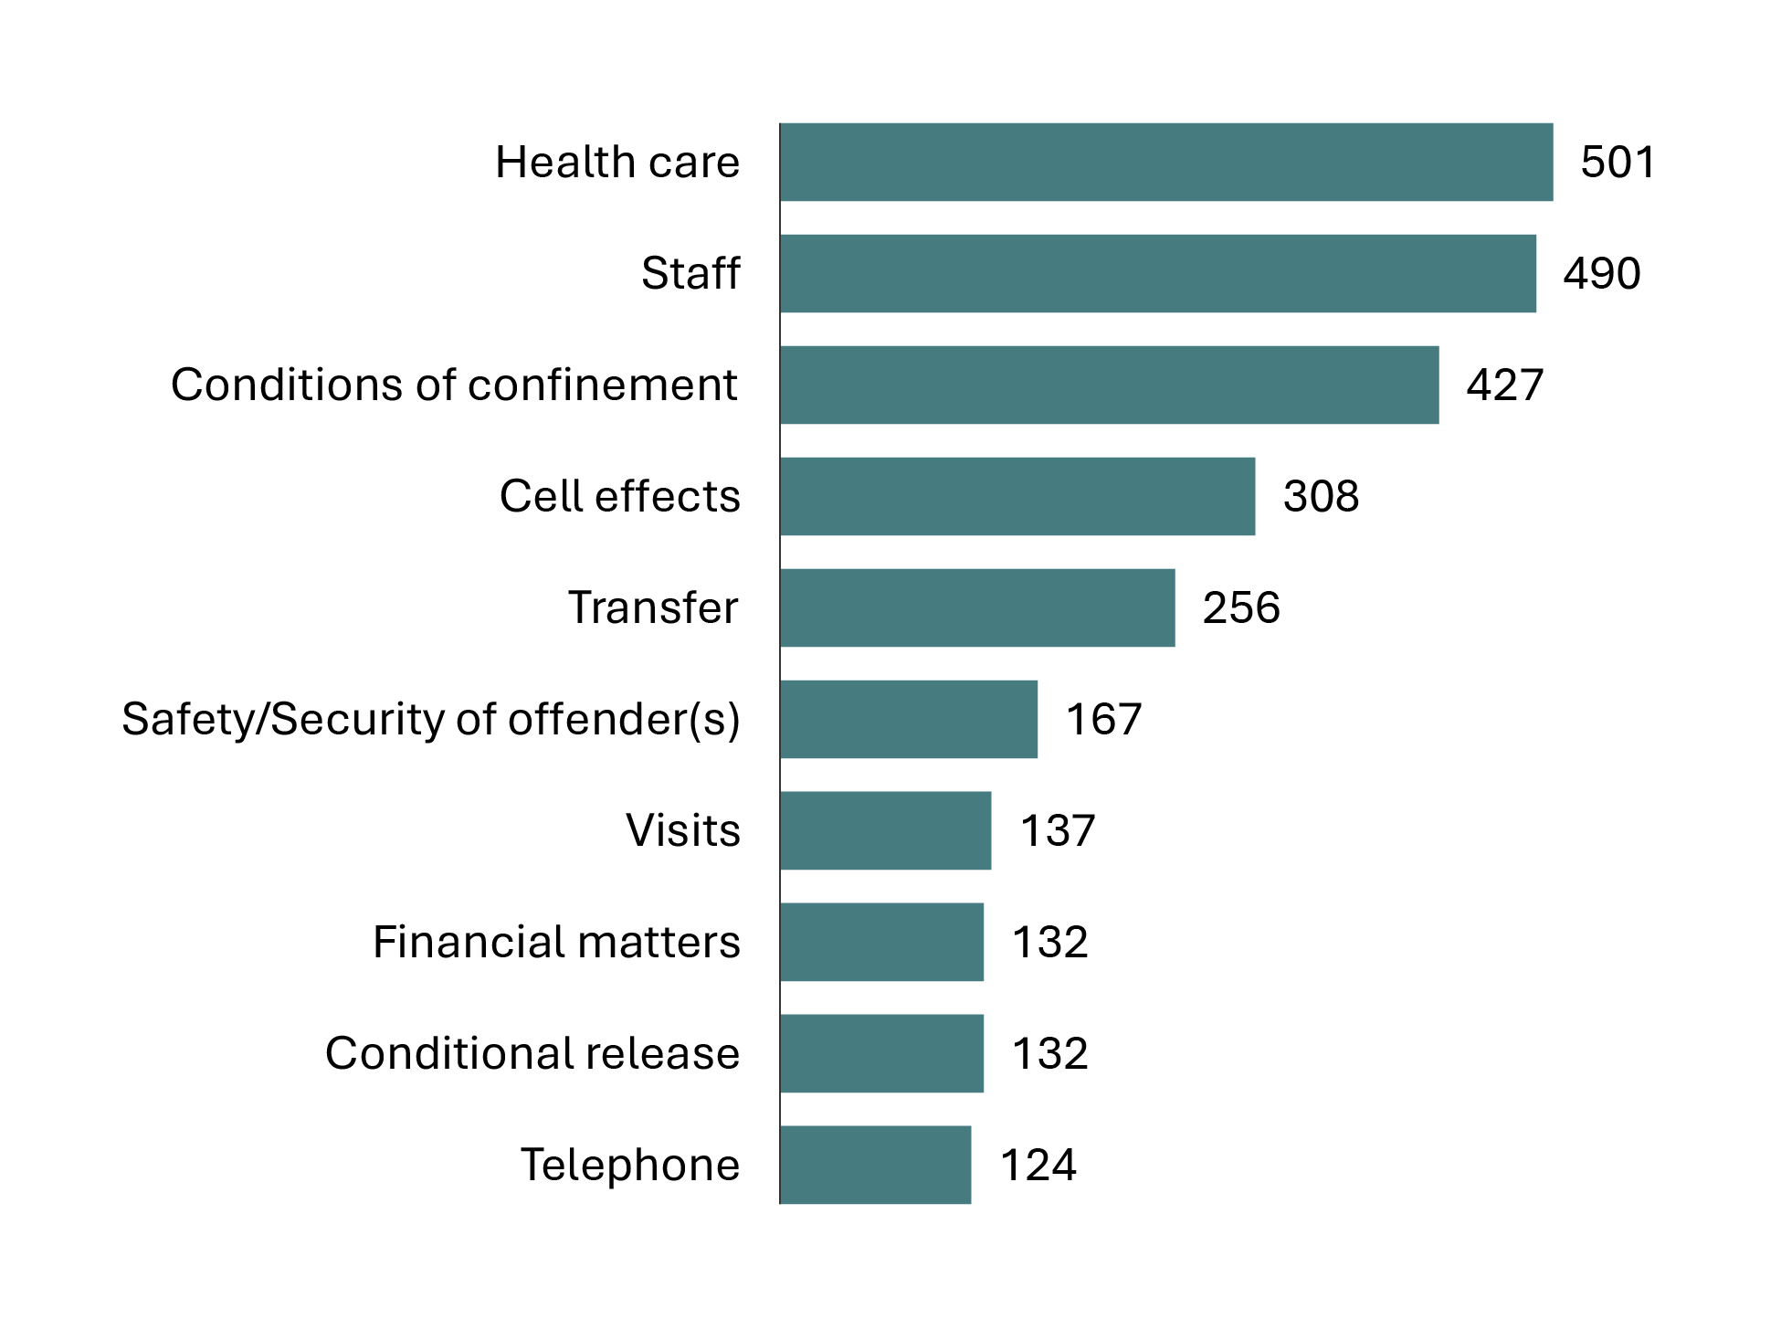
Source: Office of the Correctional Investigator.

Figure B6b. Top 5 offender complaints from fiscal year 2019-20 to 2023-24
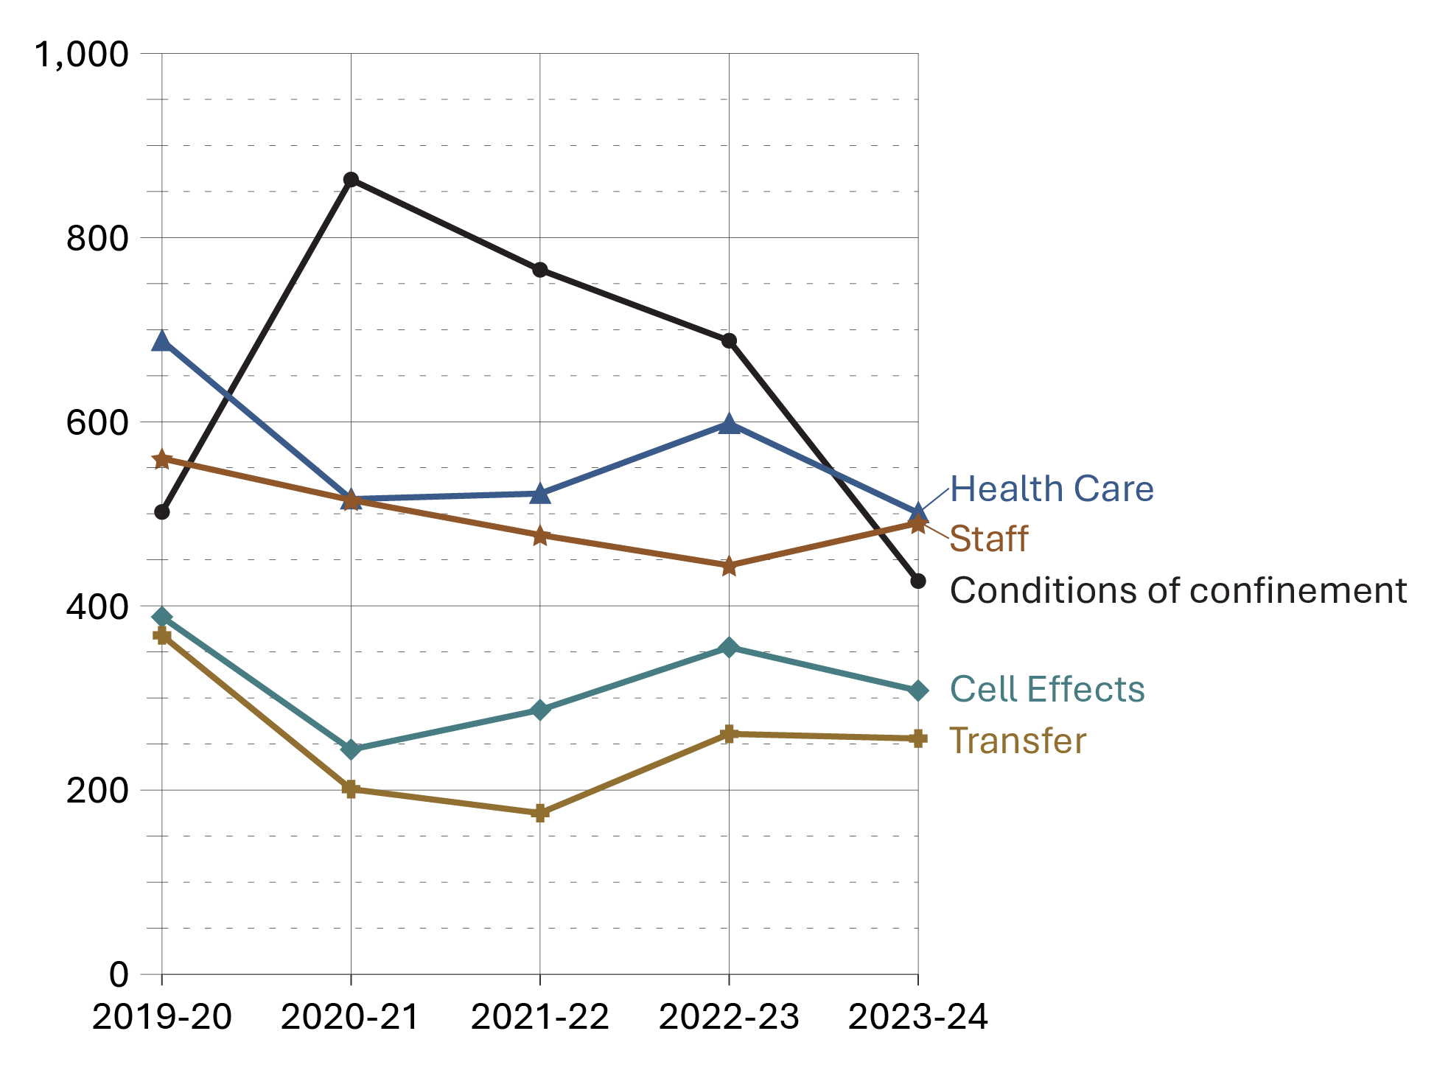
Source: Office of the Correctional Investigator.

- There were 4,237 complaints/enquiries received at the Office of the Correctional Investigator (OCI) in 2023-24, a decrease of 10.6% since 2022-23.
- Health care was the most common offender complaint category in 2023-24. From 2020-21 to 2022-23, the most common complaint was conditions of confinement. Fluctuations observed in the conditions of confinement category may be due to changes in data collection practices and how complaints are categorized. Since 2019-20, the conditions of confinement category has undergone numerous changes.
- In 2023-24, the top four reasons for complaints were health care (11.8%), staff (11.6%), conditions of confinement (10.1%), and cell effects (7.3%). Taken together, these four complaint categories accounted for 40.7% of all complaints.

Table B6. Top 20 offender complaint categories across the past 5 fiscal years*
Category of complaint | 2019-20 | 2020-21 | 2021-22 | 2022-23 | 2023-24
Conditions of confinement | 502 | 863 | 765 | 688 | 427
Health Care | 688 | 516 | 522 | 598 | 501
Staff | 560 | 515 | 477 | 444 | 490
Cell Effects | 388 | 244 | 287 | 355 | 308
Transfer | 368 | 201 | 175 | 261 | 256
Safety/Security of Offender(s) | 230 | 183 | 165 | 213 | 167
File Information | 245 | 204 | 139 | 169 | 122
Visits | 209 | 123 | 140 | 125 | 137
Telephone | 185 | 133 | 127 | 136 | 124
Financial Matters | 119 | 112 | 149 | 140 | 132
Grievance | 129 | 106 | 92 | 133 | 101
Outside OCI Jurisdiction | 133 | 65 | 71 | 119 | 88
Case Preparation | 96 | 149 | 166 | 38 | 26
Legal Counsel Access | 136 | 61 | 81 | 95 | 101
Security Classification | 63 | 69 | 128 | 107 | 97
Correspondence | 130 | 103 | 84 | 87 | 56
Programs | 112 | 71 | 73 | 93 | 108
Conditional Release | 60 | 62 | 77 | 109 | 132
Mental Health | 100 | 49 | 66 | 103 | 70
Discrimination | 38 | 65 | 86 | 78 | 102
Total of remaining categories | 1,075 | 613 | 666 | 649 | 692
Total of all categories** | 5,566 | 4,507 | 4,536 | 4,740 | 4,237
Source: Office of the Correctional Investigator.
Notes
The Office of the Correctional Investigator (OCI) may commence an investigation on receipt of a complaint by or on behalf of an offender or on its own initiative. Complaints are made by telephone, letter and during interviews with the OCI's investigative staff at federal correctional facilities. The dispositions in response to complaints involve a combination of internal responses (where the information or assistance sought by the offender can generally be provided by the OCI's investigative staff) and investigations (where, further to a review/analysis of law, policies and documentation, OCI investigative staff make an inquiry or interventions with the Correctional Service Canada and submit recommendations to address the complaint). Investigations vary considerably in terms of scope, complexity, duration, and resources required.
*These top 20 categories of complaints are based on the sum totals for the 5 reported fiscal years between 2019-20 and 2023-24.
**These totals represent all complaint categories, not only the 20 listed in the table.
Due to ongoing efforts at the OCI (Office of the Correctional Investigator) to streamline the administrative database and ensure accuracy in reporting, the numbers in this table will not always match those of past Corrections and Conditional Release Statistical Overviews or OCI Annual Reports.
Reported year periods reflect fiscal years. A fiscal year runs from April 1 to March 31 of the following year.

Section C:
Federal Offender and Registered Victims Populations



Offenders under the responsibility of CSC

Figure C1. Total offender population (2023-24) *
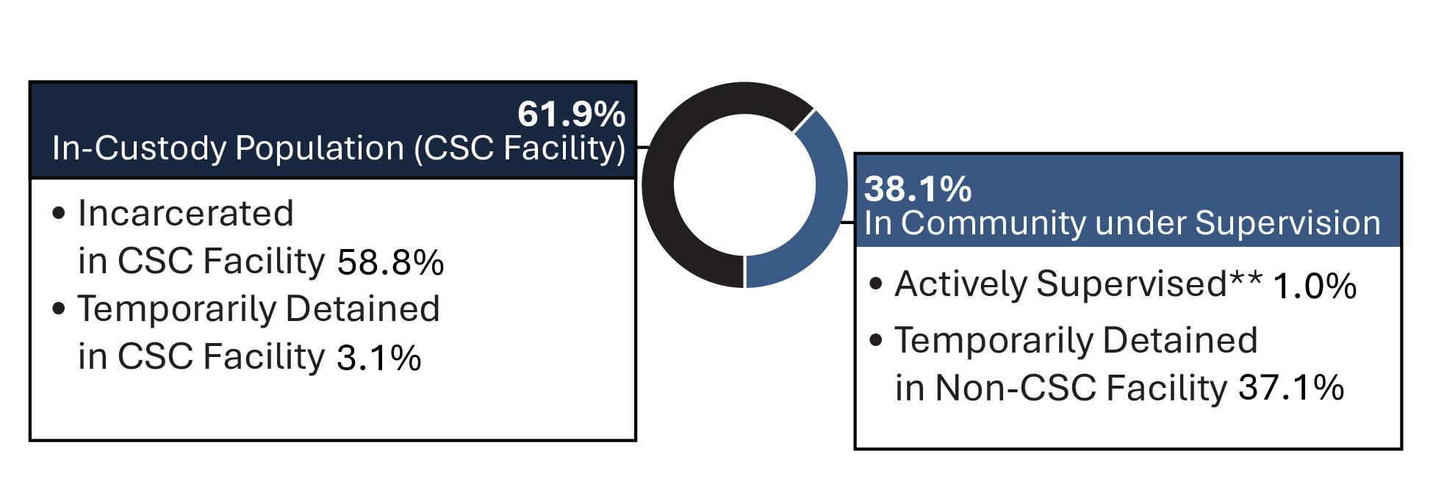
Source: Correctional Service of Canada.
- After a consistent yearly decrease in the in-custody population between 2014-15 and 2021-22, the in-custody population has seen a noticeable increase of 6.1% from 13,054 in 2022-23 to 13,855 in 2023-24.
Definitions C1:
Total Offender Population includes all active offenders who are incarcerated in a CSC facility, offenders on temporary absence from a CSC facility, offenders who are temporarily detained, offenders who are actively supervised, and offenders who are unlawfully at large for less than 90 days.
CSC Facilities include all federal institutions and federally funded Healing Lodges.
In Custody includes all active offenders incarcerated in a CSC facility, offenders on temporary absence from a CSC facility, offenders who are temporarily detained in a CSC facility and offenders on remand in a CSC facility.
In Community Under Supervision includes all active offenders on day parole, full parole, statutory release, in the community supervised on a long-term supervision order, offenders who are temporarily detained in a non-CSC facility, offenders who are unlawfully at large for less than 90 days, offenders on remand in a non-CSC facility, and offenders supervised and subject to an immigration hold by Canada Border Services Agency.
**Actively Supervised includes all active offenders on day parole, full parole or statutory release, as well as those who are in the community on long-term supervision orders.
Temporarily Detained includes offenders who are physically held in a CSC facility or a non-CSC facility after being suspended for a breach of a parole condition or to prevent a breach of parole conditions.
In addition to the total offender population, there are excluded groups such as:
Federal jurisdiction offenders incarcerated in a Community Correctional Centre or in a non-CSC facility.
Federal jurisdiction offenders deported /extradited including offenders for whom a deportation order has been enforced by Canada Border Services Agency.
Federal offenders on bail which includes offenders on a judicial interim release; they have appealed their conviction or sentence and have been released to await the results of a new trial.
Escaped includes offenders who have absconded from either a correctional facility or while on a temporary absence and whose whereabouts are unknown.
Unlawfully at Large for 90 days or more. This includes offenders who have been released to the community on day parole, full parole, statutory release or a long term supervision order for whom a warrant for suspension has been issued at least 90 days ago, but has not yet been executed.
Notes
*In addition to this total offender population, 308 offenders were on bail, 115 offenders were escapees, 416 offenders serving a federal sentence were in custody in a non-CSC facility, 304 offenders were unlawfully at large for 90 days or more, and 382 offenders were deported. This section reports all current offenders with a status of “escaped”, including those who may have escaped at any point in history. This number differs from escapees reported in Section C29, which includes all offenders who escaped custody between 2014-15 and 2023-24 (many of which were recaptured).

Table C1. Total offender population (2023-24)*
Status | Offenders under the responsibility of CSC | %
In-custody population (CSC facility) | 13,855 | 61.9
Incarcerated in CSC facility | 13,159 | 58.8
Temporarily detained in CSC facility | 696 | 3.1
Day parole | 142 | 0.6
Full parole | 66 | 0.3
Statutory release | 445 | 2.0
Long-term supervision order | 43 | 0.2
In community under supervision | 8,520 | 38.1
Actively supervised | 8,299 | 37.1
Day parole | 1,571 | 7.0
Full parole | 4,092 | 18.3
Statutory release | 2,170 | 9.7
Long-term supervision order | 466 | 2.1
Offenders temporarily detained in non-CSC facility | 221 | 1.0
Total | 22,375 | 100.0
Source: Correctional Service of Canada.
Notes
*In addition to this total offender population, 308 offenders were on bail, 115 offenders were escapees, 416 offenders serving a federal sentence were in custody in a non-CSC facility, 304 offenders were unlawfully at large for 90 days or more, and 382 offenders were deported. This section reports all current offenders with a status of “escaped”, including those who may have escaped at any point in history. This number differs from escapees reported in Section C29, which includes all offenders who escaped custody between 2014-15 and 2023-24 (many of which were recaptured).
The definition of "Offender Population" changed from previous editions of the Corrections and Conditional Release Statistical Overview (CCRSO) beginning in 2016. Previously, CSC counted the number of federal offenders; the definition has now changed to counting the number of offenders in federal facilities. As such, comparisons to editions of the CCRSO prior to 2016 should be done with caution.
Reported year periods reflect fiscal years. A fiscal year runs from April 1 to March 31 of the following year.

Number of registered victims and number of offenders with a registered victim: 5-year trend

Figure C2. Number of registered victims and number of offenders with a registered victim
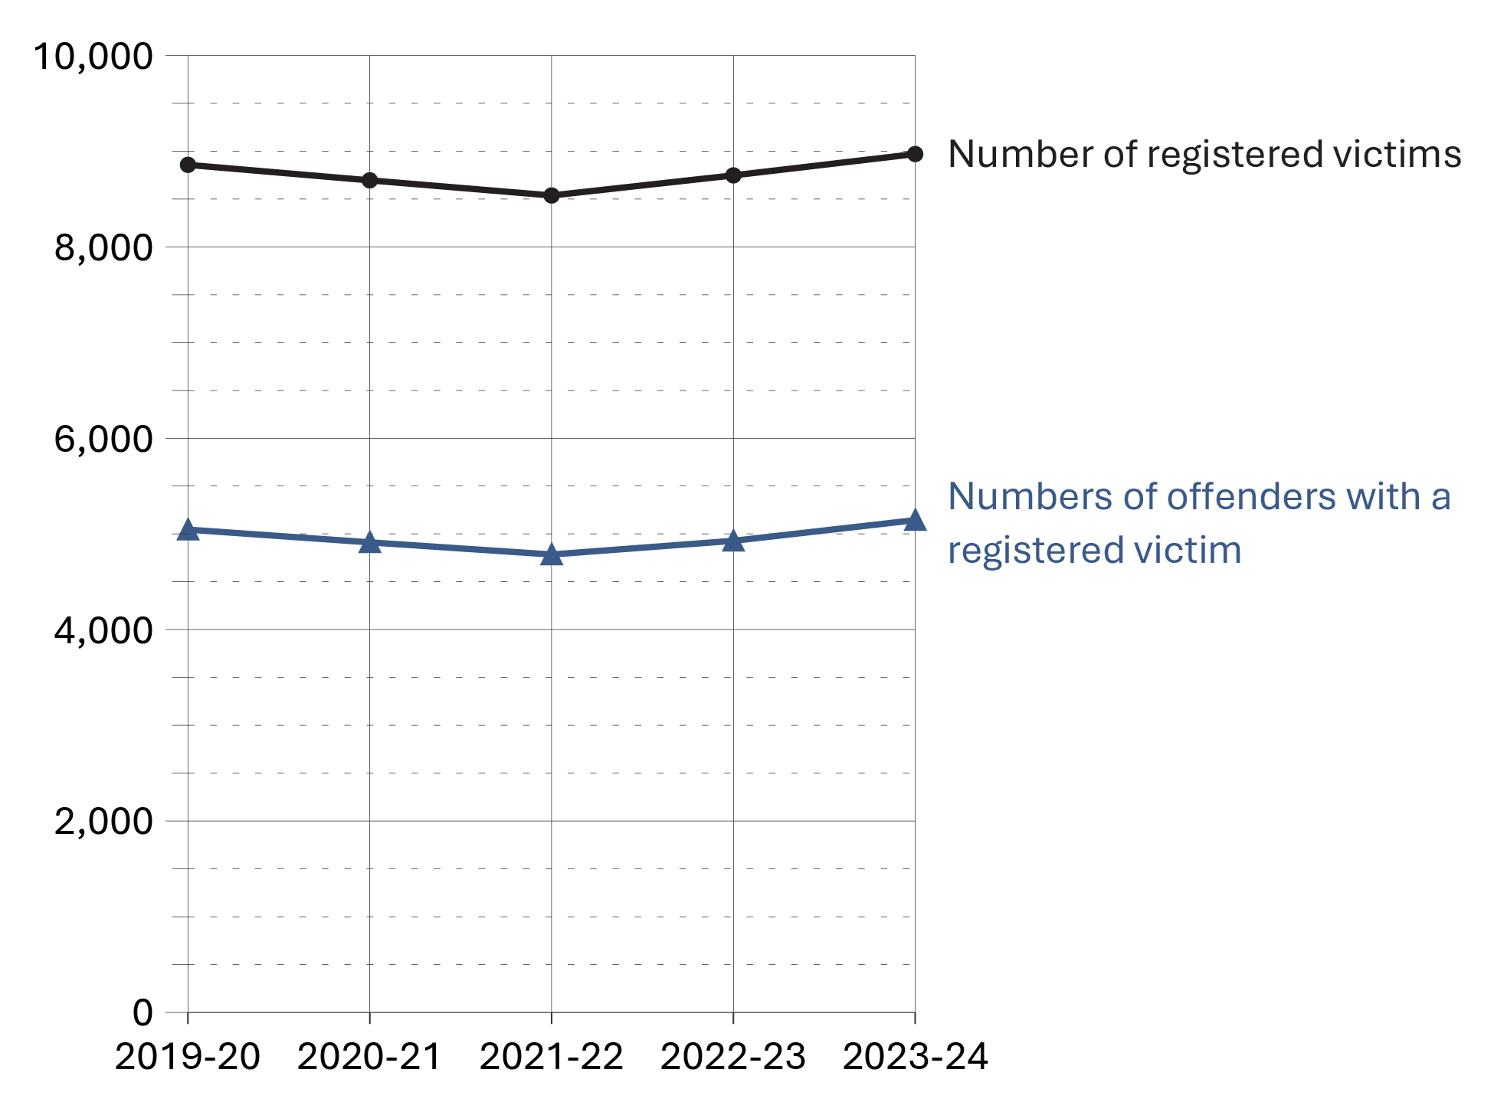
Source: Correctional Service of Canada.
- In order to register to receive information, a victim must meet the definition of a victim under the Corrections and Conditional Release Act (CCRA). Victims of federal offenders must be at least 18 years old or legally emancipated or demonstrate they can act for themselves. Victims can register with the Correctional Service of Canada or the Parole Board of Canada.
- Although the number of victims registered with the federal correctional system has fluctuated over the past 5 fiscal years, it has increased by 1.3%, from 8,857 in 2019-20 to 8,970 in 2023-24.
- Although the number of offenders with registered victims has fluctuated over the past 5 fiscal years, it has increased by 2.0% from 5,045 in 2019-20 to 5,144 in 2023-24.

Table C2. Number of registered victims and number of offenders with a registered victim
Fiscal year | Number of registered victims | Number of offenders with a registered victim
2019-20 | 8,857 | 5,045
2020-21 | 8,695 | 4,912
2021-22 | 8,537 | 4,785
2022-23 | 8,747 | 4,928
2023-24 | 8,970 | 5,144
Source: Correctional Service of Canada.
Notes
The Canadian Victims Bill of Rights defines a victim as an individual who has suffered physical or emotional harm, property damage, or economic loss as the result of the commission or alleged commission of an offence. The CCRA also allows a spouse, a relative or dependant, an individual who is responsible for the care or support of the victim or the care or support of a dependant of the victim, to act on behalf of a victim, if the victim cannot act on their own behalf. Victims include persons harmed as the result of an act of an offender, whether or not the offender was prosecuted or convicted for that act, as long as an official complaint has been made to the police or to the Crown.
Victims do not automatically receive information about the offender who harmed them. If they have been harmed by an offender serving a sentence of two years or more, victims are asked to register with the Correctional Service of Canada (CSC) or the Parole Board of Canada to receive information or access services. The registration process allows CSC to verify that the individual meets the definition of victim, which is required under law before sharing protected offender information.
Victim registration fluctuates for a number of reasons beyond organizational control. Contributing factors impacting victim registration data could be due to offenders reaching the end of their sentence or death, victims opting out of notifications for reasons such as personal preferences, death or loss of contact.
For more information about victim registration, visit: https://www.canada.ca/en/correctional-service/services/you-csc/victims/register.html
An offender may have more than one registered victim.
Reported data is current up to the end of each fiscal year.
A fiscal year runs from April 1 to March 31 of the following year.

The number of in-custody offenders: 10-year trend

Figure C3a. Number of in-custody offenders in a CSC facility at fiscal year* end
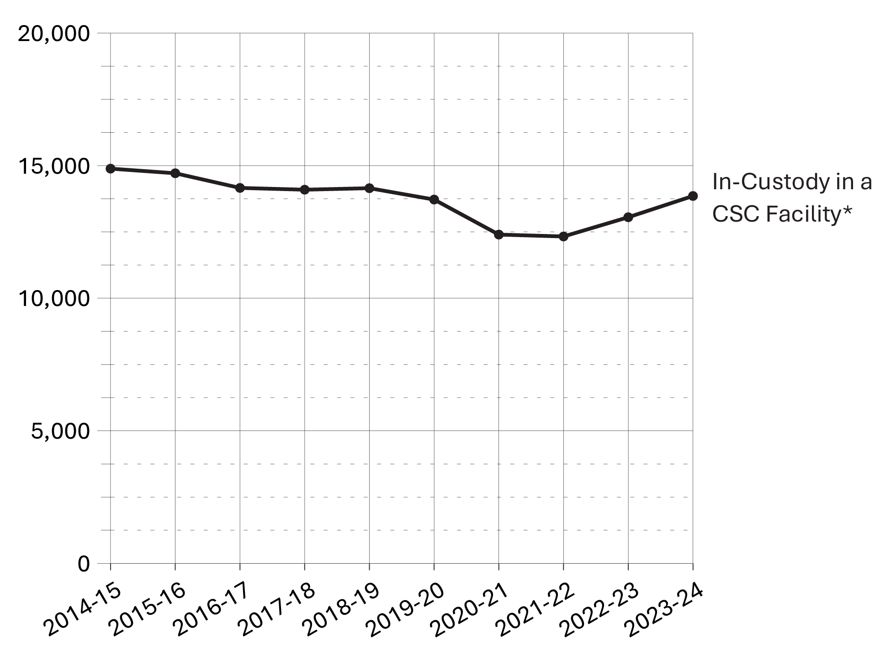
Source: Correctional Service of Canada.

Figure C3b. Number of in-custody offenders in a provincial/territorial facility fiscal year* end
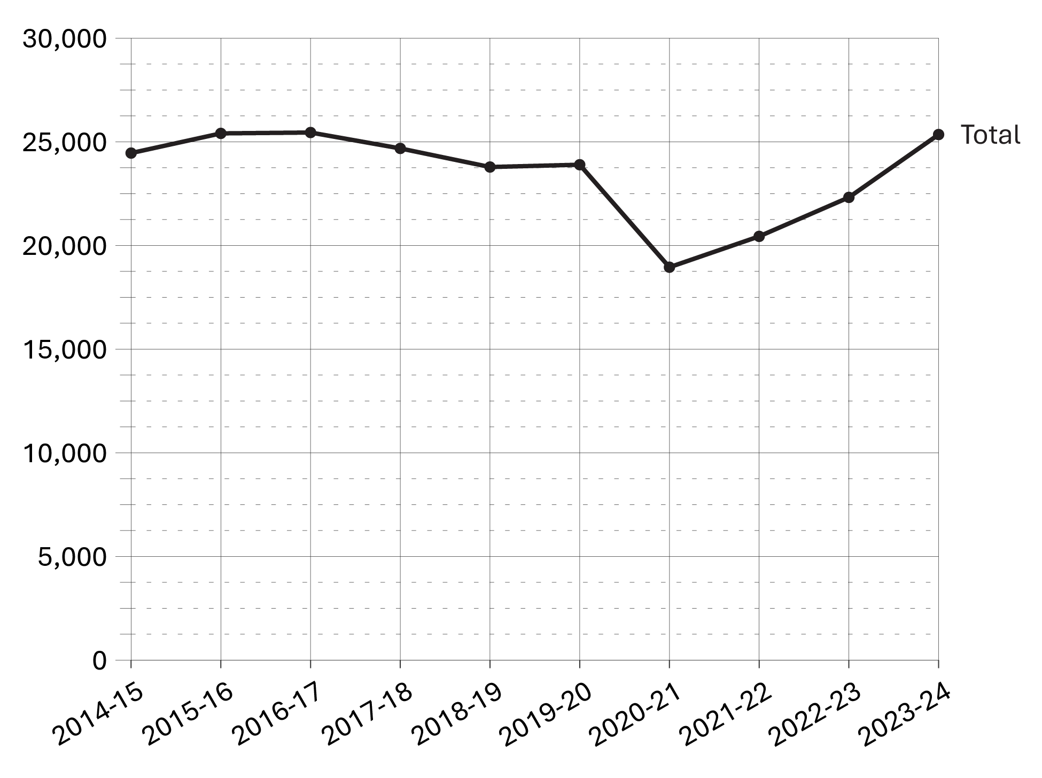
Source: Statistics Canada. Table 35-10-0154-01, Average counts of adults in provincial and territorial correctional programs.
- After a consistent yearly decrease in the in-custody population in a CSC facility between 2014-15 and 2021-22, the in-custody population has seen a noticeable increase of 6.1% from 13,054 in 2022-23 to 13,855 in 2023-24. Despite this increase, the in-custody population has not returned to pre-COVID-19 pandemic levels.
- The in-custody population in a provincial/territorial facility remained relatively stable from 2014-15 to 2019-20. From 2019-20 to 2020-21, there was a sharp decrease (-20.7%), followed by a sharp but steady increase (+33.8%) from 2020-21 to 2023-24. Over the past year (from 2022-23 to 2023-24), there was a 13.6% increase.
Notes
*The data reflect the number of offenders in custody at the end of each fiscal year. A fiscal year runs from April 1 to March 31 of the following year.
Provincial/territorial data points in Figure C3b reflect the average daily count of adult offenders in custody over the 12-month fiscal year period.

Table C3. In-custody offenders
Fiscal year | In custody in a CSC¹ facility* | Sentenced in a provincial/territorial² facility | On remand  in a provincial/territorial² facility | Other/ temporary detention in a provincial/territorial² facility | Total in a provincial/territorial² facility | Total CSC¹ and provincial/territorial²
2014-15 | 14,886 | 10,364 | 13,650 | 441 | 24,455 | 39,341
2015-16 | 14,712 | 10,091 | 14,899 | 415 | 25,405 | 40,117
2016-17 | 14,159 | 9,710 | 15,417 | 321 | 25,448 | 39,607
2017-18 | 14,092 | 9,545 | 14,833 | 303 | 24,681 | 38,773
2018-19 | 14,149 | 8,708 | 14,778 | 297 | 23,783 | 37,932
2019-20 | 13,720 | 7,947 | 15,505 | 442 | 23,894 | 37,614
2020-21 | 12,399 | 5,881 | 12,753 | 317 | 18,950 | 31,349
2021-22 | 12,328 | 5,798 | 14,415 | 226 | 20,439 | 32,767
2022-23 | 13,054 | 5,916 | 16,194 | 209 | 22,319 | 35,373
2023-24 | 13,855 | 5,895 | 19,335 | 120 | 25,350 | 39,205
Sources: ¹Correctional Service of Canada. ²Statistics Canada. Table 35-10-0154-01, Average counts of adults in provincial and territorial correctional programs.
Notes
*The data reflect the number of offenders in custody at the end of each fiscal year. A fiscal year runs from April 1 to March 31 of the following year.
The term "In custody in a CSC facility" includes all active offenders incarcerated in a CSC facility, offenders on temporary absence from a CSC facility, offenders who are temporarily detained in a CSC facility and offenders on remand in a CSC facility.

Number of admissions to CSC facilities by sex

Figure C4a. Number of female admissions to CSC facilities
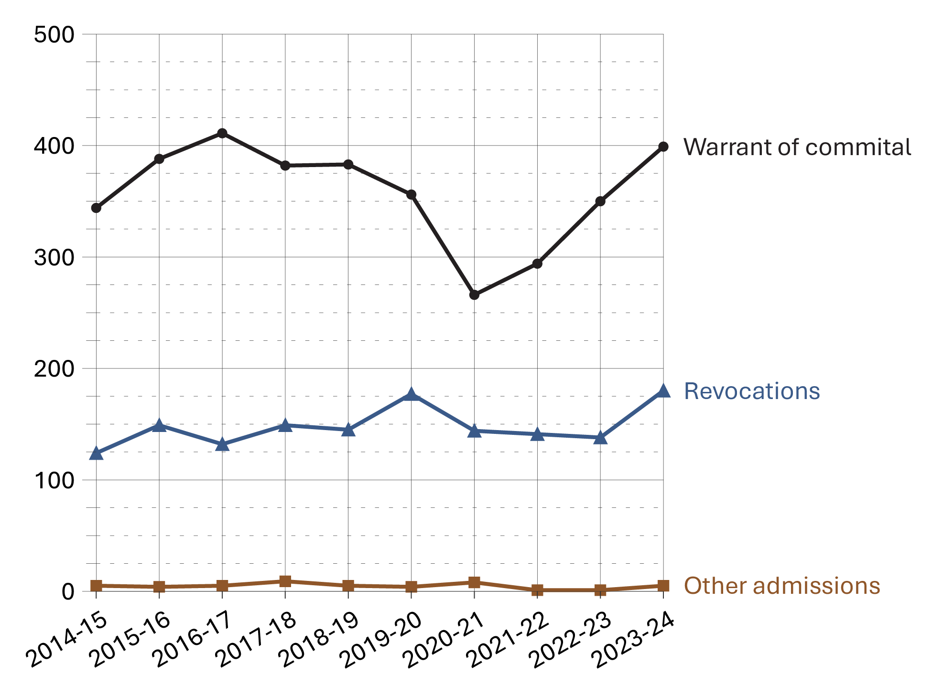
Source: Correctional Service of Canada.

Figure C4b. Number of male admissions to CSC facilities
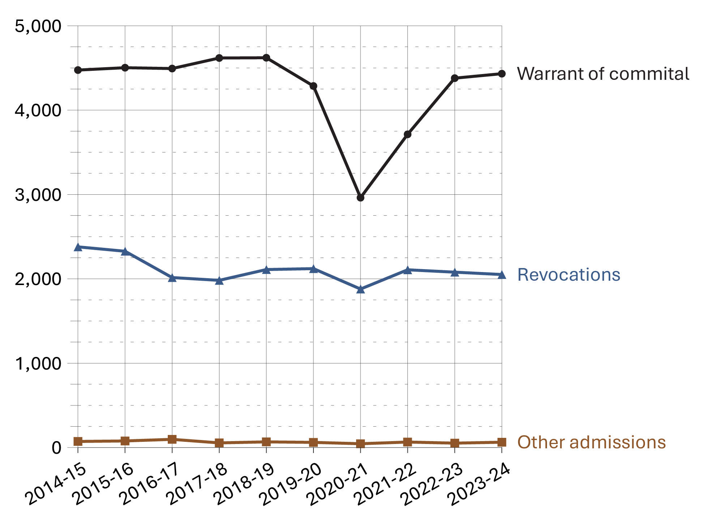
Source: Correctional Service of Canada.

Figure C4c. Total number of admissions to CSC facilities
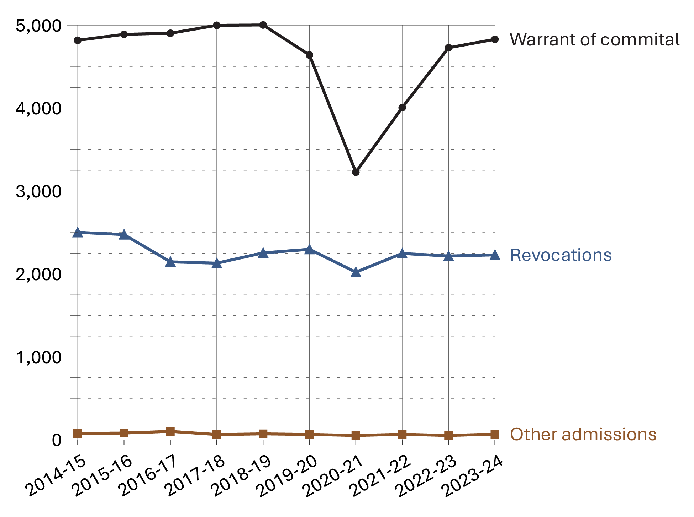
Source: Correctional Service of Canada.
- After peaking at 7,449 in 2015-16, the total number of admissions has decreased by 4.3% to 7,130 in 2023-24.
- The highest number of admissions for female offenders was in 2023-24, with 584 admissions. This is an increase of 23.5% from ten years ago (473 admissions in 2014-2015). Comparatively, between 2014-15 and 2023-24, admissions for male offenders decreased 5.5% (from 6,926 to 6,546 per year).
- The number of warrant of committal admissions has fluctuated over the past 10 fiscal years (from 2014-15 to 2023-24) but has declined by 3.5% when comparing 2023-24 data (4,831 admissions) to the highest point which occurred in fiscal year 2018-19 (5,004 admissions).
- Between 2014-15 and 2023-24, warrant of committal admissions for female offenders increased 16.0% (from 344 to 399 per year) while warrant of committal admissions for male offenders decreased 1.0% over the same timeframe (from 4,475 to 4,432 per year).
- There was a sharp decrease of 30.5% between 2019-20 to 2020-21 in the warrant of committal admissions followed by an increase of 49.7% between 2020-21 and in 2023-24. These results are comparable between both female and male offenders.
Table C4a. Number of female admissions to CSC facilities
Admission type | 2019-20 | 2020-21 | 2021-22 | 2022-23 | 2023-24
Total warrant of committal | 356 | 266 | 294 | 350 | 399
1st federal sentence | 324 | 243 | 254 | 300 | 355
Subsequent federal sentence | 31 | 23 | 39 | 47 | 44
Provincial sentence | 1 | 0 | 1 | 3 | 0
Revocations | 177 | 144 | 141 | 138 | 180
Other | 4 | 8 | 1 | 1 | 5
Total female admissions | 537 | 418 | 436 | 489 | 584
Source: Correctional Service of Canada.

Table C4b. Number of male admissions to CSC facilities
Admission type | 2019-20 | 2020-21 | 2021-22 | 2022-23 | 2023-24
Total warrant of committal | 4,286 | 2,962 | 3,713 | 4,379 | 4,432
1st federal sentence | 3,165 | 2,154 | 2,775 | 3,322 | 3,382
Subsequent federal sentence | 1,107 | 792 | 924 | 1,052 | 1,047
Provincial sentence | 14 | 16 | 14 | 5 | 3
Revocations | 2,121 | 1,879 | 2,107 | 2,079 | 2,051
Other | 61 | 45 | 65 | 52 | 63
Total male admissions | 6,468 | 4,886 | 5,885 | 6,510 | 6,546
Source: Correctional Service of Canada.

Table C4c. Total number of admissions to CSC facilities
Admission type | 2019-20 | 2020-21 | 2021-22 | 2022-23 | 2023-24
Total warrant of committal | 4,642 | 3,228 | 4,007 | 4,729 | 4,831
1st federal sentence | 3,489 | 2,397 | 3,029 | 3,622 | 3,737
Subsequent federal sentence | 1,138 | 815 | 963 | 1,099 | 1,091
Provincial sentence | 15 | 16 | 15 | 8 | 3
Revocations | 2,298 | 2,023 | 2,248 | 2,217 | 2,231
Other | 65 | 53 | 66 | 53 | 68
Total admissions | 7,005 | 5,304 | 6,321 | 6,999 | 7,130
Source: Correctional Service of Canada.
Notes
Warrant of Committal is a new admission to federal jurisdiction from the courts.
Revocation is when an offender is admitted to federal custody after conditional release and before reaching warrant expiry.
“Other” includes transfers from other jurisdictions (exchange of services), terminations, transfers from foreign countries, and admissions where a release is interrupted as a consequence of a new conviction.
These numbers refer to the total number of admissions to a federal institution or Healing Lodge during each fiscal year and may be greater than the actual number of offenders admitted, since an individual offender may be admitted more than once in a given year.
There is a lag in the data entry of admissions into CSC’s Offender Management System. The admission figures for the most recent year are under-reported by 200-400 admissions at the time of year end data extraction. More accurate figures will be available in the next year’s publication. Please use caution when including the most recent year in any trend analysis.
Reported year periods reflect fiscal years. A fiscal year runs from April 1 to March 31 of the following year.

Warrant of committal admissions to CSC facilities by sex: 10-year trend

Figure C5. Warrant of committal admissions for females and males
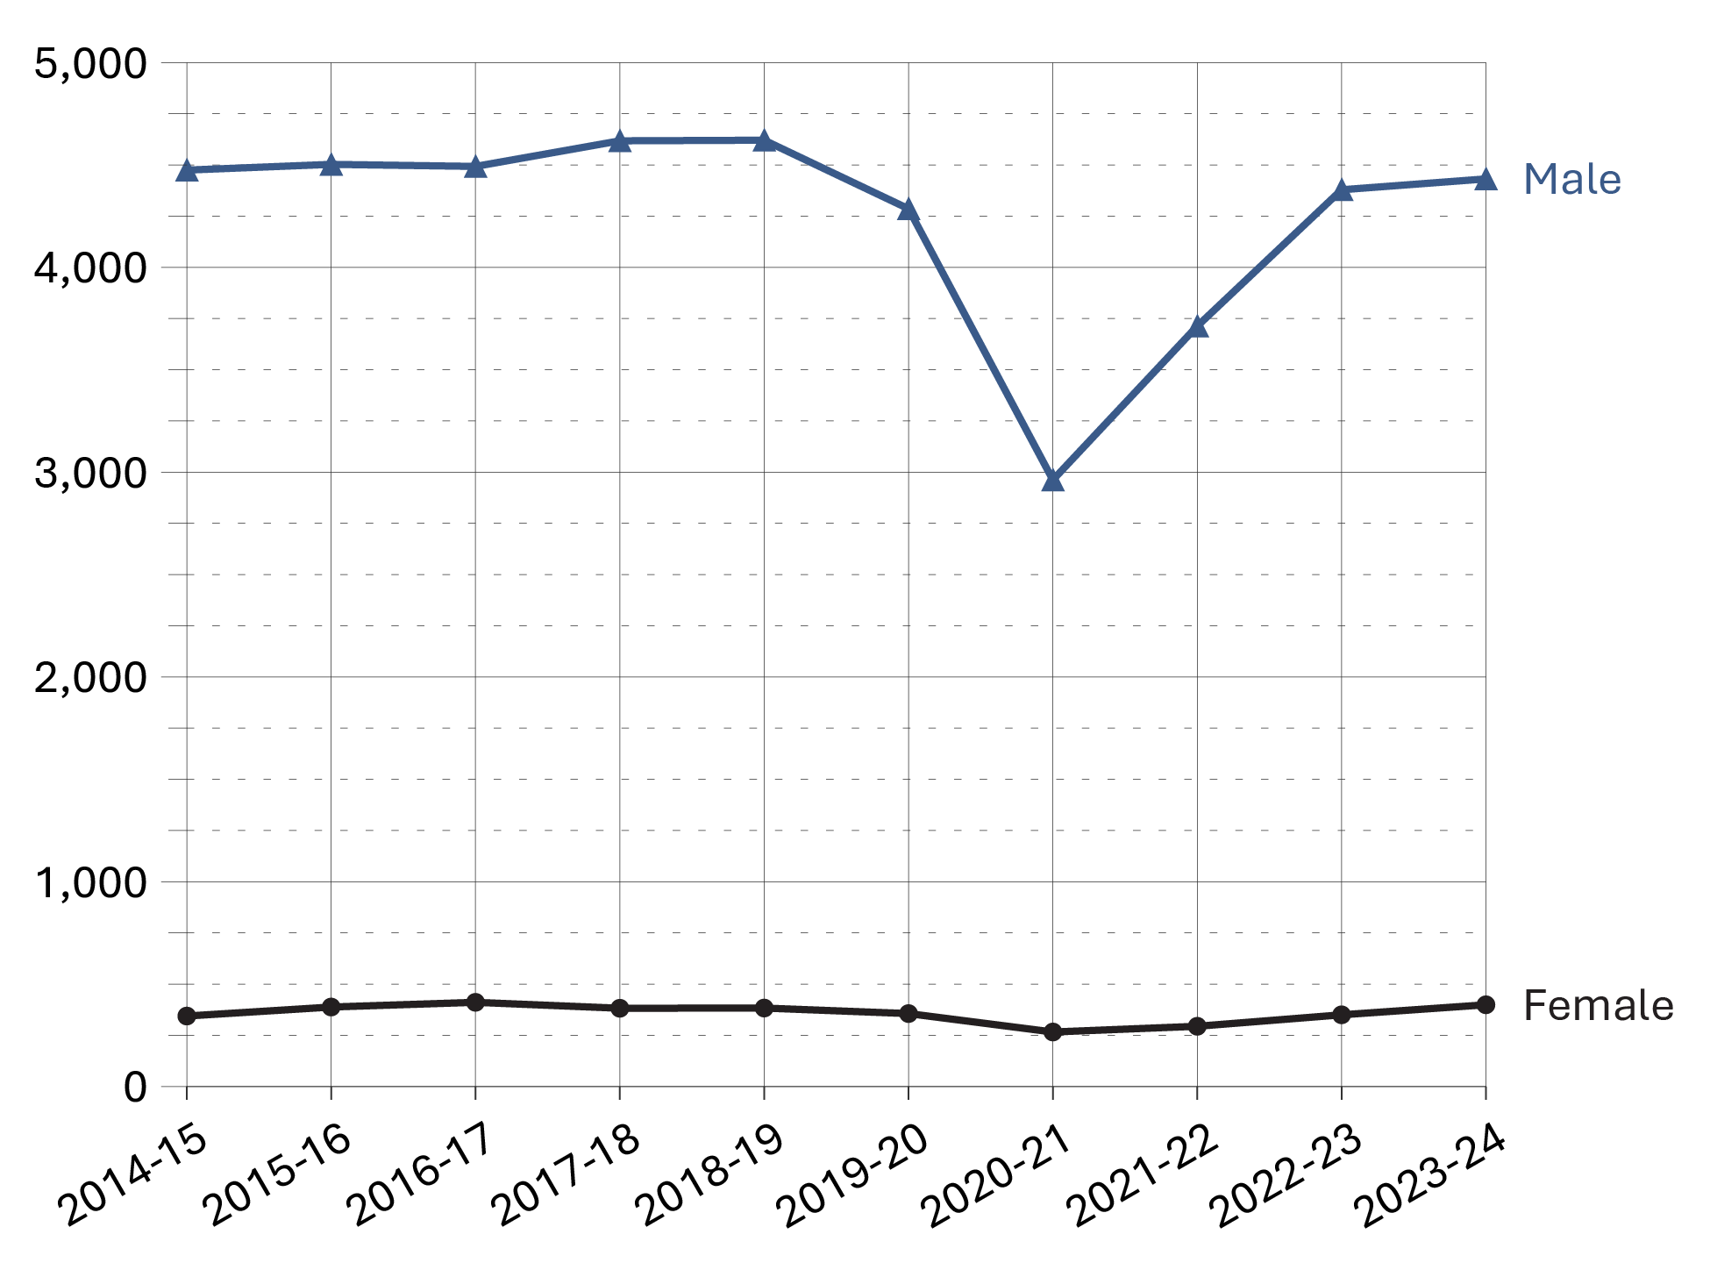
Source: Correctional Service of Canada.
- In the past 5 years, the number of females admitted to CSC facilities on a warrant of committal increased by 12.1% from 356 in 2019-20 to 399 in 2023-24. During the same time period, there was a 3.4% increase in the number of males admitted to CSC facilities on a warrant of committal from 4,286 in 2019-20 to 4,432 in 2023-24.
- Overall, females continue to represent a small proportion of the total number of warrant of committal admissions (i.e., 8.3% in 2023-24).
- At the end of fiscal year 2023-24, there were 736 female and 13,119 male offenders in custody within Correctional Service Canada facilities.

Table C5. Warrant of committal admissions for females and males
Fiscal year | Females | % | Males | % | Total
2014-15 | 344 | 7.1 | 4,475 | 92.9 | 4,819
2015-16 | 388 | 7.9 | 4,503 | 92.1 | 4,891
2016-17 | 411 | 8.4 | 4,493 | 91.6 | 4,904
2017-18 | 382 | 7.6 | 4,618 | 92.4 | 5,000
2018-19 | 383 | 7.7 | 4,621 | 92.3 | 5,004
2019-20 | 356 | 7.7 | 4,286 | 92.3 | 4,642
2020-21 | 266 | 8.2 | 2,962 | 91.8 | 3,228
2021-22 | 294 | 7.3 | 3,713 | 92.7 | 4,007
2022-23 | 350 | 7.4 | 4,379 | 92.6 | 4,729
2023-24 | 399 | 8.3 | 4,432 | 91.7 | 4,831
Source: Correctional Service of Canada.
Notes
A warrant of committal is a new admission to federal jurisdiction from the courts.
These numbers refer to the total number of admissions to a federal institution or Healing Lodge during each fiscal year and may be greater than the actual number of offenders admitted, since an individual offender may be admitted more than once in a given year.
There is a lag in the data entry of admissions into CSC’s Offender Management System. The admission figures for the most recent year are under-reported by 200-400 admissions at the time of year end data extraction. More accurate figures will be available in the next year’s publication. Please use caution when including the most recent year in any trend analysis.
Reported year periods reflect fiscal years. A fiscal year runs from April 1 to March 31 of the following year.

Number of registered victims by gender: 5-year trend

Figure C6. Number of registered victims by gender*

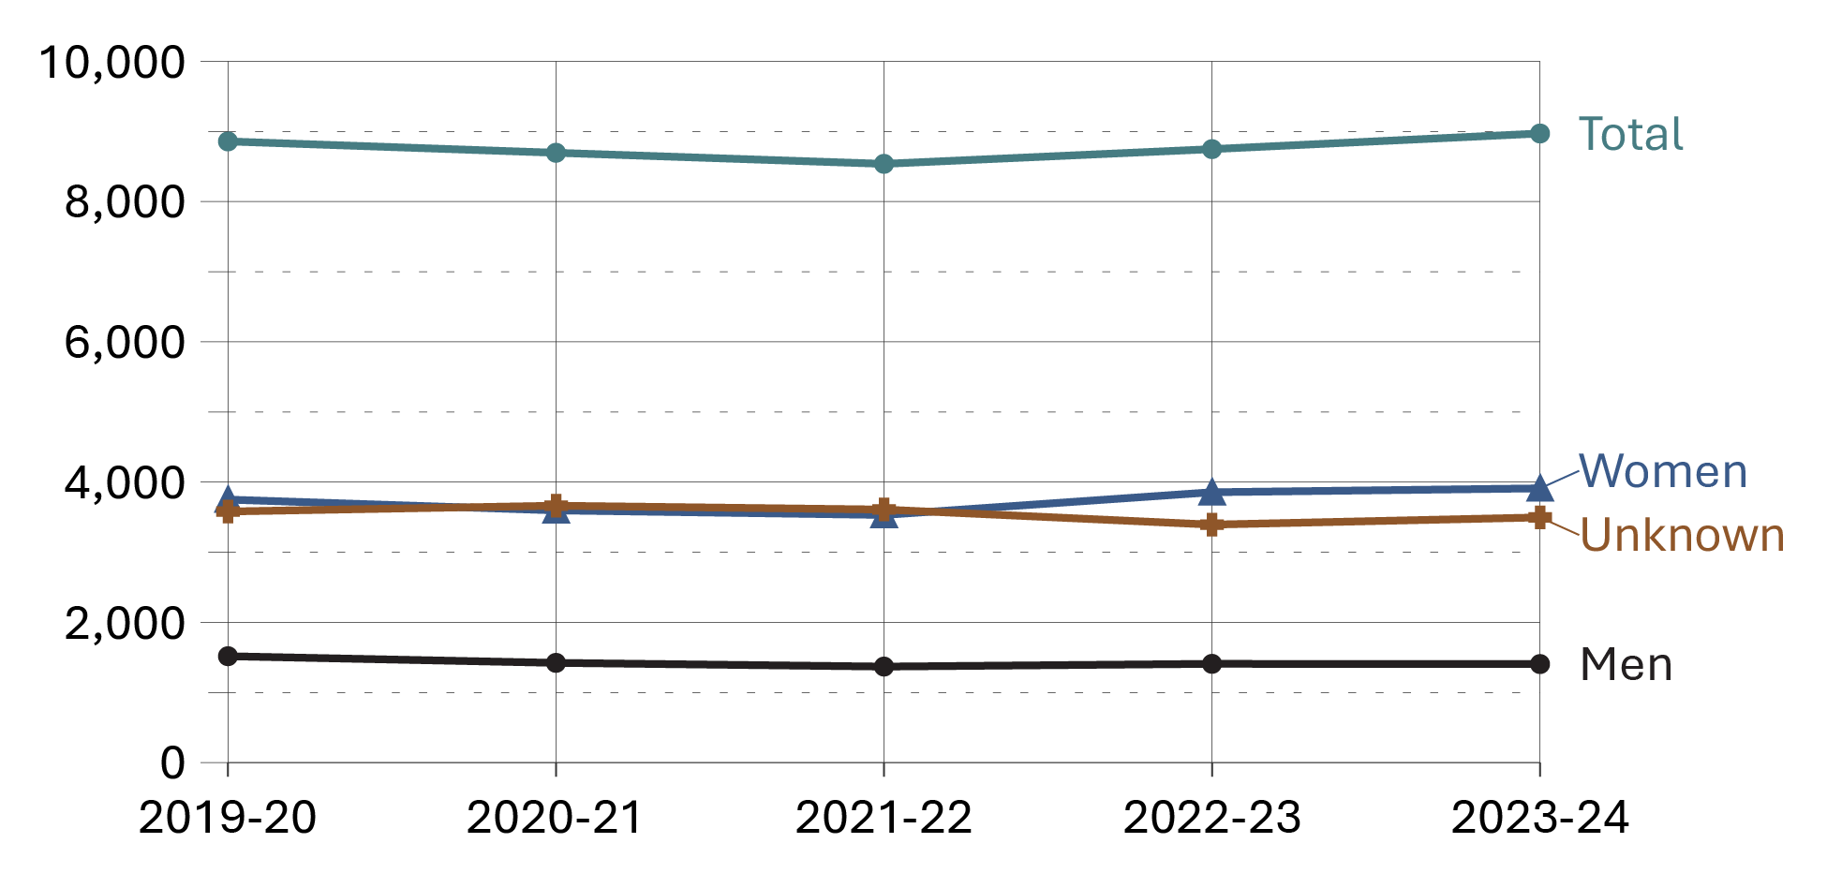
Source: Correctional Service of Canada.
- Most registered victims were of unknown gender (39.0%), or identified as women (43.6%).
- Although not displayed, 7 registered victims identified as another gender** and 152 registered victims did not want to provide a gender at the end of fiscal year 2023-24.
Notes
*Note that information provided by victims is based on gender, as opposed to information collected from offenders, which is based on biological sex.
**This option became available in the Victims Application Module (VAM) in November 2019.

Table C6. Number of registered victims by gender*
Gender | 2019-20 | 2020-21 | 2021-22 | 2022-23 | 2023-24
Men | 1,517 | 1,422 | 1,369 | 1,408 | 1,405
Women | 3,750 | 3,596 | 3,531 | 3,855 | 3,910
Another gender** | 0 | 0 | 2 | 4 | 7
Does not want to provide | 10 | 14 | 27 | 87 | 152
Unknown | 3,580 | 3,663 | 3,608 | 3,393 | 3,496
Total | 8,857 | 8,695 | 8,537 | 8,747 | 8,970
Source: Correctional Service of Canada.
Notes
*Note that information provided by victims is based on gender, as opposed to information collected from offenders, which is based on biological sex.
**This option became available in the Victims Application Module (VAM) in November 2019.
The Canadian Victims Bill of Rights defines a victim as an individual who has suffered physical or emotional harm, property damage, or economic loss as the result of the commission or alleged commission of an offence. The CCRA also allows a spouse, a relative or dependant, an individual who is responsible for the care or support of the victim or the care or support of a dependant of the victim, to act on behalf of a victim, if the victim cannot act on their own behalf. Victims include persons harmed as the result of an act of an offender, whether or not the offender was prosecuted or convicted for that act, as long as an official complaint has been made to the police or to the Crown.
Victims do not automatically receive information about the offender who harmed them. If they have been harmed by an offender serving a sentence of 2 years or more, victims are asked to register with the Correctional Service of Canada (CSC) or the Parole Board of Canada to receive information or access services. The registration process allows CSC to verify that the individual meets the definition of victim, which is required under law before sharing protected offender information.
For more information about victim registration, visit: https://www.canada.ca/en/correctional-service/services/you-csc/victims/register.html
Demographic information is voluntarily self-reported by victims who have registered with CSC to receive information about the offender who harmed them. The information does not represent victims who have not been in contact with CSC or those who choose not to register.
The difference between the total number of registered victims and the number of victims who voluntarily self-reported their gender is the result of victims choosing not to report their gender, or their gender is unknown to CSC (due to victims choosing not to share information). Some victims choose to not provide this information to CSC, and the number of victims choosing to provide information varies from year to year. The response rate for victim gender has remained stable for the past 5 fiscal years.
Victim registration fluctuates for a number of reasons beyond organizational control. Contributing factors impacting victim registration data could be due to offenders reaching the end of their sentence or death, victims opting out of notifications for reasons such as personal preferences, death or loss of contact.
Reported data is current up to the end of each fiscal year. A fiscal year runs from April 1 to March 31 of the following year.

CSC total offender population by sentence length

Figure C7. Sentence length of total offender population (2023-24)
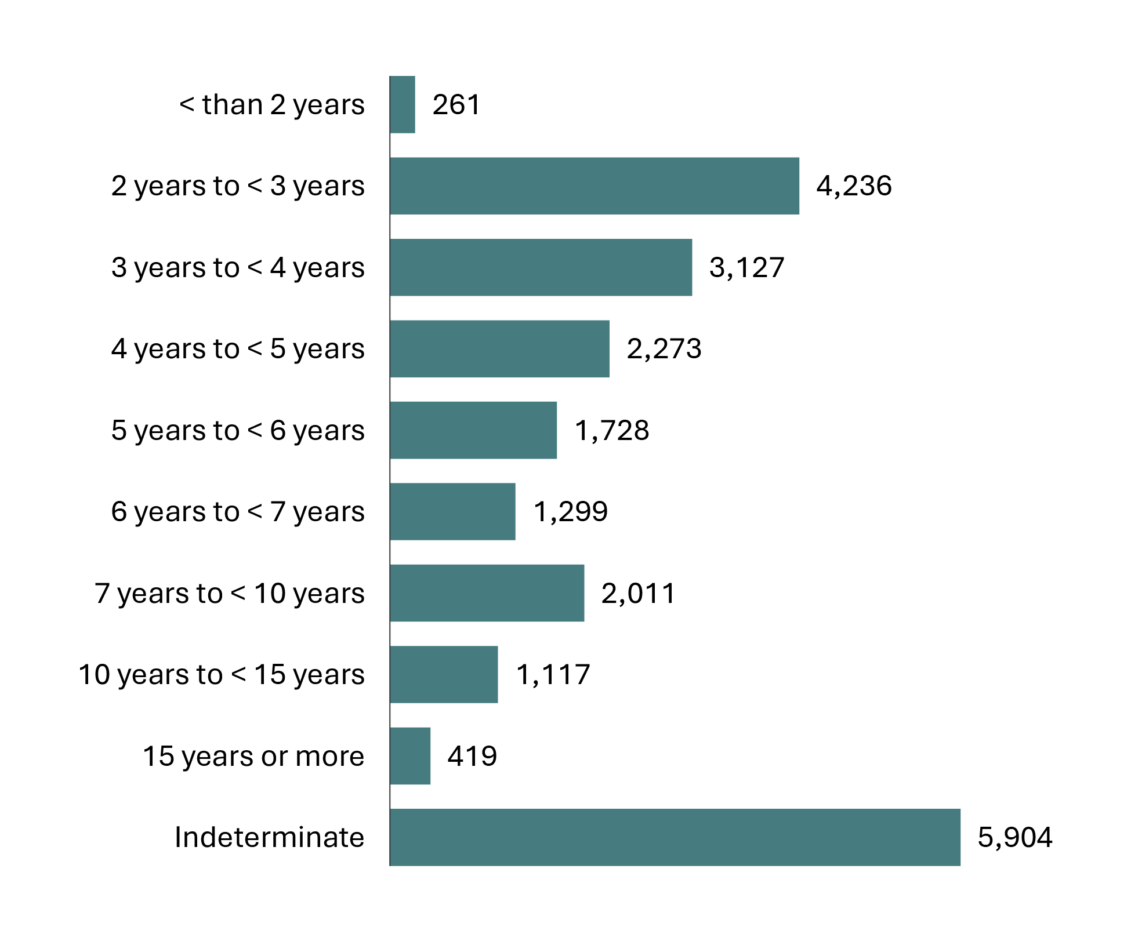
Source: Correctional Service of Canada.
- In 2023-24, almost half (44.2%) of the total offender population was serving a sentence of less than 5 years with 20.1% serving a sentence less than 3 years.
- 5,904 offenders were serving an indeterminate sentence representing 26.4% of the total offender population. The total number of offenders with indeterminate sentences has increased 2.4% since 2019-20 from 5,764 to 5,904 in 2023-24.

Table C7. Sentence length of total offender population
Sentence length | 2019-20 | % | 2020-21 | % | 2021-22 | % | 2022-23 | % | 2023-24 | %
< than 2 years | 307 | 1.3 | 293 | 1.4 | 267 | 1.3 | 253 | 1.2 | 261 | 1.2
2 years to < 3 years | 5,149 | 22.3 | 4,321 | 20.1 | 3,814 | 18.3 | 4,034 | 18.9 | 4,236 | 18.9
3 years to < 4 years | 3,389 | 14.7 | 3,060 | 14.2 | 2,917 | 14.0 | 2,886 | 13.5 | 3,127 | 14.0
4 years to < 5 years | 2,371 | 10.3 | 2,157 | 10.0 | 2,070 | 9.9 | 2,114 | 9.9 | 2,273 | 10.2
5 years to < 6 years | 1,692 | 7.3 | 1,598 | 7.4 | 1,605 | 7.7 | 1,678 | 7.8 | 1,728 | 7.7
6 years to < 7 years | 1,153 | 5.0 | 1,130 | 5.3 | 1,152 | 5.5 | 1,216 | 5.7 | 1,299 | 5.8
7 years to < 10 years | 1,841 | 8.0 | 1,795 | 8.3 | 1,795 | 8.6 | 1,893 | 8.9 | 2,011 | 9.0
10 years to < 15 years | 1,010 | 4.4 | 999 | 4.6 | 991 | 4.8 | 1,063 | 5.0 | 1,117 | 5.0
15 years or more | 426 | 1.8 | 404 | 1.9 | 403 | 1.9 | 409 | 1.9 | 419 | 1.9
Indeterminate | 5,764 | 25.0 | 5,755 | 26.8 | 5,792 | 27.8 | 5,838 | 27.3 | 5,904 | 26.4
Total | 23,102 | 100.0 | 21,512 | 100.0 | 20,806* | 100.0 | 21,384 | 100.0 | 22,375 | 100.0
Source: Correctional Service of Canada.
Notes
*As a result of a data quality issue, sentence length information on one offender was not available at the time of the data extraction; therefore, the total of the sentence length grouping will not add up to the offender population results for 2021-22.
Total Offender Population includes all active offenders, who are incarcerated in a CSC facility, offenders on temporary absence from a CSC facility, offenders who are temporarily detained, offenders who are actively supervised, and offenders who are unlawfully at large for less than 90 days.
The group of offenders serving a sentence less than 2 years includes offenders transferred from foreign countries or offenders under a long-term supervision order who received a new sentence of less than 2 years.
Indeterminate means that the offender’s term of imprisonment does not have an end date. The Parole Board of Canada reviews the cases after the number of years prescribed by legislation and sentencing.
Reported year periods reflect fiscal years. A fiscal year runs from April 1 to March 31 of the following year.

Offences of victimization among registered victims

Figure C8. Offences of victimization (2023-24)
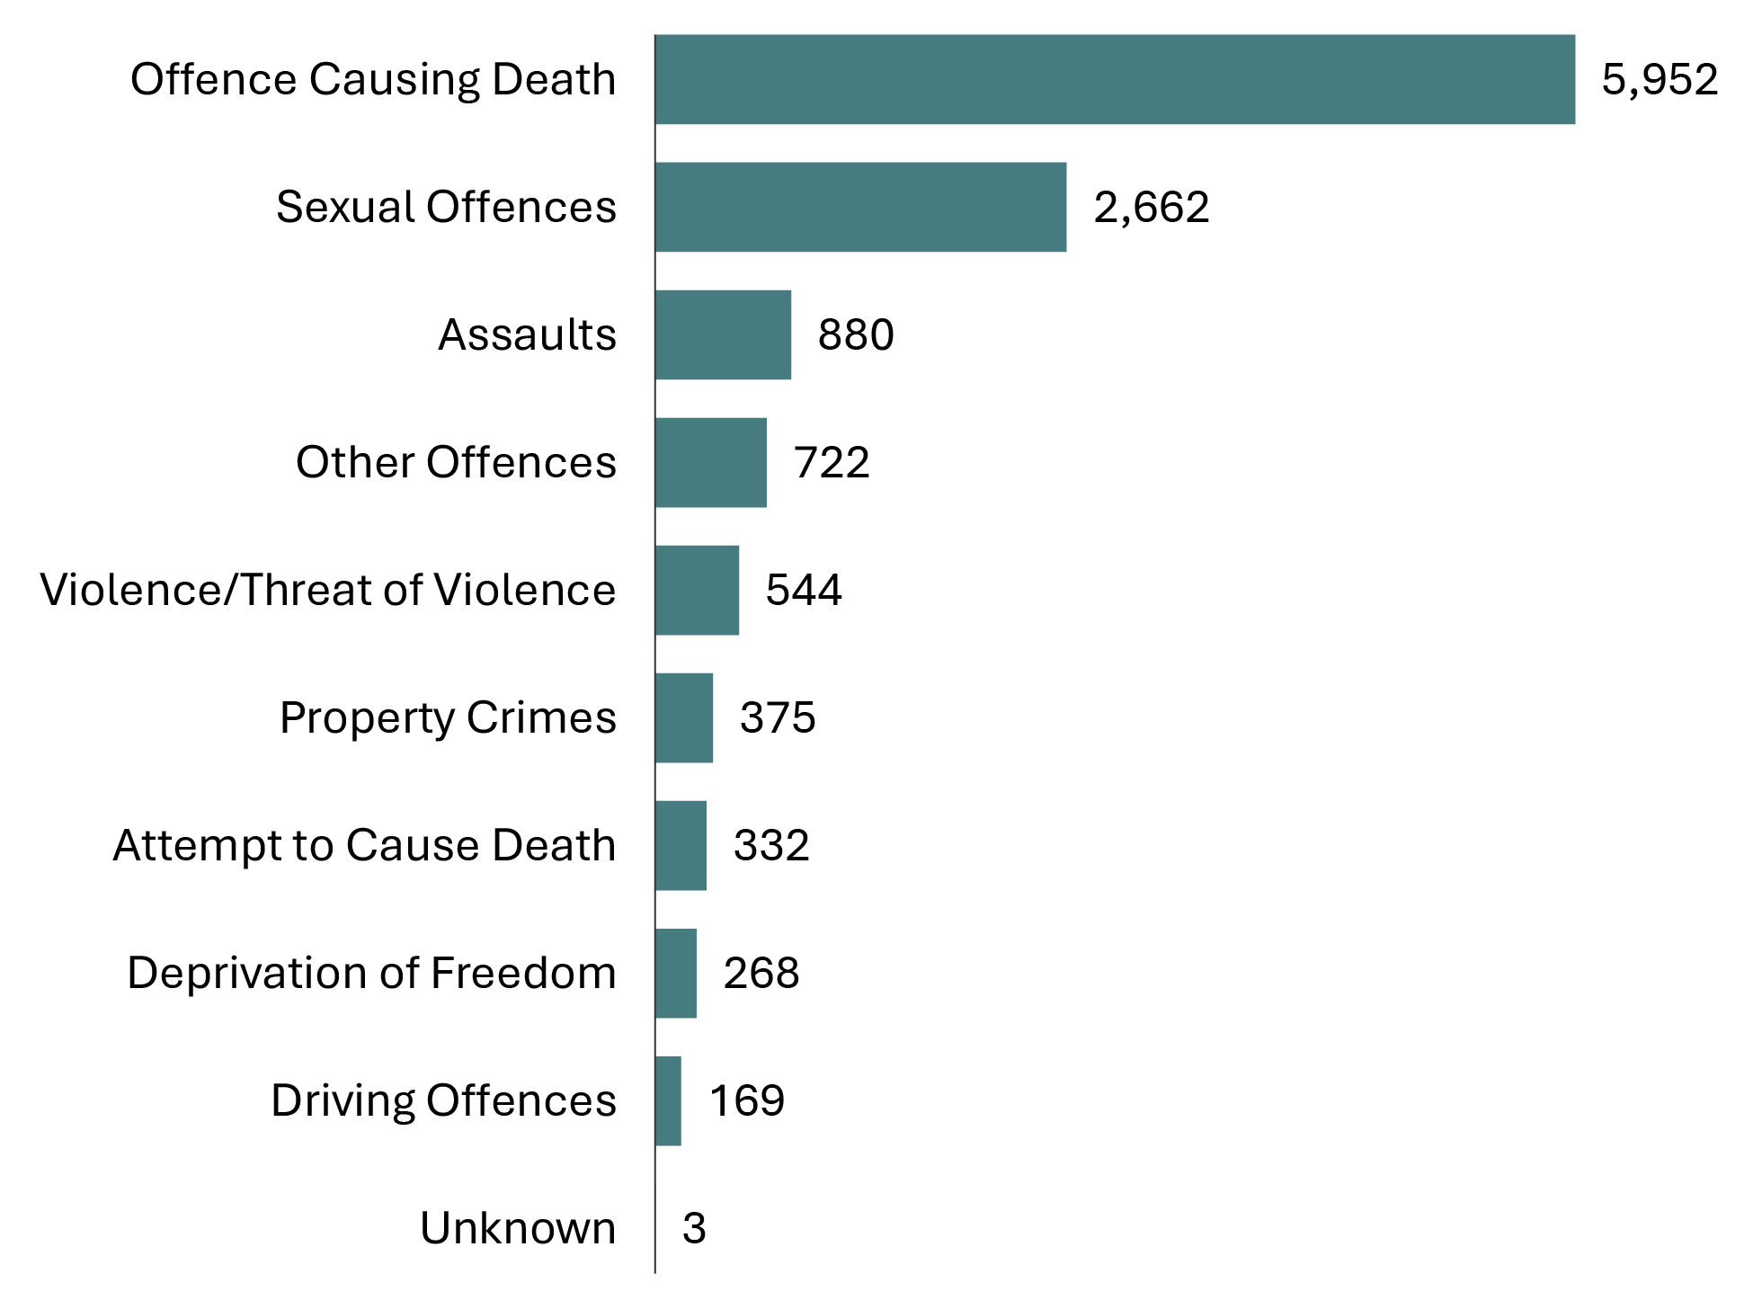
Source: Correctional Service of Canada.
- Offences causing death accounted for half of all offences of victimization (50.0%).
- Sexual offences were the second most common offence of victimization (22.4%).
Table C8. Offences of victimization
Offence type | 2019-20 | % | 2020-21 | % | 2021-22 | % | 2022-23 | % | 2023-24 | %
Offence causing death | 5,629 | 47.8 | 5,597 | 48.5 | 5,653 | 49.5 | 5,836 | 50.0 | 5,952 | 50.0
Sexual offences | 2,517 | 21.4 | 2,483 | 21.5 | 2,464 | 21.6 | 2,559 | 21.9 | 2,662 | 22.4
Assaults | 932 | 7.9 | 903 | 7.8 | 828 | 7.3 | 828 | 7.1 | 880 | 7.4
Other offences | 762 | 6.5 | 696 | 6.0 | 689 | 6.0 | 732 | 6.3 | 722 | 6.1
Violence/ Threat of violence | 540 | 4.6 | 555 | 4.8 | 555 | 4.9 | 520 | 4.5 | 544 | 4.6
Property crimes | 540 | 4.6 | 501 | 4.3 | 438 | 3.8 | 394 | 3.4 | 375 | 3.1
Attempt to cause death | 338 | 2.9 | 341 | 3.0 | 325 | 2.8 | 329 | 2.8 | 332 | 2.8
Deprivation of freedom | 279 | 2.4 | 260 | 2.3 | 260 | 2.3 | 257 | 2.2 | 268 | 2.3
Driving offences | 229 | 1.9 | 198 | 1.7 | 204 | 1.8 | 211 | 1.8 | 169 | 1.4
Unknown | 4 | 0.0 | 3 | 0.0 | 2 | 0.0 | 2 | 0.0 | 3 | 0.0
Total number of offences | 11,770 | 100.0 | 11,537 | 100.0 | 11,418 | 100.0 | 11,668 | 100.0 | 11,907 | 100.0
Source: Correctional Service of Canada.
Notes
The Canadian Victims Bill of Rights defines a victim as an individual who has suffered physical or emotional harm, property damage, or economic loss as the result of the commission or alleged commission of an offence. The CCRA also allows a spouse, a relative or dependant, an individual who is responsible for the care or support of the victim or the care or support of a dependant of the victim, to act on behalf of a victim, if the victim cannot act on their own behalf. Victims include persons harmed as the result of an act of an offender, whether or not the offender was prosecuted or convicted for that act, as long as an official complaint has been made to the police or to the Crown.
Victims do not automatically receive information about the offender who harmed them. If they have been harmed by an offender serving a sentence of two years or more, victims are asked to register with the Correctional Service of Canada (CSC) or the Parole Board of Canada to receive information or access services. The registration process allows CSC to verify that the individual meets the definition of victim, which is required under law before sharing protected offender information.
For more information about victim registration, visit: https://www.canada.ca/en/correctional-service/services/you-csc/victims/register.html
Offences of victimization are acts the offender committed that harmed the victim, and have been confirmed using police reports or judge's comments. The offender may not have been convicted of each act or may be serving a federal sentence for different offences. This could be a result of plea deals, because charges were not pursued by the Crown, or the offence may be from a previous sentence or a provincial sentence. Offences of victimization are limited to victims registered with CSC.
More than 1 offence of victimization may be recorded for each victim.
"Deprivation of freedom" offences are offences such as kidnapping, forcible confinement, hostage taking, or abduction.
Reported year periods reflect fiscal years. A fiscal year runs from April 1 to March 31 of the following year.

Warrant of committal admissions to a CSC facility by age

Figure C9. Percentage of warrant of committal admissions by age: 10-year comparison
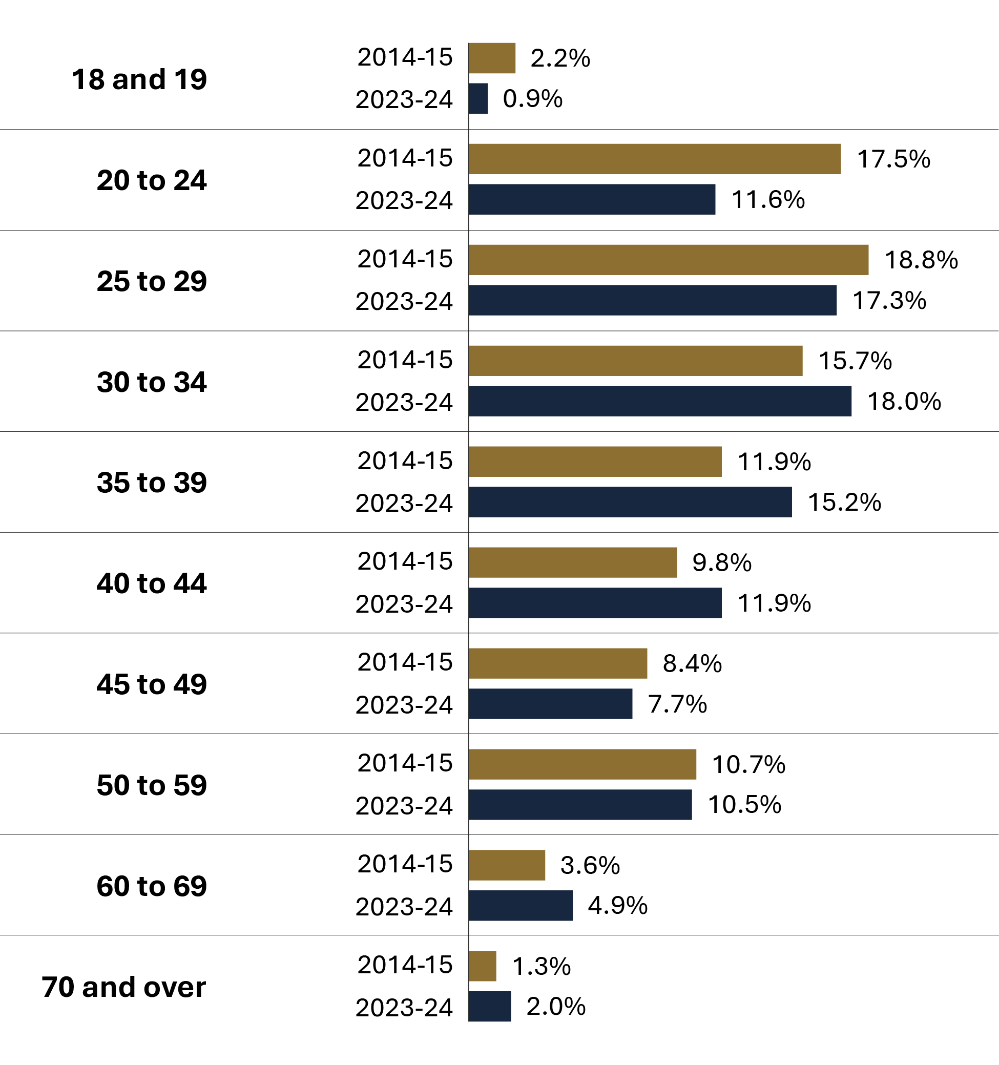
Source: Correctional Service of Canada.
- In 2023-24, 28.9% of offenders admitted on a warrant of committal to CSC facilities were between the ages of 20 and 29, and 33.2% were between 30 and 39 years of age.
- In 2023-24 most warrant of committal admissions were among those aged 30 to 34, while in 2014-15 it was among those aged 25 to 29.
- The median age of the population upon warrant of committal admission in 2023-24 was 35, compared to a median age of 33 in 2014-15.
- The number of offenders between the ages of 18 and 19 at admission decreased from 104 in 2014-15 to 43 in 2023-24, representing a 58.7% decrease.
- The number of offenders between the ages of 40 and 49 at admission increased from 881 in 2014-15 to 947 in 2023-24, representing a 7.5% increase.
- The number of offenders between the ages of 50 and 59 at admission decreased from 518 in 2014-15 to 509 in 2023-24 representing a 1.7% decrease.
- The number of offenders aged 70 and over at admission increased from 65 in 2014-15 to 95 in 2023-24, representing a 46.2% increase.

Table C9. Warrant of committal admissions by age and sex: 10-year comparison

Fiscal year 2014-15
Age at admission | Females | % | Males | % | Total | %
18 to 19 | 9 | 2.6 | 95 | 2.1 | 104 | 2.2
20 to 24 | 53 | 15.4 | 790 | 17.7 | 843 | 17.5
25 to 29 | 83 | 24.1 | 821 | 18.3 | 904 | 18.8
30 to 34 | 58 | 16.9 | 698 | 15.6 | 756 | 15.7
35 to 39 | 34 | 9.9 | 540 | 12.1 | 574 | 11.9
40 to 44 | 34 | 9.9 | 440 | 9.8 | 474 | 9.8
45 to 49 | 29 | 8.4 | 378 | 8.4 | 407 | 8.4
50 to 59 | 37 | 10.8 | 481 | 10.7 | 518 | 10.7
60 to 69 | 6 | 1.7 | 168 | 3.8 | 174 | 3.6
70 and over | 1 | 0.3 | 64 | 1.4 | 65 | 1.3
Total | 344 | 100.0 | 4,475 | 100.0 | 4,819 | 100.0

Fiscal year 2023-24
Age at admission | Females | % | Males | % | Total | %
18 to 19 | 1 | 0.3 | 42 | 0.9 | 43 | 0.9
20 to 24 | 31 | 7.8 | 529 | 11.9 | 560 | 11.6
25 to 29 | 71 | 17.8 | 765 | 17.3 | 836 | 17.3
30 to 34 | 89 | 22.3 | 779 | 17.6 | 868 | 18.0
35 to 39 | 73 | 18.3 | 663 | 15.0 | 736 | 15.2
40 to 44 | 61 | 15.3 | 514 | 11.6 | 575 | 11.9
45 to 49 | 24 | 6.0 | 348 | 7.9 | 372 | 7.7
50 to 59 | 30 | 7.5 | 479 | 10.8 | 509 | 10.5
60 to 69 | 16 | 4.0 | 221 | 5.0 | 237 | 4.9
70 and over | 3 | 0.8 | 92 | 2.1 | 95 | 2.0
Total | 399 | 100.0 | 4,432 | 100.0 | 4,831 | 100.0
Source: Correctional Service of Canada.
Notes
A warrant of committal is a new admission to federal jurisdiction from the courts.
These numbers refer to the total number of admissions to a federal institution or Healing Lodge during each fiscal year and may be greater than the actual number of offenders admitted, since an individual offender may be admitted more than once in a given year.
There is a lag in the data entry of admissions into CSC’s Offender Management System. The admission figures for the most recent year are under-reported by 200-400 admissions at the time of year end data extraction. More accurate figures will be available in the next year’s publication. Please use caution when including the most recent year in any trend analysis.
Due to rounding, percentages may not add to 100 percent.
Reported year periods reflect fiscal years. A fiscal year runs from April 1 to March 31 of the following year.

Number of registered victims by age

Figure C10. Number of registered victims by age (2023-24)
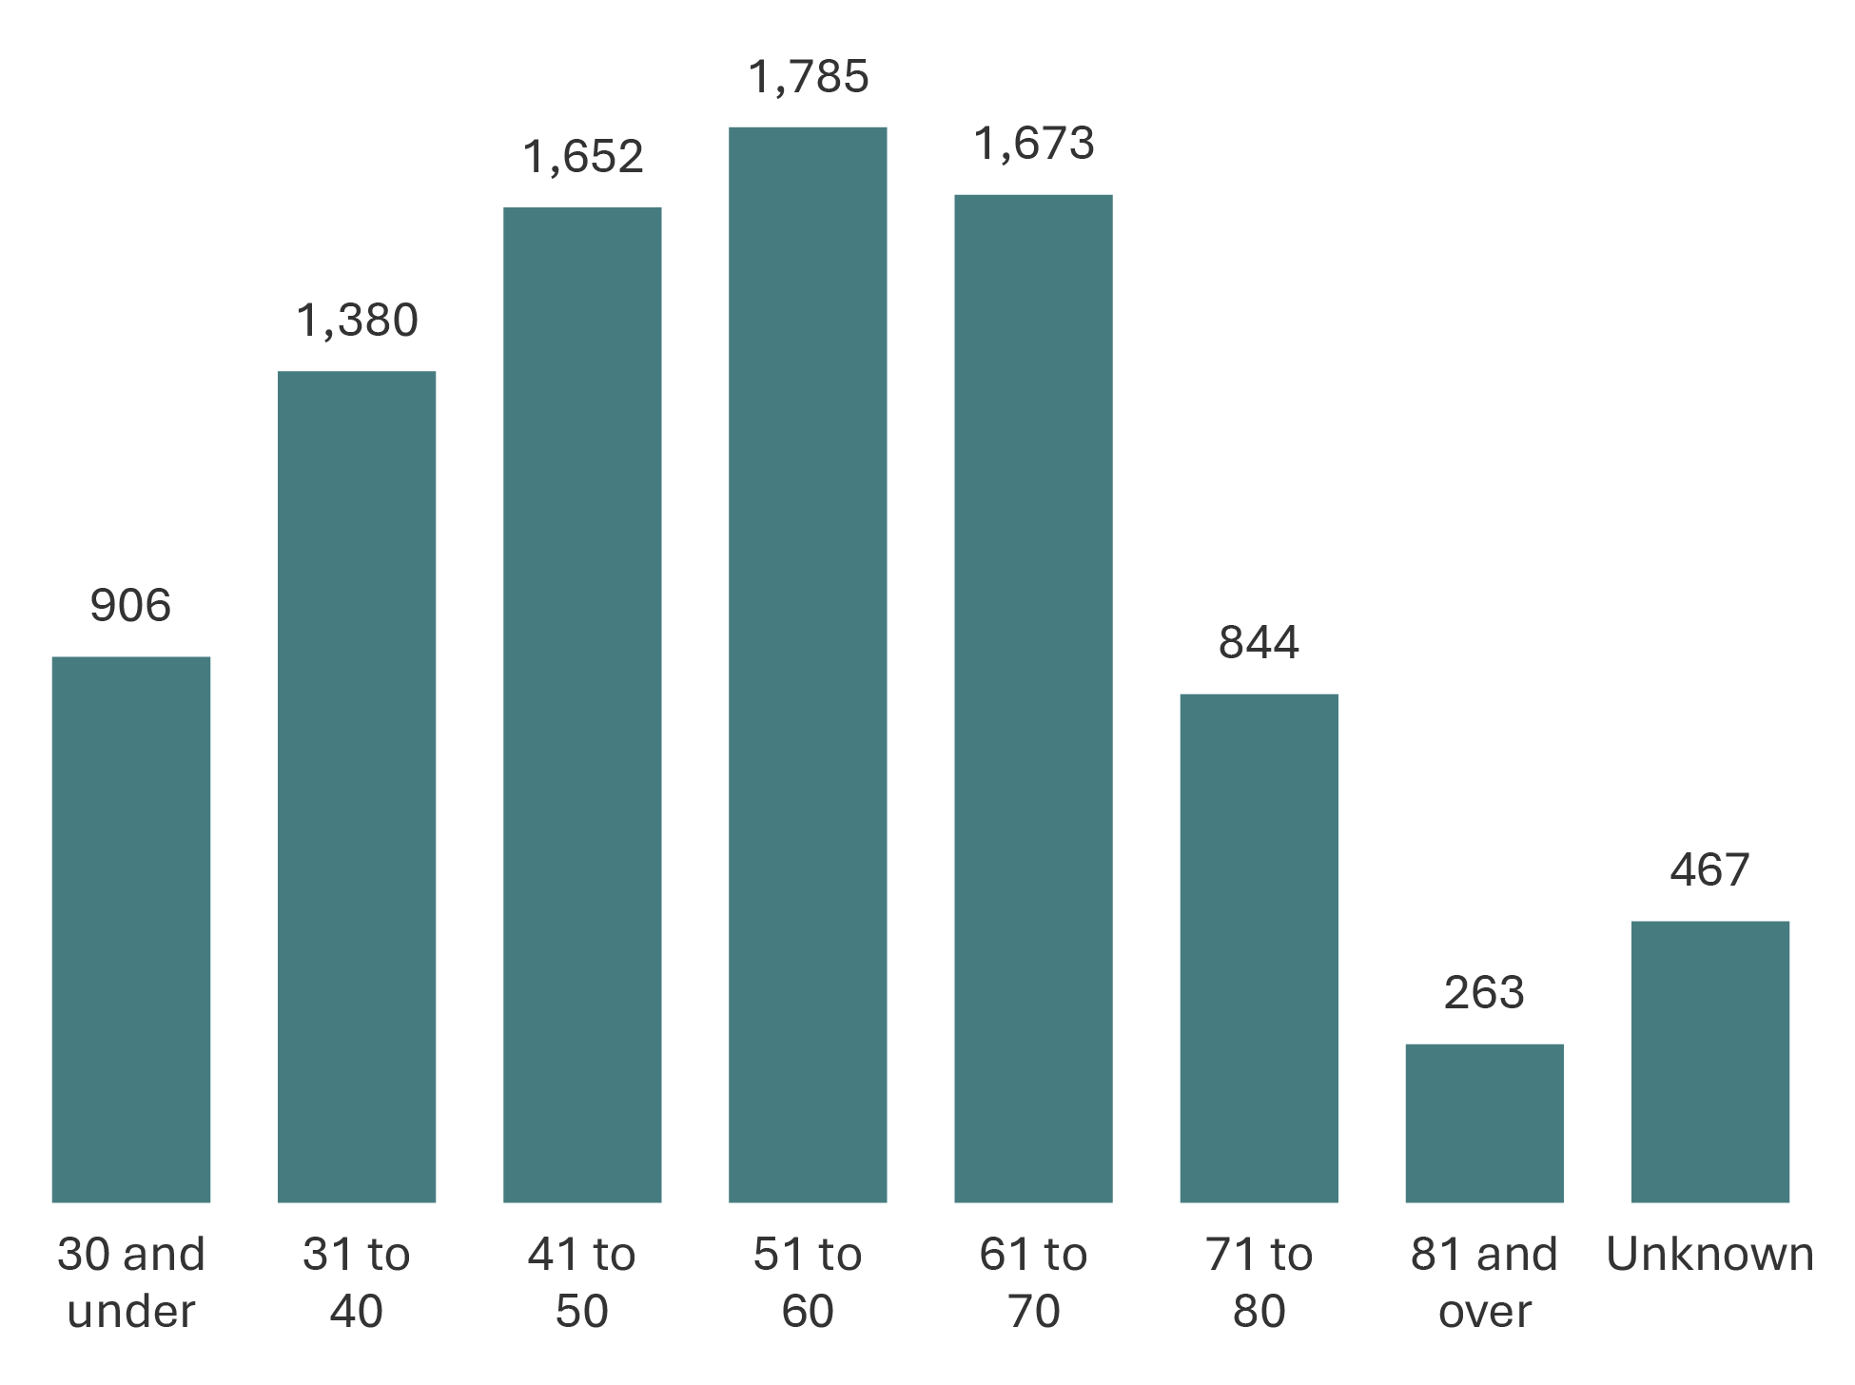
Source: Correctional Service of Canada.
- In 2023-24, 57.0% of registered victims were aged 41 to 70. The greatest proportion of victims was in the 51-60 age group (19.9%). This pattern has remained consistent over the past 5 fiscal years (from 2019-20 to 2023-24).

Table C10. Number of registered victims by age
Age group | 2019-20 | % | 2020-21 | % | 2021-22 | % | 2022-23 | % | 2023-24 | %
30 and under | 957 | 10.8 | 881 | 10.1 | 788 | 9.2 | 825 | 9.4 | 906 | 10.1
31 to 40 | 1,274 | 14.4 | 1,288 | 14.8 | 1,313 | 15.4 | 1,359 | 15.5 | 1,380 | 15.4
41 to 50 | 1,598 | 18.0 | 1,585 | 18.2 | 1,517 | 17.8 | 1,552 | 17.7 | 1,652 | 18.4
51 to 60 | 1,928 | 21.8 | 1,852 | 21.3 | 1,808 | 21.2 | 1,805 | 20.6 | 1,785 | 19.9
61 to 70 | 1,455 | 16.4 | 1,504 | 17.3 | 1,546 | 18.1 | 1,638 | 18.7 | 1,673 | 18.7
71 to 80 | 715 | 8.1 | 748 | 8.6 | 766 | 9.0 | 799 | 9.1 | 844 | 9.4
81 and older | 246 | 2.8 | 252 | 2.9 | 258 | 3.0 | 263 | 3.0 | 263 | 2.9
Unknown | 684 | 7.7 | 585 | 6.7 | 541 | 6.3 | 506 | 5.8 | 467 | 5.2
Total | 8,857 | 100.0 | 8,695 | 100.0 | 8,537 | 100.0 | 8,747 | 100.0 | 8,970 | 100.0
Source: Correctional Service of Canada.
Notes
The Canadian Victims Bill of Rights defines a victim as an individual who has suffered physical or emotional harm, property damage, or economic loss as the result of the commission or alleged commission of an offence. The CCRA also allows a spouse, a relative or dependant, an individual who is responsible for the care or support of the victim or the care or support of a dependant of the victim, to act on behalf of a victim, if the victim cannot act on their own behalf. Victims include persons harmed as the result of an act of an offender, whether or not the offender was prosecuted or convicted for that act, as long as an official complaint has been made to the police or to the Crown.
Victims do not automatically receive information about the offender who harmed them. If they have been harmed by an offender serving a sentence of 2 years or more, victims are asked to register with the Correctional Service of Canada (CSC) or the Parole Board of Canada to receive information or access services. The registration process allows CSC to verify that the individual meets the definition of victim, which is required under law before sharing protected offender information.
For more information about victim registration, visit: https://www.canada.ca/en/correctional-service/services/you-csc/victims/register.html
Representatives acting on behalf of a victim are not included in the count unless they are also registered victims. In all cases, the reported age corresponds to the victim, not the representative.
Reporting rates ranged from 92.3% in 2019-2020 to 94.8% in 2023-2024. The difference between the total number of registered victims and the number of victims who reported their age is the result of victims choosing not to report their age during registration, or their age is unknown to CSC. The information does not represent victims who have not been in contact with CSC or those who choose not to register.
Victim registration fluctuates for a number of reasons beyond organizational control. Contributing factors impacting victim registration data could be due to offenders reaching the end of their sentence or death, victims opting out of notifications for reasons such as personal preferences, death or loss of contact.
Note that all registered victims are 18 years of age or older except for exceptional circumstances (i.e., emancipations).
Due to rounding, percentages may not add to 100 percent.
Reported year periods reflect fiscal years. A fiscal year runs from April 1 to March 31 of the following year.

Warrant of committal admissions to a CSC facility for Indigenous and non-Indigenous offenders by age

Figure C11. Percentage of warrant of committal admissions for Indigenous and non-Indigenous offenders by age (2023-24)
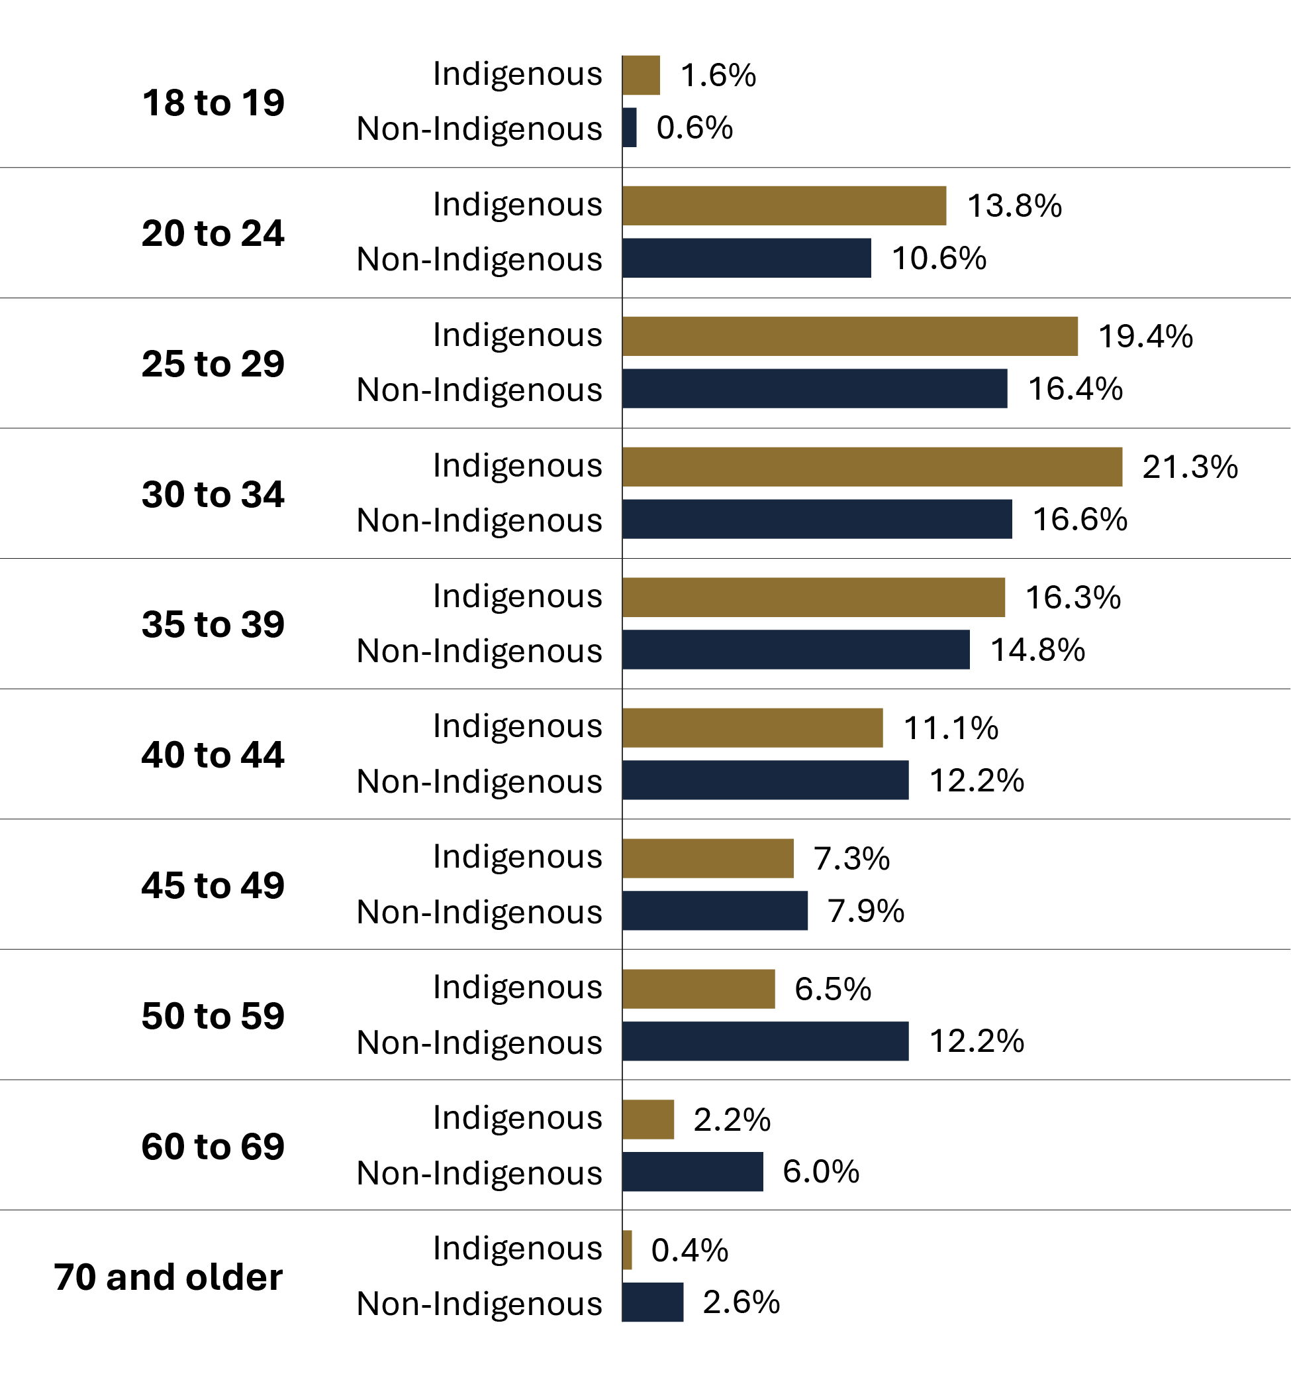
Source: Correctional Service of Canada.
- Of those offenders admitted on a warrant of committal to CSC facilities in 2023-24, 34.8% of Indigenous offenders were under the age of 30, compared to 27.6% of non-Indigenous offenders.
- The number of Indigenous offenders between the ages of 18 and 19 at admission decreased from 40 in 2014-15 to 23 in 2023-24, representing a 42.5% decrease.
- The number of Indigenous offenders aged 70 and over at admission increased from 4 in 2014-15 to 6 in 2023-24, representing a 50.0% increase.
- In fiscal year 2023-24, the median age of Indigenous offenders at admission was 33, compared to a median age of 37 for non-Indigenous offenders.
- In fiscal year 2023-24, the median age of Indigenous female offenders at admission was 32, compared to a median age of 38 for non-Indigenous female offenders.

Table C11. Warrant of committal admissions for Indigenous and non-Indigenous offenders by age

Fiscal year 2014-15
Age at admission | Indigenous | % | Non-Indigenous | % | Total | %
18 to 19 | 40 | 3.4 | 64 | 1.8 | 104 | 2.2
20 to 24 | 255 | 21.8 | 588 | 16.1 | 843 | 17.5
25 to 29 | 257 | 22.0 | 647 | 17.7 | 904 | 18.8
30 to 34 | 199 | 17.0 | 557 | 15.3 | 756 | 15.7
35 to 39 | 114 | 9.8 | 460 | 12.6 | 574 | 11.9
40 to 44 | 114 | 9.8 | 360 | 9.9 | 474 | 9.8
45 to 49 | 88 | 7.5 | 319 | 8.7 | 407 | 8.4
50 to 59 | 79 | 6.8 | 439 | 12.0 | 518 | 10.7
60 to 69 | 19 | 1.6 | 155 | 4.2 | 174 | 3.6
70 and older | 4 | 0.3 | 61 | 1.7 | 65 | 1.3
Total | 1,169 | 100.0 | 3,650 | 100.0 | 4,819 | 100.0

Fiscal year 2023-24
Age at admission | Indigenous | % | Non-Indigenous | % | Total | %
18 to 19 | 23 | 1.6 | 20 | 0.6 | 43 | 0.9
20 to 24 | 199 | 13.8 | 361 | 10.6 | 560 | 11.6
25 to 29 | 279 | 19.4 | 557 | 16.4 | 836 | 17.3
30 to 34 | 306 | 21.3 | 562 | 16.6 | 868 | 18.0
35 to 39 | 234 | 16.3 | 502 | 14.8 | 736 | 15.2
40 to 44 | 160 | 11.1 | 415 | 12.2 | 575 | 11.9
45 to 49 | 105 | 7.3 | 267 | 7.9 | 372 | 7.7
50 to 59 | 94 | 6.5 | 415 | 12.2 | 509 | 10.5
60 to 69 | 32 | 2.2 | 205 | 6.0 | 237 | 4.9
70 and older | 6 | 0.4 | 89 | 2.6 | 95 | 2.0
Total | 1,438 | 100.0 | 3,393 | 100.0 | 4,831 | 100.0
Source: Correctional Service of Canada.
Notes
A warrant of committal is a new admission to federal jurisdiction from the courts.
These numbers refer to the total number of admissions to a federal institution or Healing Lodge during each fiscal year and may be greater than the actual number of offenders admitted, since an individual offender may be admitted more than once in a given year.
There is a lag in the data entry of admissions into CSC’s Offender Management System. The admission figures for the most recent year are under-reported by 200-400 admissions at the time of year end data extraction. More accurate figures will be available in the next year’s publication. Please use caution when including the most recent year in any trend analysis.
Due to rounding, percentages may not add to 100 percent.
Reported year periods reflect fiscal years. A fiscal year runs from April 1 to March 31 of the following year.

Age distribution of the CSC offender population

Figure C12. Percentage of in-custody offender population (2023-24) vs. in community under supervision (2023-24)
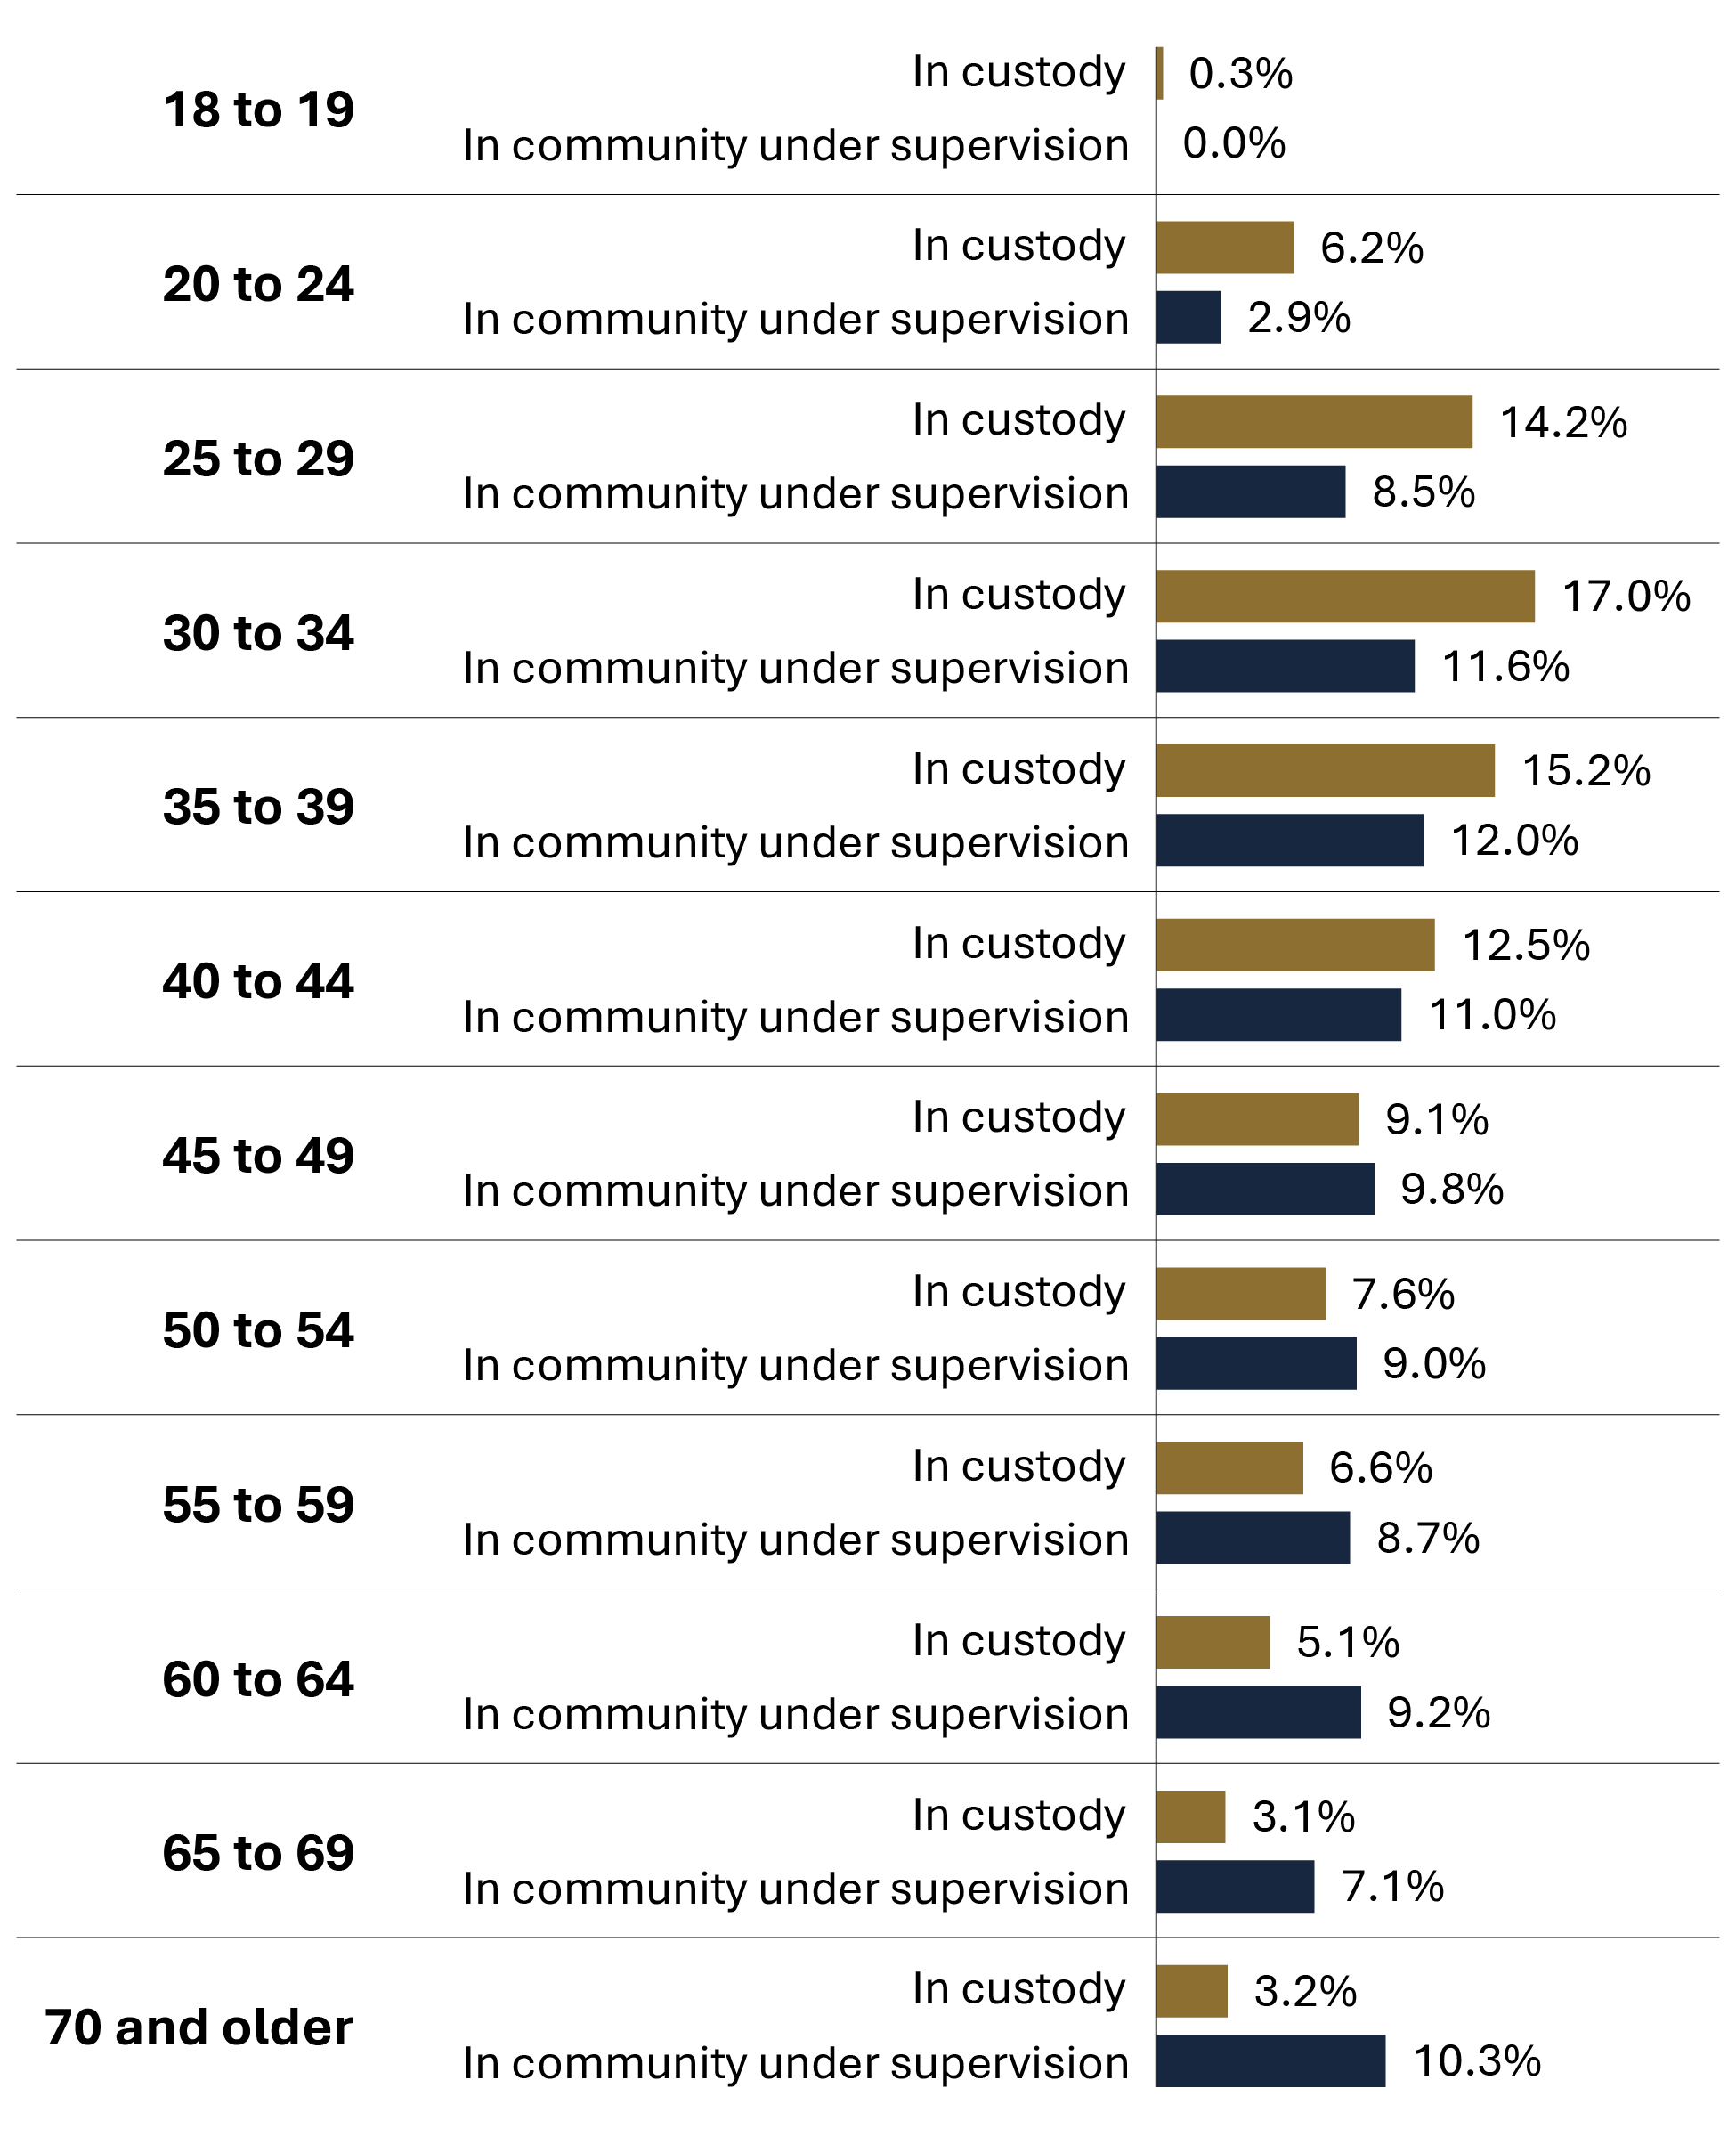

Source: Correctional Service of Canada.
- In 2023-24, 52.9% of in-custody offenders were under the age of 40.
- In 2023-24, 25.5% of in-custody offenders was aged 50 and over.
- In 2023-24, the community offender population was older than the in-custody population; 44.3% of offenders in the community were aged 50 and over, compared to 25.5% of the in-custody offenders in this age group.
- As of 2023-24, 0.04% of the Canadian adult population* are in-custody offenders, and 0.03% of the Canadian adult population* are offenders in the community under supervision. Taken together, the total federal offender population represents 0.07% of the Canadian adult population*.

Notes
*Statistics Canada. Table 17-10-0005-01, Population estimates on July 1, by age and gender.

Table C12. Percentage of in-custody offender population (2023-24) vs. in community under supervision (2023-24) vs. overall distribution of the Canadian adult population (2023)
Age | In custody¹ | %¹ | In community under supervision¹ | %¹ | Total¹ | %¹ | % of Canadian adult population²
18 to 19 | 37 | 0.3 | 0 | 0.0 | 37 | 0.2 | 2.8
20 to 24 | 862 | 6.2 | 246 | 2.9 | 1,108 | 5.0 | 8.0
25 to 29 | 1,961 | 14.2 | 722 | 8.5 | 2,683 | 12.0 | 8.9
30 to 34 | 2,361 | 17.0 | 986 | 11.6 | 3,347 | 15.0 | 9.2
35 to 39 | 2,112 | 15.2 | 1,022 | 12.0 | 3,134 | 14.0 | 8.6
40 to 44 | 1,731 | 12.5 | 936 | 11.0 | 2,667 | 11.9 | 8.2
45 to 49 | 1,256 | 9.1 | 837 | 9.8 | 2,093 | 9.4 | 7.5
50 to 54 | 1,055 | 7.6 | 770 | 9.0 | 1,825 | 8.2 | 7.5
55 to 59 | 908 | 6.6 | 743 | 8.7 | 1,651 | 7.4 | 7.8
60 to 64 | 703 | 5.1 | 780 | 9.2 | 1,483 | 6.6 | 8.2
65 to 69 | 431 | 3.1 | 601 | 7.1 | 1,032 | 4.6 | 7.3
70 and older | 438 | 3.2 | 877 | 10.3 | 1,315 | 5.9 | 15.9
Total | 13,855 | 100.0 | 8,520 | 100.0 | 22,375 | 100.0 | 100.0
Sources: ¹Correctional Service of Canada; ²Statistics Canada. Table 17-10-0005-01, Population estimates on July 1, by age and gender.
Notes
In-custody population includes all active offenders incarcerated in a CSC facility, offenders on temporary absence from a CSC facility, offenders who are temporarily detained in a CSC facility and offenders on remand in a CSC facility.
In community under supervision includes all active offenders on day parole, full parole, statutory release, or in the community supervised on a long-term supervision order, offenders who are temporarily detained in a non-CSC facility, offenders who are unlawfully at large for less than 90 days, offenders on remand in a non-CSC facility, and offenders supervised and subject to an immigration hold by Canada Border Services Agency.
Due to rounding, percentage may not add to 100 percent.
For offender population data, the reported year period (2023-24) reflects a fiscal year. A fiscal year runs from April 1 to March 31 of the following year.

CSC offender population by self-reported race

Figure C13. Percentage of total offender population by self-reported race
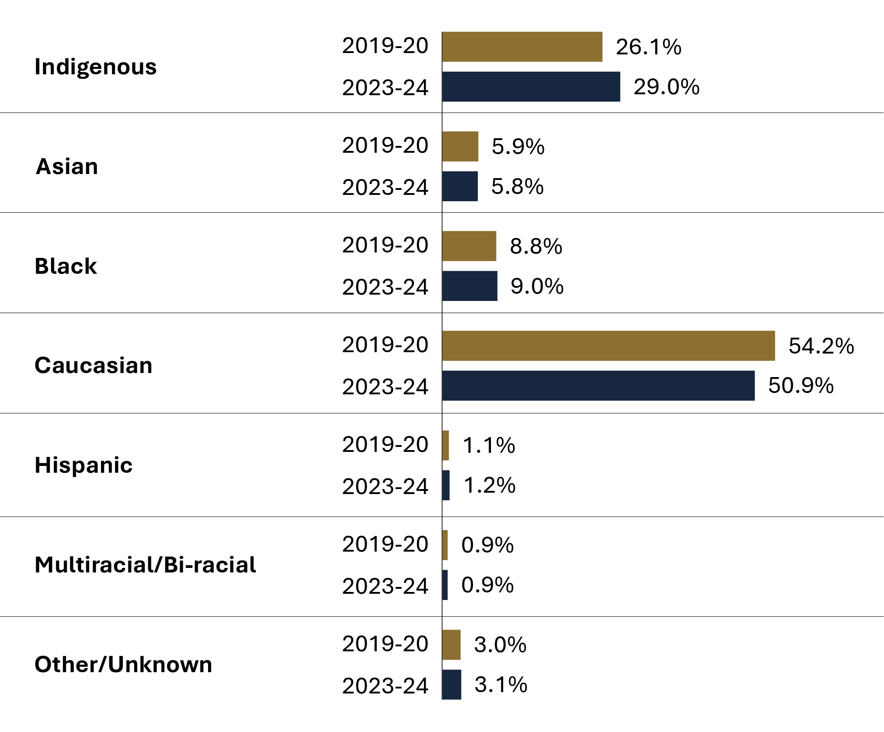
Source: Correctional Service of Canada.
- The CSC offender population is becoming more diverse, as evidenced by the decrease in the proportion of Caucasian offenders (down from 54.2% in 2019-20 to 50.9% in 2023-24). In comparison, close to 70% of the Canadian population identified as White (as reported in the 2021 Census*).
- Between 2019-20 and 2023-24, the Indigenous offender population increased by 7.6% (from 6,027 to 6,487).
- Indigenous offenders represented 29.0% of the 2023-24 total CSC offender population and 29.8% of 2023-24 warrant of committal admissions to CSC facilities, despite representing only 5.0% of the Canadian population (as reported in the 2021 Census**).

Notes
*Statistics Canada. Table 98-10-0324-01, Visible minority and population group by generation status: Canada, provinces and territories, census metropolitan areas and census agglomerations with parts.
**Statistics Canada. Table 98-10-0293-01, Indigenous identity population by gender and age: Canada, provinces and territories, census divisions and census subdivisions.

Table C13. Total offender population by self-reported race*
Self-reported race* | 2019-20 | % | 2023-24 | %
Caucasian total | 12,511 | 54.2 | 11,380 | 50.9
Indigenous total | 6,027 | 26.1 | 6,487 | 29.0
First Nations | 4,109 | 17.8 | 4,542 | 20.3
Inuit | 197 | 0.9 | 183 | 0.8
Métis | 1,721 | 7.4 | 1,762 | 7.9
Black total | 2,026 | 8.8 | 2,022 | 9.0
Black | 1,866 | 8.1 | 1,834 | 8.2
Caribbean | 102 | 0.4 | 127 | 0.6
Sub-Saharan African | 58 | 0.3 | 61 | 0.3
Asian total | 1,371 | 5.9 | 1,305 | 5.8
Arab | 195 | 0.8 | 241 | 1.1
Arab/West Asian | 185 | 0.8 | 142 | 0.6
Asiatic | 431 | 1.9 | 410 | 1.8
Chinese | 105 | 0.5 | 85 | 0.4
East Indian | 14 | 0.1 | 14 | 0.1
Filipino | 83 | 0.4 | 73 | 0.3
Japanese | 8 | 0.0 | 6 | 0.0
Korean | 14 | 0.1 | 16 | 0.1
Southeast Asian | 180 | 0.8 | 157 | 0.7
South Asian | 156 | 0.7 | 161 | 0.7
Hispanic total | 258 | 1.1 | 276 | 1.2
Hispanic | 7 | 0.0 | 5 | 0.0
Latin American | 251 | 1.1 | 271 | 1.2
Multiracial/Bi-Racial total | 209 | 0.9 | 206 | 0.9
Other/Unknown total | 700 | 3.0 | 699 | 3.1
Total | 23,102 | 100.0 | 22,375 | 100.0
Source: Correctional Service of Canada.
Notes
*The offenders self-report race. The list of categories may not fully account for all races and the race grouping information has changed starting in 2022-23; therefore, the comparison of the information before and after 2022-23 should be done with caution.
"Indigenous" includes offenders who identify as Inuit, Innu, Métis and First Nations.
"Asian" includes offenders who identify as Arab, Arab/West Asian, Asian-East and Southeast, Asian-South, Asian West, Asiatic, Chinese, East Indian, Filipino, Japanese, Korean, South Asian and South East Asian.
"Hispanic" includes offenders who identify as Hispanic and Latin American.
“Multiracial/Bi-Racial” includes offenders who identify as Multiracial/Ethnic.
"Black" includes offenders who identify as Black, Caribbean, or Sub-Sahara African.
“Caucasian” includes offenders who identify as British Isles, European French, European-Eastern, European-Northern, European-Southern, European-Western, or White.
"Other/Unknown" includes offenders who identify as Oceania, offenders unable to identify to one race, other, and unknown.
Asiatic includes Asian-East and Southeast, Asian South, Asian West, and Asiatic.
The data reflect all active offenders, who are incarcerated in a CSC facility, offenders on temporary absence from a CSC facility, offenders who are temporarily detained, offenders who are actively supervised, and offenders who are unlawfully at large for less than 90 days.
Due to rounding, percentages may not add to 100 percent.
The data reflect the number of offenders active at the end of each fiscal year. A fiscal year runs from April 1 to March 31 of the following year.

Number of registered victims by self-reported race

Figure C14. Number of registered victims by self-reported race (2023-24)
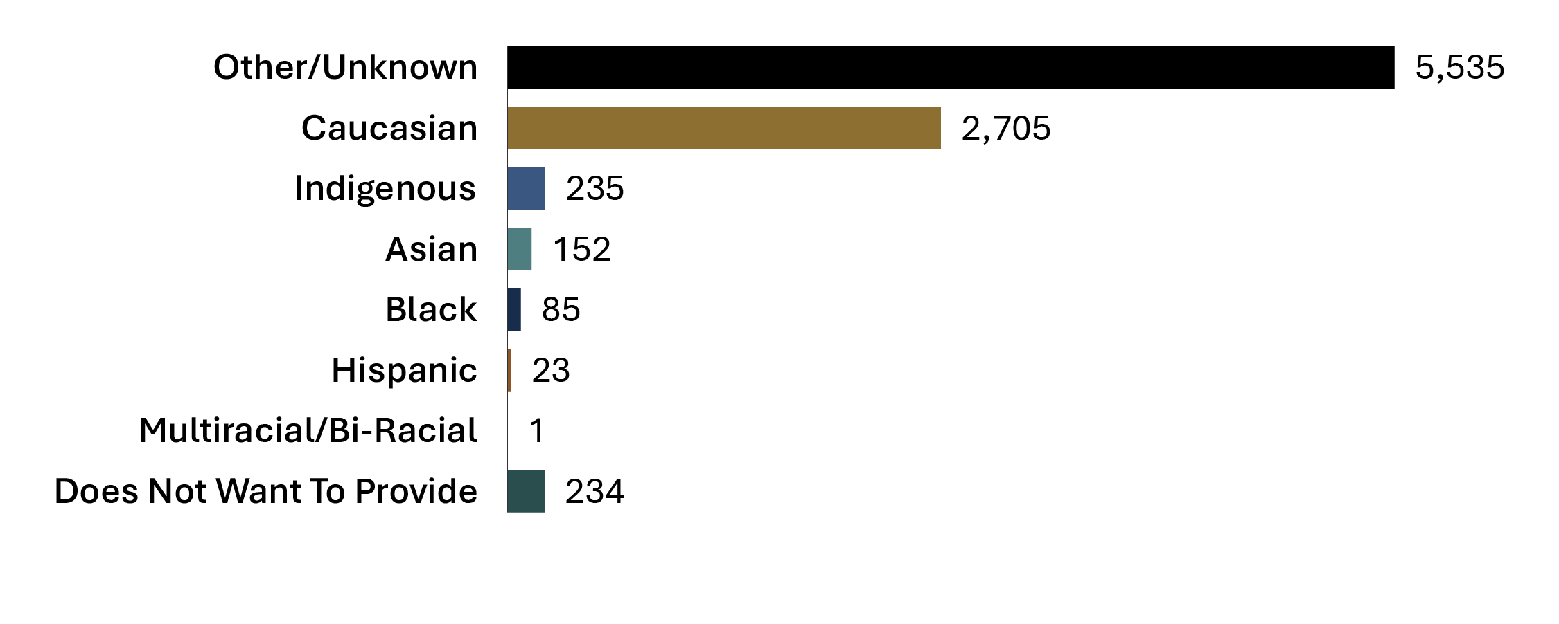
Source: Correctional Service of Canada.
- Most registered victims (61.7%) were of unknown race. More than a quarter of registered victims (30.2%) identified as Caucasian.

Table C14. Number of registered victims by self-reported race
Race | 2019-20 | % | 2020-21 | % | 2021-22 | % | 2022-23 | % | 2023-24 | %
Caucasian total | 2,382 | 26.9 | 2,241 | 25.8 | 2,255 | 26.4 | 2,569 | 29.4 | 2,705 | 30.2
Indigenous total | 181 | 2.0 | 180 | 2.1 | 187 | 2.2 | 238 | 2.7 | 235 | 2.6
First Nations | 122 | 1.4 | 115 | 1.3 | 118 | 1.4 | 153 | 1.7 | 141 | 1.6
Inuit | 25 | 0.3 | 27 | 0.3 | 26 | 0.3 | 23 | 0.3 | 22 | 0.2
Métis | 34 | 0.4 | 38 | 0.4 | 43 | 0.5 | 62 | 0.7 | 72 | 0.8
Black total | 77 | 0.9 | 72 | 0.8 | 67 | 0.8 | 79 | 0.9 | 85 | 0.9
Black | 77 | 0.9 | 72 | 0.8 | 67 | 0.8 | 77 | 0.9 | 83 | 0.9
Caribbean | 0 | 0.0 | 0 | 0.0 | 0 | 0.0 | 1 | 0.0 | 2 | 0.0
Sub-Saharan African | 0 | 0.0 | 0 | 0.0 | 0 | 0.0 | 1 | 0.0 | 0 | 0.0
Asian total | 107 | 1.2 | 110 | 1.3 | 119 | 1.4 | 136 | 1.6% | 152 | 1.7
Arab | 0 | 0.0 | 0 | 0.0 | 0 | 0.0 | 2 | 0.0 | 2 | 0.0
Asiatic | 66 | 0.7 | 67 | 0.8 | 74 | 0.9 | 83 | 0.9 | 96 | 1.1
Chinese | 34 | 0.4 | 35 | 0.4 | 36 | 0.4 | 36 | 0.4 | 36 | 0.4
Filipino | 5 | 0.1 | 4 | 0.0 | 4 | 0.0 | 8 | 0.1 | 10 | 0.1
Japanese | 1 | 0.0 | 3 | 0.0 | 4 | 0.0 | 4 | 0.0 | 4 | 0.0
Korean | 1 | 0.0 | 1 | 0.0 | 1 | 0.0 | 3 | 0.0 | 4 | 0.0
Hispanic total | 14 | 0.2 | 14 | 0.2 | 12 | 0.1 | 18 | 0.2 | 23 | 0.3
Does not want to provide | 45 | 0.5 | 51 | 0.6 | 102 | 1.2 | 176 | 2.0 | 234 | 2.6
Other/  Unknown total | 6,051 | 68.3 | 6,027 | 69.3 | 5,795 | 67.9 | 5,531 | 63.2 | 5,535 | 61.7
Total | 8,857 | 100.0 | 8,695 | 100.0 | 8,537 | 100.0 | 8,747 | 100.0 | 8,970 | 100.0
Source: Correctional Service of Canada.
Notes
The Canadian Victims Bill of Rights defines a victim as an individual who has suffered physical or emotional harm, property damage, or economic loss as the result of the commission or alleged commission of an offence. The CCRA also allows a spouse, a relative or dependant, an individual who is responsible for the care or support of the victim or the care or support of a dependant of the victim, to act on behalf of a victim, if the victim cannot act on their own behalf. Victims include persons harmed as the result of an act of an offender, whether or not the offender was prosecuted or convicted for that act, as long as an official complaint has been made to the police or to the Crown.
Victims do not automatically receive information about the offender who harmed them. If they have been harmed by an offender serving a sentence of two years or more, victims are asked to register with the Correctional Service of Canada (CSC) or the Parole Board of Canada to receive information or access services. The registration process allows CSC to verify that the individual meets the definition of victim, which is required under law before sharing protected offender information.
For more information about victim registration, visit: https://www.canada.ca/en/correctional-service/services/you-csc/victims/register.html
Demographic information is voluntarily self-reported by victims who have registered with CSC to receive information about the offender who harmed them. The information does not represent victims who have not been in contact with CSC or those who choose not to register.
Victim registration fluctuates for a number of reasons beyond organizational control. Contributing factors impacting victim registration data could be due to offenders reaching the end of their sentence or death, victims opting out of notifications for reasons such as personal preferences, death or loss of contact.
The difference between the total number of registered victims and the number of victims who voluntarily self-reported their race is the result of victims choosing not to report their race or their race is unknown to CSC (due to a lack of response by victim).
The response rate for victim race has remained stable for the past 3 fiscal years.
The total number of victims for whom CSC has reported race data for 2023-24 is 3,526 whereby it is 5,444 for unknown, which means CSC has self-reported race data for approximately 39% of registered victims. Therefore, these statistics do not accurately provide self-reported race disaggregation for the entirety of registered victims.
Reported year periods reflect fiscal years. A fiscal year runs from April 1 to March 31 of the following year.

CSC offender population by religion

Figure C15. Percentage of total offender population by religious identification (2023-24)
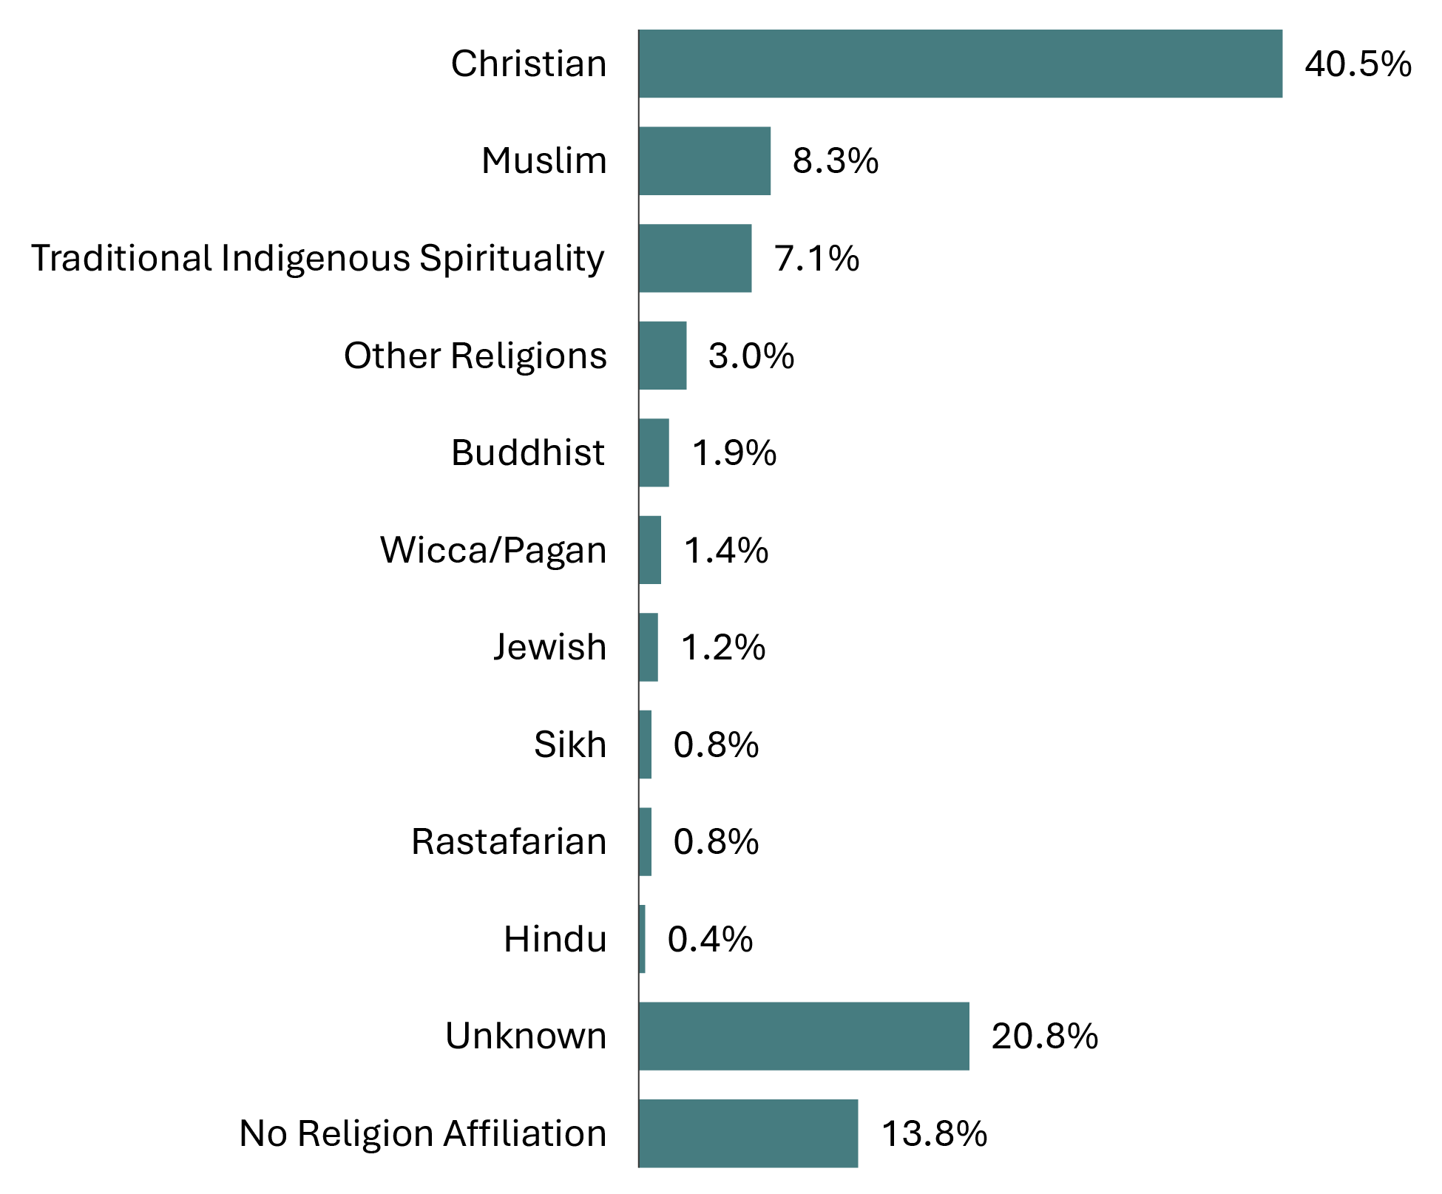
Source: Correctional Service of Canada.
- The religious identification of the CSC offender population is diverse. While those identifying as Christian continue to represent the largest group, their proportions decreased from 45.0% in 2019-20 to 40.5% in 2023-24.
- Religious identification was unknown for 20.8% of offenders, whereas 13.8% stated they had no religion affiliation.

Table C15. Total offender population by religious identification
Religious identification | 2019-20 | % | 2023-24 | %
Buddhist | 478 | 2.1 | 419 | 1.9
Christian | 10,406 | 45.0 | 9,063 | 40.5
Hindu | 74 | 0.3 | 81 | 0.4
Jewish | 257 | 1.1 | 277 | 1.2
Muslim | 1,736 | 7.5 | 1,863 | 8.3
Rastafarian | 175 | 0.8 | 177 | 0.8
Sikh | 196 | 0.8 | 182 | 0.8
Traditional Aboriginal spirituality | 1,646 | 7.1 | 1,586 | 7.1
Wicca/Pagan | 350 | 1.5 | 317 | 1.4
Other religions | 555 | 2.4 | 664 | 3.0
No religion affiliation | 3,540 | 15.3 | 3,083 | 13.8
Unknown | 3,689 | 16.0 | 4,663 | 20.8
Total | 23,102 | 100.0 | 22,375 | 100.0
Source: Correctional Service of Canada.
Notes
Religious identification is self-reported by offenders while they are incarcerated, and the categories are not comprehensive; therefore, the reader should interpret these data with caution.
Buddhist includes offenders who belong to the following group: Buddhist, Mahayana Buddhist, Theravadan Buddhist and Vajrayana Buddhist.
Christian includes offenders who belong to the following group: Amish, Anglican (Episcopal Church of England), Antiochian Orthodox, Apostolic Christian Church, Armenian Orthodox/Apostolic, Associated Gospel, Assyrian Chaldean Catholic, Baptist, Brethren In Christ, Bulgarian Orthodox, Canadian Reformed Church, Catholic- Greek, Catholic-Roman, Catholic-Ukrainian, Catholic Non-Specific, Churches of Christ/Christian Churches, Charismatic, Christadelphian, Christian & Missionary Alliance, Christian Congregational, Christian Non Specific, Christian Or Plymouth Brethren, Christian Orthodox, Christian Reformed, Christian Reformed Church, Christian Science, Church of Christ Scientist, Church of God, Church of Jesus Christ of Latter-Day Saint, Community of Christ, Coptic Orthodox, Doukhobor, Dutch Reformed Church, Ethiopian Orthodox, Evangelical, Evangelical Free Church , Evangelical Missionary Church, Free Methodist, Free Reformed Church, Grace Communion International, Greek Orthodox, Hutterite, Iglesia Ni Cristo, Jehovah's Witnesses, Lutheran, Macedonian Orthodox, Maronite, Melkite, Mennonite, Messianic Jew, Methodist Christian, Metropolitan Community Church, Mission de l'Esprit Saint, Moravian, Mormon (Latter Day Saints), Nazarene Christian, Netherlands Reformed, New Apostolic, Pentecostal (4-Square), Pentecostal Assembly of God, Pentecôtiste, Philadelphia Church of God, Presbyterian, Protestant Non-Specific, Quaker (Society of Friends), Reformed Christian, Romanian Orthodox, Russian Orthodox, Salvation Army, Serbian Orthodox, Seventh Day Adventist, Shaker, Swedenborgian (New Church), Syrian/Syriac Orthodox, Ukrainian Catholic, Ukrainian Orthodox, United Church, United Reformed Church, Vineyard Christian Fellowship, Wesleyan Christian and Worldwide Church of God.
Hindu includes offenders who belong to the following group: Hindu and Siddha Yoga.
Jewish includes offenders who belong to the following group: Jewish Orthodox, Jewish Reformed and Judaism.
Muslim includes offenders who belong to the following group: Muslim and Sufism.
Rastafarian includes offenders who belong to the following group: Rastafarian.
Sikh includes offenders who belong to the following group: Sikh.
Traditional Indigenous Spirituality includes offenders who belong to the following group: Indigenous Spirituality Catholic, Traditional Indigenous Protestant, Traditional Indigenous Catholic, Native Spirituality, Catholic - Native Spirituality, Native Spirituality Protestant and Indigenous Spirituality.
Wiccan/Pagan includes offenders who belong to the following group: Asatru Paganism, Druidry Paganism, Pagan and Wicca.
Other Religion includes offenders who belong to the following group: Baha'i, Eckankar, Independent Spirituality, Jain, Krishna, New Age, New Thought-Unity-Religious Science, Other, Pantheist, Rosicrucian, Satanist, Scientology, Shintoïste, Spiritualist, Taoism, Transcendental Meditation, Unification Church, Unitarian, Visnabha and Zoroastrian.
No religion Affiliation includes offenders who belong to the following group: Agnostic, Atheist, Gnostic, Humanist and offenders who have no religion affiliation.
Unknown includes offenders who belong to the following group: Unknown, not stated as well as those offenders who have no religion specified.
The data reflect all active offenders, who are incarcerated in a CSC facility, offenders on temporary absence from a CSC facility, offenders who are temporarily detained, offenders who are actively supervised, and offenders who are unlawfully at large for less than 90 days.
The data reflect the number of offenders active at the end of each fiscal year.
A fiscal year runs from April 1 to March 31 of the following year.
Due to rounding, percentages may not add to 100 percent.

CSC offenders by Indigenous and non-Indigenous self-identification

Figure C16. Percentage of Indigenous and non-Indigenous offenders in custody
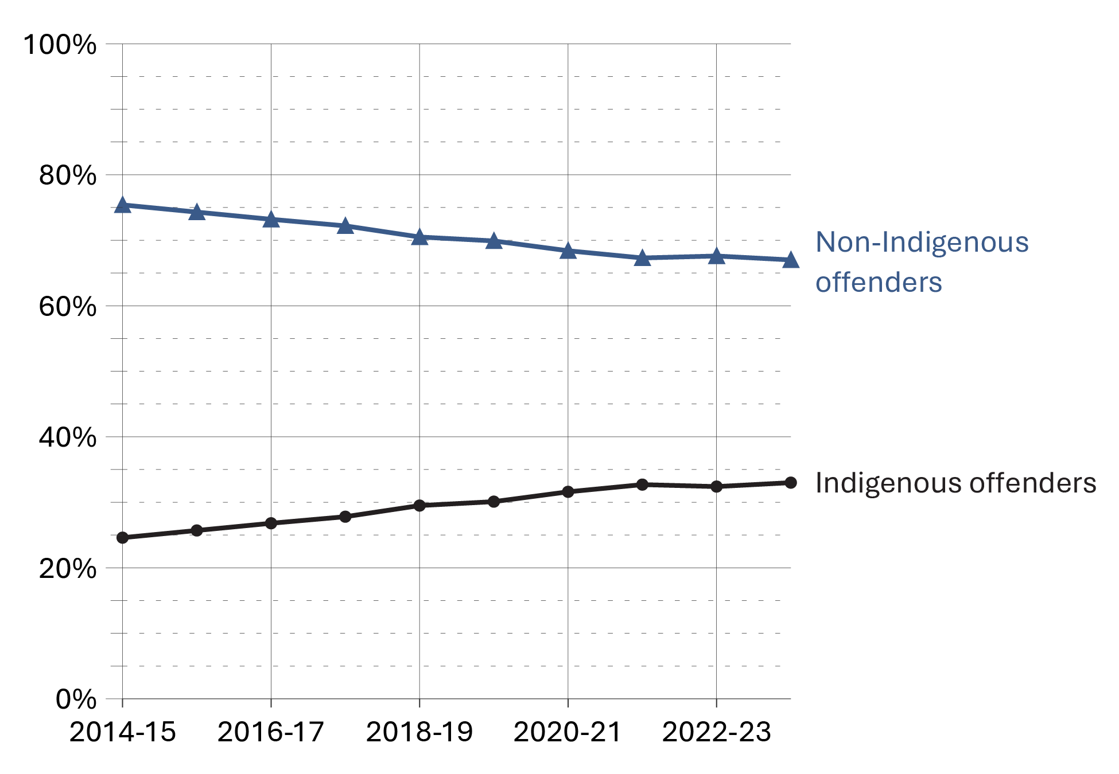
Source: Correctional Service of Canada.
- At the end of fiscal year 2023-24, the proportion of offenders in custody was 12.2% greater for Indigenous offenders (70.6%) than for non-Indigenous offenders (58.4%).
- At the end of fiscal year 2023-24, Indigenous females in custody represented 49.3% of all in-custody females while Indigenous males who were in custody represented 32.1% of all males in custody.
- At the end of fiscal year 2023-24, Indigenous offenders represented 29.0% of the total offender population.
- Indigenous offenders accounted for 33.0% of the in-custody population and 22.4% of the community population in 2023-24, despite representing only 5.0% of the Canadian population (as reported in the 2021 Census*).
Notes
*Statistics Canada. Table 98-10-0293-01. Indigenous identity population by gender and age: Canada, provinces and territories, census divisions and census subdivisions.

Table C16. Indigenous and non-Indigenous offenders in custody vs. in the community under supervision

Fiscal year 2019-20
 | In-custody | % | In community under supervision | % | Total
Female total | 685 | 48.4 | 731 | 51.6 | 1,416
Indigenous | 279 | 57.3 | 208 | 42.7 | 487
Non-Indigenous | 406 | 43.7 | 523 | 56.3 | 929
Male total | 13,032 | 60.1 | 8,650 | 39.9 | 21,682
Indigenous | 3,855 | 69.6 | 1,684 | 30.4 | 5,539
Non-Indigenous | 9,177 | 56.8 | 6,966 | 43.2 | 16,143
Intersex total | 3 | 75.0 | 1 | 25.0 | 4
Indigenous | 1 | 100.0 | 0 | 0.0 | 1
Non-Indigenous | 2 | 66.7 | 1 | 33.3 | 3

Fiscal year 2020-21
 | In-custody | % | In community under supervision | % | Total
Female total | 618 | 46.3 | 717 | 53.7 | 1,335
Indigenous | 267 | 55.2 | 217 | 44.8 | 484
Non-Indigenous | 351 | 41.2 | 500 | 58.8 | 851
Male total | 11,778 | 58.4 | 8,396 | 41.6 | 20,174
Indigenous | 3,646 | 68.5 | 1,678 | 31.5 | 5,324
Non-Indigenous | 8,132 | 54.8 | 6,718 | 45.2 | 14,850
Intersex total | 3 | 100.0 | 0 | 0.0 | 3
Indigenous | 1 | 100.0 | 0 | 0.0 | 1
Non-Indigenous | 2 | 100.0 | 0 | 0.0 | 2

Fiscal year 2021-22
 | In-custody | % | In community under supervision | % | Total
Female total | 588 | 47.8 | 643 | 52.2 | 1,231
Indigenous | 291 | 59.4 | 199 | 40.6 | 490
Non-Indigenous | 297 | 40.1 | 444 | 59.9 | 741
Male total | 11,740 | 60.0 | 7,836 | 40.0 | 19,576
Indigenous | 3,737 | 69.9 | 1,613 | 30.1 | 5,350
Non-Indigenous | 8,003 | 56.3 | 6,223 | 43.7 | 14,226
Intersex total | 0 | 0.0 | 0 | 0.0 | 0
Indigenous | 0 | 0.0 | 0 | 0.0 | 0
Non-Indigenous | 0 | 0.0 | 0 | 0.0 | 0

Fiscal year 2022-23
 | In-custody | % | In community under supervision | % | Total
Female total | 645 | 49.5 | 659 | 50.5 | 1,304
Indigenous | 309 | 55.8 | 245 | 44.2 | 554
Non-Indigenous | 336 | 44.8 | 414 | 55.2 | 750
Male total | 12,407 | 61.8 | 7,671 | 38.2 | 20,078
Indigenous | 3,914 | 70.3 | 1,652 | 29.7 | 5,566
Non-Indigenous | 8,493 | 58.5 | 6,019 | 41.5 | 14,512
Intersex total | 2 | 100.0 | 0 | 0.0 | 2
Indigenous | 0 | 0.0 | 0 | 0.0 | 0
Non-Indigenous | 2 | 100.0 | 0 | 0.0 | 2

Fiscal year 2023-24
 | In-custody | % | In community under supervision | % | Total
Female total | 736 | 51.7 | 687 | 48.3 | 1,423
Indigenous | 363 | 59.9 | 243 | 40.1 | 606
Non-Indigenous | 373 | 45.7 | 444 | 54.3 | 817
Male total | 13,119 | 62.6 | 7,833 | 37.4 | 20,952
Indigenous | 4,216 | 71.7 | 1,665 | 28.3 | 5,881
Non-Indigenous | 8,903 | 59.1 | 6,168 | 40.9 | 15,071
Intersex total | 0 | 0.0 | 0 | 0.0 | 0
Indigenous | 0 | 0.0 | 0 | 0.0 | 0
Non-Indigenous | 0 | 0.0 | 0 | 0.0 | 0
Source: Correctional Service of Canada.
Notes
Total Offender Population includes all active offenders who are incarcerated in a CSC facility, offenders on temporary absence from a CSC facility, offenders who are temporarily detained, offenders who are actively supervised, and offenders who are unlawfully at large for less than 90 days.
In Custody includes all active offenders incarcerated in a CSC facility, offenders on temporary absence from a CSC facility, offenders who are temporarily detained in a CSC facility, and offenders on remand in a CSC facility.
In Community Under Supervision includes all active offenders on day parole, full parole, statutory release, in the community supervised on a long-term supervision order, offenders who are temporarily detained in a non-CSC facility, offenders who are unlawfully at large for less than 90 days, offenders on remand in a non-CSC facility, and offenders supervised and subject to an immigration hold by Canada Border Services Agency.
Indigenous identity is self-reported. Non-indigenous offenders includes offenders who do not identify as Indigenous. See Table C9 for the ethnic diversity of CSC’s offender population.
The data reflect the number of offenders active at the end of each fiscal year. A fiscal year runs from April 1 to March 31 of the following year.

Offenders in custody at a CSC facility by security risk classification

Figure C17a. Percentage of classified in-custody offenders by Indigenous self-identification (2023-24)
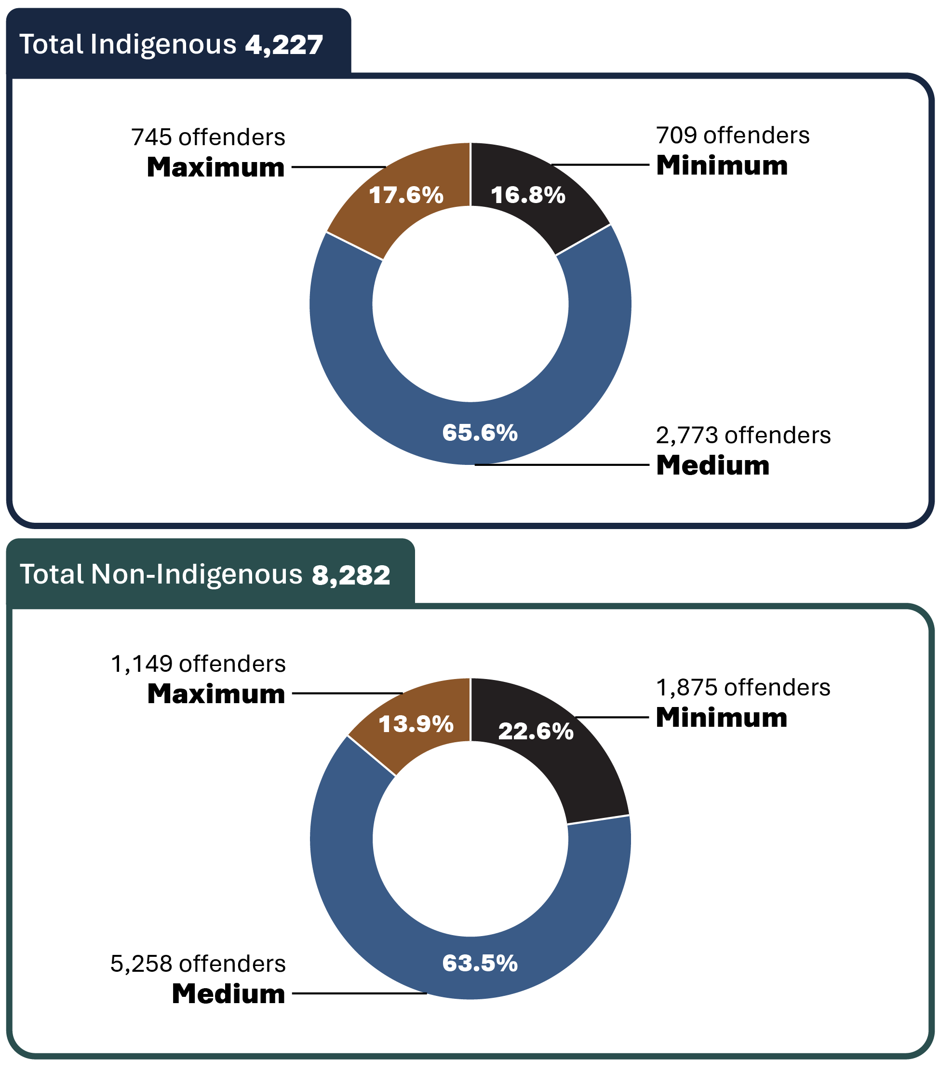
Source: Correctional Service of Canada.

Figure C17b. Total percentage of classified in-custody offenders (2023-24)
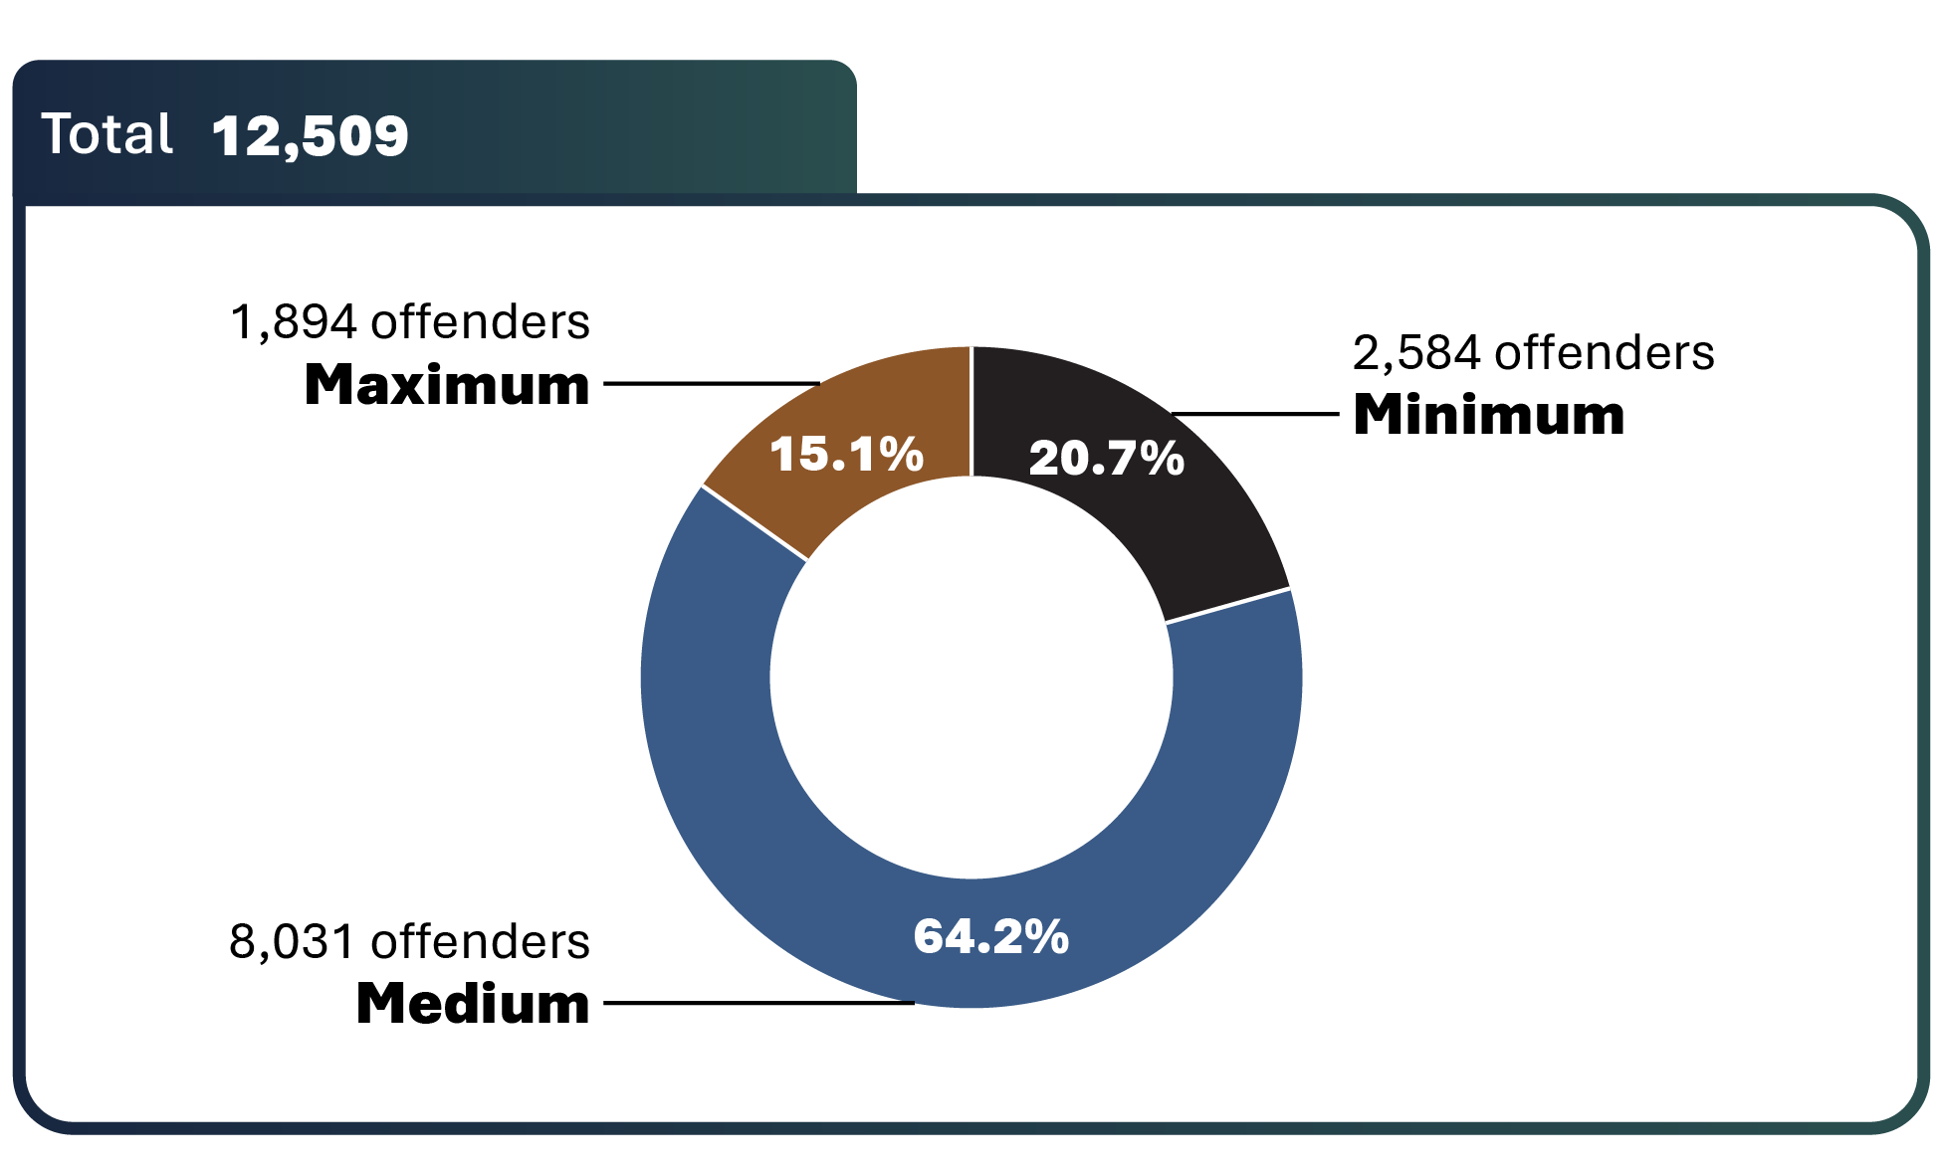
Source: Correctional Service of Canada.
- In 2023-24, approximately two-thirds (64.2%) of offenders were classified as medium security risk. Indigenous offenders were more likely to be classified to a medium or maximum security risk compared to non-Indigenous offenders.
- Compared to non-Indigenous offenders, a lower percentage of Indigenous offenders were classified as minimum security risk (16.8% vs. 22.6%) and a higher percentage were classified as medium (65.6% vs. 63.5%) and maximum (17.6% vs. 13.9%) security risk.

Table C17. Total of classified in-custody offenders (2023-24)
Security risk level | Indigenous | % | Non-Indigenous | % | Total | %
Total security level | 4,227 | 100.0 | 8,282 | 100.0 | 12,509 | 100.0
Minimum | 709 | 16.8 | 1,875 | 22.6 | 2,584 | 20.7
Medium | 2,773 | 65.6 | 5,258 | 63.5 | 8,031 | 64.2
Maximum | 745 | 17.6 | 1,149 | 13.9 | 1,894 | 15.1
Not yet determined | 352 | 100.0 | 994 | 100.0 | 1,346 | 100.0
Total | 4,579 | 100.0 | 9,276 | 100.0 | 13,855 | 100.0
Source: Correctional Service of Canada.
Notes
The "Not yet determined" category includes offenders who have not yet been classified.
In-Custody includes all active offenders incarcerated in a CSC facility, offenders on temporary absence from a CSC facility, offenders who are temporarily detained in a CSC facility and offenders on remand in a CSC facility.
The data represent the offender security level decision at the end of fiscal year 2023-24. A fiscal year runs from April 1 to March 31 of the following year.

Admissions to federal jurisdiction with a life and/or indeterminate sentence* by sex and Indigenous self-identification: 10-year trend

Figure C18a. Number of warrant of committal admissions for life and/or indeterminate sentences* among female offenders
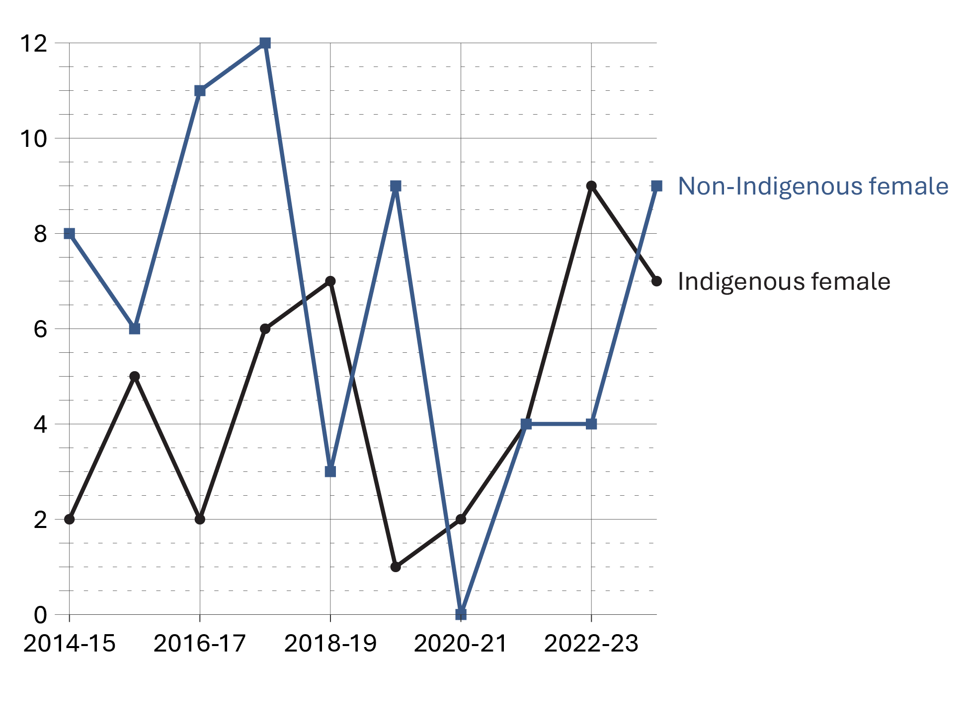
Source: Correctional Service of Canada.

Figure C18b. Number of warrant of committal admissions for life and/or indeterminate sentences* among male offenders
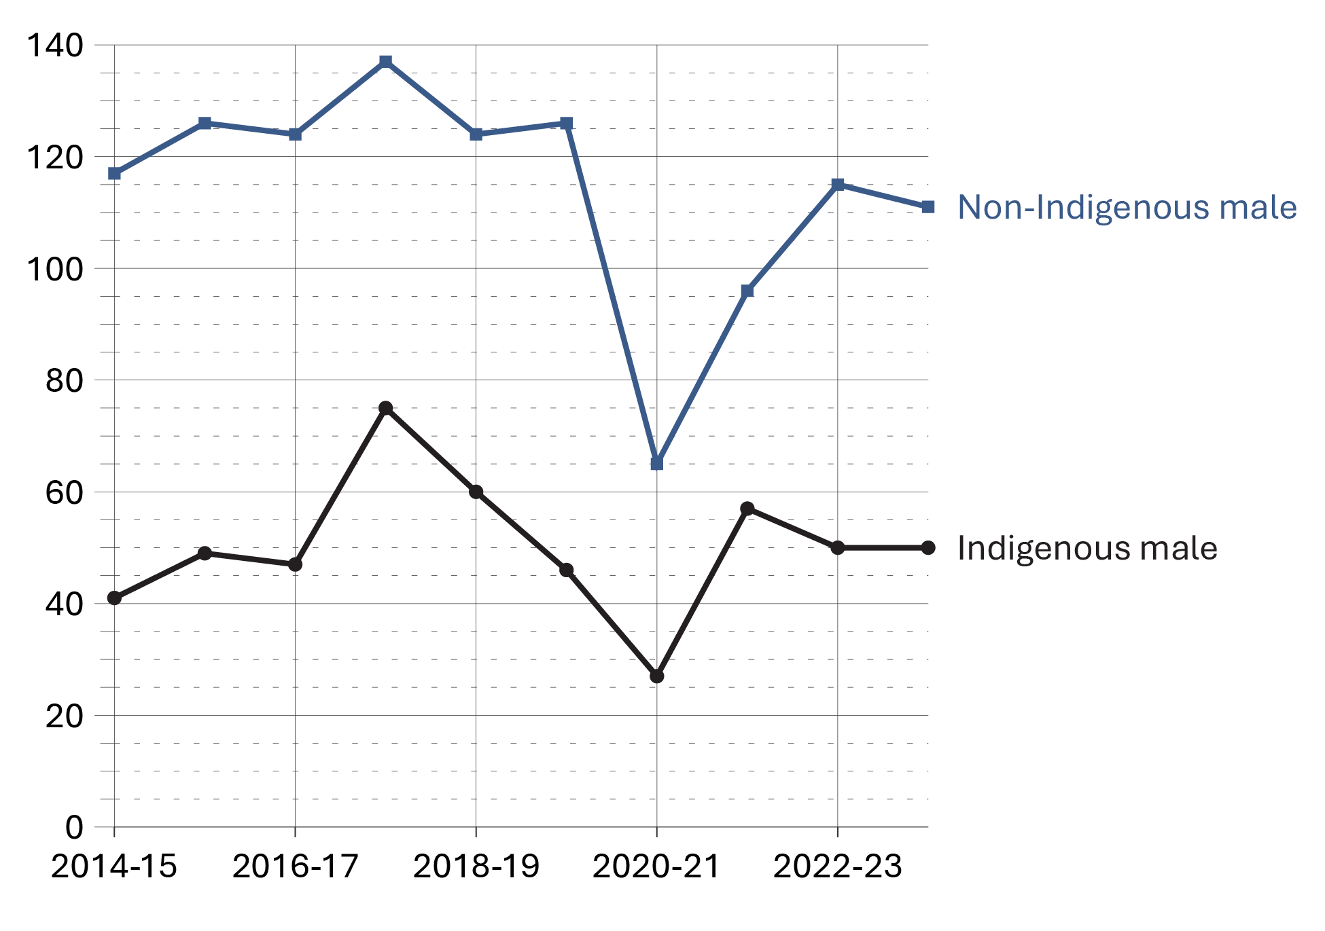
Source: Correctional Service of Canada.

Figure C18c. Total number of warrant of committal admissions for life and/or indeterminate sentences*
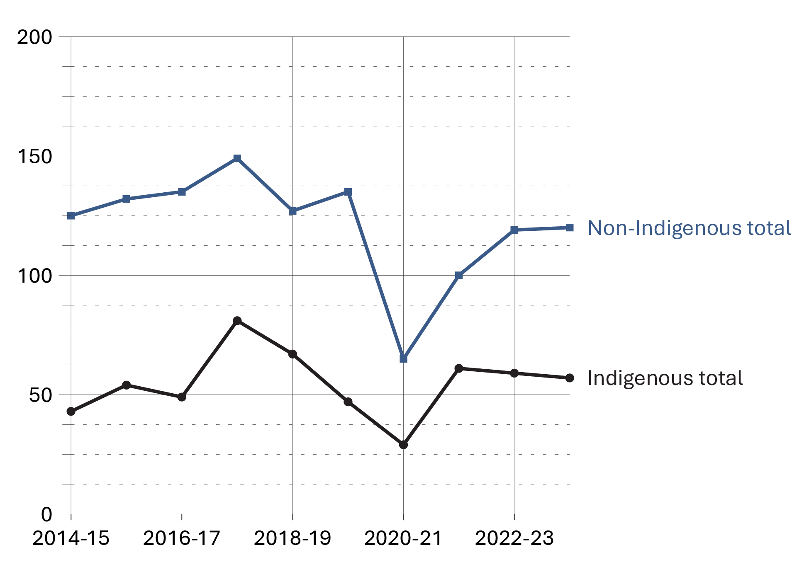
Source: Correctional Service of Canada.
- From 2014-15 to 2023-24, there was an increase of 5.4% in the number of warrant of committal admissions to CSC facilities with a life and/or indeterminate* sentence from 168 to 177.
- At the end of fiscal year 2023-24, there were a total of 3,610 offenders in custody with a life and/or indeterminate sentence. Of these, 3,468 (96.1%) were male, 142 (3.9%) were female; 1,103 (30.6%) were Indigenous and 2,507 (69.4%) were non-Indigenous.
- At the end of fiscal year 2023-24, 26.4% of the total population was serving a life and/or indeterminate sentence. Of these offenders, 61.1% were in custody and 38.9% were in the community under supervision.
Notes
*Although life sentences and indeterminate sentences both may result in imprisonment for life, they are different. A life sentence is a sentence of life imprisonment, imposed by a judge at the time of sentencing, for example murder. An indeterminate sentence is a result of a designation, where an application is made to the court to declare an offender a Dangerous Offender, and the consequence of this designation is imprisonment for an indeterminate period.

Table C18a. Number of warrant of committal admissions for life and/or indeterminate sentences* by Indigenous offenders
Fiscal year | Indigenous females | Indigenous males | Indigenous total
2014-15 | 2 | 41 | 43
2015-16 | 5 | 49 | 54
2016-17 | 2 | 47 | 49
2017-18 | 6 | 75 | 81
2018-19 | 7 | 60 | 67
2019-20 | 1 | 46 | 47
2020-21 | 2 | 27 | 29
2021-22 | 4 | 57 | 61
2022-23 | 9 | 50 | 59
2023-24 | 7 | 50 | 57
Source: Correctional Service of Canada.

Table C18b. Number of warrant of committal admissions for life and/or indeterminate sentences* by non-Indigenous offenders
Fiscal year | Non-Indigenous females | Non-Indigenous males | Non-Indigenous total
2014-15 | 8 | 117 | 125
2015-16 | 6 | 126 | 132
2016-17 | 11 | 124 | 135
2017-18 | 12 | 137 | 149
2018-19 | 3 | 124 | 127
2019-20 | 9 | 126 | 135
2020-21 | 0 | 65 | 65
2021-22 | 4 | 96 | 100
2022-23 | 4 | 115 | 119
2023-24 | 9 | 111 | 120
Source: Correctional Service of Canada.

Table C18c. Total number of warrant of committal admissions for life and/or indeterminate sentences* by sex
Fiscal year | Females | Males | Total
2014-15 | 10 | 158 | 168
2015-16 | 11 | 175 | 186
2016-17 | 13 | 171 | 184
2017-18 | 18 | 212 | 230
2018-19 | 10 | 184 | 194
2019-20 | 10 | 172 | 182
2020-21 | 2 | 92 | 94
2021-22 | 8 | 153 | 161
2022-23 | 13 | 165 | 178
2023-24 | 16 | 161 | 177
Source: Correctional Service of Canada.
Notes
*Although life sentences and indeterminate sentences both may result in imprisonment for life, they are different. A life sentence is a sentence of life imprisonment, imposed by a judge at the time of sentencing, for example murder. An indeterminate sentence is a result of a designation, where an application is made to the court to declare an offender a Dangerous Offender, and the consequence of this designation is imprisonment for an indeterminate period.
A warrant of committal is a new admission to federal jurisdiction from the courts.
These numbers refer to the total number of admissions to a federal institution or Healing Lodge during each fiscal year and may be greater than the actual number of offenders admitted, since an individual offender may be admitted more than once in a given year.
There is a lag in the data entry of admissions into CSC’s Offender Management System. The admission figures for the most recent year are under-reported by 200-400 admissions at the time of year end data extraction. More accurate figures will be available in the next year’s publication. Please use caution when including the most recent year in any trend analysis.
Total Offender Population includes all active offenders, who are incarcerated in a CSC facility, offenders on temporary absence from a CSC facility, offenders who are temporarily detained, offenders who are actively supervised, and offenders who are unlawfully at large for less than 90 days.
In-Custody includes all active offenders incarcerated in a CSC facility, offenders on temporary absence from a CSC facility, offenders who are temporarily detained in a CSC facility, and offenders on remand in a CSC facility.
In Community Under Supervision includes all active offenders on day parole, full parole, statutory release, in the community supervised on a long-term supervision order, offenders who are temporarily detained in a non-CSC facility, offenders who are unlawfully at large for less than 90 days, offenders on remand in a non-CSC facility, and offenders supervised and subject to an immigration hold by Canada Border Services Agency.
This table combines offenders serving life sentences and offenders serving indeterminate sentences.
Reported year periods reflect fiscal years. A fiscal year runs from April 1 to March 31 of the following year.

Proportion of offenders with life and/or indeterminate sentences

Figure C19. Sentence imposed for the total offender population (2023-24)
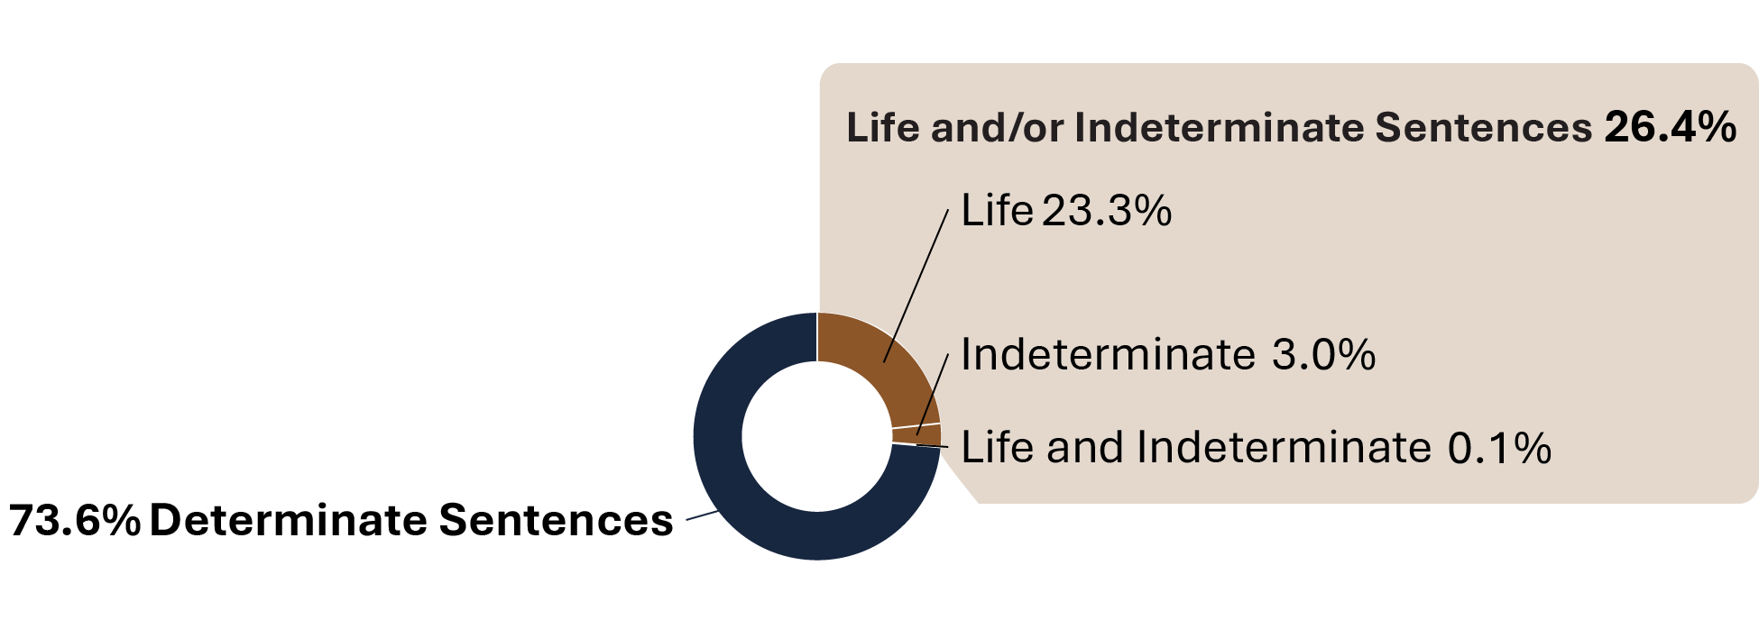
Source: Correctional Service of Canada.
- At the end of fiscal year 2023-24, there were 5,904 offenders serving a life sentence and/or an indeterminate sentence. This represents 26.4% of the total offender population. The majority (61.1%) of these offenders were in custody. Of the 2,294 offenders serving a life and/or an indeterminate sentence who were in the community under supervision, the majority (78.8%) were serving a life sentence for 2nd degree murder.
- There were 20 offenders who were serving both a life sentence and an indeterminate sentence*.
- There were 666 offenders who were serving an indeterminate sentence as a result of a special designation. The remaining 5,218 offenders did not receive a special designation, but were serving a life sentence.
- 93.0% of the 660 Dangerous Offenders with indeterminate sentences were in custody and 7.0% were in the community under supervision.
- In contrast, 33.3% of the 6 Dangerous Sexual Offenders were in custody.
- One offender with an Habitual Offender designation was included in the Designation and Life grouping and this offender was in the community under supervision (see Table C19a).
Notes
*Although life sentences and indeterminate sentences both may result in imprisonment for life, they are different. A life sentence is a sentence of life imprisonment, imposed by a judge at the time of sentencing, for example murder. An indeterminate sentence is a result of a designation, where an application is made to the court to declare an offender a Dangerous Offender, and the consequence of this designation is imprisonment for an indeterminate period. The Dangerous Sexual Offender and Habitual Offender designations were replaced with Dangerous Offender legislation in 1977.

Table C19a. Total offender population by location (2023-24)
Offender population | In custody in a CSC facility:  Incarcerated | In community under supervision:  Day parole | In community under supervision:  Full parole | In community under supervision:  Other****
Total offenders with a life and/or indeterminate sentence | 3,610 | 367 | 1,927 | 0
Total offenders with a life sentence | 2,977 | 350 | 1,891 | 0
1st degree murder | 979 | 79 | 276 | 0
2nd degree murder | 1,886 | 262 | 1,546 | 0
Other offences* | 112 | 9 | 69 | 0
Total offenders with indeterminate sentences resulting from the special designation of: | 616 | 17 | 33 | 0
Dangerous Offender | 614 | 16***** | 30***** | 0
Dangerous Sexual Offender | 2 | 1***** | 3***** | 0
Habitual Offender | 0 | 0 | 0 | 0
Offenders serving an indeterminate sentence (due to a special designation) and a life sentence (due to an offence)** | 17 | 0 | 3***** | 0
Offenders serving determinate sentences*** | 10,245 | 1,229 | 2,208 | 2,789
Total | 13,855 | 1,596 | 4,135 | 2,789
Source: Correctional Service of Canada.

Table C19b. Total offender population (2023-24)
Offender population | Total population | %
Total offenders with a life and/or indeterminate sentence | 5,904 | 26.4
Total offenders with a life sentence | 5,218 | 23.3
1st degree murder | 1,334 | 6.0
2nd degree murder | 3,694 | 16.5
Other offences* | 190 | 0.8
Total offenders with indeterminate sentences resulting from the special designation of: | 666 | 3.0
Dangerous Offender | 660 | 2.9
Dangerous Sexual Offender | 6 | 0.0
Habitual Offender | 0 | 0.0
Offenders serving an indeterminate sentence (due to a special designation) and a life sentence (due to an offence)** | 20 | 0.1
Offenders serving determinate sentences*** | 16,471 | 73.6
Total | 22,375 | 100.0
Source: Correctional Service of Canada.
Notes
* Other offences include Schedule 1, Schedule 2 and Non-Schedule types of offences.
** In this table there is one offender with an Habitual Offender designation included in the Designation and Life grouping, this offender was in the community under supervision.
*** This includes 230 offenders designated as Dangerous Offenders who were serving determinate sentences.
**** Other in the community under supervision population includes federal offenders on statutory release and on a long-term supervision order.
***** As with all parole reviews, when determining whether to grant parole, the Parole Board of Canada (PBC) will review all relevant available information to determine whether the individual presents an undue risk to society, and whether their release will contribute to the protection of society by facilitating their reintegration into society as a law-abiding citizen. The protection of society is the paramount consideration in all PBC decisions.
Although life sentences and indeterminate sentences both may result in imprisonment for life, they are different. A life sentence is a sentence of life imprisonment, imposed by a judge at the time of sentence, for example for murder. An indeterminate sentence is a result of a designation, where an application is made to the court to declare an offender a Dangerous Offender, and the consequence of this designation is imprisonment for an indeterminate period. The Dangerous Sexual Offender and Habitual Offender designations were replaced with Dangerous Offender legislation in 1977.
As per the Criminal Code of Canada under Section 231: Murder I (first degree) occurs when: (1) it is planned and deliberate; or (2) the victim is a person employed and acting in the course of his/her work for the preservation and maintenance of the public peace (e.g. police officer, correctional worker); or (3) the death is caused by a person committing or attempting to commit certain serious offences (e.g. treason, kidnapping, hijacking, sexual assault, robbery and arson). Murder II (second degree) is all murder that is not Murder I.
Total Offender Population includes all active offenders, who are incarcerated in a CSC facility, offenders on temporary absence from a CSC facility, offenders who are temporarily detained, offenders who are actively supervised, and offenders who are unlawfully at large for less than 90 days.
In Custody includes all active offenders incarcerated in a CSC facility, offenders on temporary absence from a CSC facility, offenders who are temporarily detained in a CSC facility, and offenders on remand in a CSC facility.
In Community Under Supervision includes all active offenders on day parole, full parole, statutory release, in the community supervised on a long-term supervision order, offenders who are temporarily detained in a non-CSC facility, offenders who are unlawfully at large for less than 90 days, offenders on remand in a non-CSC facility, and offenders supervised and subject to an immigration hold by Canada Border Services Agency.
Reported year periods reflect fiscal years. A fiscal year runs from April 1 to March 31 of the following year.

Percentage of total offender population serving a sentence for a violent offence

Figure C20. Percentage of total offender population serving a sentence for a violent offence* (2023-24)
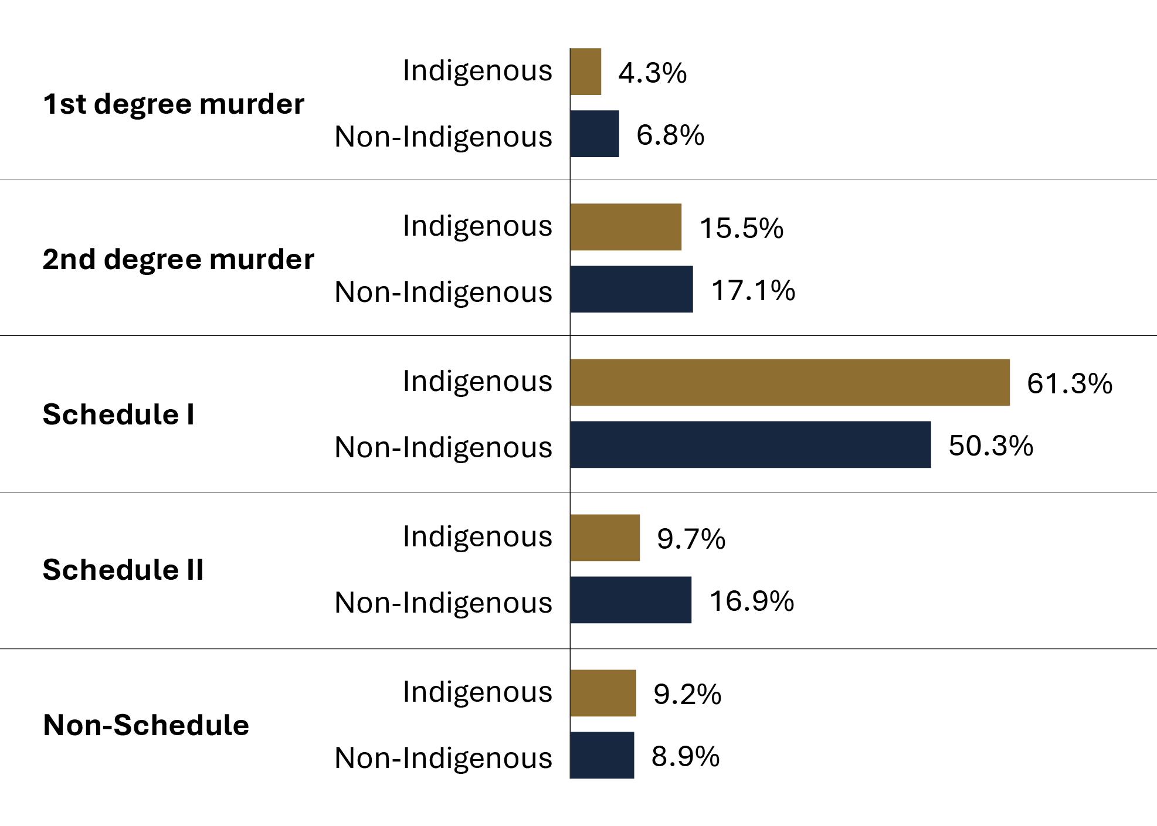
Source: Correctional Service of Canada.
- At the end of fiscal year 2023-24, Indigenous offenders were more likely to be serving a sentence for a violent offence (81.0% for Indigenous versus 74.2% for non-Indigenous).
- 71.6% of Indigenous female offenders were serving a sentence for a violent offence compared to 52.9% of non-Indigenous female offenders.
- Of the total number of offenders serving a sentence for murder (i.e., 1st degree or 2nd degree), 5.1% were female and 25.3% were Indigenous.
- A greater proportion of Indigenous offenders than non-Indigenous offenders were serving a sentence for a Schedule I offence (61.3% versus 50.3%, respectively).
- 9.7% of Indigenous offenders were serving a sentence for a Schedule II offence compared to 16.9% of non-Indigenous offenders.
- 25.9% of female offenders were serving a sentence for a Schedule II offence compared to 14.1% for male offenders.
Notes
*Violent offences include first degree murder, second degree murder, and Schedule I offences.

Table C20a. Indigenous offender population serving a sentence for a violent offence* (2023-24)
Offence category | Indigenous Female | % | Indigenous Male | % | Indigenous Total
1st degree murder | 14 | 2.3 | 263 | 4.5 | 277
2nd degree murder | 86 | 14.2 | 919 | 15.6 | 1,005
Schedule I | 334 | 55.1 | 3,640 | 61.9 | 3,974
Schedule II | 109 | 18.0 | 522 | 8.9 | 631
Non-schedule | 63 | 10.4 | 537 | 9.1 | 600
Total | 606 | 100.0 | 5,881 | 100.0 | 6,487
Source: Correctional Service of Canada.

Table C20b. Non-Indigenous offender population serving a sentence for a violent offence* (2023-24)
Offence category | Non-Indigenous Female | % | Non-Indigenous Male | % | Non-Indigenous Total
1st degree murder | 43 | 5.3 | 1,030 | 6.8 | 1,073
2nd degree murder | 117 | 14.3 | 2,597 | 17.2 | 2,714
Schedule I | 272 | 33.3 | 7,726 | 51.3 | 7,998
Schedule II | 260 | 31.8 | 2,430 | 16.1 | 2,690
Non-schedule | 125 | 15.3 | 1,288 | 8.5 | 1,413
Total | 817 | 100.0 | 15,071 | 100.0 | 15,888
Source: Correctional Service of Canada.

Table C20c. Total offender population serving a sentence for a violent offence* by sex (2023-24)
Offence category | Female | % | Male | % | Total
1st degree murder | 57 | 4.0 | 1,293 | 6.2 | 1,350
2nd degree murder | 203 | 14.3 | 3,516 | 16.8 | 3,719
Schedule I | 606 | 42.6 | 11,366 | 54.2 | 11,972
Schedule II | 369 | 25.9 | 2,952 | 14.1 | 3,321
Non-schedule | 188 | 13.2 | 1,825 | 8.7 | 2,013
Total | 1,423 | 100.0 | 20,952 | 100.0 | 22,375
Source: Correctional Service of Canada.
Notes
*Violent offences include first degree murder, second degree murder, and Schedule I offences.
Schedule I is comprised of sexual offences and other violent crimes excluding first and second degree murder (see the Corrections and Conditional Release Act).
Schedule II is comprised of serious drug offences or conspiracy to commit serious drug offences (see the Corrections and Conditional Release Act).
As per the Criminal Code of Canada under Section 231: Murder I (first degree) occurs when: (1) it is planned and deliberate; or (2) the victim is a person employed and acting in the course of his/her work for the preservation and maintenance of the public peace (e.g. police officer, correctional worker); or (3) the death is caused by a person committing or attempting to commit certain serious offences (e.g., treason, kidnapping, hijacking, sexual assault, robbery and arson). Murder II (second degree) is all murder that is not Murder I.
Total Offender Population includes all active offenders who are incarcerated in a CSC facility, offenders on temporary absence from a CSC facility, offenders who are temporarily detained, offenders who are actively supervised, and offenders who are unlawfully at large for less than 90 days.
Due to rounding, percentages may not add up to 100 percent.
Reported year periods reflect fiscal years. A fiscal year runs from April 1 to March 31 of the following year.

Indigenous offenders under the responsibility of CSC

Figure C21. Indigenous offender population
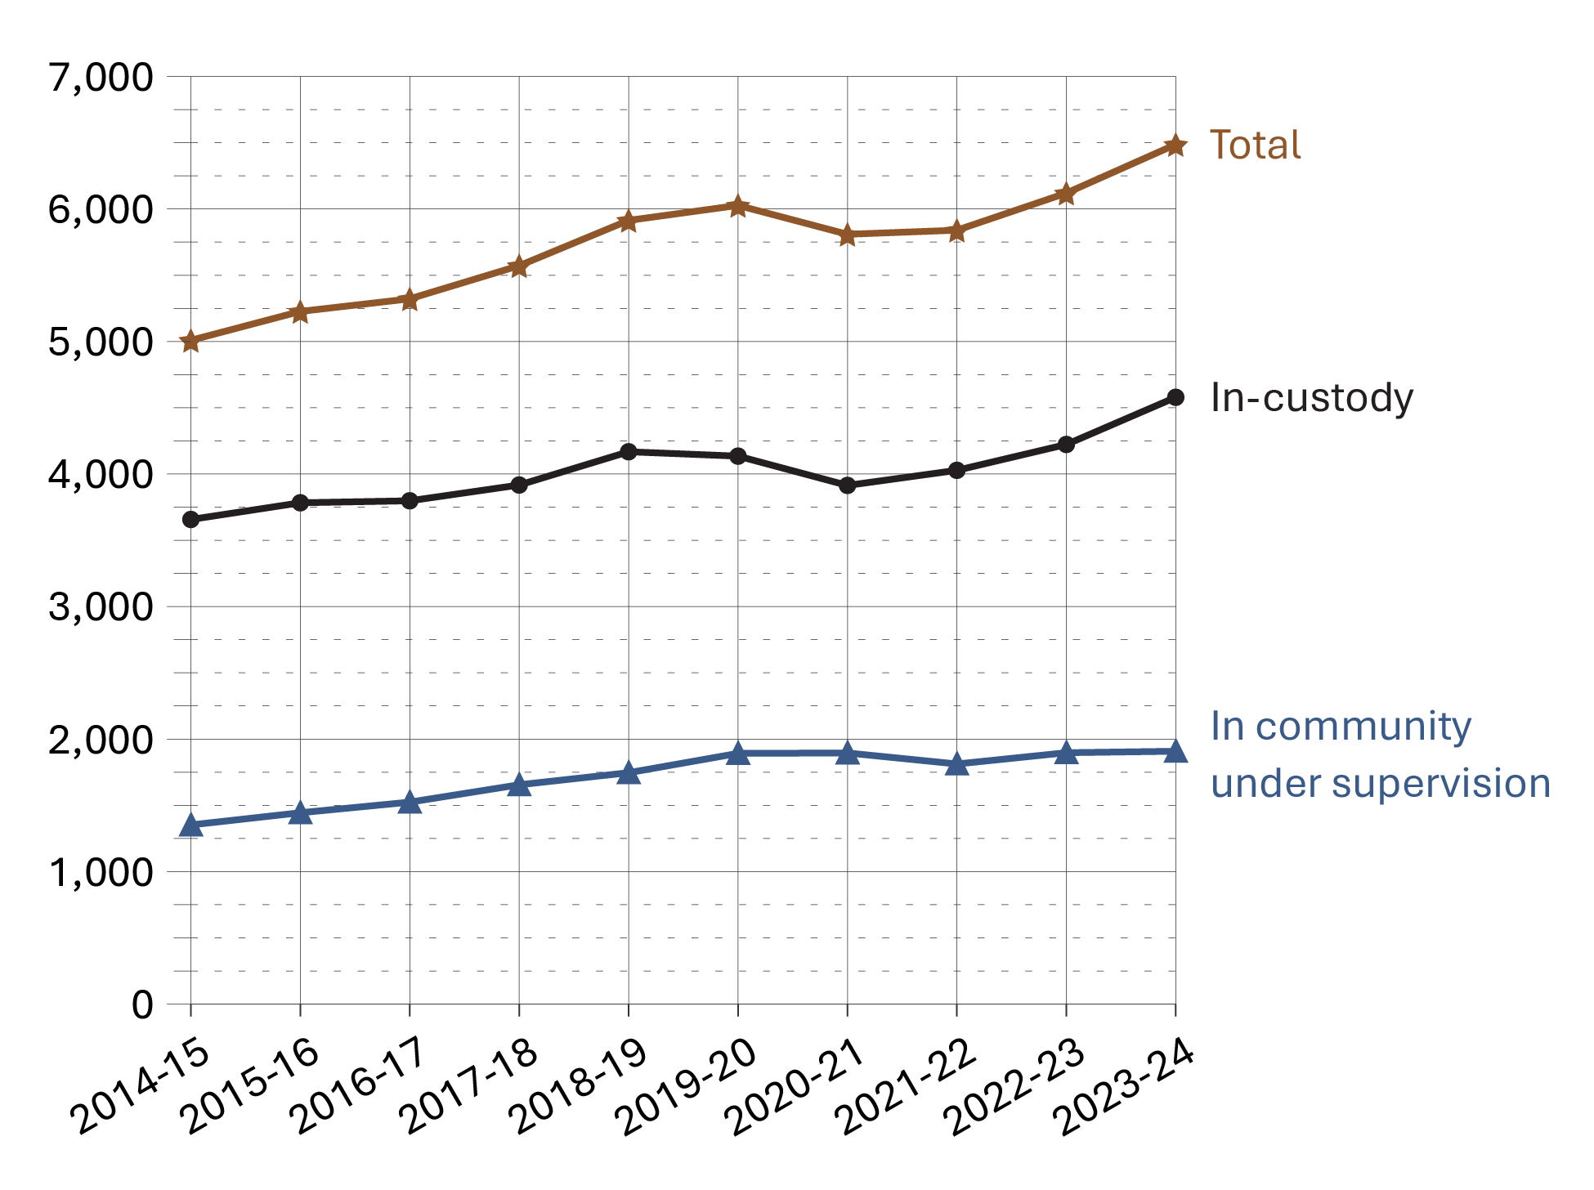
Source: Correctional Service of Canada.
- From 2014-15 to 2023-24, the in-custody Indigenous offender population increased by 25.2%, while the total Indigenous offender population increased 29.5% over the same period of time.
- The number of in-custody Indigenous female offenders increased steadily from 240 in 2014-15 to 363 in 2023-24, representing an increase of 51.3%. The increase for in-custody Indigenous male offenders was 23.4% for the same period, increasing from 3,417 to 4,216.
- From 2014-2015 to 2023-24, the number of Indigenous offenders on community supervision increased 41.1%, from 1,352 to 1,908. The Indigenous community population accounted for 22.4% of the total community population in 2023-24.

Table C21a. Indigenous offender population in custody
Region | 2019-20 | 2020-21 | 2021-22 | 2022-23 | 2023-24
Atlantic region total | 252 | 236 | 227 | 231 | 267
Female | 18 | 25 | 19 | 20 | 25
Male | 234 | 211 | 208 | 211 | 242
Intersex | 0 | 0 | 0 | 0 | 0
Quebec region total | 383 | 366 | 408 | 437 | 506
Female | 13 | 14 | 19 | 15 | 19
Male | 370 | 352 | 389 | 422 | 487
Intersex | 0 | 0 | 0 | 0 | 0
Ontario region total | 661 | 581 | 666 | 759 | 777
Female | 49 | 53 | 60 | 62 | 74
Male | 612 | 528 | 606 | 697 | 703
Intersex | 0 | 0 | 0 | 0 | 0
Prairie region total | 2,120 | 2,052 | 2,099 | 2,139 | 2,360
Female | 152 | 127 | 156 | 167 | 196
Male | 1,968 | 1,925 | 1,943 | 1,972 | 2,164
Intersex | 0 | 0 | 0 | 0 | 0
Pacific region total | 719 | 679 | 628 | 657 | 669
Female | 47 | 48 | 37 | 45 | 49
Male | 671 | 630 | 591 | 612 | 620
Intersex | 1 | 1 | 0 | 0 | 0
National total | 4,135 | 3,914 | 4,028 | 4,223 | 4,579
Female total | 279 | 267 | 291 | 309 | 363
Male total | 3,855 | 3,646 | 3,737 | 3,914 | 4,216
Intersex total | 1 | 1 | 0 | 0 | 0
Source: Correctional Service of Canada.

Table C21b. Indigenous offender population in community under supervision
Region | 2019-20 | 2020-21 | 2021-22 | 2022-23 | 2023-24
Atlantic region total | 119 | 110 | 109 | 120 | 120
Female | 13 | 13 | 10 | 15 | 20
Male | 106 | 97 | 99 | 105 | 100
Intersex | 0 | 0 | 0 | 0 | 0
Quebec region total | 190 | 191 | 156 | 187 | 204
Female | 8 | 9 | 6 | 8 | 6
Male | 182 | 182 | 150 | 179 | 198
Intersex | 0 | 0 | 0 | 0 | 0
Ontario region total | 305 | 325 | 343 | 354 | 385
Female | 28 | 34 | 39 | 52 | 54
Male | 277 | 291 | 304 | 302 | 331
Intersex | 0 | 0 | 0 | 0 | 0
Prairie region total | 869 | 879 | 790 | 845 | 808
Female | 119 | 123 | 103 | 132 | 123
Male | 750 | 756 | 687 | 713 | 685
Intersex | 0 | 0 | 0 | 0 | 0
Pacific region total | 409 | 390 | 414 | 391 | 391
Female | 40 | 38 | 41 | 38 | 40
Male | 369 | 352 | 373 | 353 | 351
Intersex | 0 | 0 | 0 | 0 | 0
National total | 1,892 | 1,895 | 1,812 | 1,897 | 1,908
Female total | 208 | 217 | 199 | 245 | 243
Male total | 1,684 | 1,678 | 1,613 | 1,652 | 1,665
Intersex total | 0 | 0 | 0 | 0 | 0
Source: Correctional Service of Canada.
Notes
Total Offender Population includes all active offenders who are incarcerated in a CSC facility, offenders on temporary absence from a CSC facility, offenders who are temporarily detained, offenders who are actively supervised, and offenders who are unlawfully at large for less than 90 days.
In Custody includes all active offenders incarcerated in a CSC facility, offenders on temporary absence from a CSC facility, offenders who are temporarily detained in a CSC facility, and offenders on remand in a CSC facility.
In Community Under Supervision includes all active offenders on day parole, full parole, statutory release, or in the community supervised on a long-term supervision order, offenders who are temporarily detained in a non-CSC facility, offenders who are unlawfully at large for less than 90 days, offenders on remand in a non-CSC facility, and offenders supervised and subject to an immigration hold by Canada Border Services Agency.
Regional statistics for the Correctional Service of Canada account for data relating to the northern territories in the following manner: data for Nunavut are reported in the Ontario Region, data for the Northwest Territories are reported in the Prairies Region, and data for Yukon under the Pacific Region.
Reported year periods reflect fiscal years. A fiscal year runs from April 1 to March 31 of the following year.

Number of authorizations for transfer to Structured Intervention Units in federal institutions: 5-year trend

Figure C22. Number of authorizations for transfer to Structured Intervention Units in federal institutions
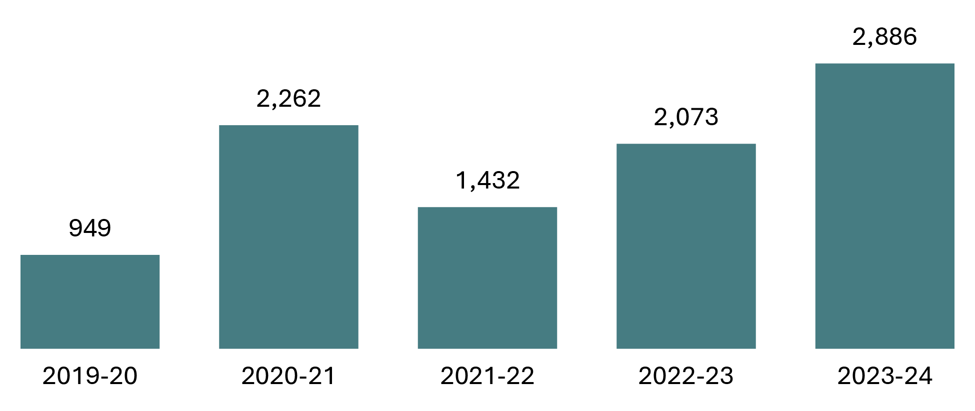
Source: Correctional Service of Canada.
- The number of authorizations for transfer to Structured Intervention Units in federal institutions has fluctuated over the past 5 fiscal years.
- In fiscal year 2023-24, there were 2,886 authorizations for transfer to a Structured Intervention Unit, which is a 39.2% increase (from 2,073 to 2,886) compared to the previous fiscal year.

Table C22. Number of authorizations for transfer to Structured Intervention Units in federal institutions
Fiscal year | Total
2019-20 | 949
2020-21 | 2,262
2021-22 | 1,432
2022-23 | 2,073
2023-24 | 2,886
Source: Correctional Service of Canada.
Notes
Structured Intervention Units (SIUs) are used when inmates cannot be managed safely within a mainstream inmate population. In SIUs, inmates receive targeted interventions, programs and healthcare with the goal of returning to a mainstream inmate population as soon as possible.
The result represents authorizations for transfer to a Structured Intervention Unit (SIU) where the start date was between the implementation on November 30, 2019 and March 31, 2024.
Authorizations for transfer to an SIU include all inmates who were transferred in, even if attempts to transfer them out were unsuccessful. A single transfer into an SIU may involve multiple subsequent attempts to transfer out.
The decision to transfer an inmate to an SIU is a decision made by CSC staff, not a request initiated by the offender. A designated staff member may authorize such a transfer only if criteria outlined in CCRA section 29.01(1) and section 34(1) is met. As per CCRA 34(2), CSC maintains a record of every instance in which an inmate is authorized to be transferred into an SIU.
Reported year periods reflect fiscal years. A fiscal year runs from April 1 to March 31 of the following year.

Percentage of successful transfers out of Structured Intervention Units in federal institutions

Figure C23. Percentage of successful transfers out of Structured Intervention Units
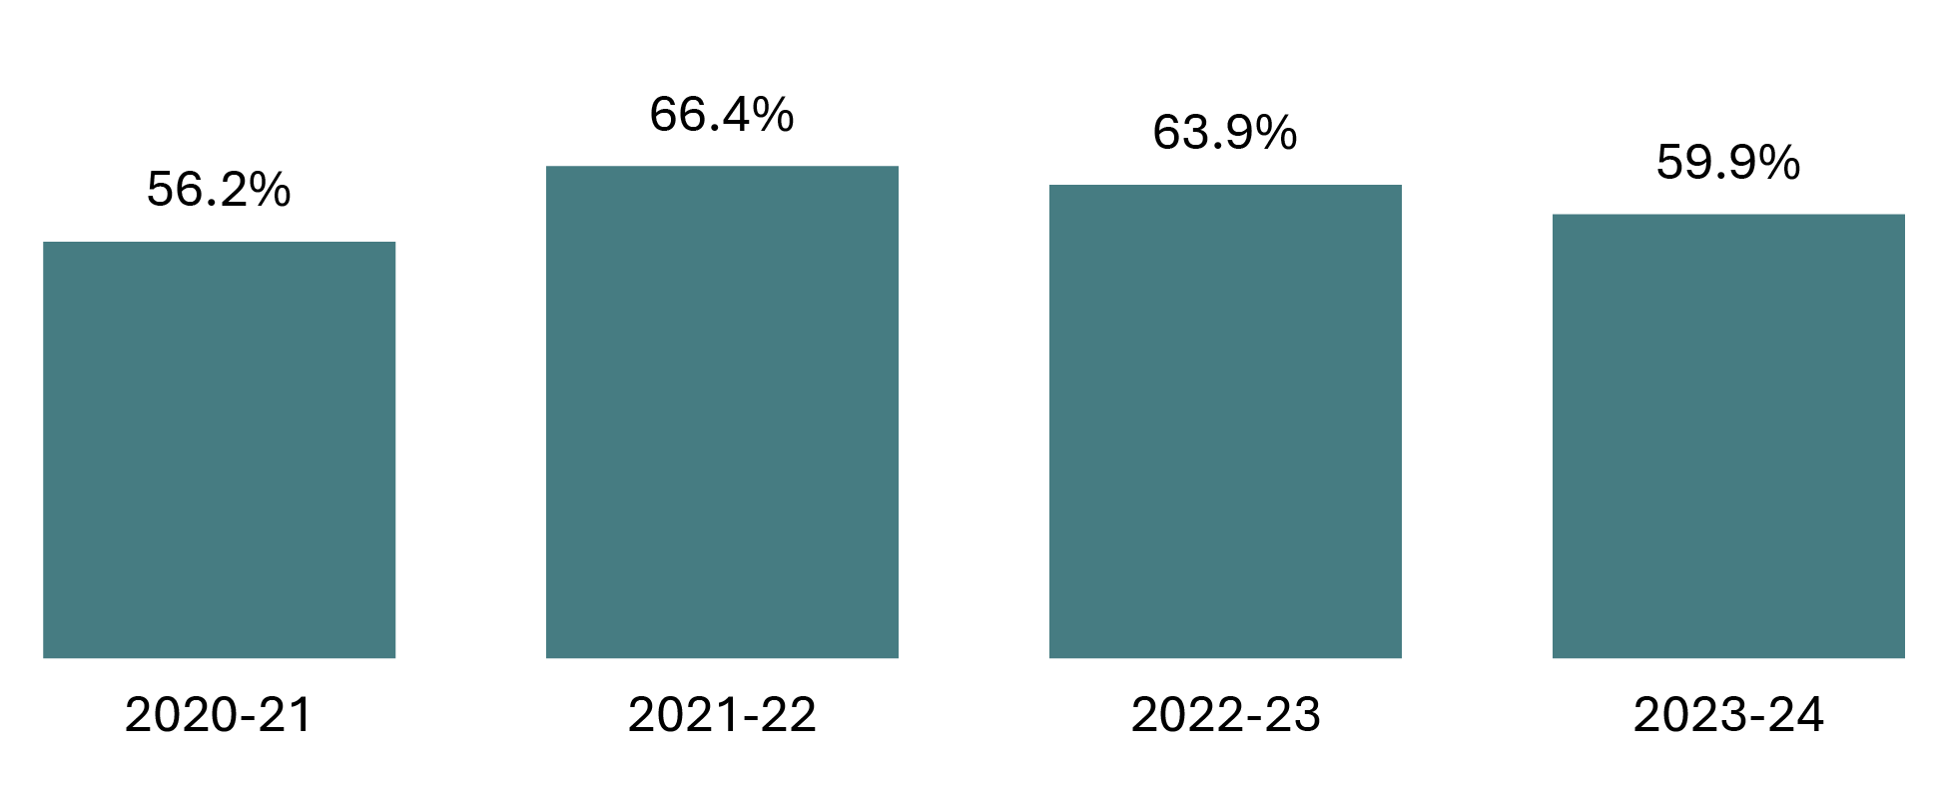
Source: Correctional Service of Canada.
- Of the 2,704 transfers out of a Structured Intervention Unit in 2023-24, 59.9% were successful.

Table C23. Percentage of successful transfers out of Structured Intervention Units
Fiscal year | Successful transfer count | % | Unsuccessful transfer count | % | Total transfer count | %
2020-21 | 1,286 | 56.2 | 1,004 | 43.8 | 2,290 | 100.0
2021-22 | 1,150 | 66.4 | 582 | 33.6 | 1,732 | 100.0
2022-23 | 1,088 | 63.9 | 615 | 36.1 | 1,703 | 100.0
2023-24 | 1,620 | 59.9 | 1,084 | 40.1 | 2,704 | 100.0
Source: Correctional Service of Canada.
Notes
Structured Intervention Units (SIUs) are used when inmates cannot be managed safely within a mainstream inmate population. In SIUs, inmates receive targeted interventions, programs and healthcare with the goal of returning to a mainstream inmate population as soon as possible.
A transfer out of Structured Intervention Units is successful if the inmate remains in mainstream population for a period of 120 days.
Reported year periods reflect a fiscal year. A fiscal year runs from April 1 to March 31 of the following year.

Structured Intervention Units: Time Outside of Cell

Figure C24a. Number of days offenders housed in SIUs were offered time out of their cell
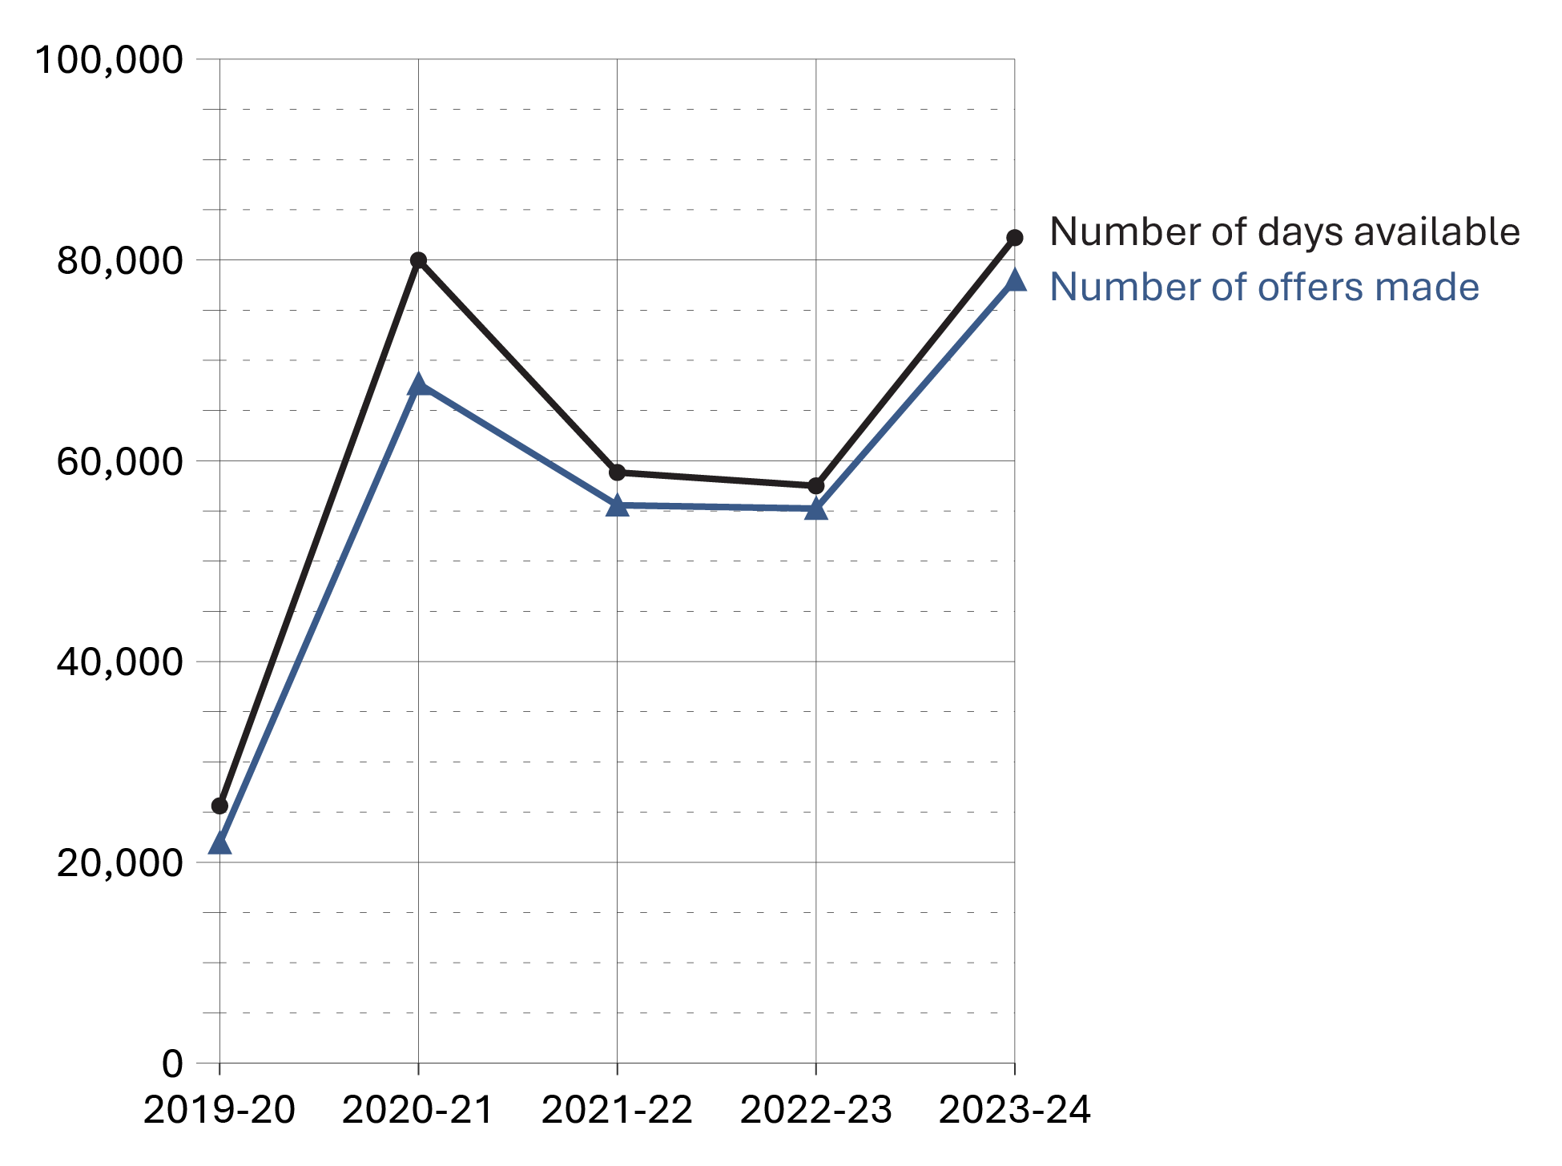
Source: Correctional Service of Canada.

Figure C24b. Percentage of offers accepted by offenders housed in SIUs for time out of their cell
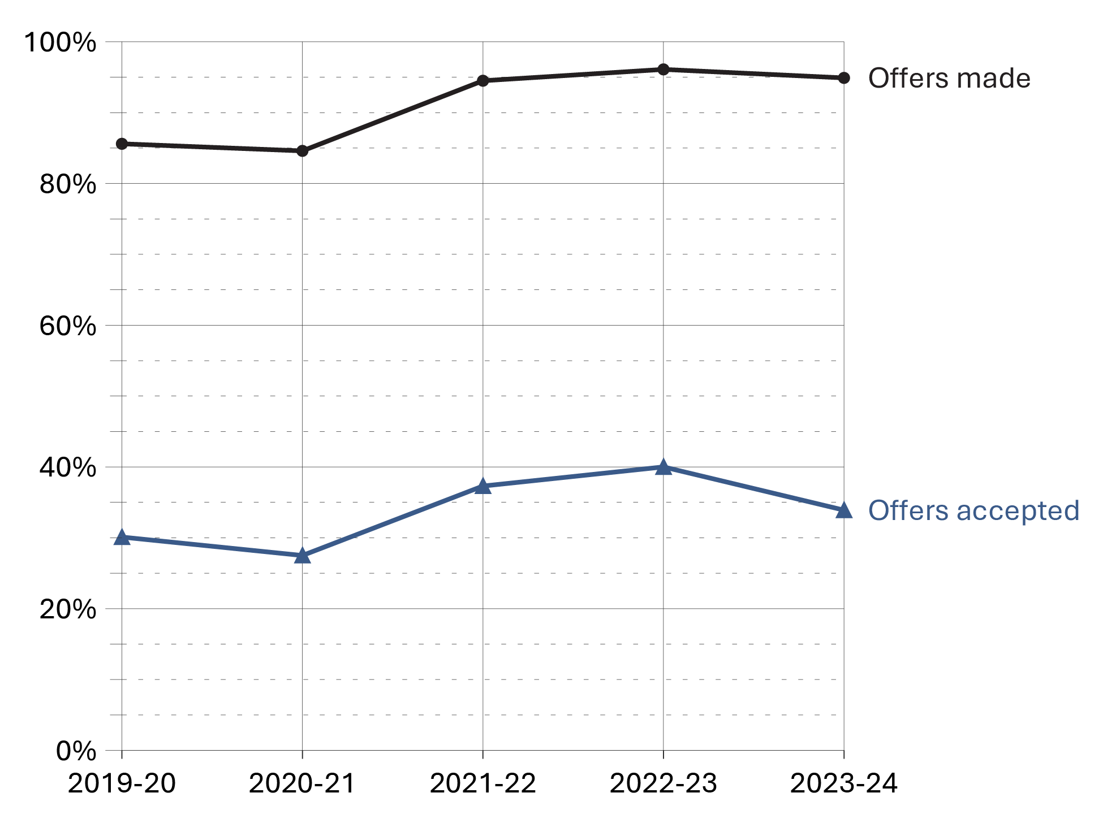
Source: Correctional Service of Canada.
- In 2023-24, the offenders were offered time out of their cell 94.9% of days where they were available in SIU; 33.9% of those offers were accepted.

Table C24. Percentage of days offenders housed in SIUs were offered time out of their cell
Fiscal Year | Days Available | Offers Made | % | Offers Accepted | %
2019-20 | 25,619 | 21,919 | 85.6 | 6,588 | 30.1
2020-21 | 79,970 | 67,661 | 84.6 | 18,609 | 27.5
2021-22 | 58,831 | 55,566 | 94.5 | 20,742 | 37.3
2022-23 | 57,496 | 55,234 | 96.1 | 22,094 | 40.0
2023-24 | 82,215 | 78,019 | 94.9 | 26,411 | 33.9
Source: Correctional Service of Canada.
Notes
Structured Intervention Units (SIUs) are used when inmates cannot be managed safely within a mainstream inmate population. In SIUs, inmates receive targeted interventions, programs and healthcare with the goal of returning to a mainstream inmate population as soon as possible.
The results represent the total number of days offenders housed in Structured Intervention Units were out of their cell per the total number of days offenders were available to be out of their cell (based on four hours out of cell per day).
The data is constrained to days where offenders were present in the Structured Intervention Unit for a minimum of four hours, with offers and accepted offers limited to those that occurred between 7am and 10pm.
Reported year periods reflect fiscal years. A fiscal year runs from April 1 to March 31 of the following year.

Structured Intervention Units: Duration of Stay

Figure C25. Median number of days offenders spent in Structured Intervention Units
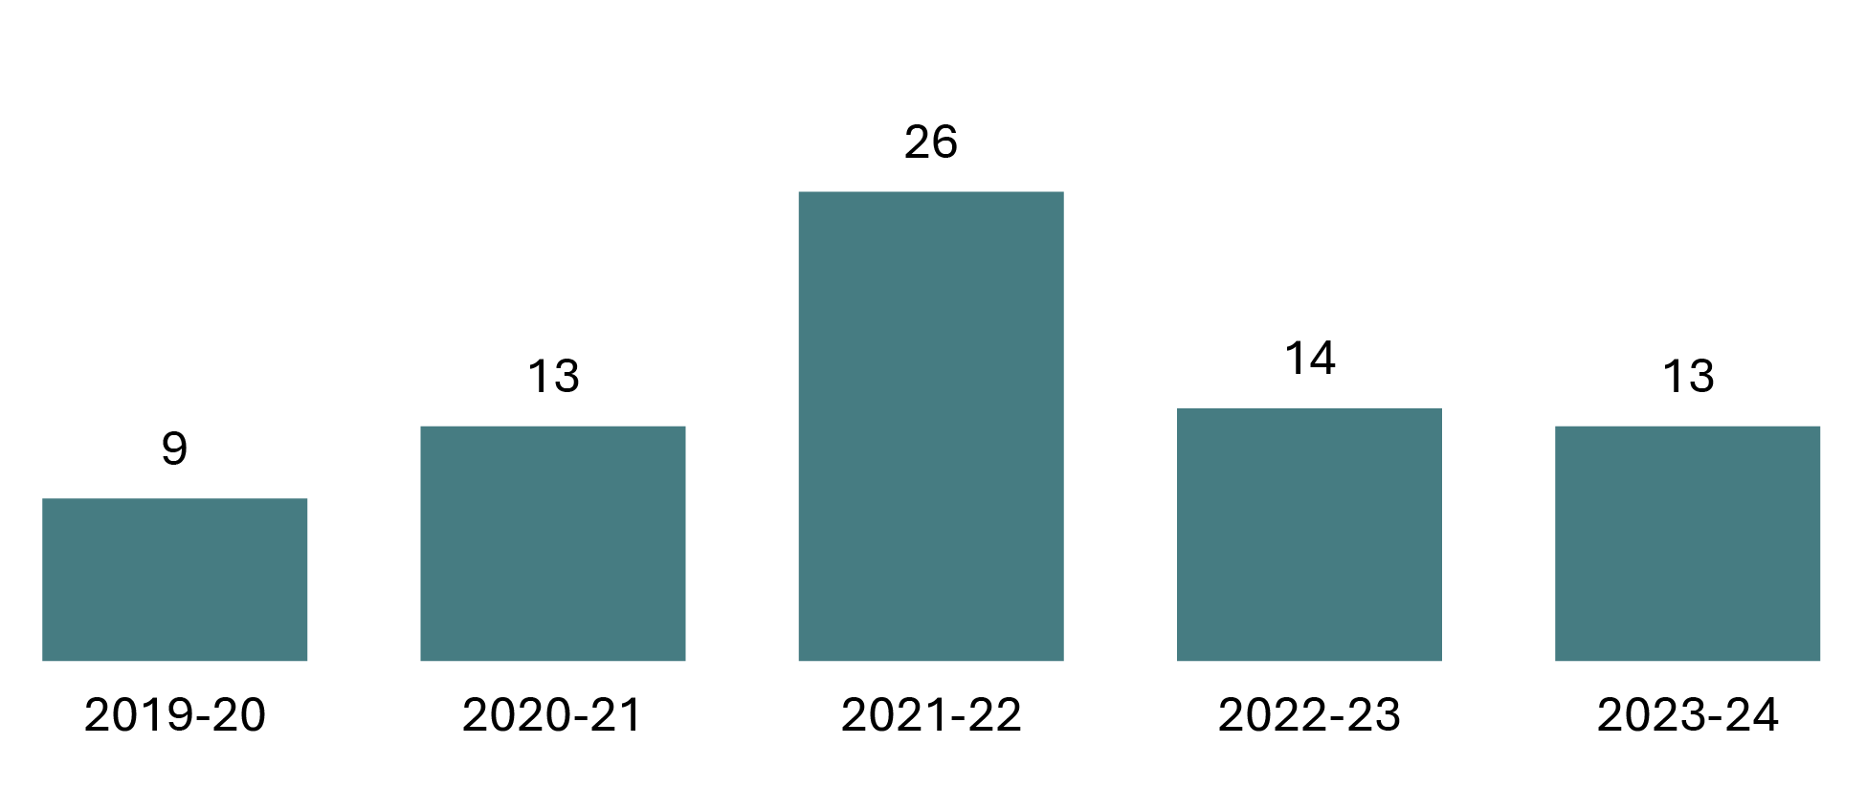
Source: Correctional Service of Canada.
- In 2023-24, the median number of days an offender spent in a Structured Intervention Unit per transfer was 13 days.

Table C25. Median number of days offenders spent in Structured Intervention Units
Fiscal year | Median number of days
2019-20 | 9
2020-21 | 13
2021-22 | 26
2022-23 | 14
2023-24 | 13
Source: Correctional Service of Canada.
Notes
Structured Intervention Units (SIUs) are used when inmates cannot be managed safely within a mainstream inmate population. In SIUs, inmates receive targeted interventions, programs and healthcare with the goal of returning to a mainstream inmate population as soon as possible.
The result represents the median duration in days of the SIU stays that ended in each fiscal year, between the implementation on November 30, 2019 and March 31, 2024.
Reported year periods reflect fiscal years. A fiscal year runs from April 1 to March 31 of the following year.

Characteristics of Offenders in Structured Intervention Unit Cells by Indigenous and non-Indigenous

Figure C26a. Characteristics of offenders in SIU cells by Indigenous and non-Indigenous
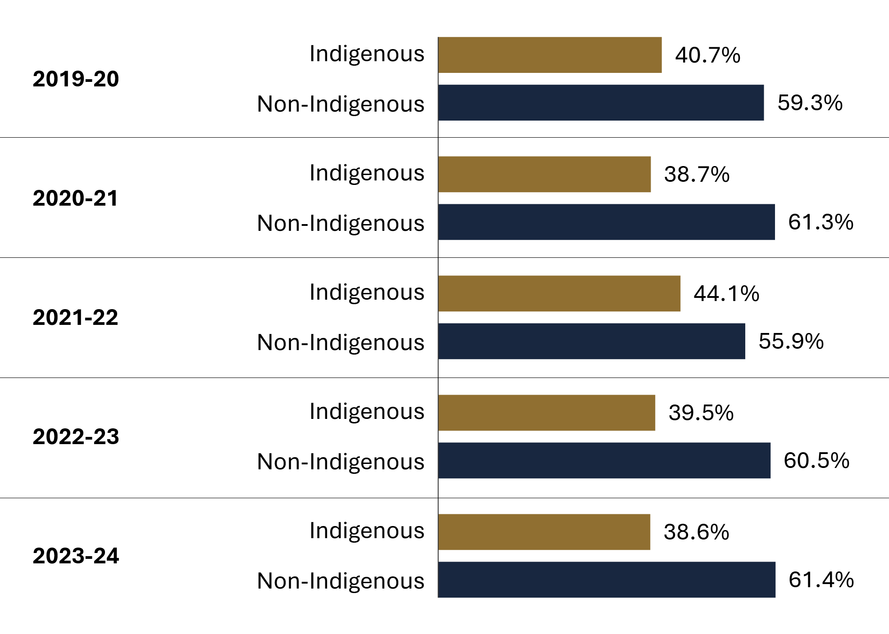
Source: Correctional Service of Canada.

Figure C26b. Characteristics of offenders in SIU cells by sex
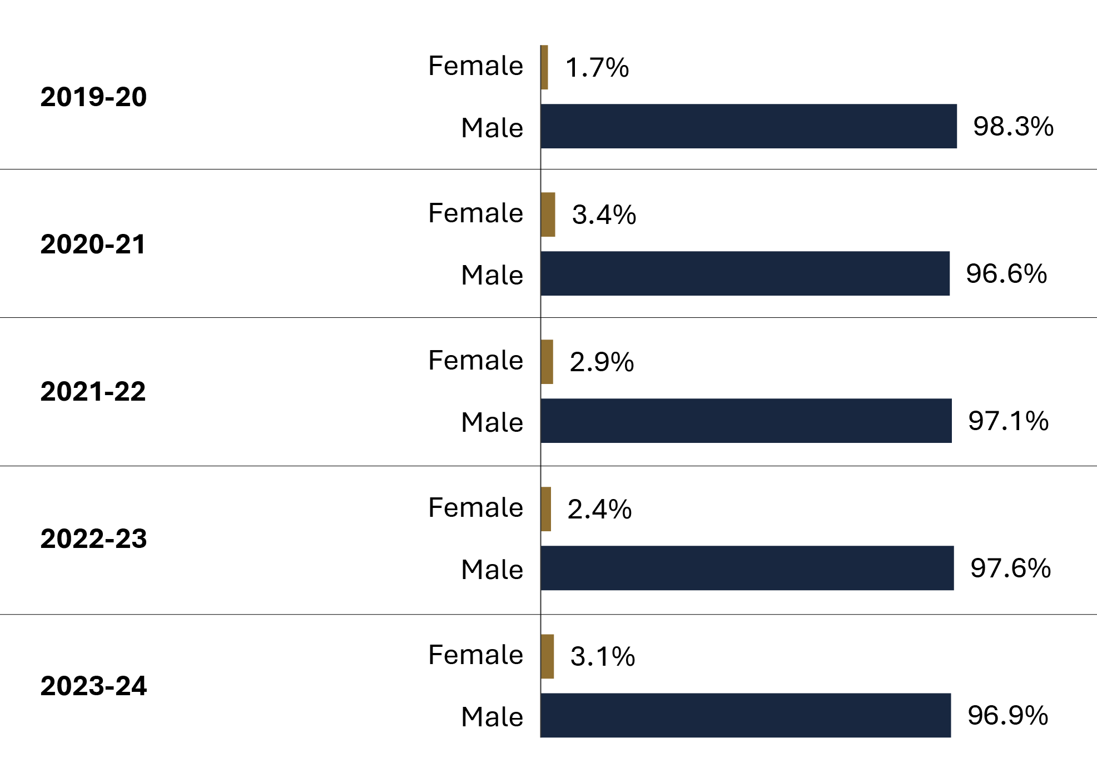
Source: Correctional Service of Canada.
- In 2023-24, 38.6% of the population in SIU were Indigenous. The majority of the population (96.9%) in 2023-24 was male.

Table C26a. Characteristics of offenders in SIU cells by sex and Indigenous and non-Indigenous
Fiscal year | Indigenous females | Indigenous males | Indigenous total | Non- Indigenous females | Non- Indigenous males | Non- Indigenous total
2019-20 | 14 | 372 | 386 | 2 | 561 | 563
2020-21 | 58 | 817 | 875 | 18 | 1,369 | 1,387
2021-22 | 31 | 600 | 631 | 11 | 790 | 801
2022-23 | 45 | 774 | 819 | 5 | 1,249 | 1,254
2023-24 | 74 | 1,039 | 1,113 | 15 | 1,758 | 1,773
Source: Correctional Service of Canada.

Table C26b. Characteristics of offenders in SIU cells by sex
Fiscal year | Females | Males | Total
2019-20 | 16 | 933 | 949
2020-21 | 76 | 2,186 | 2,262
2021-22 | 42 | 1,390 | 1,432
2022-23 | 50 | 2,023 | 2,073
2023-24 | 89 | 2,797 | 2,886
Source: Correctional Service of Canada.
Notes
Structured Intervention Units (SIUs) are used when inmates cannot be managed safely within a mainstream inmate population. In SIUs, inmates receive targeted interventions, programs and healthcare with the goal of returning to a mainstream inmate population as soon as possible.
The result represents authorizations for transfer to a Structured Intervention Unit (SIU) where the start date was between the implementation on November 30, 2019 and March 31, 2024.
Note that the offenders themselves identify to which race they belong.
The sex corresponds to the biological sex of the offender entered in the Offender Management System at the date of extraction.
Reported year periods reflect fiscal years. A fiscal year runs from April 1 to March 31 of the following year.

Reasons for Transfer to Structured Intervention Units

Figure C27. Reasons for transfer to SIUs based on all transfers into an SIU
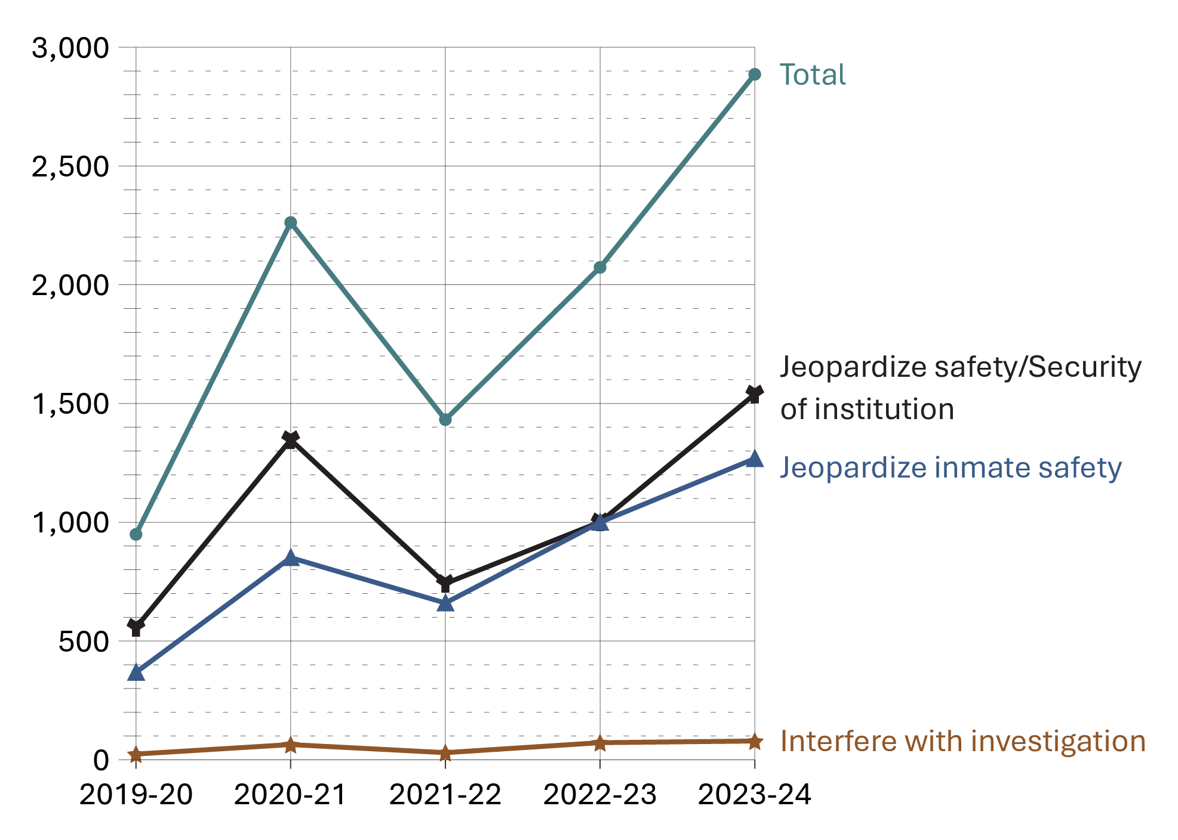
Source: Correctional Service of Canada.
- In 2023-24, from the 2,886 transfers to SIU, 1,268 were completed under the reason of jeopardizing inmate safety (CCRA 34.1B), 1,539 under the reason of jeopardizing the safety/security of institution (CCRA 34.1A) and 79 under the reason of interfering with an investigation (CCRA 34.1C).
- Variations in SIU transfer authorizations during and after the COVID‑19 period may reflect broader impacts on the federal criminal justice system, as well as internal operational factors. For example, pandemic-related restrictions reduced inmate interactions in CSC institutions, with increases in SIU transfer authorizations observed as operations gradually returned to more typical activity levels. These explanations are provided as general context only and are not evidence‑based findings.

Table C27. Reasons for transfer to SIUs based on all transfers into an SIU
Reason for transfer | 2019-20 | 2020-21 | 2021-22 | 2022-23 | 2023-24
CCRA 34.1A Jeopardize safety/security of institution | 557 | 1,347 | 742 | 1,001 | 1,539
CCRA 34.1B Jeopardize inmate safety | 368 | 851 | 660 | 1,000 | 1,268
CCRA 34.1C Interfere with an investigation | 24 | 64 | 30 | 72 | 79
Total | 949 | 2,262 | 1,432 | 2,073 | 2,886
Source: Correctional Service of Canada.
Notes
Structured Intervention Units (SIUs) are used when inmates cannot be managed safely within a mainstream inmate population. In SIUs, inmates receive targeted interventions, programs and healthcare with the goal of returning to a mainstream inmate population as soon as possible.
The result represents authorizations for transfer to a Structured Intervention Unit (SIU) where the start date was between the implementation on November 30, 2019 and March 31, 2024. The information is broken down to transfer presented in the Corrections and Conditional Release Act (CCRA).
CCRA 34.1A Jeopardize Safety/Security of Institution: the inmate has acted, has attempted to act or intends to act in a manner that jeopardizes the safety of any person or the security of a penitentiary and allowing the inmate to be in the mainstream inmate population would jeopardize the safety of any person or the security of the penitentiary.
CCRA 34.1B Jeopardize Inmate Safety: allowing the inmate to be in the mainstream inmate population would jeopardize the inmate’s safety.
CCRA 34.1C Interfere with an Investigation: allowing the inmate to be in the mainstream inmate population would interfere with an investigation that could lead to a criminal charge or a charge under subsection 41(2) of a serious disciplinary offence.
Figures in this table represent SIU Authorizations to Transfer. They do not reflect the subsequent decision to approve or not approve an SIU transfer.
The 2019-20 data reflect only a five-month period at the inception of SIUs.
Reported year periods reflect fiscal years. A fiscal year runs from April 1 to March 31 of the following year.

Number of offender deaths while in custody: 10-year trend

Figure C28a. Number of deaths in federal custody by cause of death
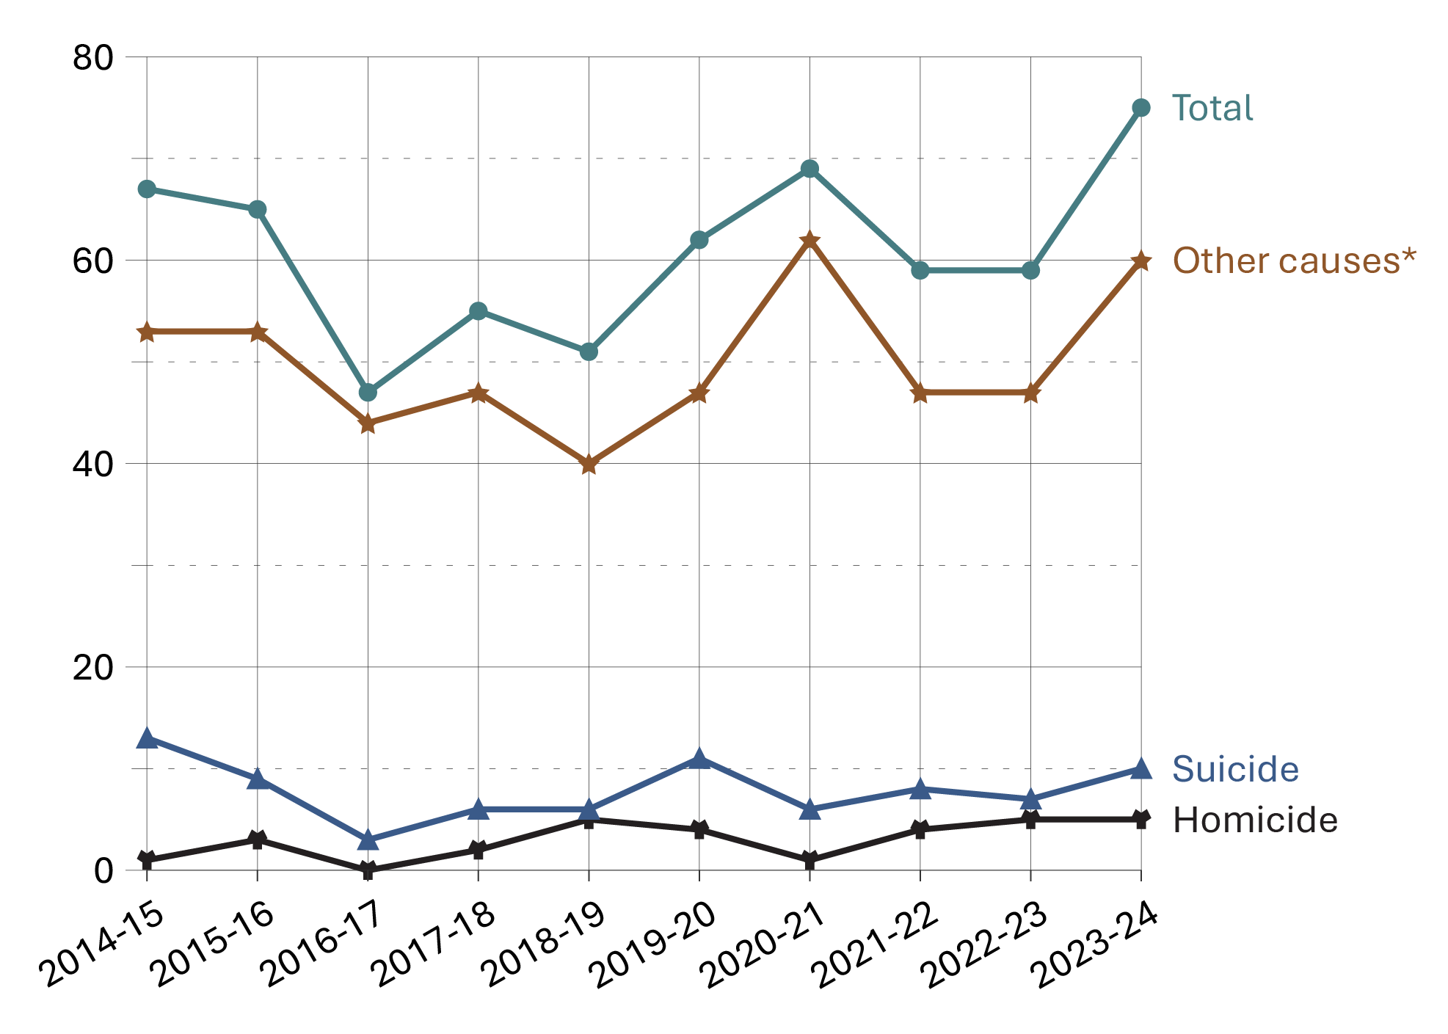
Source: Statistics Canada, Canadian Centre for Justice and Community Safety Statistics, Adult Correctional Services Survey.

Figure C28b. Number of deaths in provincial/territorial custody by cause of death
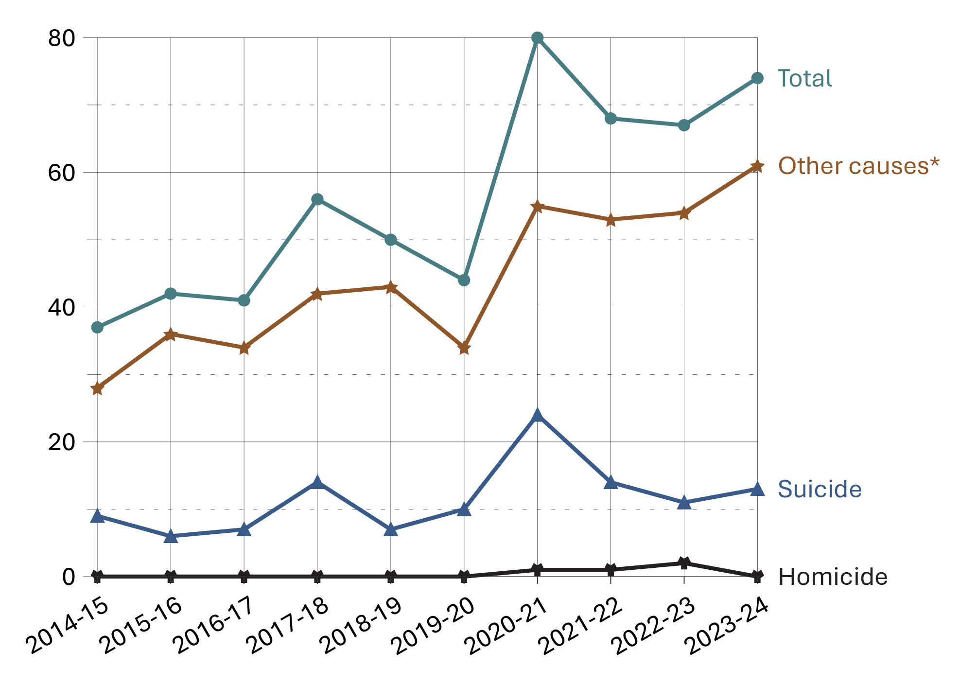
Source: Statistics Canada, Canadian Centre for Justice and Community Safety Statistics, Adult Correctional Services Survey.
- In the 10-year period from 2014-15 to 2023-24, a total of 609 federal offenders and 559 provincial/territorial offenders died while in custody. During this time period, suicides accounted for 13.0% of federal offender deaths and 20.6% of provincial offender deaths. The suicide rate was approximately 58 per 100,000 for incarcerated federal offenders, and approximately 49 per 100,000 for incarcerated provincial offenders.
- Between 2014-15 and 2023-24, 4.9% of federal offender deaths and 0.7% of provincial offender deaths were due to homicide. The homicide rate for incarcerated federal offenders was approximately 22 per 100,000 and 2 per 100,000 for incarcerated provincial offenders.
Notes
*Other causes of death includes death from natural causes, accidental deaths, death as a result of legal intervention, unknown cause of death, and other.

Table C28. Deaths in federal and provincial/territorial custody by cause of death
Fiscal year | Homicide | % | Suicide | % | Other causes* | % | Total
Federal total | 30 | 4.9 | 79 | 13.0 | 500 | 82.1 | 609
2014-15 | 1 | 1.5 | 13 | 19.4 | 53 | 79.1 | 67
2015-16 | 3 | 4.6 | 9 | 13.8 | 53 | 81.5 | 65
2016-17 | 0 | 0.0 | 3 | 6.4 | 44 | 93.6 | 47
2017-18 | 2 | 3.6 | 6 | 10.9 | 47 | 85.5 | 55
2018-19 | 5 | 9.8 | 6 | 11.8 | 40 | 78.4 | 51
2019-20 | 4 | 6.5 | 11 | 17.7 | 47 | 75.8 | 62
2020-21 | 1 | 1.4 | 6 | 8.7 | 62 | 89.9 | 69
2021-22 | 4 | 6.8 | 8 | 13.6 | 47 | 79.7 | 59
2022-23 | 5 | 8.5 | 7 | 11.9 | 47 | 79.7 | 59
2023-24 | 5 | 6.7 | 10 | 13.3 | 60 | 80.0 | 75
Provincial/  territorial total | 4 | 0.7 | 115 | 20.6 | 440 | 78.7 | 559
2014-15 | 0 | 0.0 | 9 | 24.3 | 28 | 75.7 | 37
2015-16 | 0 | 0.0 | 6 | 14.3 | 36 | 85.7 | 42
2016-17 | 0 | 0.0 | 7 | 17.1 | 34 | 82.9 | 41
2017-18 | 0 | 0.0 | 14 | 25.0 | 42 | 75.0 | 56
2018-19 | 0 | 0.0 | 7 | 14.0 | 43 | 86.0 | 50
2019-20 | 0 | 0.0 | 10 | 22.7 | 34 | 77.3 | 44
2020-21 | 1 | 1.3 | 24 | 30.0 | 55 | 68.8 | 80
2021-22 | 1 | 1.5 | 14 | 20.6 | 53 | 77.9 | 68
2022-23 | 2 | 3.0 | 11 | 16.4 | 54 | 80.6 | 67
2023-24 | 0 | 0.0 | 13 | 17.6 | 61 | 82.4 | 74
Total federal and provincial/ territorial offender deaths | 34 | 2.9 | 194 | 16.6 | 940 | 80.5 | 1,168
Source: Statistics Canada, Canadian Centre for Justice and Community Safety Statistics, Adult Correctional Services Survey.
Notes
*Other causes of death includes death from natural causes, accidental deaths, death as a result of legal intervention, unknown cause of death, and other.
Data for Newfoundland and Labrador are not available for 2018-19 to 2022-23. Data for Prince Edward Island are not available for 2022-23 and 2023-24. Some jurisdictions are unable to provide the breakdown by cause of death.
For the calculation of rates, the total actual in-count numbers between 2014-15 and 2023-24 was used as the denominator.
The data on cause of death are subject to change following an official review or investigation, and should be used/interpreted with caution. The data presented were provided by the Canadian Centre for Justice and Community Safety Statistics at Statistics Canada, and may not reflect the outcome of recent reviews or investigations on cause of death.
The figure includes data from the most recent year available at the time of preparation.
Reported year periods reflect a fiscal year. A fiscal year runs from April 1 to March 31 of the following year.

Number of escapees and escape incidents from federal institutions or Healing Lodges: 10-year trend

Figure C29. Total number of escapees from federal institutions or Healing Lodges
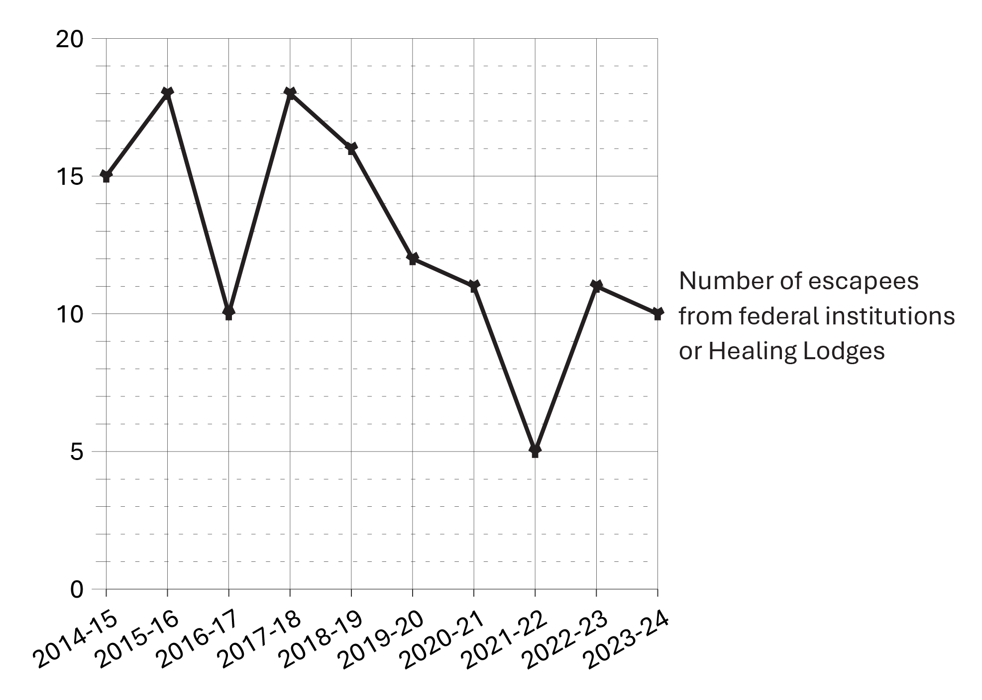
Source: Correctional Service of Canada.
- In 2023-24, there were 9 escape incidents involving a total of 10 offenders. 8 of the 10 offenders were recaptured at the time of the extraction while 2 remained at large.
- Offenders who escaped from federal institutions or healing lodges in 2023-24 represented 0.07% of the in-custody population.
- Over the past 10 years, the number of escapees from federal institutions decreased 33.3% from 15 in 2014-15 to 10 in 2023-24.

Table C29. Number of escapees and escape incidents from federal institutions or Healing Lodges
Fiscal year | Total number of escape incidents | Total number of escapees
2014-15 | 14 | 15
2015-16 | 15 | 18
2016-17 | 10 | 10
2017-18 | 13 | 18
2018-19 | 15 | 16
2019-20 | 10 | 12
2020-21 | 11 | 11
2021-22 | 5 | 5
2022-23 | 10 | 11
2023-24 | 9 | 10
Total | 112 | 126
Source: Correctional Service of Canada.
Notes
An escape incident refers to any act or attempted act to breach (break) prison, escape from lawful custody, or without lawful excuse be at large before the expiration of a term of imprisonment to which that person has been sentenced.
The data represent the number of escape incidents from federal facilities or Healing Lodges during each fiscal year. An escape can involve more than 1 offender.
These numbers are subject to change further to new information becoming available.
Reported year periods reflect fiscal years. A fiscal year runs from April 1 to March 31 of the following year.

CSC offenders in community under supervision by sex: 10-year trend

Figure C30a. Females in community under supervision population at fiscal year end
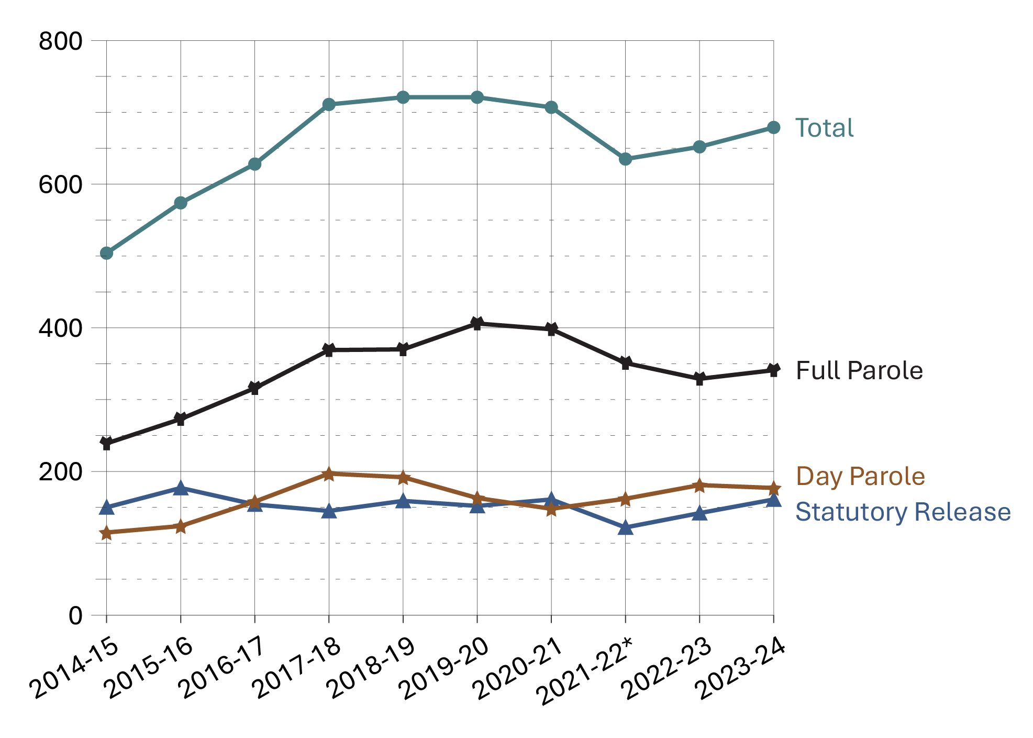
Source: Correctional Service of Canada.

Figure C30b. Males in community under supervision population at fiscal year end
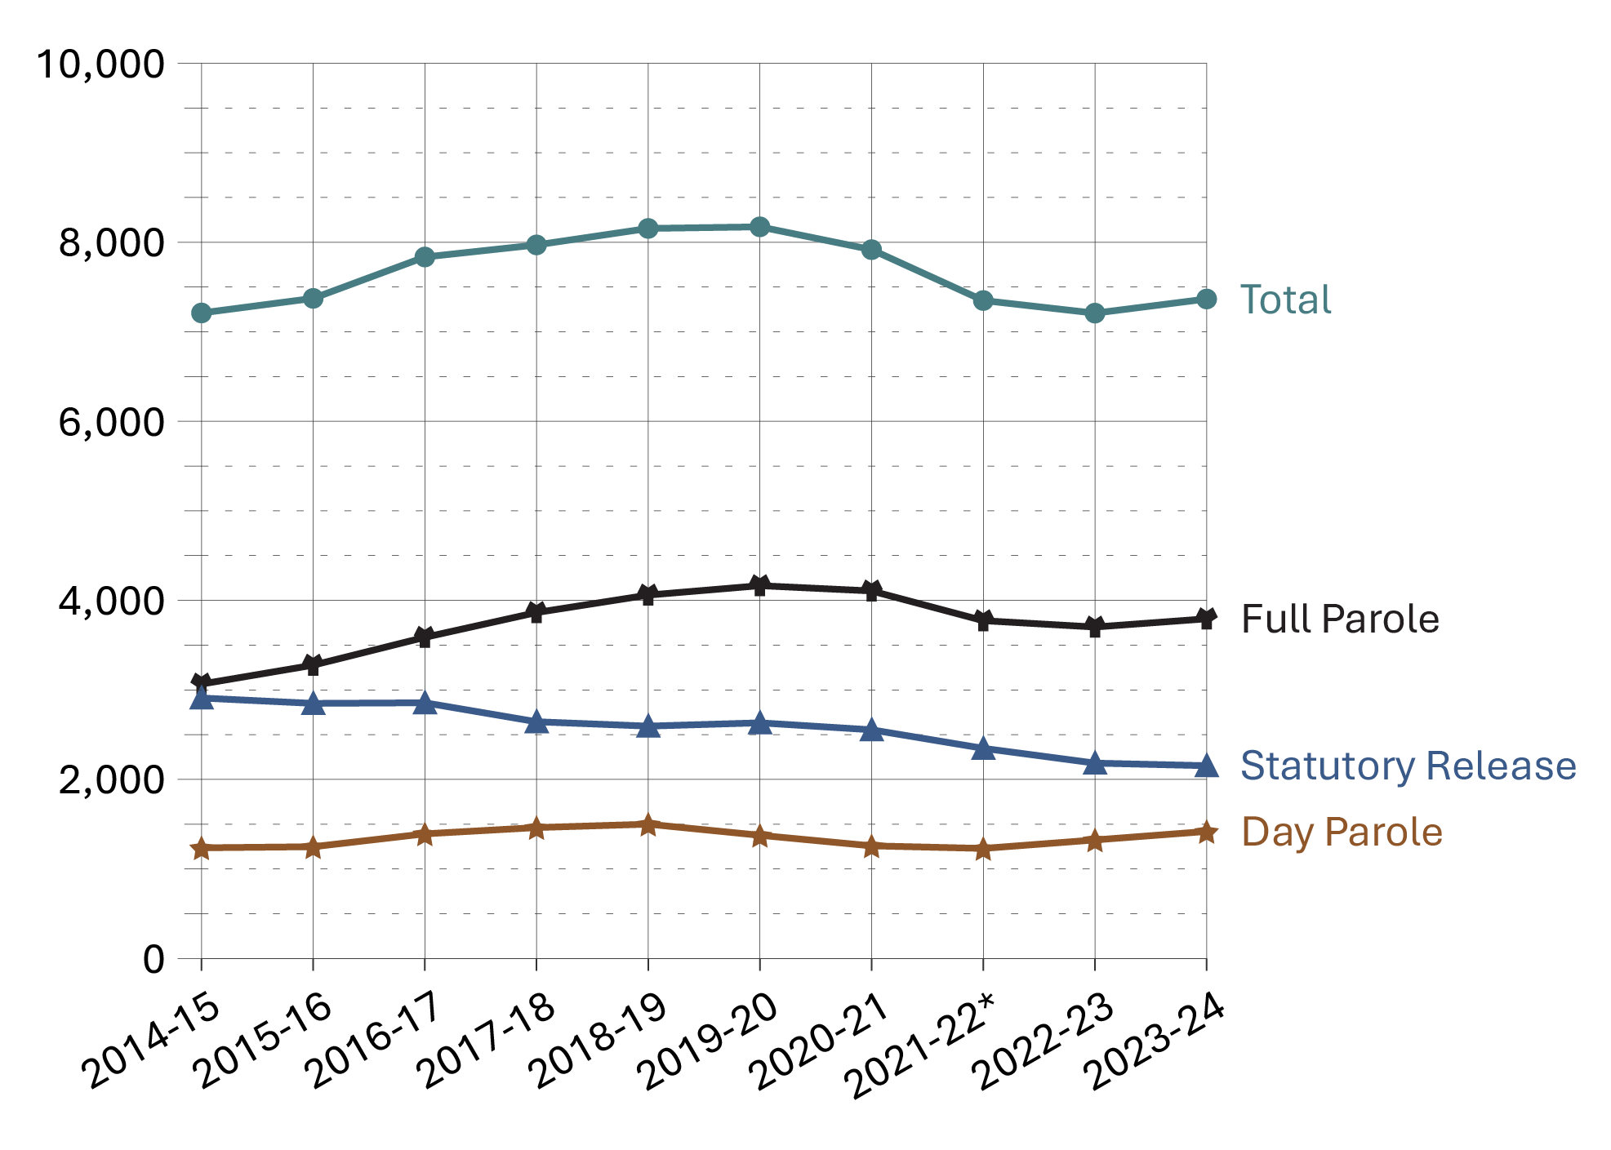
Source: Correctional Service of Canada.

Figure C30c. Total in community under supervision population at fiscal year end
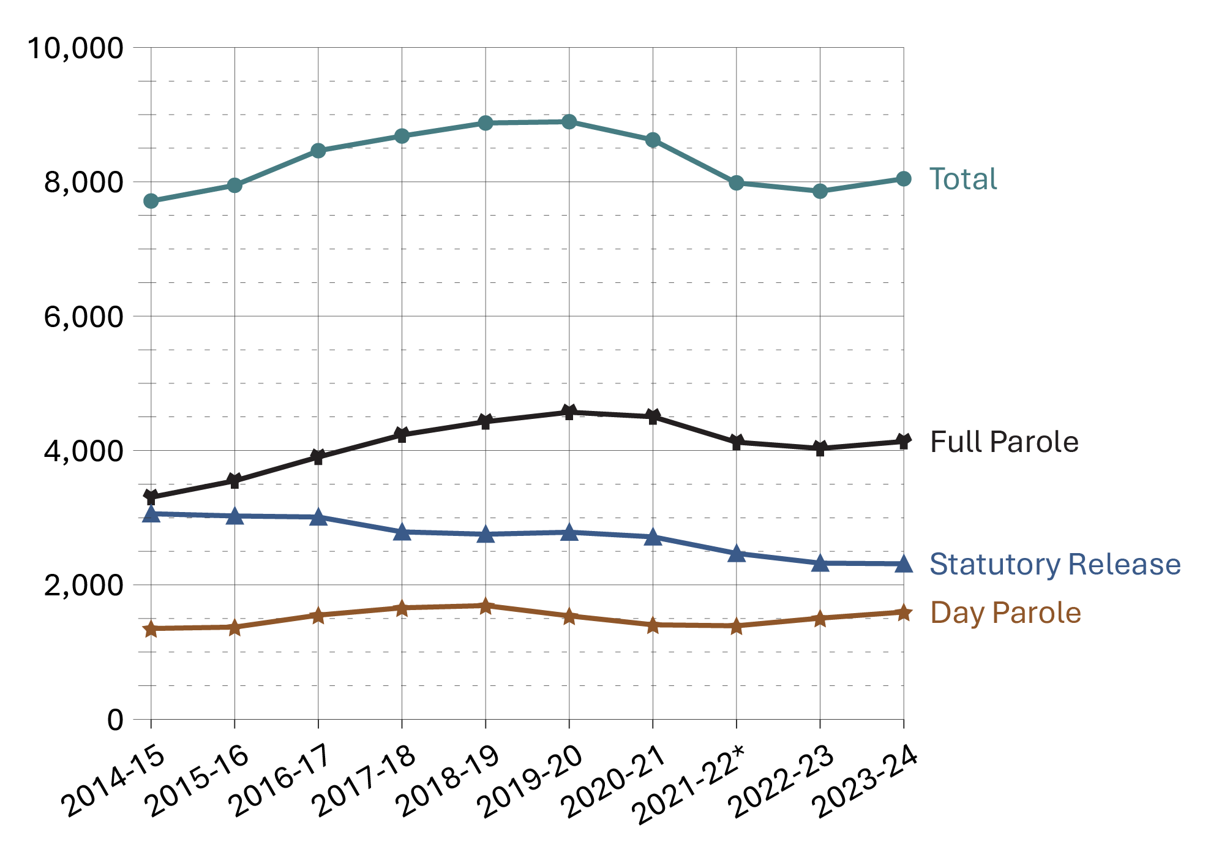
Source: Correctional Service of Canada.
- Over the past 5 fiscal years (from 2019-20 to 2023-24), the total offender population supervised in the community decreased by 9.5%. For the same period, the total number of offenders on full parole decreased by 9.5% while the proportion of offenders on statutory release decreased by 16.9%. At the end of fiscal year 2023-24, there were 7,366 males and 679 females on active community supervision.
- Over the past 10 fiscal years (from 2014-15 to 2023-24), the total offender population supervised in the community increased by 4.3%. For the same period, the total number of offenders on full parole increased by 25.2% and the proportion of offenders on statutory release decreased by 24.4%.

Table C30. In community under supervision population at fiscal year end
Supervision type | 2014-15 | 2015-16 | 2016-17 | 2017-18 | 2018-19 | 2019-20 | 2020-21 | 2021-22* | 2022-23 | 2023-24
Day parole total | 1,351 | 1,372 | 1,550 | 1,659 | 1,692 | 1,539 | 1,406 | 1,391 | 1,505 | 1,596
Females | 115 | 124 | 158 | 197 | 192 | 163 | 148 | 162 | 181 | 177
Males | 1,236 | 1,248 | 1,392 | 1,462 | 1,500 | 1,376 | 1,258 | 1,229 | 1,324 | 1,419
Intersex | NR | NR | NR | NR | NR | 0 | 0 | 0 | 0 | 0
Full parole total | 3,304 | 3,549 | 3,903 | 4,233 | 4,429 | 4,571 | 4,503 | 4,124 | 4,031 | 4,135
Females | 239 | 273 | 316 | 369 | 370 | 406 | 398 | 351 | 329 | 341
Males | 3,065 | 3,276 | 3,587 | 3,864 | 4,059 | 4,164 | 4,105 | 3,773 | 3,702 | 3,794
Intersex | NR | NR | NR | NR | NR | 1 | 0 | 0 | 0 | 0
Statutory release total | 3,059 | 3,026 | 3,010 | 2,789 | 2,754 | 2,784 | 2,715 | 2,469 | 2,324 | 2,314
Females | 150 | 177 | 154 | 145 | 159 | 152 | 161 | 122 | 142 | 161
Males | 2,909 | 2,849 | 2,856 | 2,644 | 2,595 | 2,632 | 2,554 | 2,347 | 2,182 | 2,153
Intersex | NR | NR | NR | NR | NR | 0 | 0 | 0 | 0 | 0
Total | 7,714 | 7,947 | 8,463 | 8,681 | 8,875 | 8,894 | 8,624 | 7,984 | 7,860 | 8,045
Females total | 504 | 574 | 628 | 711 | 721 | 721 | 707 | 635 | 652 | 679
Males total | 7,210 | 7,373 | 7,835 | 7,970 | 8,154 | 8,172 | 7,917 | 7,349 | 7,208 | 7,366
Intersex total | NR | NR | NR | NR | NR | 1 | 0 | 0 | 0 | 0
Source: Correctional Service of Canada.
Notes
Results for “Intersex” were unavailable prior to 2019-20. “Not reported” is abbreviated to “NR” in this table due to formatting.
The data reflect the offender population in the community under supervision, which includes all active offenders on day parole, full parole, statutory release, offenders who are temporarily detained in a non-CSC facility, offenders who are unlawfully at large for less than 90 days, offenders on remand in a non-CSC facility, and offenders supervised and subject to an immigration hold by Canada Border Services Agency.
The data presented above do not include offenders who were on long-term supervision orders (See Figure/Table E4).
*As a result of a data quality issue, supervision information on 1 offender was not available at the time of the data extraction for fiscal year 2021-22.
Day parole is a type of conditional release granted by the Parole Board of Canada whereby offenders are permitted to participate in community-based activities in preparation for full parole or statutory release. The conditions require offenders to return nightly to an institution or half-way house unless otherwise authorized by the Parole Board of Canada.
Full parole is a type of conditional release granted by the Parole Board of Canada whereby the remainder of the sentence is served under supervision in the community.
Statutory release refers to a conditional release that is subject to supervision after the offender has served two-thirds of the sentence.
These cases reflect the number of offenders on active supervision at fiscal year-end. A fiscal year runs from April 1 to March 31 of the following year.

Offenders under provincial/territorial supervision on probation or conditional sentence: 10-year trend

Figure C31. Average offender counts
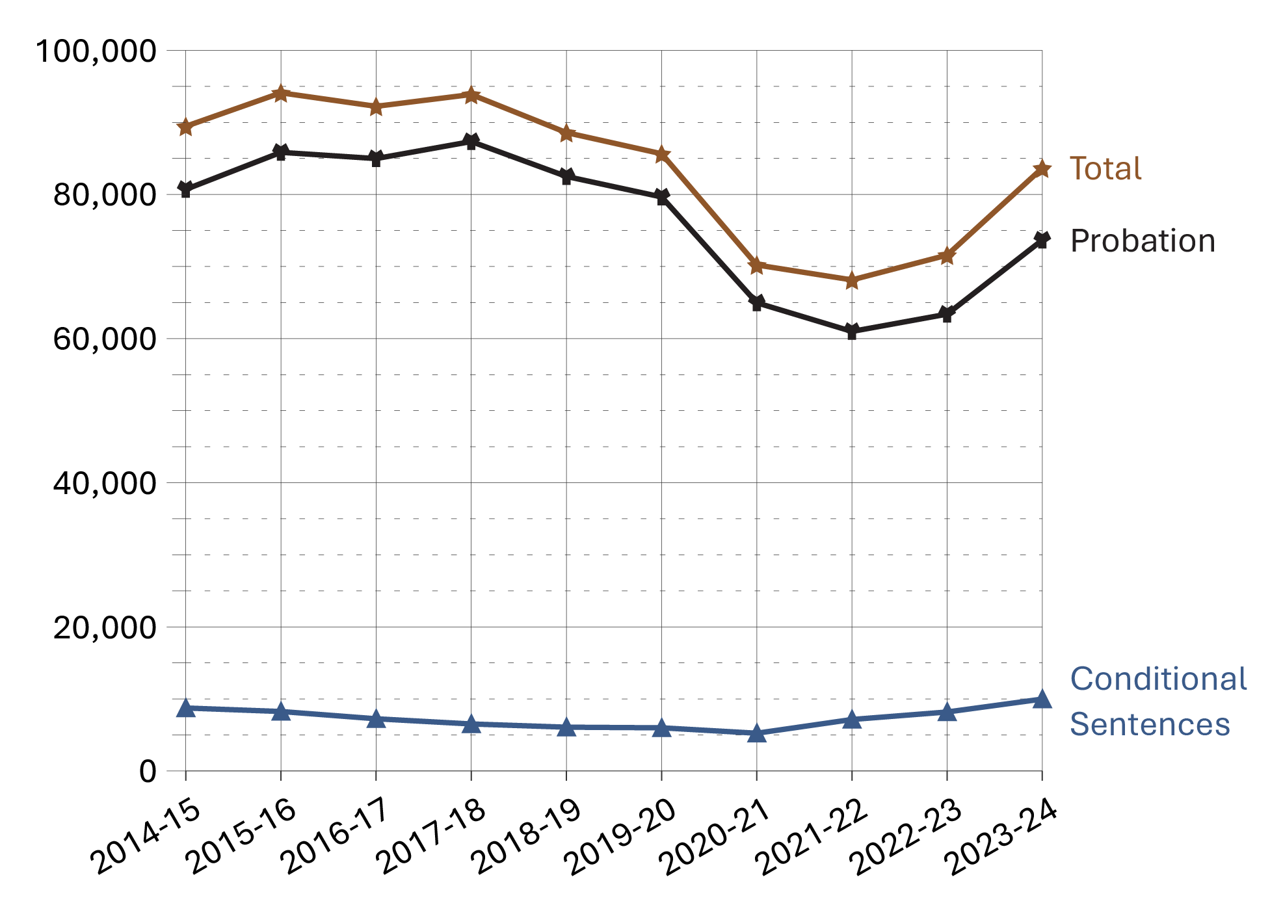
Source: Statistics Canada. Table 35-10-0154-01, Average counts of adults in provincial and territorial correctional programs.
- In the 10-year period between 2014-15 and 2023-24, there was a 6.5% decrease in the provincial/territorial community corrections population. The 2023-24 rate is 16.9% higher than in 2022-23, and -2.3% lower than the rate 5 years prior in 2019-20.
- The number of offenders on conditional sentence orders increased 14.2% from 8,746 in 2014-15 to 9,983 in 2023-24. The 2023-24 rate is 21.9% higher than 2022-23 and 66.5% higher than the rate 5 years prior in 2019-20.
- The number of offenders on probation decreased 8.7% from 2014-15 to 2023-24. The 2023-24 rate is 16.2% higher than in 2022-23 and 7.5% lower than the rate in 2019-20.

Table C31. Average offender counts
Fiscal year | Average offender counts on probation | Average offender counts on conditional sentence | Total
2014-15 | 80,705 | 8,746 | 89,451
2015-16 | 85,845 | 8,259 | 94,104
2016-17 | 84,978 | 7,249 | 92,228
2017-18 | 87,342 | 6,529 | 93,871
2018-19 | 82,500 | 6,082 | 88,582
2019-20 | 79,652 | 5,996 | 85,648
2020-21 | 64,971 | 5,246 | 70,216
2021-22 | 60,994 | 7,150 | 68,144
2022-23 | 63,393 | 8,191 | 71,584
2023-24 | 73,673 | 9,983 | 83,656
Source: Statistics Canada. Table 35-10-0154-01, Average counts of adults in provincial and territorial correctional programs.
Notes
Data points reflect the average daily count of adult offenders on probation/conditional sentence over the 12-month fiscal year period.
A conditional sentence is a disposition of the court where the offender serves a term of imprisonment in the community under specified conditions. This type of sentence can only be imposed in cases where the term of imprisonment would be less than 2 years. Conditional sentences have been a provincial and territorial sentencing option since September 1996.
The figure includes data from the most recent year available at the time of preparation.
Reported year periods reflect a fiscal year. A fiscal year runs from April 1 to March 31 of the following year.

Population of offenders on provincial parole*: 10-year trend

Figure C32. Average monthly counts of offenders on provincial parole as reported by provincial parole boards*
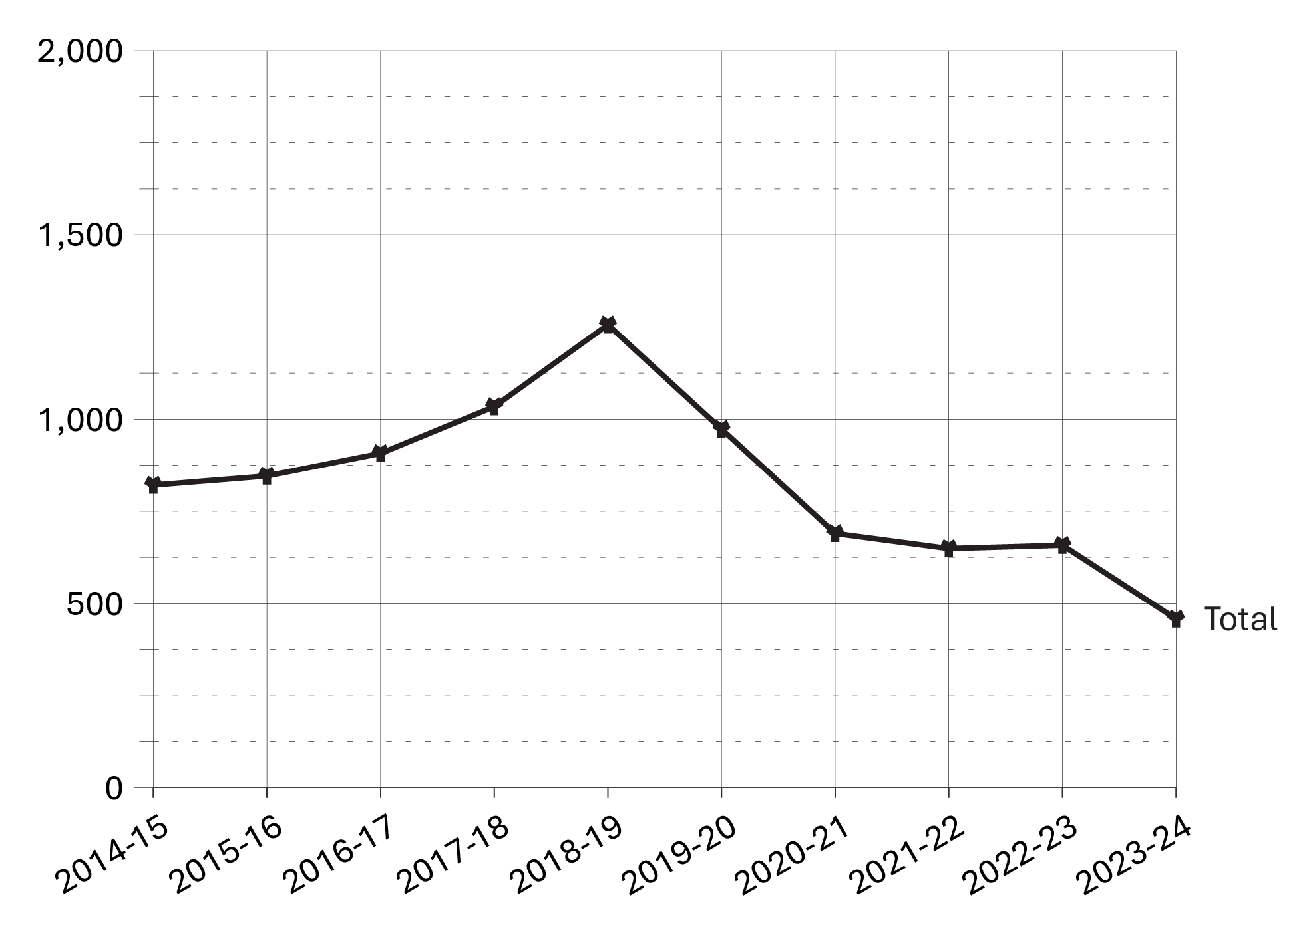
Source: Statistics Canada. Table 35-10-0154-01, Average counts of adults in provincial and territorial correctional programs.
- The number of offenders on provincial parole (as reported by provincial parole boards only*) decreased 30.4% from 2022-23 to 2023-24 (658 offenders to 458).
- In the 5 years between 2019-20 to 2023-24, there was a 52.9% decrease in the number of offenders on provincial parole (as reported by provincial parole boards only*), down from 973 in 2019-20 to 458 in 2023-24. Fluctuations observed between 2019-20 and 2022-23 may be due to the imposition and cessation of the COVID-19 pandemic lockdown restrictions.
Notes
*Data on Parole Board of Canada (federal) average monthly counts are not available for 2023-24; therefore, the data displayed in Figure C32 and accompanying bullets only represent the total average monthly counts from the Quebec, Ontario, and Alberta provincial boards (see “Total provincial boards” column in Table C32). Please exercise caution when comparing Section C32 to previous CCRSO reports.

Table C32. Average monthly counts of offenders on provincial day or full parole
Fiscal year | Quebec provincial board | Ontario provincial board | Alberta provincial board | Total provincial boards | Parole Board of Canada* | Total provincial and federal boards | % change
2014-15 | 612 | 207 | NR | 821 | 151 | 972 | 100
2015-16 | 639 | 207 | NR | 846 | 139 | 985 | 1.3
2016-17 | 701 | 205 | NR | 907 | 151 | 1,058 | 6.9
2017-18 | 792 | 242 | NR | 1,034 | 163 | 1,197 | 11.6
2018-19 | 858 | 398 | NR | 1,256 | 152 | 1,408 | 15.0
2019-20 | 682 | 289 | NR | 973 | 127 | 1,100 | -28.1
2020-21 | 490 | 197 | 2 | 690 | 117 | 807 | -36.3
2021-22 | 489 | 140 | 20 | 649 | 93 | 742 | -8.8
2022-23 | 475 | 162 | 22 | 658 | 82 | 740 | -0.2
2023-24 | 310 | 132 | 16 | 458 | NA** | NA** | NA**
Source: Statistics Canada. Table 35-10-0154-01, Average counts of adults in provincial and territorial correctional programs.
Notes
* Includes provincial offenders on full parole and day parole.
** Data on Parole Board of Canada (federal) average monthly counts are not available for 2023-24.
“Not reported” is abbreviated to “NR” in this table due to formatting.
In 2020, provincial parole boards operated in Quebec and Ontario. The provincial parole board in Alberta was officially introduced on February 1st, 2021. Thus, data related to the latter is only available beginning in 2020-21. On April 1, 2007, the Parole Board of Canada assumed responsibility for parole decisions relating to offenders serving sentences in British Columbia's provincial correctional facilities. The Parole Board of Canada has jurisdiction over granting parole to provincial offenders in the Atlantic and Prairie provinces, British Columbia, and to territorial offenders in Yukon, Nunavut, and the Northwest Territories.
The table includes data from the most recent year available at the time of preparation.
Reported year periods reflect fiscal years. A fiscal year runs from April 1 to March 31 of the following year.

Section D:
Conditional Release



Number of CSC offenders granted temporary absences: 10-year trend

Figure D1. Number of offenders granted temporary absences and work releases
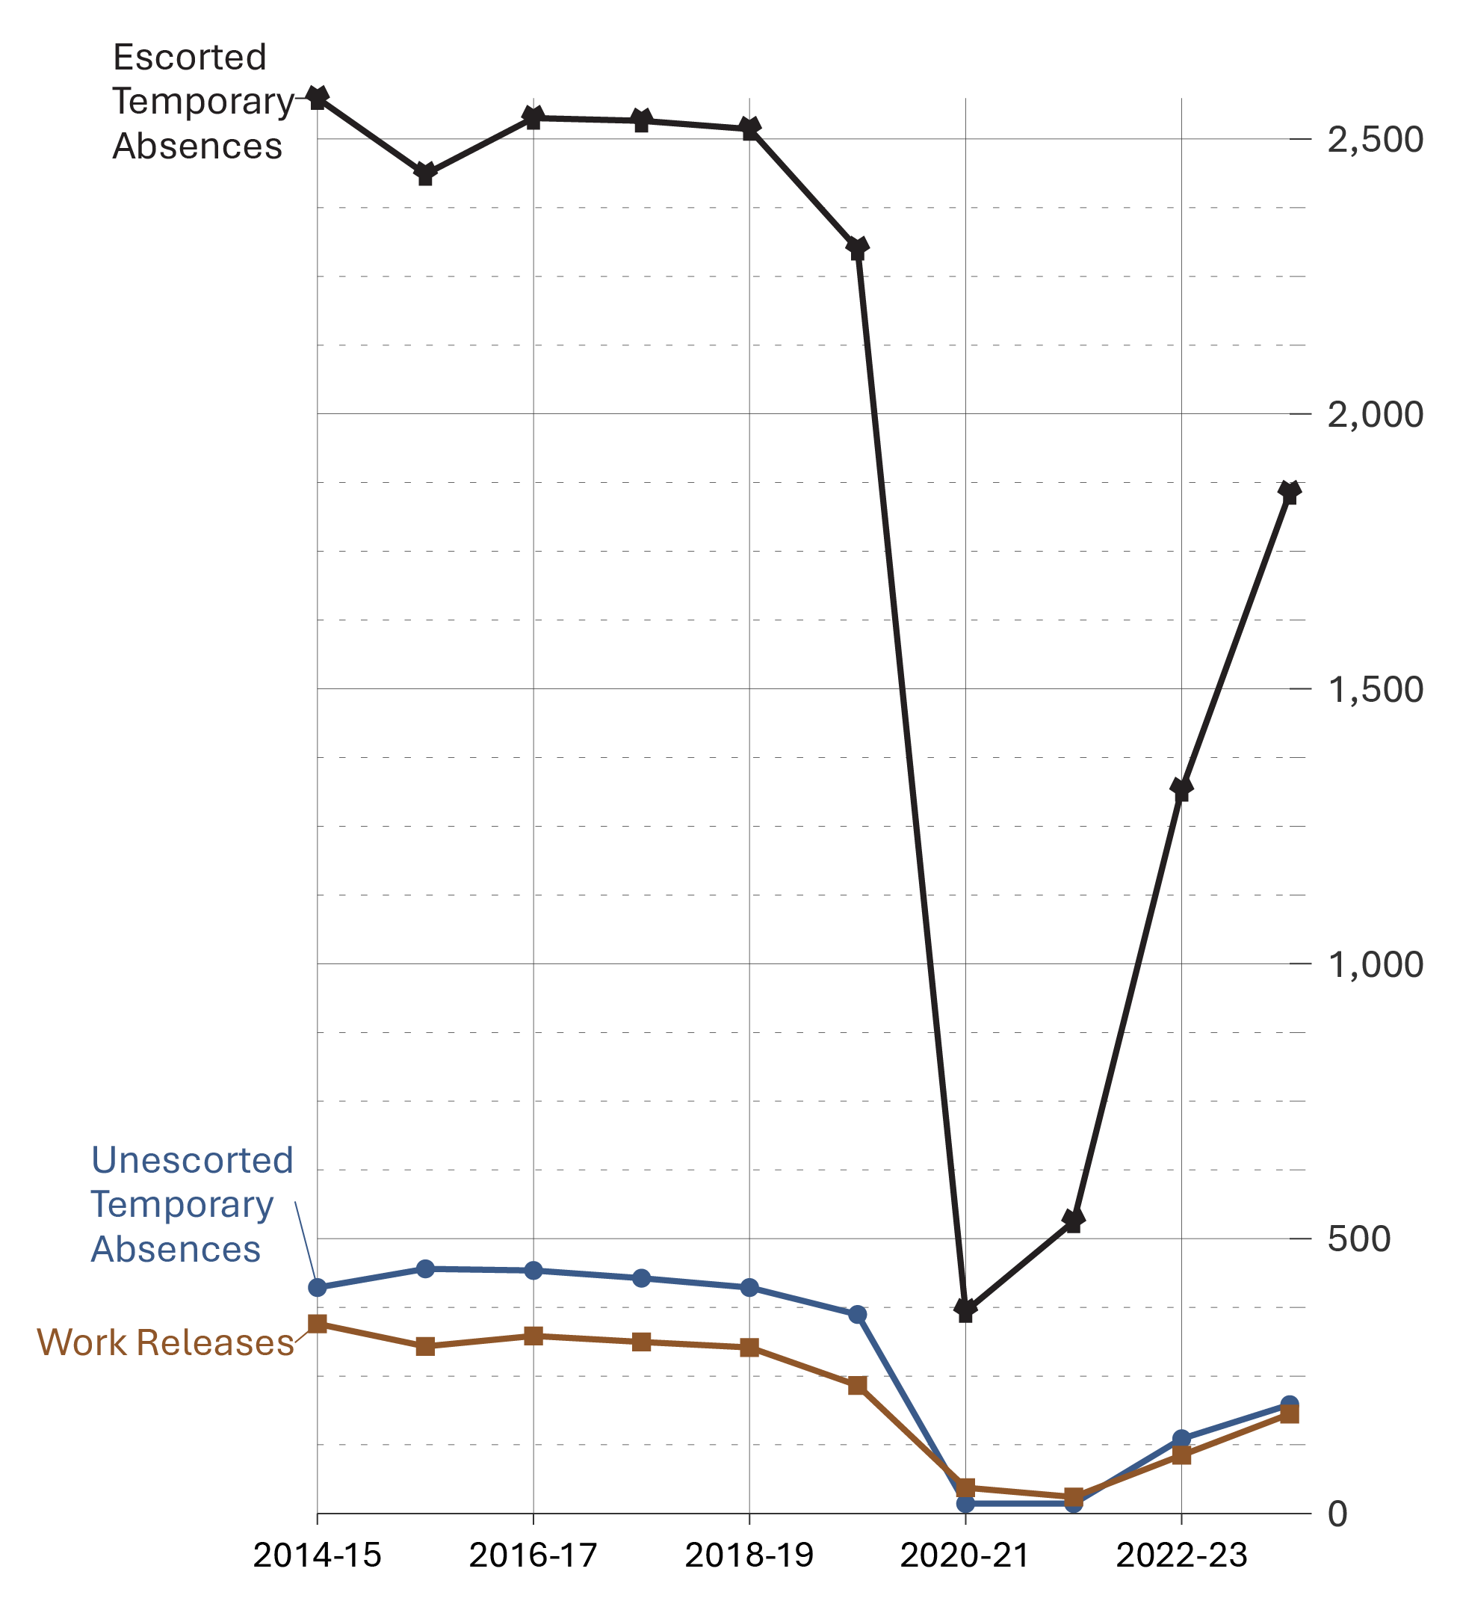
Source: Correctional Service of Canada.
- There was an increase in the number of offenders receiving escorted temporary absences, from 1,316 in 2022-23 to 1,856 in 2023-24.
- There was an increase in the number of offenders receiving unescorted temporary absences, from 136 in 2022-23 to 198 in 2023-24.
- The number of offenders receiving work releases increased from 106 in 2022-23 to 181 in 2023-24.
- For the past 10 years (from 2014-15 to 2023-24), the average successful completion rates for escorted temporary absences was 99.6%, 98.7% for unescorted temporary absences and 93.6% for work releases.

Table D1. Number of offenders granted temporary absences and work releases
Fiscal year | Escorted temporary absences (# of offenders) | Escorted temporary absences (# of permits) | Unescorted temporary absences (# of offenders) | Unescorted temporary absences (# of permits) | Work releases (# of offenders) | Work releases (# of permits)
2014-15 | 2,574 | 49,628 | 411 | 3,563 | 345 | 489
2015-16 | 2,436 | 47,066 | 445 | 4,078 | 304 | 418
2016-17 | 2,538 | 48,568 | 442 | 3,782 | 323 | 477
2017-18 | 2,533 | 50,459 | 428 | 3,163 | 312 | 443
2018-19 | 2,518 | 55,914 | 411 | 2,819 | 302 | 434
2019-20 | 2,300 | 50,984 | 362 | 2,892 | 233 | 314
2020-21 | 368 | 2,602 | 18 | 59 | 47 | 54
2021-22 | 531 | 3,859 | 18 | 44 | 30 | 36
2022-23 | 1,316 | 19,844 | 136 | 761 | 106 | 135
2023-24 | 1,856 | 35,273 | 198 | 1,455 | 181 | 277
Source: Correctional Service of Canada.
Notes
A temporary absence is permission given to an eligible offender to be away from the normal place of confinement for medical, administrative, community service, family contact, personal development for rehabilitative purposes, or compassionate reasons, including parental responsibilities.
A work release is a structured program of release of specified duration for work or community service outside the penitentiary, under the supervision of a staff member or other authorized person or organization.
Successful completion includes temporary absences or work releases with a completion status of “on time” or “extension”.
These numbers depict the number of offenders who received at least one temporary absence permit (excluding those for medical purposes) or at least one work release. An offender may be granted more than one temporary absence permit or work release over a period of time.
Reported year periods reflect fiscal years. A fiscal year runs from April 1 to March 31 of the following year.

Offenders released from federal institutions, including Healing Lodges, on parole: 10-year trend

Figure D2a. Percentage* of Indigenous offenders released from a federal institution or Healing Lodge
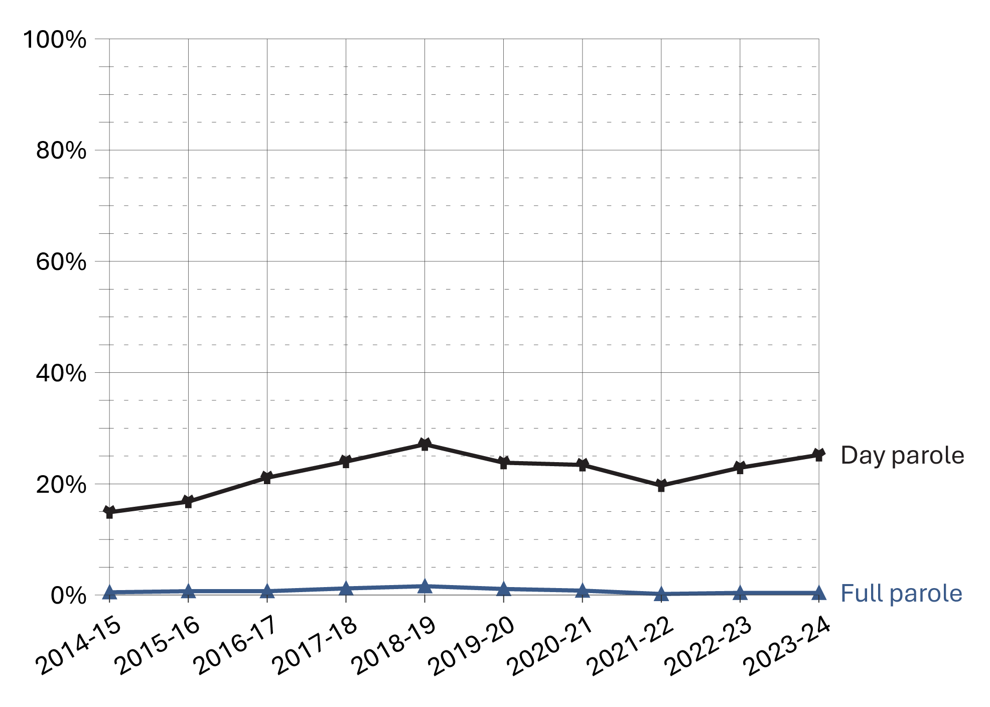
Source: Correctional Service of Canada.

Figure D2b. Percentage* of non-Indigenous offenders released from a federal institution or Healing Lodge
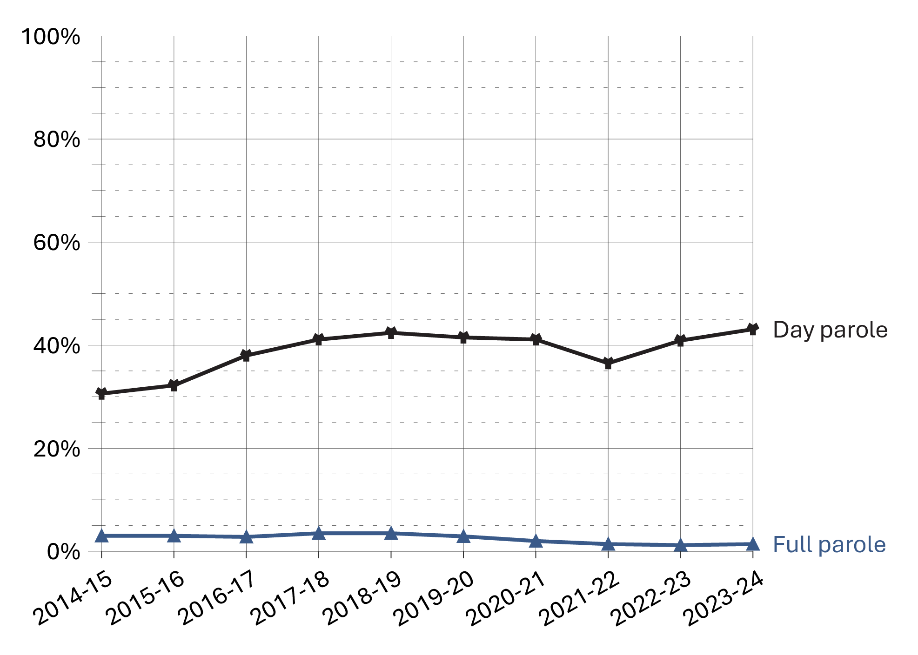
Source: Correctional Service of Canada.

Figure D2c. Percentage* of total offenders released from a federal institution or Healing Lodge
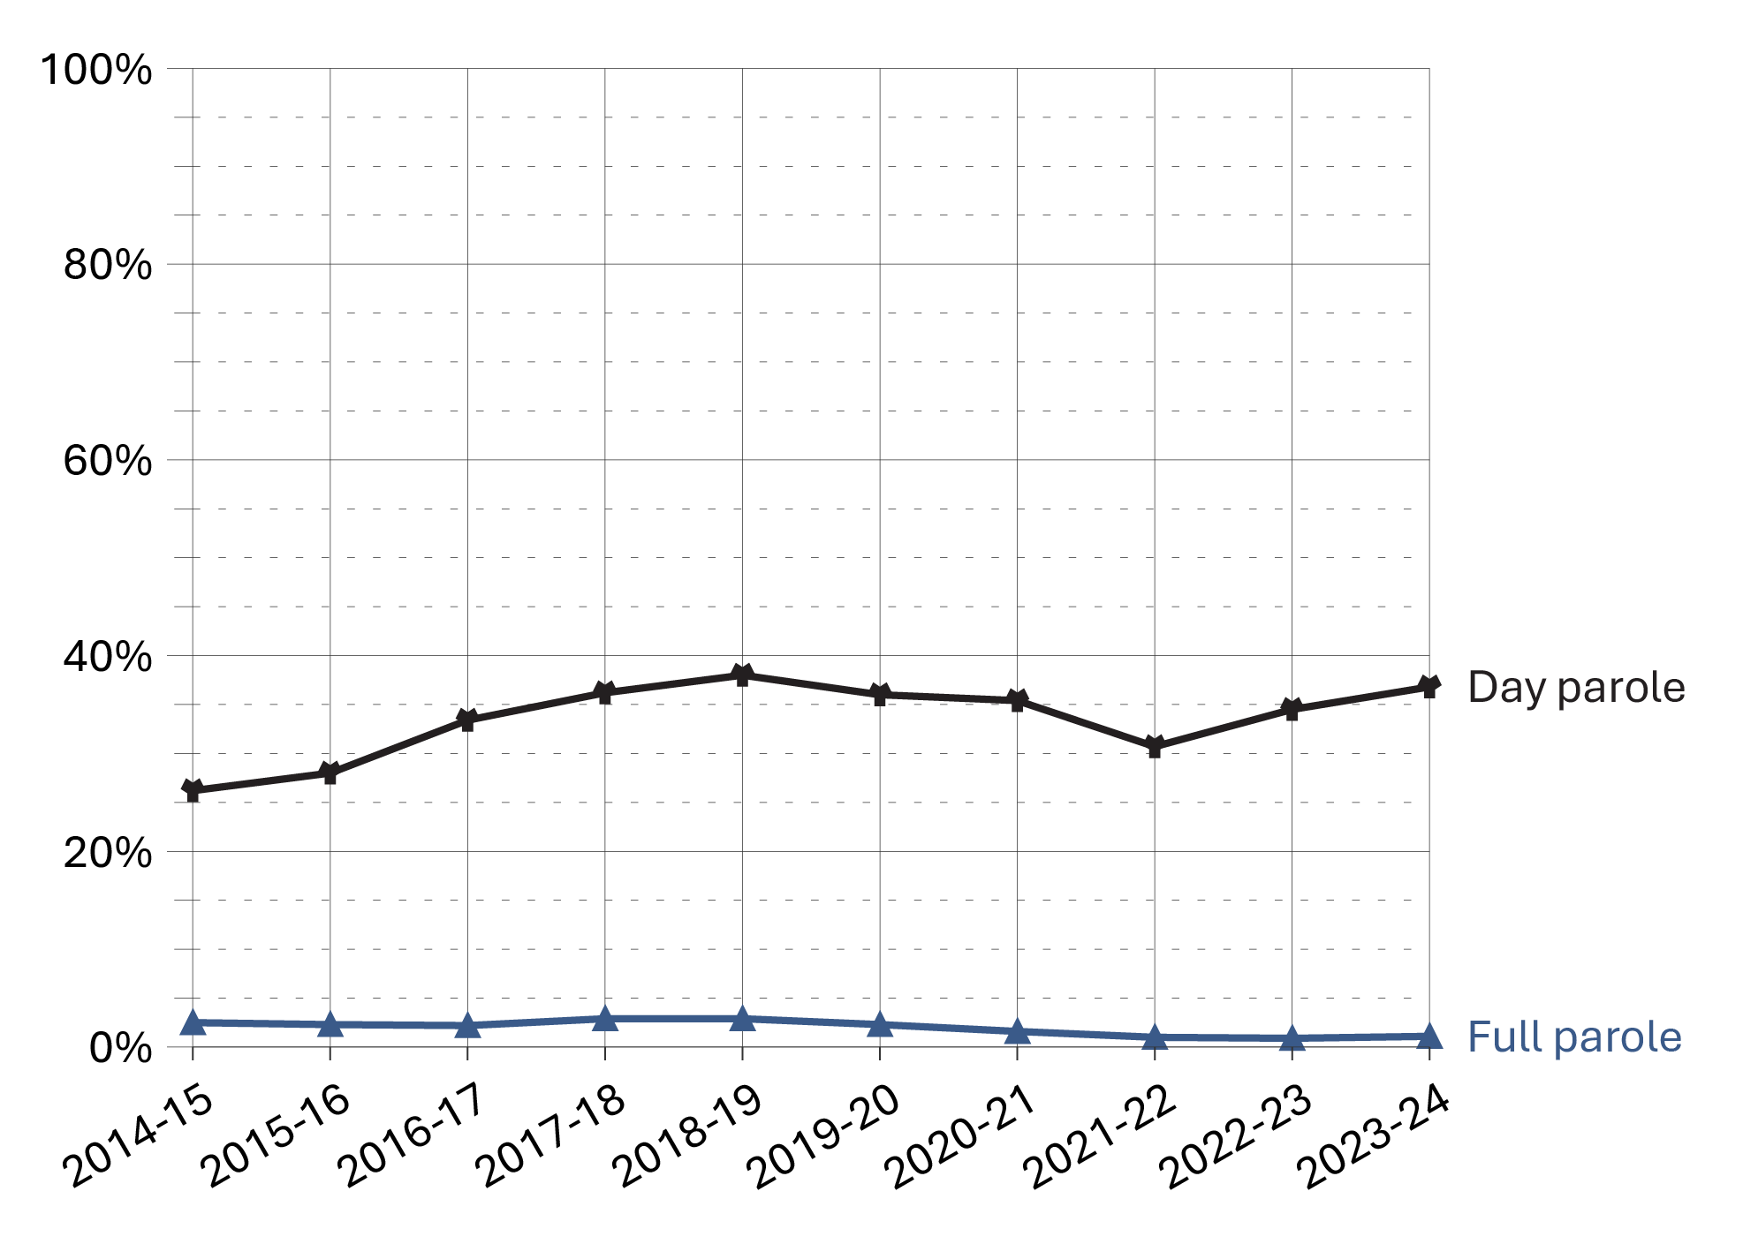
Source: Correctional Service of Canada.
- In fiscal year 2023-24, 36.8% of all releases from federal institutions were on day parole and 1.1% were on full parole.
- In fiscal year 2023-24, 25.2% of releases for Indigenous offenders were on day parole and 0.4% were on full parole compared to 43.1% and 1.4% respectively for non-Indigenous offenders.
- In fiscal year 2023-24, 35.6% of releases from federal institutions for male offenders were on day parole and 1.1% were on full parole, compared to 51.1% and 1.2%, respectively, for female offenders.
- Over the past ten years (from 2014-15 to 2023-24), the percentage of releases on day parole increased from 26.2% to 36.8% and the percentage of releases on full parole decreased from 2.5% to 1.1%.
Notes
*Percentage is calculated based on the number of day and full paroles compared to the total releases for each offender group.

Table D2a. Indigenous offenders released from a federal institution or Healing Lodge
Fiscal year | Day parole | % | Full parole | % | Total Indigenous releases
2014-15 | 314 | 14.9 | 10 | 0.5 | 2,106
2015-16 | 349 | 16.8 | 14 | 0.7 | 2,079
2016-17 | 441 | 21.1 | 14 | 0.7 | 2,086
2017-18 | 507 | 24.0 | 26 | 1.2 | 2,109
2018-19 | 557 | 27.1 | 33 | 1.6 | 2,053
2019-20 | 522 | 23.8 | 24 | 1.1 | 2,196
2020-21 | 491 | 23.4 | 16 | 0.8 | 2,102
2021-22 | 440 | 19.7 | 5 | 0.2 | 2,232
2022-23 | 514 | 22.9 | 10 | 0.4 | 2,245
2023-24 | 563 | 25.2 | 10 | 0.4 | 2,235
Source: Correctional Service of Canada.

Table D2b. Non-Indigenous offenders released from a federal institution or Healing Lodge
Fiscal year | Day parole | % | Full parole | % | Total non-Indigenous releases
2014-15 | 1,661 | 30.6 | 175 | 3.2 | 5,426
2015-16 | 1,781 | 32.2 | 164 | 3.0 | 5,537
2016-17 | 2,086 | 38.0 | 153 | 2.8 | 5,491
2017-18 | 2,115 | 41.1 | 182 | 3.5 | 5,141
2018-19 | 2,126 | 42.4 | 175 | 3.5 | 5,011
2019-20 | 2,019 | 41.5 | 140 | 2.9 | 4,865
2020-21 | 1,822 | 41.1 | 87 | 2.0 | 4,435
2021-22 | 1,521 | 36.5 | 57 | 1.4 | 4,166
2022-23 | 1,639 | 40.9 | 49 | 1.2 | 4,003
2023-24 | 1,797 | 43.1 | 59 | 1.4 | 4,171
Source: Correctional Service of Canada.

Table D2c. Male offenders released from a federal institution or Healing Lodge
Fiscal year | Day parole | % | Full parole | % | Total male releases
2014-15 | 1,790 | 25.2 | 165 | 2.3 | 7,091
2015-16 | 1,923 | 27.0 | 160 | 2.2 | 7,112
2016-17 | 2,245 | 32.0 | 143 | 2.0 | 7,015
2017-18 | 2,301 | 34.4 | 188 | 2.8 | 6,682
2018-19 | 2,369 | 36.4 | 193 | 3.0 | 6,516
2019-20 | 2,248 | 34.5 | 155 | 2.4 | 6,522
2020-21 | 2,076 | 34.2 | 91 | 1.5 | 6,064
2021-22 | 1,709 | 28.9 | 57 | 1.0 | 5,913
2022-23 | 1,912 | 33.0 | 56 | 1.0 | 5,787
2023-24 | 2,096 | 35.6 | 63 | 1.1 | 5,889
Source: Correctional Service of Canada.

Table D2d. Female offenders released from a federal institution or Healing Lodge
Fiscal year | Day parole | % | Full parole | % | Total female releases
2014-15 | 185 | 42.0 | 20 | 4.5 | 441
2015-16 | 207 | 41.1 | 18 | 3.6 | 504
2016-17 | 282 | 50.2 | 24 | 4.3 | 562
2017-18 | 321 | 56.5 | 20 | 3.5 | 568
2018-19 | 314 | 57.3 | 15 | 2.7 | 548
2019-20 | 293 | 54.4 | 9 | 1.7 | 539
2020-21 | 237 | 50.1 | 12 | 2.5 | 473
2021-22 | 252 | 52.0 | 5 | 1.0 | 485
2022-23 | 241 | 52.3 | 3 | 0.7 | 461
2023-24 | 264 | 51.1 | 6 | 1.2 | 517
Source: Correctional Service of Canada.

Table D2e. Total offenders released from a federal institution or Healing Lodge
Fiscal year | Day parole | % | Full parole | % | Total releases
2014-15 | 1,975 | 26.2 | 185 | 2.5 | 7,532
2015-16 | 2,130 | 28.0 | 178 | 2.3 | 7,616
2016-17 | 2,527 | 33.4 | 167 | 2.2 | 7,577
2017-18 | 2,622 | 36.2 | 208 | 2.9 | 7,250
2018-19 | 2,683 | 38.0 | 208 | 2.9 | 7,064
2019-20 | 2,541 | 36.0 | 164 | 2.3 | 7,061
2020-21 | 2,313 | 35.4 | 103 | 1.6 | 6,537
2021-22 | 1,961 | 30.7 | 62 | 1.0 | 6,398
2022-23 | 2,153 | 34.5 | 59 | 0.9 | 6,248
2023-24 | 2,360 | 36.8 | 69 | 1.1 | 6,406
Source: Correctional Service of Canada.
Notes
All releases include: Conditional releases of day parole, full parole or statutory release.
The data include all releases from a federal institution or Healing Lodge in a given fiscal year excluding offenders with quashed sentences, offenders who died in custody, LTSO releases, offenders released at warrant expiry, and offenders transferred to foreign countries. An offender may be released more than once during the reporting timeframe in cases where a previous release was subject to revocation, suspension, temporary detention, interruption, or in cases where an offender served more than one sentence.
Day parole is a type of conditional release granted by the Parole Board of Canada whereby offenders are permitted to participate in community-based activities in preparation for full parole or statutory release. The conditions require offenders to return nightly to an institution or halfway house unless otherwise authorized by the Parole Board of Canada.
Full parole is a type of conditional release granted by the Parole Board of Canada whereby the remainder of the sentence is served under supervision in the community.
Percentage is calculated based on the number of day and full paroles compared to the total releases for each offender group.
Reported year periods reflect fiscal years. A fiscal year runs from April 1 to March 31 of the following year.

Federal day and full parole grant rates by gender: 10-year trend

Figure D3a. Federal parole grant rates* among women
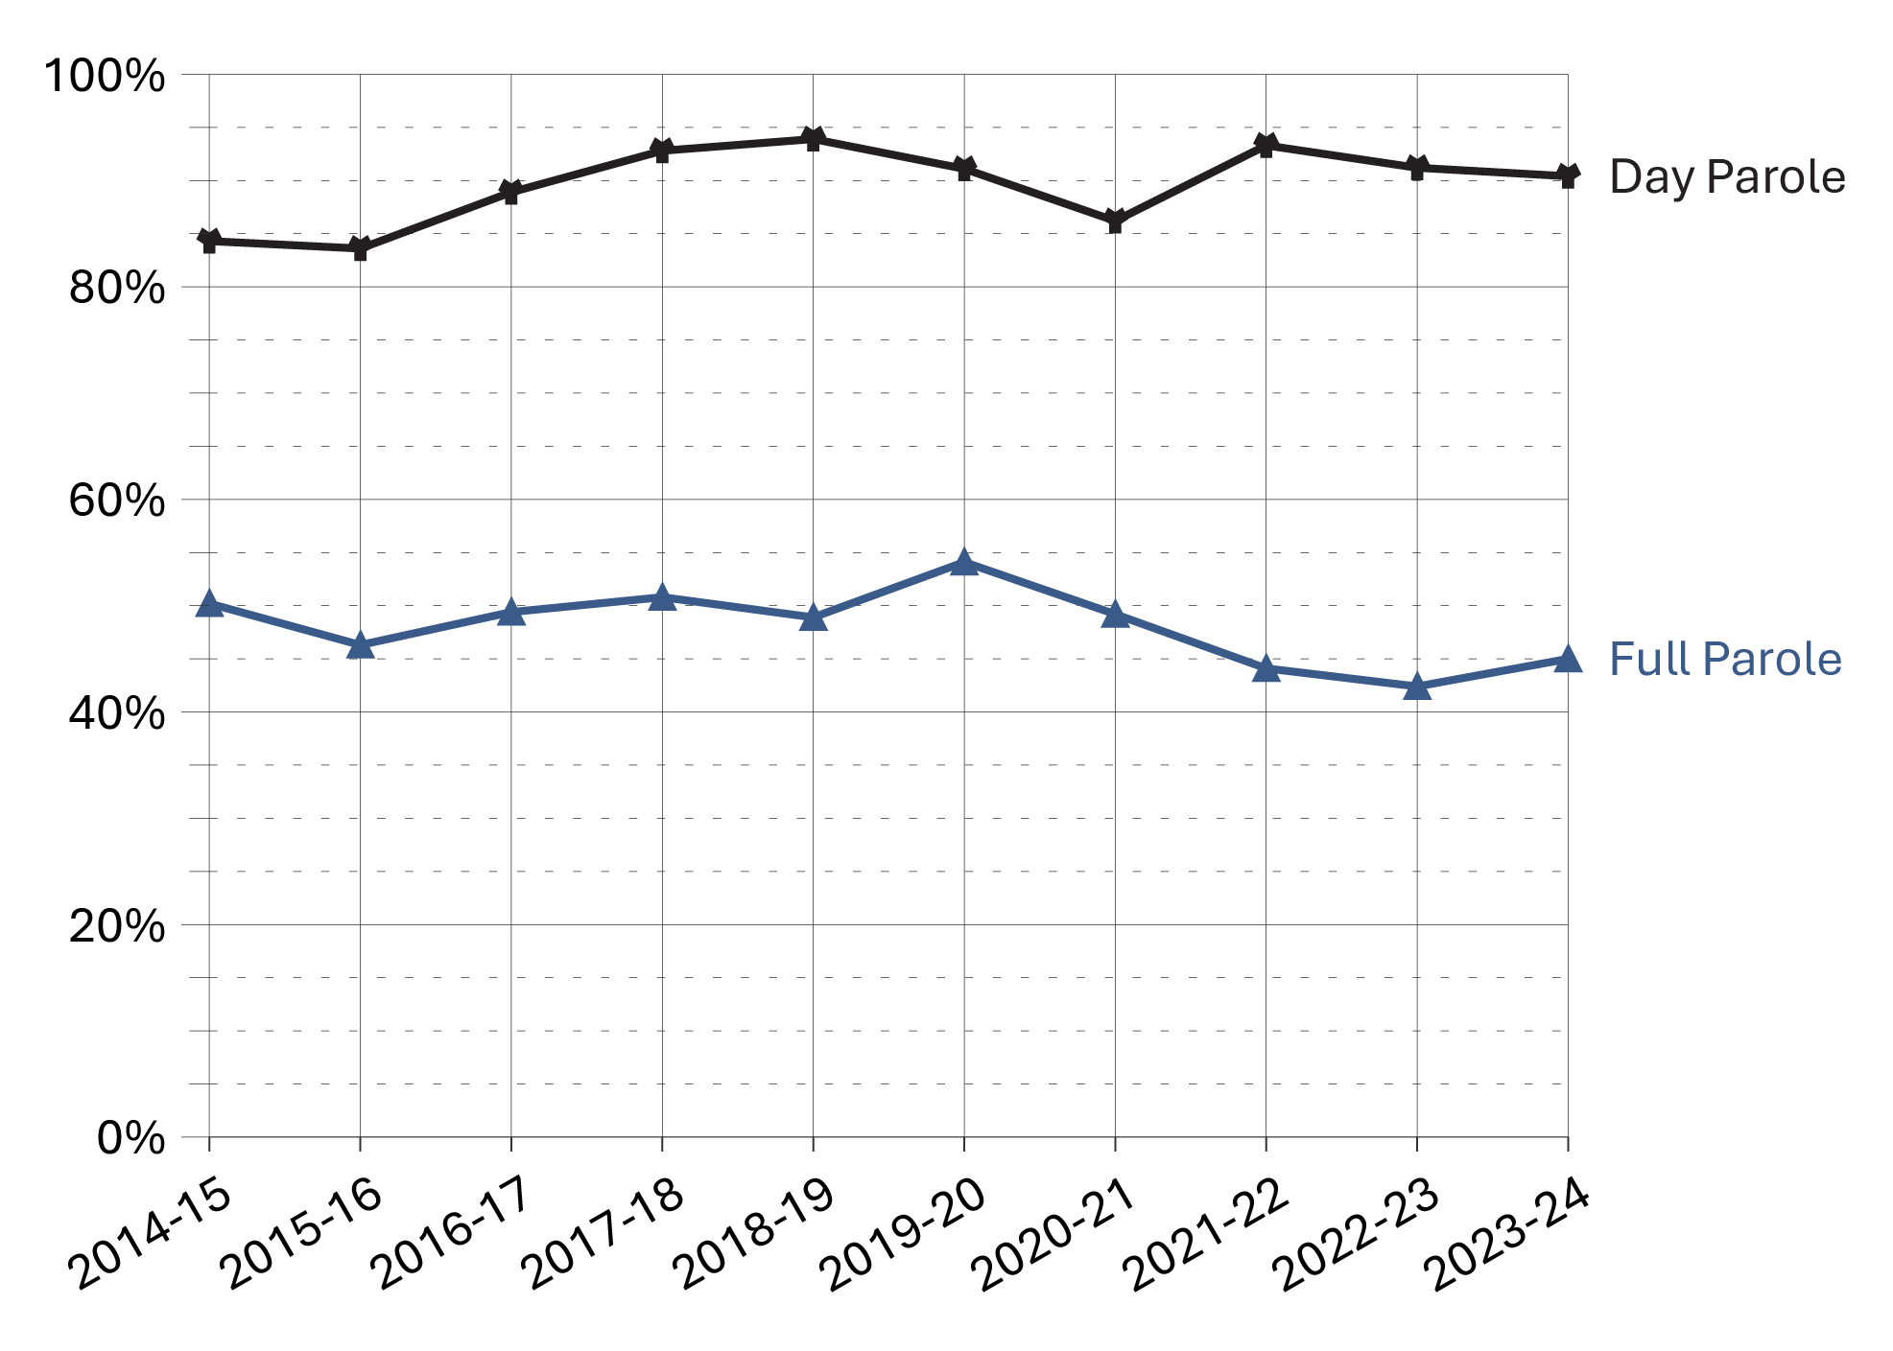
Source: Parole Board of Canada.

Figure D3b. Federal parole grant rates* among men
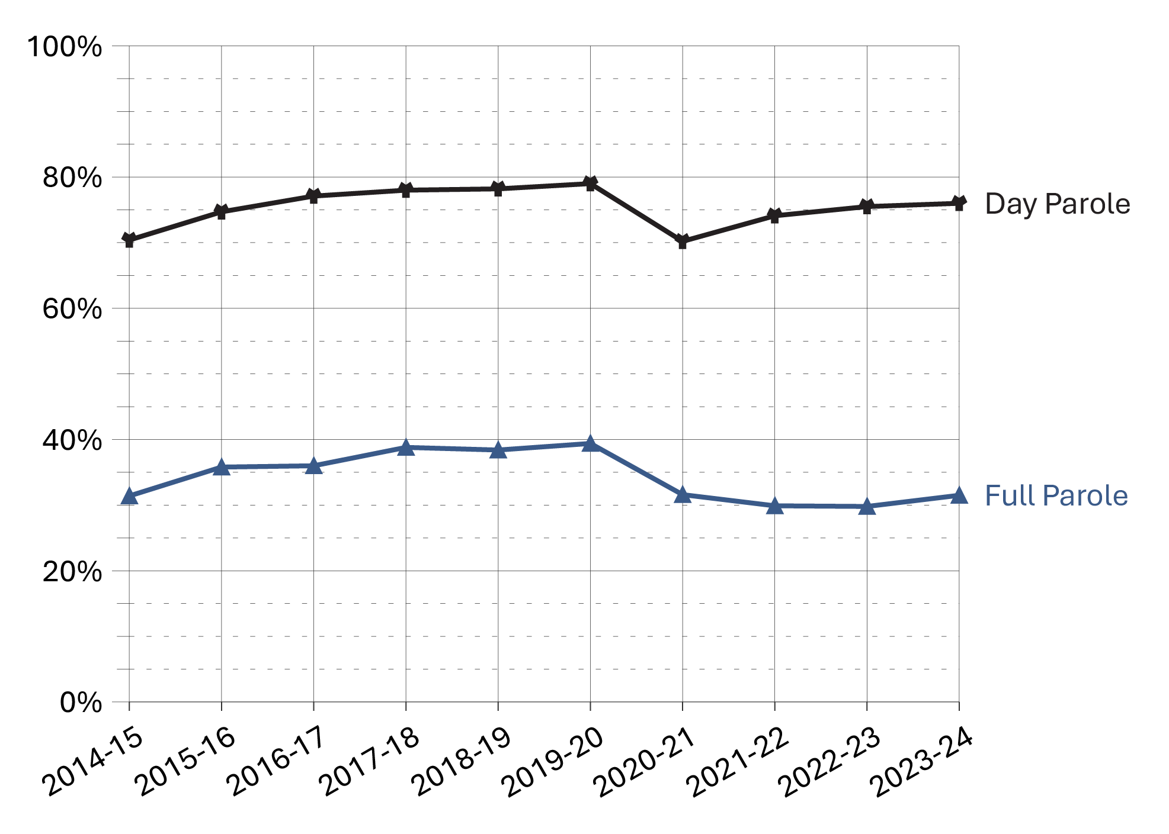
Source: Parole Board of Canada.

Figure D3c. Total federal parole grant rates*
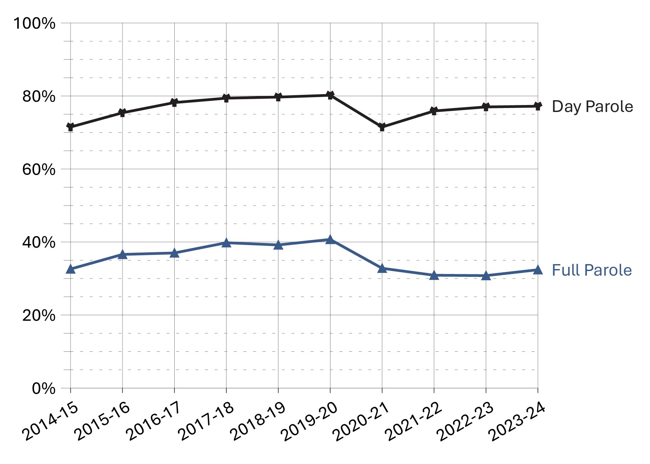
Source: Parole Board of Canada.
- In 2023-24, the federal day parole grant rate* remained stable (77.2%, +0.2%) compared to the previous fiscal year.
- In 2023-24, the federal full parole grant rate* increased slightly (32.4%, +1.7%) compared to the previous fiscal year.
- Over the past 10 fiscal years (from 2014-15 to 2023-24), women offenders had a much higher grant rate* of federal day parole and full parole (89.9% and 48.3%) than men offenders (75.4% and 34.3%).
Notes
*The grant rate represents the percentage of pre-release reviews resulting in a grant by the Parole Board of Canada.

Table D3a. Federal day parole grant rates*
Fiscal year | Granted: Women | Denied: Women | Grant rate*: Women (%) | Granted: Men | Denied: Men | Grant rate*: Men (%) | Grant rate*: Total (%)
2014-15 | 301 | 56 | 84.3 | 3,056 | 1,283 | 70.4 | 71.5
2015-16 | 305 | 60 | 83.6 | 3,164 | 1,074 | 74.7 | 75.4
2016-17 | 417 | 52 | 88.9 | 3,507 | 1,039 | 77.1 | 78.2
2017-18 | 462 | 36 | 92.8 | 3,687 | 1,039 | 78.0 | 79.4
2018-19 | 481 | 31 | 93.9 | 3,780 | 1,051 | 78.2 | 79.7
2019-20 | 448 | 44 | 91.1 | 3,623 | 963 | 79.0 | 80.2
2020-21 | 363 | 58 | 86.2 | 3,422 | 1,451 | 70.2 | 71.5
2021-22 | 391 | 28 | 93.3 | 2,932 | 1,027 | 74.1 | 75.9
2022-23 | 412 | 40 | 91.2 | 3,234 | 1,052 | 75.5 | 77.0
2023-24 | 395 | 42 | 90.4 | 3,538 | 1,120 | 76.0 | 77.2
Source: Parole Board of Canada.

Table D3b. Federal full parole grant rates*
Fiscal year | Granted: Women | Denied: Women | Grant rate*: Women (%) | Granted: Men | Denied: Men | Grant rate*: Men (%) | Grant rate*: Total (%)
2014-15 | 111 | 110 | 50.2 | 1,064 | 2,320 | 31.4 | 32.6
2015-16 | 118 | 137 | 46.3 | 1,207 | 2,163 | 35.8 | 36.6
2016-17 | 161 | 165 | 49.4 | 1,336 | 2,379 | 36.0 | 37.0
2017-18 | 187 | 181 | 50.8 | 1,490 | 2,355 | 38.8 | 39.8
2018-19 | 171 | 179 | 48.9 | 1,503 | 2,416 | 38.4 | 39.2
2019-20 | 198 | 168 | 54.1 | 1,429 | 2,199 | 39.4 | 40.7
2020-21 | 149 | 154 | 49.2 | 1,309 | 2,828 | 31.6 | 32.8
2021-22 | 119 | 151 | 44.1 | 977 | 2,296 | 29.9 | 30.9
2022-23 | 120 | 163 | 42.4 | 1,036 | 2,440 | 29.8 | 30.8
2023-24 | 122 | 149 | 45.0 | 1,138 | 2,477 | 31.5 | 32.4
Source: Parole Board of Canada.
Notes
*The grant rate represents the percentage of pre-release reviews resulting in a grant by the Parole Board of Canada (PBC).
Accelerated Parole Review (APR): A parole review mechanism – eliminated on March 28, 2011, under the Abolition of Early Parole Act (AEPA) – that was available to non-violent offenders serving a first-time sentence in a federal institution. These offenders became eligible for APR after serving the greater of six months or one-sixth of their sentence. The AEPA’s transitional provisions have been a matter of federal and provincial litigation, which has resulted in variations in their application across Canada.
Between 2014-15 and 2023-24, the PBC rendered 515 federal APR day parole release decisions (94.8% were directed) and 844 federal APR full parole release decisions (94.4% were directed).
Day parole is a type of conditional release granted by the Parole Board of Canada in which offenders are permitted to participate in community-based activities in preparation for full parole or statutory release. The conditions require offenders to return nightly to an institution, half-way house, or other location deemed appropriate for managing their risk, unless otherwise authorized by the Parole Board of Canada. Not all offenders apply for day parole, and some apply more than once before being granted day parole.
Full parole is a type of conditional release granted by the Parole Board of Canada in which the remainder of the sentence is served under supervision in the community. The Parole Board of Canada must review the cases of all offenders for full parole at the time prescribed by legislation, unless the offender advises the Parole Board of Canada in writing that they do not wish to be considered for full parole.
Not included were parole release decisions made in respect of offenders who identified as another gender.
Between 2014-15 and 2023-24, there were 27 federal day parole release decisions (59.3% were granted) and 19 federal full parole release decisions (10.5% were granted) made in respect of offenders who identified as another gender.
Reported year periods reflect fiscal years. A fiscal year runs from April 1 to March 31 of the following year.

Federal day and full parole grant rates by Indigenous and non-Indigenous offenders: 10-year trend

Figure D4. Federal parole grant rates* by Indigenous and non-Indigenous offenders
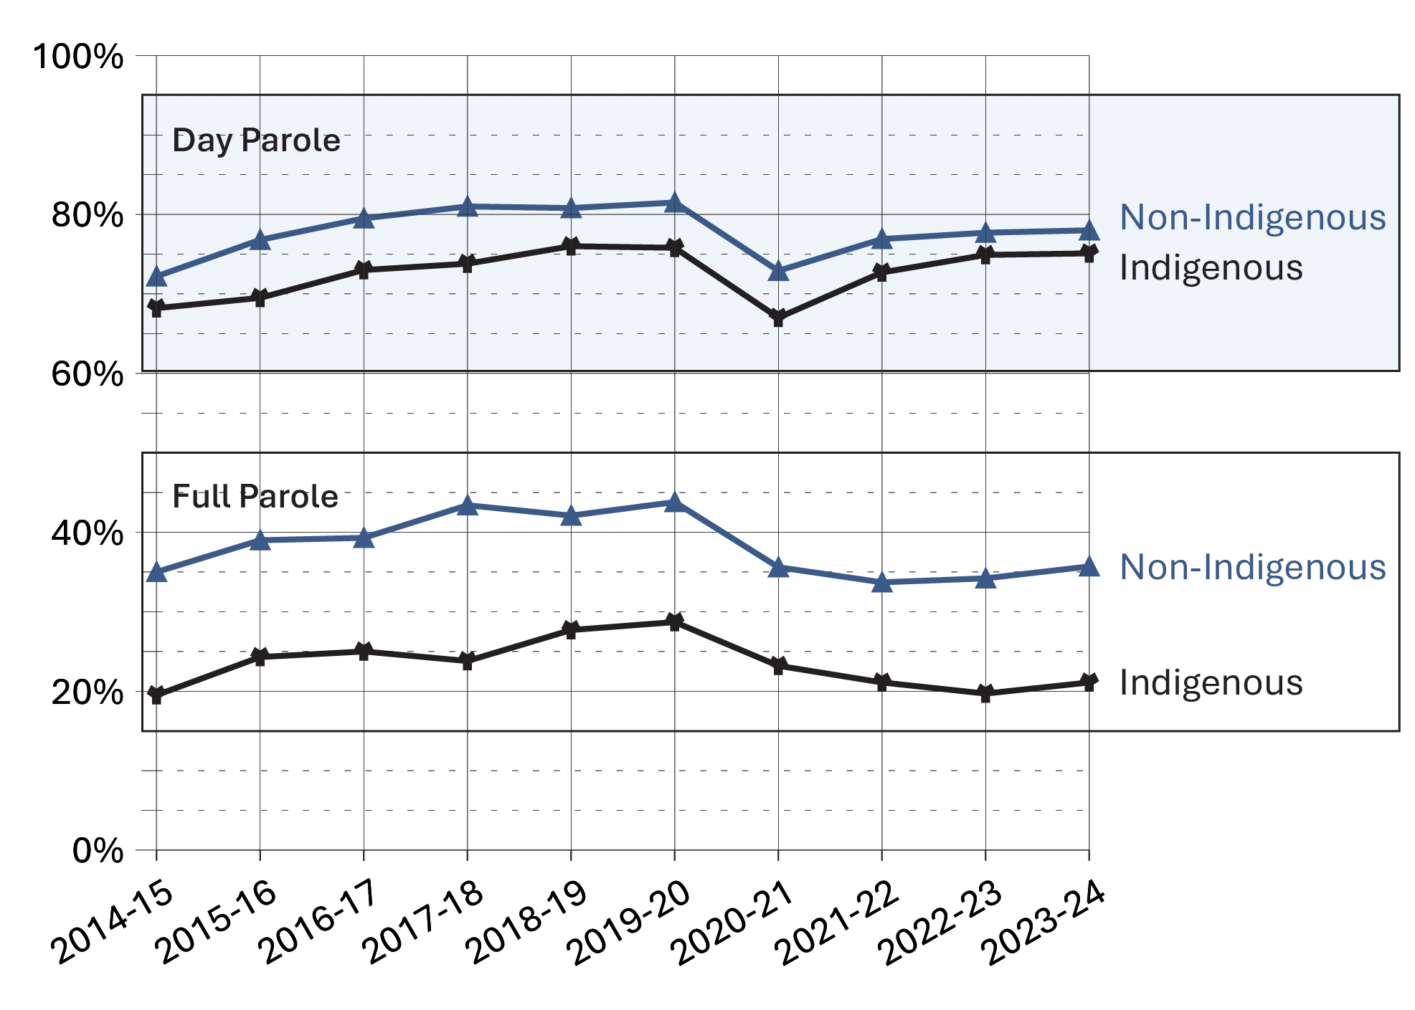
Source: Parole Board of Canada.
- In 2023-24, the federal day parole grant rate remained stable for both Indigenous (75.1%; +0.2%) and non-Indigenous offenders (78.0%; +0.3%) compared to 2022-23.
- In 2023-24, the federal full parole grant rate increased slightly for both Indigenous (21.1%; +1.4%) and non-Indigenous offenders (35.7%; +1.6%) compared to 2022-23.
- For each of the past 10 fiscal years (from 2014-15 to 2023-24), lower federal day and full parole grant rates have been reported for Indigenous offenders than for non-Indigenous offenders.

Notes
*The grant rate represents the percentage of pre-release reviews resulting in a grant by the Parole Board of Canada.

Table D4a. Federal day parole grant rates* by offender race group
Race group | 2014-15 | 2015-16 | 2016-17 | 2017-18 | 2018-19 | 2019-20 | 2020-21 | 2021-22 | 2022-23 | 2023-24
Indigenous  grant rate (%) | 68.2 | 69.5 | 73.0 | 73.8 | 76.0 | 75.8 | 67.0 | 72.7 | 74.9 | 75.1
Granted (#) | 581 | 626 | 731 | 838 | 943 | 917 | 881 | 787 | 927 | 1,023
Denied (#) | 271 | 275 | 271 | 298 | 297 | 292 | 433 | 296 | 311 | 340
Asian grant rate (%) | 76.2 | 78.1 | 82.8 | 82.4 | 84.0 | 82.1 | 75.4 | 82.2 | 85.1 | 82.4
Granted (#) | 250 | 236 | 270 | 263 | 263 | 256 | 242 | 221 | 274 | 267
Denied (#) | 78 | 66 | 56 | 56 | 50 | 56 | 79 | 48 | 48 | 57
Black grant rate (%) | 69.7 | 71.0 | 76.1 | 73.3 | 78.2 | 76.2 | 67.5 | 71.0 | 72.1 | 74.6
Granted (#) | 223 | 252 | 245 | 266 | 295 | 311 | 291 | 259 | 263 | 312
Denied (#) | 97 | 103 | 77 | 97 | 82 | 97 | 140 | 106 | 102 | 106
Caucasian grant rate (%) | 72.3 | 77.3 | 79.5 | 81.7 | 80.9 | 81.8 | 73.1 | 77.5 | 77.5 | 77.9
Granted (#) | 2,234 | 2,246 | 2,504 | 2,605 | 2,619 | 2,430 | 2,240 | 1,940 | 2,031 | 2,162
Denied (#) | 857 | 660 | 644 | 584 | 620 | 539 | 823 | 564 | 588 | 612
Other grant rate (%) | 65.7 | 78.6 | 79.8 | 81.6 | 80.2 | 87.4 | 78.7 | 73.0 | 77.6 | 78.2
Granted (#) | 71 | 110 | 174 | 177 | 142 | 159 | 133 | 116 | 152 | 176
Denied (#) | 37 | 30 | 44 | 40 | 35 | 23 | 36 | 43 | 44 | 49
Total day parole grant rate (%) | 71.5 | 75.4 | 78.2 | 79.4 | 79.7 | 80.2 | 71.5 | 75.9 | 76.9 | 77.2
Total granted (#) | 3,359 | 3,470 | 3,924 | 4,149 | 4,262 | 4,073 | 3,787 | 3,323 | 3,647 | 3,940
Total denied (#) | 1,340 | 1,134 | 1,092 | 1,075 | 1,084 | 1,007 | 1,511 | 1,057 | 1,093 | 1,164
Source: Parole Board of Canada.
Table D4b. Federal full parole grant rates* by offender race group
Race group | 2014-15 | 2015-16 | 2016-17 | 2017-18 | 2018-19 | 2019-20 | 2020-21 | 2021-22 | 2022-23 | 2023-24
Indigenous  grant rate (%) | 19.5 | 24.3 | 25.0 | 23.8 | 27.7 | 28.7 | 23.2 | 21.1 | 19.7 | 21.1
Granted (#) | 111 | 144 | 161 | 182 | 237 | 232 | 229 | 166 | 175 | 186
Denied (#) | 458 | 449 | 482 | 583 | 618 | 576 | 760 | 621 | 715 | 696
Asian grant rate (%) | 47.2 | 48.2 | 51.1 | 52.9 | 49.5 | 49.5 | 44.5 | 41.2 | 45.4 | 49.6
Granted (#) | 153 | 122 | 160 | 164 | 158 | 147 | 141 | 101 | 118 | 141
Denied (#) | 171 | 131 | 154 | 146 | 161 | 150 | 176 | 144 | 142 | 143
Black grant rate (%) | 39.6 | 37.8 | 39.9 | 43.6 | 38.7 | 44.0 | 36.2 | 33.7 | 33.1 | 28.4
Granted (#) | 113 | 129 | 110 | 144 | 121 | 155 | 150 | 121 | 111 | 98
Denied (#) | 172 | 212 | 166 | 186 | 192 | 197 | 264 | 238 | 224 | 247
Caucasian grant rate (%) | 33.0 | 37.6 | 37.6 | 41.5 | 41.3 | 42.7 | 33.6 | 32.6 | 33.1 | 35.2
Granted (#) | 768 | 870 | 979 | 1,079 | 1,072 | 1,010 | 858 | 652 | 693 | 767
Denied (#) | 1,562 | 1,441 | 1,626 | 1,522 | 1,524 | 1,357 | 1,695 | 1,349 | 1,398 | 1,413
Other grant rate (%) | 30.6 | 47.2 | 42.6 | 52.2 | 46.0 | 48.8 | 47.1 | 36.4 | 31.9 | 34.5
Granted (#) | 30 | 60 | 87 | 108 | 86 | 83 | 80 | 56 | 59 | 70
Denied (#) | 68 | 67 | 117 | 99 | 101 | 87 | 90 | 98 | 126 | 133
Total full parole  grant rate (%) | 32.6 | 36.6 | 37.0 | 39.8 | 39.2 | 40.7 | 32.8 | 30.9 | 30.7 | 32.4
Total granted (#) | 1,175 | 1,325 | 1,497 | 1,677 | 1,674 | 1,627 | 1,458 | 1,096 | 1,156 | 1,262
Total denied (#) | 2,431 | 2,300 | 2,545 | 2,536 | 2,596 | 2,367 | 2,985 | 2,450 | 2,605 | 2,632

Source: Parole Board of Canada.
Notes
*The grant rate represents the percentage of pre-release reviews resulting in a grant by the Parole Board of Canada.
Accelerated Parole Review (APR): A parole review mechanism – eliminated on March 28, 2011, under the Abolition of Early Parole Act (AEPA) – that was available to non-violent offenders serving a first-time sentence in a federal institution. These offenders became eligible for APR after serving the greater of six months or one-sixth of their sentence. The AEPA’s transitional provisions have been a matter of federal and provincial litigation, which has resulted in variations in their application across Canada.
Between 2014-15 and 2023-24, the PBC rendered 515 federal APR day parole release decisions (94.8% were directed) and 844 federal APR full parole release decisions (94.4% were directed).
During intake assessment, parole officers ask federal offenders to self-identify their race and this information is entered into the Correctional Service of Canada’s (CSC) Offender Management System. Parole Board of Canada (PBC) uses the term “race grouping” as this is the term used by CSC to collect the information from offenders and also reflects how the data is captured in CSC’s and PBC’s data tables.
Day parole is a type of conditional release granted by the Parole Board of Canada in which offenders are permitted to participate in community-based activities in preparation for full parole or statutory release. The conditions require offenders to return nightly to an institution, halfway house, or other location deemed appropriate for managing their risk, unless otherwise authorized by the Parole Board of Canada. Not all offenders apply for day parole, and some apply more than once before being granted day parole.
Full parole is a type of conditional release granted by the Parole Board of Canada in which the remainder of the sentence is served under supervision in the community. The Parole Board of Canada must review the cases of all offenders for full parole at the time prescribed by legislation, unless the offender advises the Parole Board of Canada in writing that they do not wish to be considered for full parole.
Reported year periods reflect fiscal years. A fiscal year runs from April 1 to March 31 of the following year.

Number of Culturally Responsive Hearings: 10-year trend

Figure D5. Number of Culturally Responsive Hearings
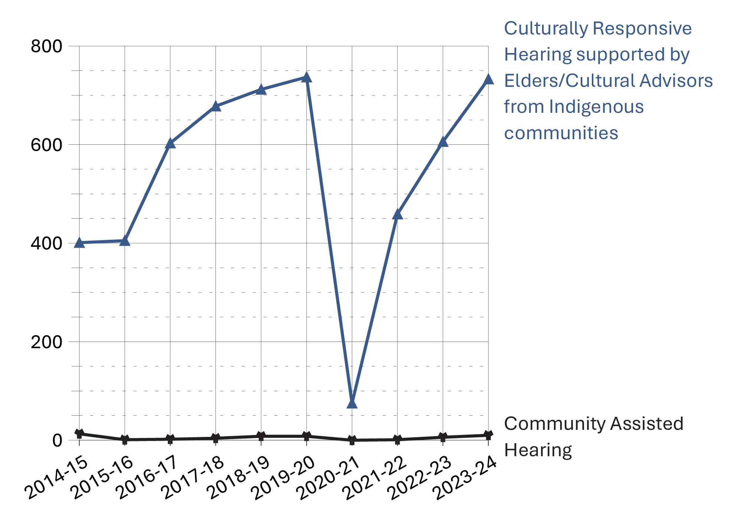
Source: Parole Board of Canada.
- After reporting a decrease of 89.9% in 2020-21 due to health and safety measures put in place to respond to the COVID-19 pandemic, the number of federal Community Assisted and Culturally Responsive Hearings supported by Elders/Cultural Advisors from Indigenous communities increased significantly in 2021-22 (to 460 from 75). In 2023-24, the number of Community-Assisted and Culturally Responsive Hearings supported by Elders/Cultural Advisors from Indigenous communities further increased to 743, reaching pre-pandemic levels.
- In the 10-year period from 2014-15 to 2023-24, the number of Community-Assisted and Culturally Responsive Hearings supported by Elders/Cultural Advisors from Indigenous communities has increased by 79.5%.

Table D5. Number of Culturally Responsive Hearings
Fiscal year | Community Assisted Hearings | Culturally Responsive Hearings supported by Elders/Cultural Advisors from Indigenous communities
2014-15 | 13 | 401
2015-16 | 1 | 405
2016-17 | 2 | 603
2017-18 | 4 | 678
2018-19 | 8 | 712
2019-20 | 8 | 737
2020-21 | 0 | 75
2021-22 | 1 | 459
2022-23 | 6 | 606
2023-24 | 10 | 733
Source: Parole Board of Canada.
Notes
Per section 9.1.1 of the Parole Board of Canada’s Decision-Making Policy Manual, the objective of Culturally Responsive Hearings is to provide an adapted hearing processes for Indigenous and Black offenders that adhere to the decision-making criteria set out in law.
Community Assisted: A Culturally Responsive Hearing that involves the application of Section 84 of the Corrections and Conditional Release Act and allows members of the Indigenous community where the offender’s release is being proposed to participate. Community Assisted Hearings are generally conducted in the community.
In June 2022, to address the over-representation of Black individuals in the criminal justice system, the PBC introduced a pilot project based out of the Atlantic region to offer Culturally Responsive Hearings (CRHs) supported by Cultural Advisors from Black communities. In January 2024, the PBC implemented CRHs supported by Cultural Advisors from Black communities across all regions. In 2023-24, there were 23 CRHs supported by Cultural Advisors from Black communities, an increase from the 18 held in 2022-23 during the first fiscal year of the pilot.
Reported year periods reflect fiscal years. A fiscal year runs from April 1 to March 31 of the following year.

Proportion of sentence served prior to being released on parole: 10-year trend

Figure D6. Proportion of sentence served in custody before first federal parole
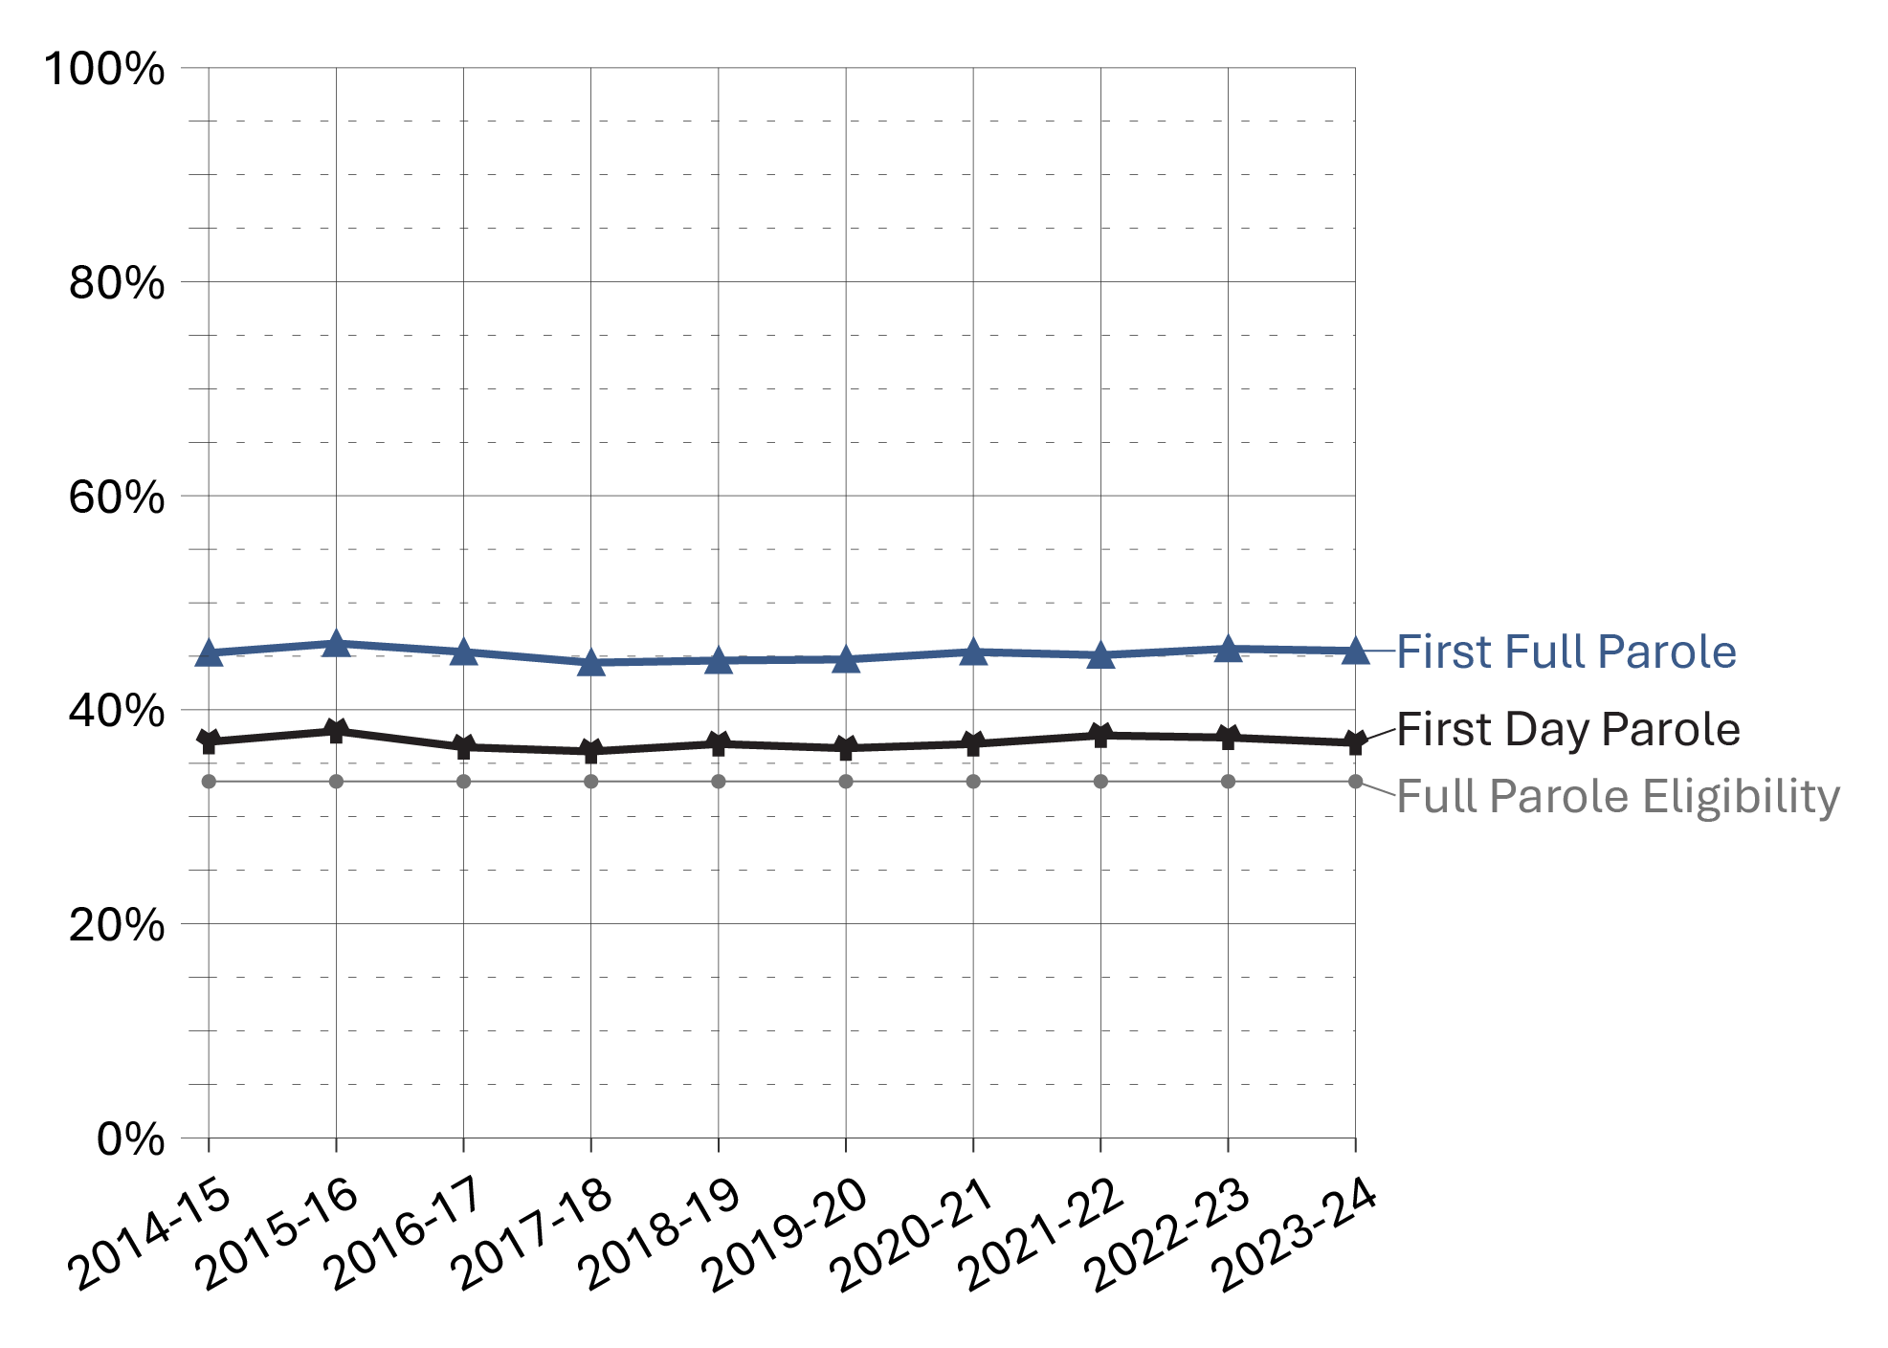
Source: Parole Board of Canada.
- In 2023-24, the average proportion of sentence served before the first federal day parole release for offenders serving determinate sentences remained stable (36.9%; -0.4%) from the previous fiscal year.
- The proportion of sentence served prior to the first federal full parole release for offenders serving determinate sentences remained stable (45.5%; -0.2%) in 2023-24 when compared to the previous fiscal year.
- In 2023-24, men offenders served a higher proportion of their sentences before being released on their first federal day parole and full parole (37.3%; 45.8%) than women offenders (33.9%; 42.5%).
- In 2023-24, the average proportion of sentence served by both men and women offenders before their first federal day parole release remained stable (+0.1% and -0.9%, respectively) compared to 2014-15.
- In 2023-24, the average proportion of sentence served before the first federal full parole release decreased for women offenders (-1.7%) and remained stable for men offenders (+0.5%) compared to 2014-15.

Table D6a. Proportion of sentence served in custody before first federal day parole
Fiscal year | Women (%) | Men (%) | Total (%)
2014-15 | 34.8 | 37.2 | 37.0
2015-16 | 36.5 | 38.1 | 38.0
2016-17 | 33.1 | 37.0 | 36.5
2017-18 | 32.5 | 36.6 | 36.1
2018-19 | 32.0 | 37.4 | 36.8
2019-20 | 30.4 | 37.2 | 36.4
2020-21 | 33.2 | 37.2 | 36.8
2021-22 | 33.9 | 38.2 | 37.6
2022-23 | 35.1 | 37.6 | 37.4
2023-24 | 33.9 | 37.3 | 36.9
Source: Parole Board of Canada.

Table D6b. Proportion of sentence served in custody before first federal full parole
Fiscal year | Women (%) | Men (%) | Total (%)
2014-15 | 44.3 | 45.4 | 45.3
2015-16 | 44.9 | 46.3 | 46.2
2016-17 | 43.3 | 45.7 | 45.4
2017-18 | 41.7 | 44.8 | 44.4
2018-19 | 41.5 | 44.9 | 44.6
2019-20 | 41.4 | 45.1 | 44.7
2020-21 | 42.7 | 45.8 | 45.4
2021-22 | 42.2 | 45.5 | 45.1
2022-23 | 44.0 | 45.9 | 45.7
2023-24 | 42.5 | 45.8 | 45.5
Source: Parole Board of Canada.
Notes
Full parole is a type of conditional release granted by the Parole Board of Canada in which the remainder of the sentence is served under supervision in the community. The Parole Board of Canada must review the cases of all offenders for full parole at the time prescribed by legislation, unless the offender advises the Parole Board of Canada in writing that they do not wish to be considered for full parole.
Day parole is a type of conditional release granted by the Parole Board of Canada in which offenders are permitted to participate in community-based activities in preparation for full parole or statutory release. The conditions require offenders to return nightly to an institution, halfway house, or other location deemed appropriate for managing their risk, unless otherwise authorized by the Parole Board of Canada. Not all offenders apply for day parole, and some apply more than once before being granted day parole.
Timing of parole in the sentence refers to the percentage of the sentence served at the time the first day parole or full parole starts during the sentence. In most cases a full parole is preceded by a day parole. These calculations are based on sentences under federal jurisdiction, excluding life sentences and indeterminate sentences. Offenders (other than those serving life or indeterminate sentences or subject to judicial determination) normally become eligible for full parole after serving 1/3 of their sentence or 7 years, whichever is less. Eligibility for day parole is normally at 6 months before full parole eligibility.
Not included were the proportion of sentence served by offenders who identified as another gender. In 2023-24, the proportion of sentence served by those offenders prior to being release on federal day parole was 35.2 % and 45.0% on federal full parole.
Reported year periods reflect fiscal years. A fiscal year runs from April 1 to March 31 of the following year.

Proportion of sentence served by Indigenous and non-Indigenous offenders prior to being released on parole: 10-year trend

Figure D7a. Proportion of sentence served in custody before first federal day parole
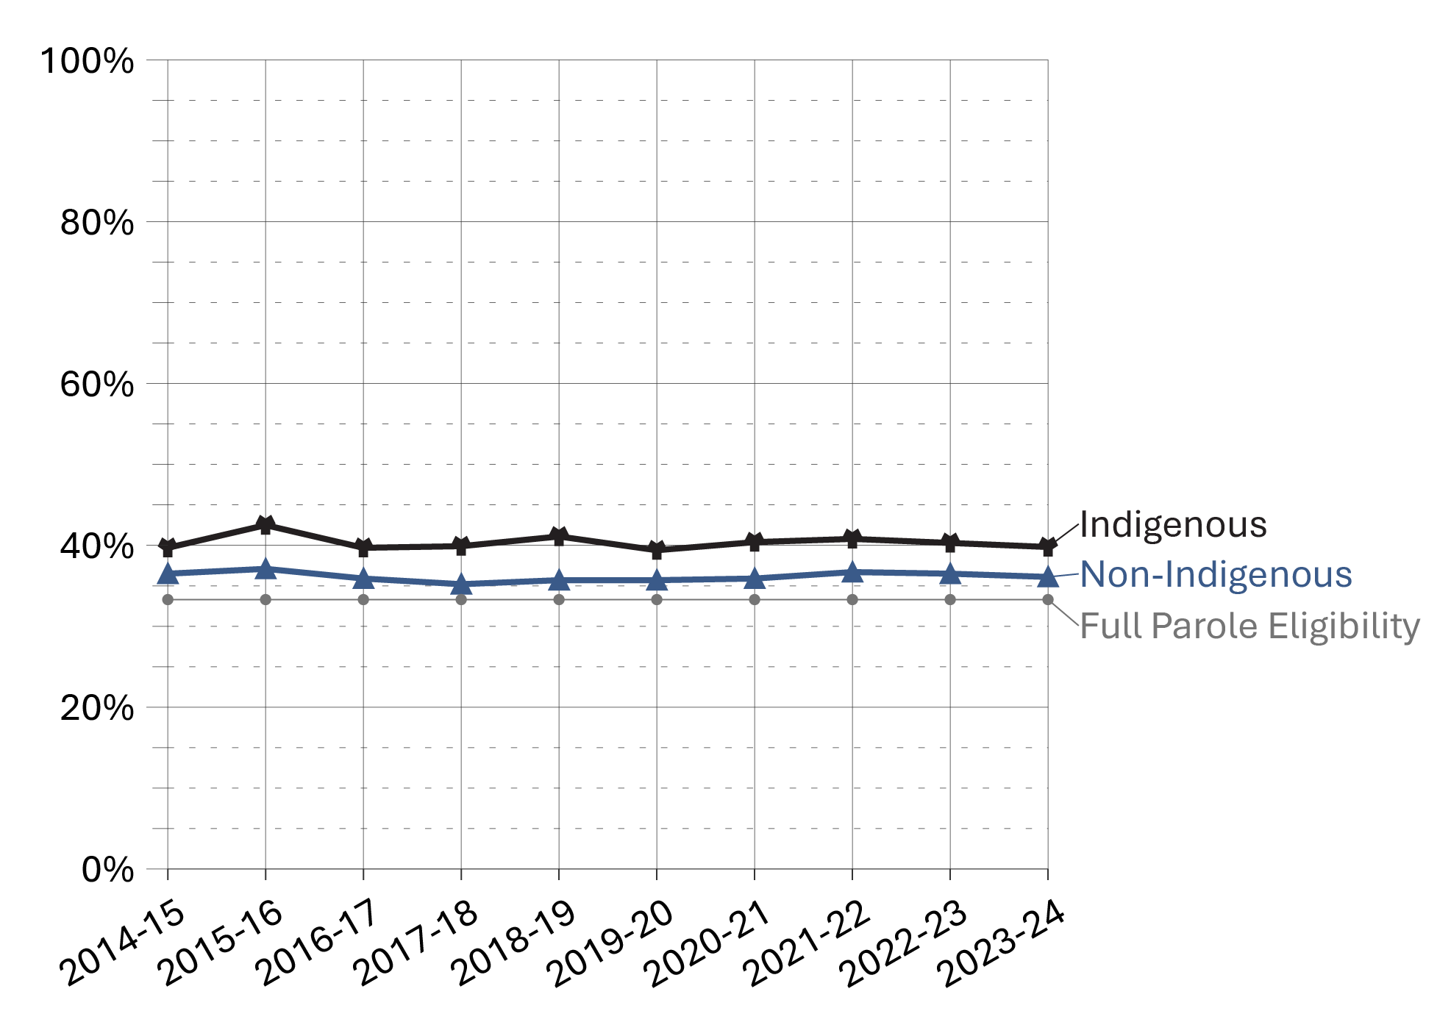
Source: Parole Board of Canada.

Figure D7b. Proportion of sentence served in custody before first federal full parole
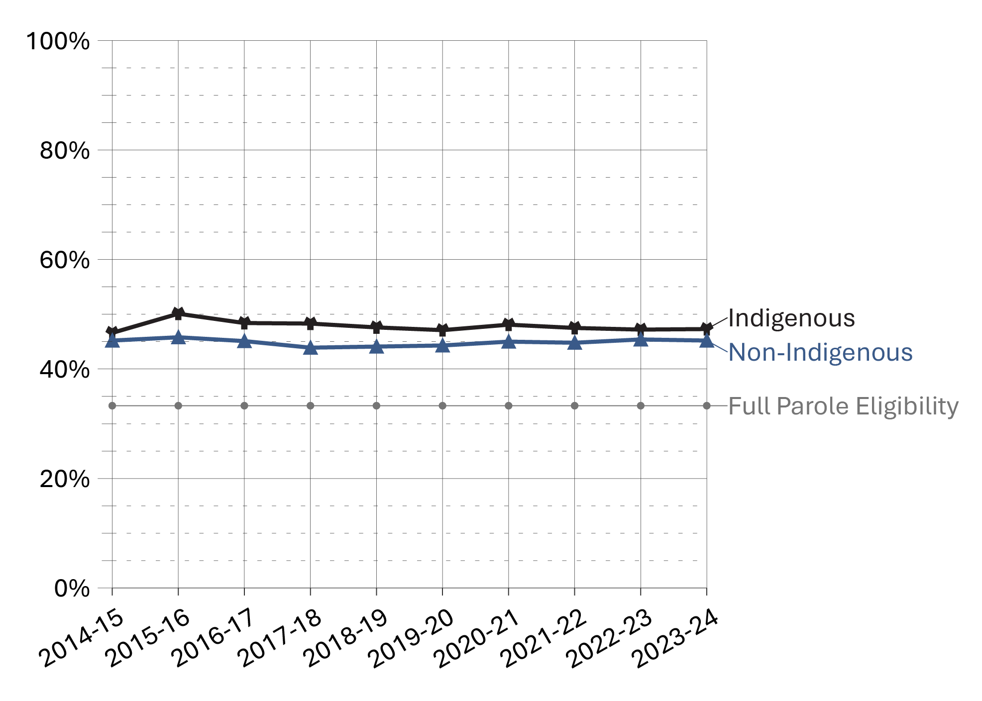
Source: Parole Board of Canada.
- In 2023-24, Indigenous offenders served a higher proportion of their sentences before being released on their first federal day parole (39.8% vs 36.1%) and full parole (47.3% vs 45.2%) than non-Indigenous offenders.
- In 2023-24, the average proportion of sentence served by Indigenous offenders before their first federal day parole release and full parole release remained stable (+0.1% and +0.6%, respectively) compared to 2014-15.
- In 2023-24, the average proportion of sentence served by non-Indigenous offenders before their first federal day parole and full parole release remained stable (-0.4% and 0.0%, respectively) compared to 2014-15.

Table D7a. Proportion of sentence served in custody before first federal day parole (%)
Race group | 2014-15 | 2015-16 | 2016-17 | 2017-18 | 2018-19 | 2019-20 | 2020-21 | 2021-22 | 2022-23 | 2023-24
Indigenous | 39.7 | 42.5 | 39.7 | 39.9 | 41.1 | 39.4 | 40.4 | 40.8 | 40.3 | 39.7
Asian | 33.6 | 34.2 | 32.5 | 32.6 | 35.6 | 33.7 | 33.8 | 34.9 | 34.5 | 32.9
Black | 40.4 | 38.9 | 39.4 | 36.6 | 38.8 | 34.7 | 36.8 | 37.8 | 38.0 | 37.2
Caucasian | 36.4 | 37.2 | 36.0 | 35.3 | 35.5 | 36.2 | 36.1 | 36.7 | 36.6 | 36.3
Other | 37.1 | 35.8 | 33.7 | 34.6 | 32.8 | 34.6 | 34.4 | 37.1 | 36.0 | 36.7
Total | 37.0 | 38.0 | 36.5 | 36.1 | 36.8 | 36.4 | 36.8 | 37.6 | 37.4 | 36.9
Source: Parole Board of Canada.

Table D7b. Proportion of sentence served in custody before first federal full parole (%)
Race group | 2014-15 | 2015-16 | 2016-17 | 2017-18 | 2018-19 | 2019-20 | 2020-21 | 2021-22 | 2022-23 | 2023-24
Indigenous | 46.6 | 50.1 | 48.4 | 48.3 | 47.6 | 47.1 | 48.1 | 47.5 | 47.2 | 47.3
Asian | 43.3 | 43.5 | 44.5 | 41.3 | 42.6 | 43.0 | 42.9 | 43.4 | 44.6 | 42.7
Black | 44.6 | 47.8 | 45.0 | 43.8 | 43.3 | 45.6 | 45.0 | 44.4 | 46.7 | 47.3
Caucasian | 45.6 | 45.9 | 45.4 | 44.2 | 44.6 | 44.3 | 45.3 | 45.2 | 45.5 | 45.2
Other | 44.8 | 44.4 | 42.5 | 45.0 | 43.0 | 44.3 | 45.8 | 43.7 | 44.5 | 46.8
Total | 45.3 | 46.2 | 45.4 | 44.4 | 44.6 | 44.7 | 45.4 | 45.1 | 45.7 | 45.5
Source: Parole Board of Canada.
Notes
During intake assessment, parole officers ask federal offenders to self-identify their race and this information is entered into the Correctional Service of Canada’s (CSC) Offender Management System. Parole Board of Canada (PBC) uses the term “race grouping” as this is the term used by CSC to collect the information from offenders and also reflects how the data is captured in CSC’s and PBC’s data tables.
Full parole is a type of conditional release granted by the Parole Board of Canada in which the remainder of the sentence is served under supervision in the community. The Parole Board of Canada must review the cases of all offenders for full parole at the time prescribed by legislation, unless the offender advises the Parole Board of Canada in writing that they do not wish to be considered for full parole.
Day parole is a type of conditional release granted by the Parole Board of Canada in which offenders are permitted to participate in community-based activities in preparation for full parole or statutory release. The conditions require offenders to return nightly to an institution, halfway house, or other location deemed appropriate for managing their risk, unless otherwise authorized by the Parole Board of Canada. Not all offenders apply for day parole, and some apply more than once before being granted day parole.
Timing of parole in the sentence refers to the percentage of the sentence served at the time the first day parole or full parole starts during the sentence. In most cases a full parole is preceded by a day parole. These calculations are based on sentences under federal jurisdiction, excluding life sentences and indeterminate sentences. Offenders (other than those serving life or indeterminate sentences or subject to judicial determination) normally become eligible for full parole after serving 1/3 of their sentence or 7 years, whichever is less. Eligibility for day parole is normally at 6 months before full parole eligibility.
Reported year periods reflect fiscal years. A fiscal year runs from April 1 to March 31 of the following year.

Outcome of federal day parole supervision periods

Figure D8. Day parole outcomes – 10-year trend
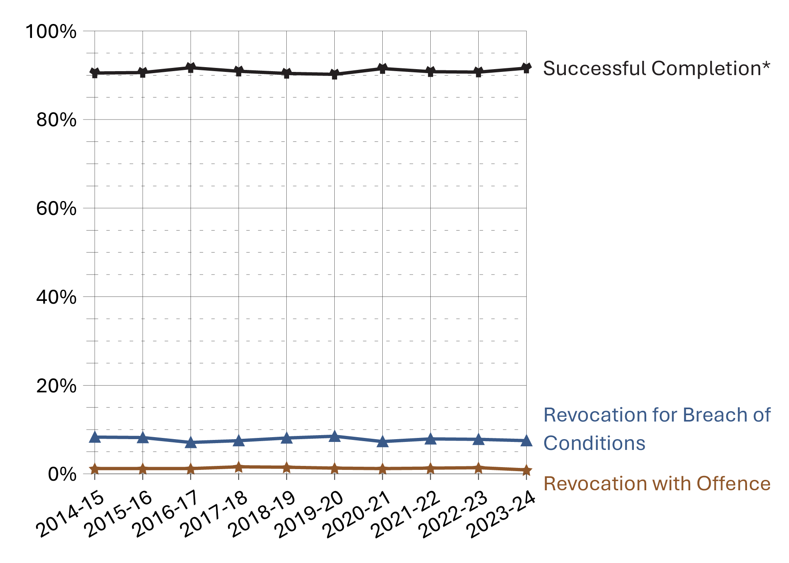
Source: Parole Board of Canada.
- In the past 10 fiscal years (from 2014-15 to 2023-24), the successful completion* rate of federal day parole supervision periods was on average 90.9%. Of the 9.1% unsuccessful completions, most were for breach of conditions.
- In 2023-24, the successful completion* rate of federal day parole supervision periods remained stable (91.6%; +0.9%) compared to 2022-23.
- The rate of violent reoffending of federal day parole supervision periods has been very low in the past 5 fiscal years, averaging 0.2%.
Notes
*Federal parole outcomes reflect the performance of offenders who were on conditional release during the supervision period in question. Supervision periods end in one of the following ways: (1) Successful completion: supervision periods that are completed without a breach of condition or a new offence; (2) revocation for breach of condition: a positive intervention, which reduces the risk of reoffending; (3) revocation with non-violent / violent offence: a negative end to the supervision period, which results in a new conviction.

Table D8. Day parole outcomes*
Federal day parole outcomes | 2019-20 | % | 2020-21 | % | 2021-22 | % | 2022-23 | % | 2023-24 | %
Successful  completion | 3,772 | 90.2 | 3,562 | 91.5 | 3,028 | 90.8 | 3,088 | 90.7 | 3,430 | 91.6
Revocation for breach of conditions | 356 | 8.5 | 284 | 7.3 | 262 | 7.9 | 266 | 7.8 | 279 | 7.5
Revocation with  non-violent offence | 47 | 1.1 | 36 | 0.9 | 38 | 1.1 | 41 | 1.2 | 28 | 0.7
Revocation with violent offence | 9 | 0.2 | 12 | 0.3 | 7 | 0.2 | 8 | 0.2 | 6 | 0.2
Total | 4,184 | 100.0 | 3,894 | 100.0 | 3,335 | 100.0 | 3,403 | 100.0 | 3,743 | 100.0
Source: Parole Board of Canada.
Notes
*Federal parole outcomes reflect the performance of offenders who were on conditional release during the supervision period in question. Supervision periods end in one of the following ways: (1) Successful completion: supervision periods that are completed without a breach of condition or a new offence; (2) revocation for breach of condition: a positive intervention, which reduces the risk of reoffending; (3) revocation with non-violent / violent offence: a negative end to the supervision period, which results in a new conviction.
Outcome counts include offenders who have passed away during the specified time period.
Accelerated Parole Review (APR): A parole review mechanism – eliminated on March 28, 2011, under the Abolition of Early Parole Act (AEPA) – that was available to non-violent offenders serving a first-time sentence in a federal institution. These offenders became eligible for APR after serving the greater of 6 months or one-sixth of their sentence. The AEPA’s transitional provisions have been a matter of federal and provincial litigation, which has resulted in variations in their application across Canada.
In the past 5 fiscal year (between 2019-20 and 2023-24), a total of 165 APR day parole supervision periods were completed, the successful completion rate was 95.8%.
Violent offences include murder and Schedule I offences (listed in the Corrections and Conditional Release Act) such as assaults, sexual offences, arson, abduction, robbery, and some weapon offences.
Reported year periods reflect fiscal years. A fiscal year runs from April 1 to March 31 of the following year.

Outcome of federal full parole supervision periods
Figure D9. Full parole outcomes* – 10-year trend
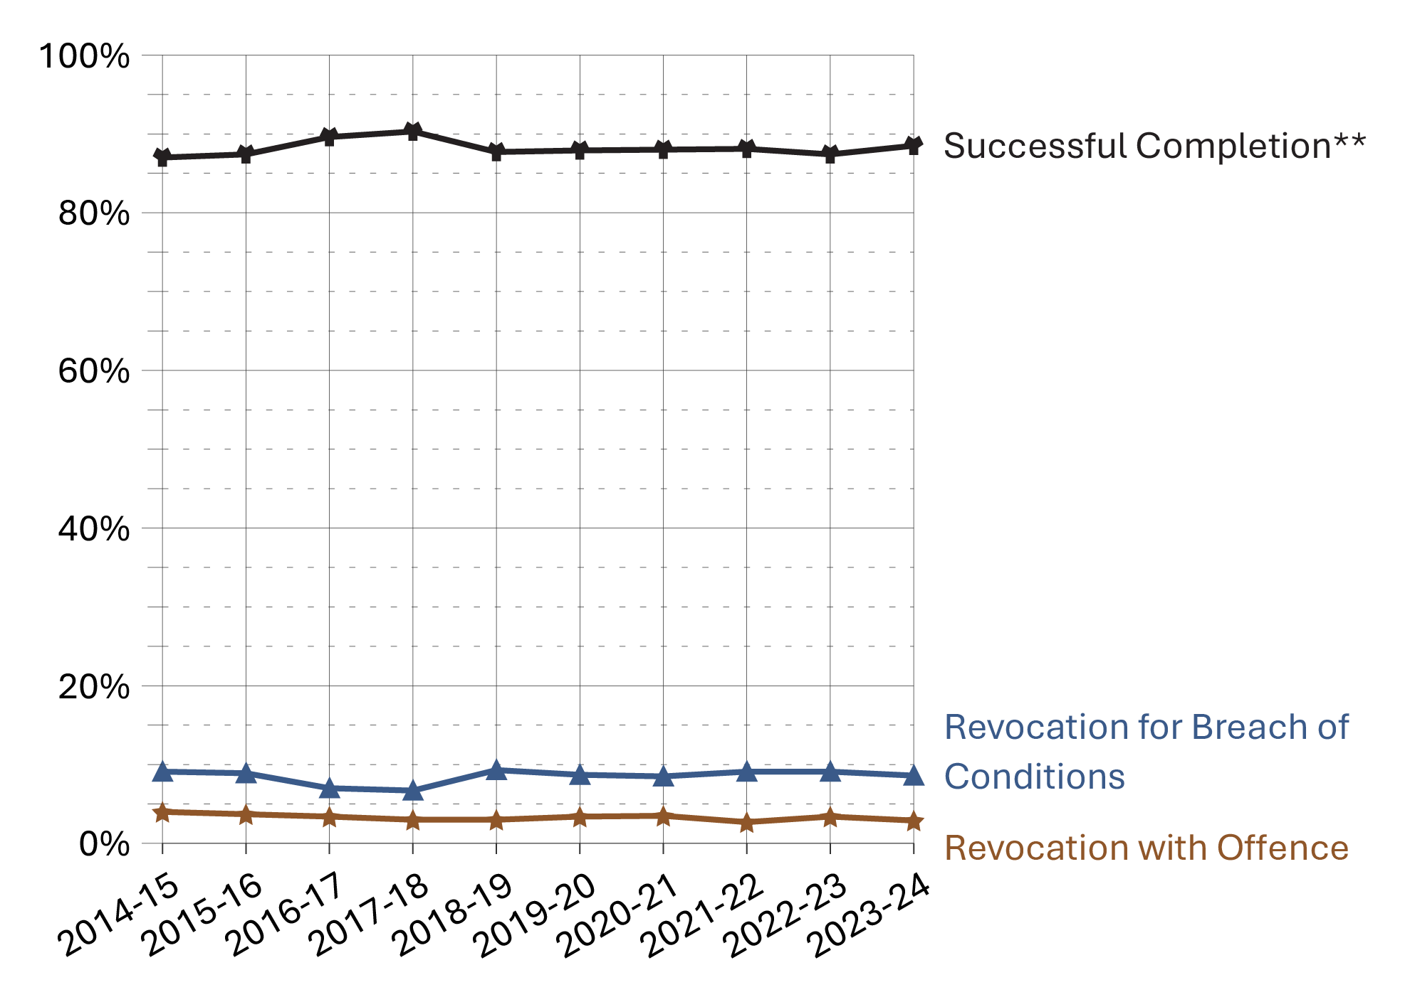
Source: Parole Board of Canada.
- In the past 10 fiscal years (from 2014-15 to 2023-24), the successful completion rate** of federal full parole supervision periods for offenders serving determinate sentences was on average 88.2%. Of the 11.8% unsuccessful completions, most were for breach of conditions.
- In 2023-24, the successful completion rate** of federal full parole supervision periods slightly increased to 88.5% (+1.1%) compared to 2022-23.
- The rate of violent reoffending of federal full parole supervision periods has been low in the past 5 fiscal years, averaging 0.8% (and ranging from 0.4% to 1.1%).
Notes
*Excludes offenders serving indeterminate sentences because they do not have a warrant expiry date and can only successfully complete full parole upon (their) death.
**Federal parole outcomes reflect the performance of offenders who were on conditional release during the supervision period in question. Supervision periods end in one of the following ways: (1) Successful completion: supervision periods that are completed without a breach of condition or a new offence; (2) revocation for breach of condition: a positive intervention, which reduces the risk of reoffending; (3) revocation with non-violent / violent offence: a negative end to the supervision period, which results in a new conviction.

Table D9. Full parole outcomes*
Federal full parole outcomes | 2019-20 | % | 2020-21 | % | 2021-22 | % | 2022-23 | % | 2023-24 | %
Successful  completion** | 1,274 | 87.9 | 1,272 | 88.0 | 1,253 | 88.1 | 996 | 87.4 | 924 | 88.5
Revocation for breach of conditions | 126 | 8.7 | 123 | 8.5 | 130 | 9.1 | 104 | 9.1 | 90 | 8.6
Revocation with  non-violent offence | 37 | 2.6 | 40 | 2.8 | 26 | 1.8 | 27 | 2.4 | 26 | 2.5
Revocation with violent offence | 13 | 0.9 | 10 | 0.7 | 13 | 0.9 | 12 | 1.1 | 4 | 0.4
Total | 1,450 | 100.0 | 1,445 | 100.0 | 1,422 | 100.0 | 1,139 | 100.0 | 1,044 | 100.0
Source: Parole Board of Canada.
Notes
*Excludes offenders serving indeterminate sentences because they do not have a warrant expiry date and can only successfully complete full parole upon (their) death.
**Federal parole outcomes reflect the performance of offenders who were on conditional release during the supervision period in question. Supervision periods end in one of the following ways: (1) Successful completion: supervision periods that are completed without a breach of condition or a new offence; (2) revocation for breach of condition: a positive intervention, which reduces the risk of reoffending; (3) revocation with non-violent / violent offence: a negative end to the supervision period, which results in a new conviction.
Outcome counts include offenders who have passed away during the specified time period.
Accelerated Parole Review (APR): A parole review mechanism – eliminated on March 28, 2011, under the Abolition of Early Parole Act (AEPA) – that was available to non-violent offenders serving a first-time sentence in a federal institution. These offenders became eligible for APR after serving the greater of 6 months or one-sixth of their sentence. The AEPA’s transitional provisions have been a matter of federal and provincial litigation, which has resulted in variations in their application across Canada.
In the past 5 fiscal year (between 2019-20 and 2023-24), a total of 405 APR full parole supervision periods were completed, the successful completion rate was 94.3%.
Violent offences include murder and Schedule I offences (listed in the Corrections and Conditional Release Act) such as assaults, sexual offences, arson, abduction, robbery, and some weapon offences.
Reported year periods reflect fiscal years. A fiscal year runs from April 1 to March 31 of the following year.

Offenders released from federal institutions including Healing Lodges on statutory release: 10-year trend

Figure D10. Percentage* of offenders released on statutory release
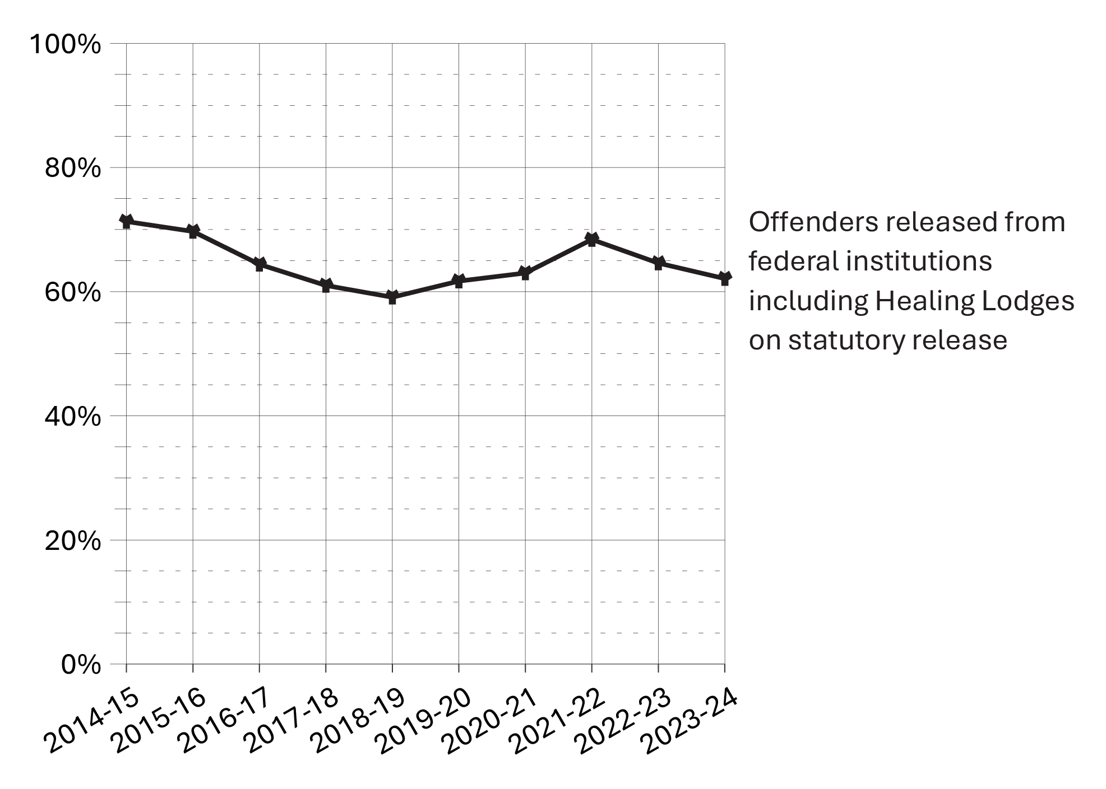
Source: Correctional Service of Canada.
- In fiscal year 2023-24, 62.1% of all releases from federal institutions were at statutory release.
- In fiscal year 2023-24, 74.4% of releases for Indigenous offenders were at statutory release compared to 55.5% of releases for non-Indigenous offenders.
- In fiscal year 2023-24, 63.3% of all releases from federal institutions for male offenders were at statutory release, compared to 47.8% of releases for female offenders.
- Over the past ten years (from 2014-15 to 2023-24), the percentage of releases at statutory release decreased from 71.3% to 62.1%.
Notes
*Percentage is calculated based on the number of statutory releases compared to the total releases for each offender group.

Table D10a. Offenders released on statutory release by Indigenous and non-Indigenous
Fiscal year | Indigenous: Statutory release | Indigenous: Total releases | %* | Non-Indigenous: Statutory release | Non-Indigenous: Total releases | %*
2014-15 | 1,782 | 2,106 | 84.6 | 3,590 | 5,426 | 66.2
2015-16 | 1,716 | 2,079 | 82.5 | 3,592 | 5,537 | 64.9
2016-17 | 1,631 | 2,086 | 78.2 | 3,252 | 5,491 | 59.2
2017-18 | 1,576 | 2,109 | 74.7 | 2,844 | 5,141 | 55.3
2018-19 | 1,463 | 2,053 | 71.3 | 2,710 | 5,011 | 54.1
2019-20 | 1,650 | 2,196 | 75.1 | 2,706 | 4,865 | 55.6
2020-21 | 1,595 | 2,102 | 75.9 | 2,526 | 4,435 | 57.0
2021-22 | 1,787 | 2,232 | 80.1 | 2,588 | 4,166 | 62.1
2022-23 | 1,721 | 2,245 | 76.7 | 2,315 | 4,003 | 57.8
2023-24 | 1,662 | 2,235 | 74.4 | 2,315 | 4,171 | 55.5
Source: Correctional Service of Canada.

Table D10b. Offenders released on statutory release by sex
Fiscal year | Male:  Statutory release | Male:  Total releases | %* | Female:  Statutory release | Female:  Total releases | %*
2014-15 | 5,136 | 7,091 | 72.4 | 236 | 441 | 53.5
2015-16 | 5,029 | 7,112 | 70.7 | 279 | 504 | 55.4
2016-17 | 4,627 | 7,015 | 66.0 | 256 | 562 | 45.6
2017-18 | 4,193 | 6,682 | 62.8 | 227 | 568 | 40.0
2018-19 | 3,954 | 6,516 | 60.7 | 219 | 548 | 40.0
2019-20 | 4,119 | 6,522 | 63.2 | 237 | 539 | 44.0
2020-21 | 3,897 | 6,064 | 64.3 | 224 | 473 | 47.4
2021-22 | 4,147 | 5,913 | 70.1 | 228 | 485 | 47.0
2022-23 | 3,819 | 5,787 | 66.0 | 217 | 461 | 47.1
2023-24 | 3,730 | 5,889 | 63.3 | 247 | 517 | 47.8
Source: Correctional Service of Canada.

Table D10c. Total offenders released on statutory release
Fiscal year | Statutory release | Total releases | %*
2014-15 | 5,372 | 7,532 | 71.3
2015-16 | 5,308 | 7,616 | 69.7
2016-17 | 4,883 | 7,577 | 64.4
2017-18 | 4,420 | 7,250 | 61.0
2018-19 | 4,173 | 7,064 | 59.1
2019-20 | 4,356 | 7,061 | 61.7
2020-21 | 4,121 | 6,537 | 63.0
2021-22 | 4,375 | 6,398 | 68.4
2022-23 | 4,036 | 6,248 | 64.6
2023-24 | 3,977 | 6,406 | 62.1
Source: Correctional Service of Canada.
Notes
The data include all releases from a federal institution or Healing Lodge in a given fiscal year excluding offenders with quashed sentences, offenders who died in custody, LTSO releases, offenders released at warrant expiry, and offenders transferred to foreign countries. An offender may be released more than once during the reporting timeframe in cases where a previous release was subject to revocation, suspension, temporary detention, interruption, or in cases where an offender served more than one sentence.
Statutory release refers to a conditional release that is subject to supervision after the offender has served two-thirds of the sentence.
All releases include: Conditional releases of day parole, full parole or statutory release.
*Percentage is calculated based on the number of statutory releases compared to the total releases for each offender group.
Reported year periods reflect fiscal years. A fiscal year runs from April 1 to March 31 of the following year.

Outcome of federal statutory release supervision periods

Figure D11. Statutory release* outcomes – 10-year trend
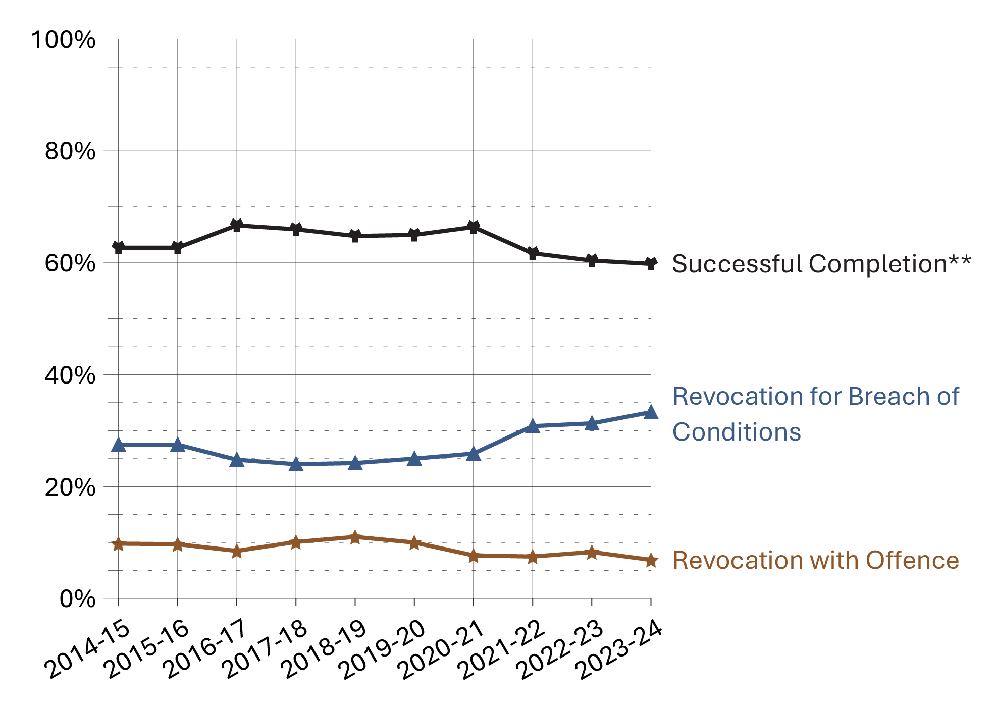
Source: Parole Board of Canada.
- In 2023-24, the successful completion** rate of statutory release* supervision periods remained stable (59.8%; -0.6%) compared to 2022-23.
- Over the past 5 fiscal years (from 2019-20 to 2023-24), the revocation with violent offence rates (1.4%) were, on average, 6.2 times higher for offenders on statutory release than for offenders on federal day parole (0.2%) and 1.8 times higher than for offenders on federal full parole (0.8%).
Notes
*Statutory release refers to a conditional release that is subject to supervision after the offender has served two-thirds of the sentence.
**A statutory release supervision period is considered successful if it was completed without a return to prison for a breach of conditions or for a new offence.

Table D11. Statutory release* outcomes
Statutory release*  outcomes | 2019-20 | % | 2020-21 | % | 2021-22 | % | 2022-23 | % | 2023-24 | %
Successful  completion** | 3,381 | 65.0 | 3,329 | 66.4 | 3,238 | 61.7 | 2,932 | 60.4 | 2,741 | 59.8
Revocation for breach of conditions | 1,299 | 25.0 | 1,297 | 25.9 | 1,615 | 30.8 | 1,522 | 31.3 | 1,524 | 33.3
Revocation with  non-violent offence | 407 | 7.8 | 304 | 6.1 | 316 | 6.0 | 352 | 7.3 | 287 | 6.3
Revocation with violent offence | 111 | 2.1 | 81 | 1.6 | 78 | 1.5 | 49 | 1.0 | 30 | 0.7
Total | 5,198 | 100.0 | 5,011 | 100.0 | 5,247 | 100.0 | 4,855 | 100.0 | 4,582 | 100.0
Source: Parole Board of Canada.
Notes
*Statutory release refers to a conditional release that is subject to supervision after the offender has served two-thirds of the sentence.
**A statutory release supervision period is considered successful if it was completed without a return to prison for a breach of conditions or for a new offence.
Revocation for breach of conditions includes revocation with outstanding charges.
Violent offences include murder and Schedule I offences (listed in the Corrections and Conditional Release Act) such as assaults, sexual offences, arson, abduction, robbery, and some weapon offences.
An offender serving a determinate sentence, if not detained, will be subject to statutory release after serving two-thirds of their sentence if they are not on full parole at that time. On statutory release, an offender is subject to supervision until the end of their sentence.
Reported year periods reflect fiscal years. A fiscal year runs from April 1 to March 31 of the following year.

Rates of violent offence convictions for offenders on federal conditional release: 10-year trend

Figure D12. Rates of violent offence convictions per 1,000 supervised offenders
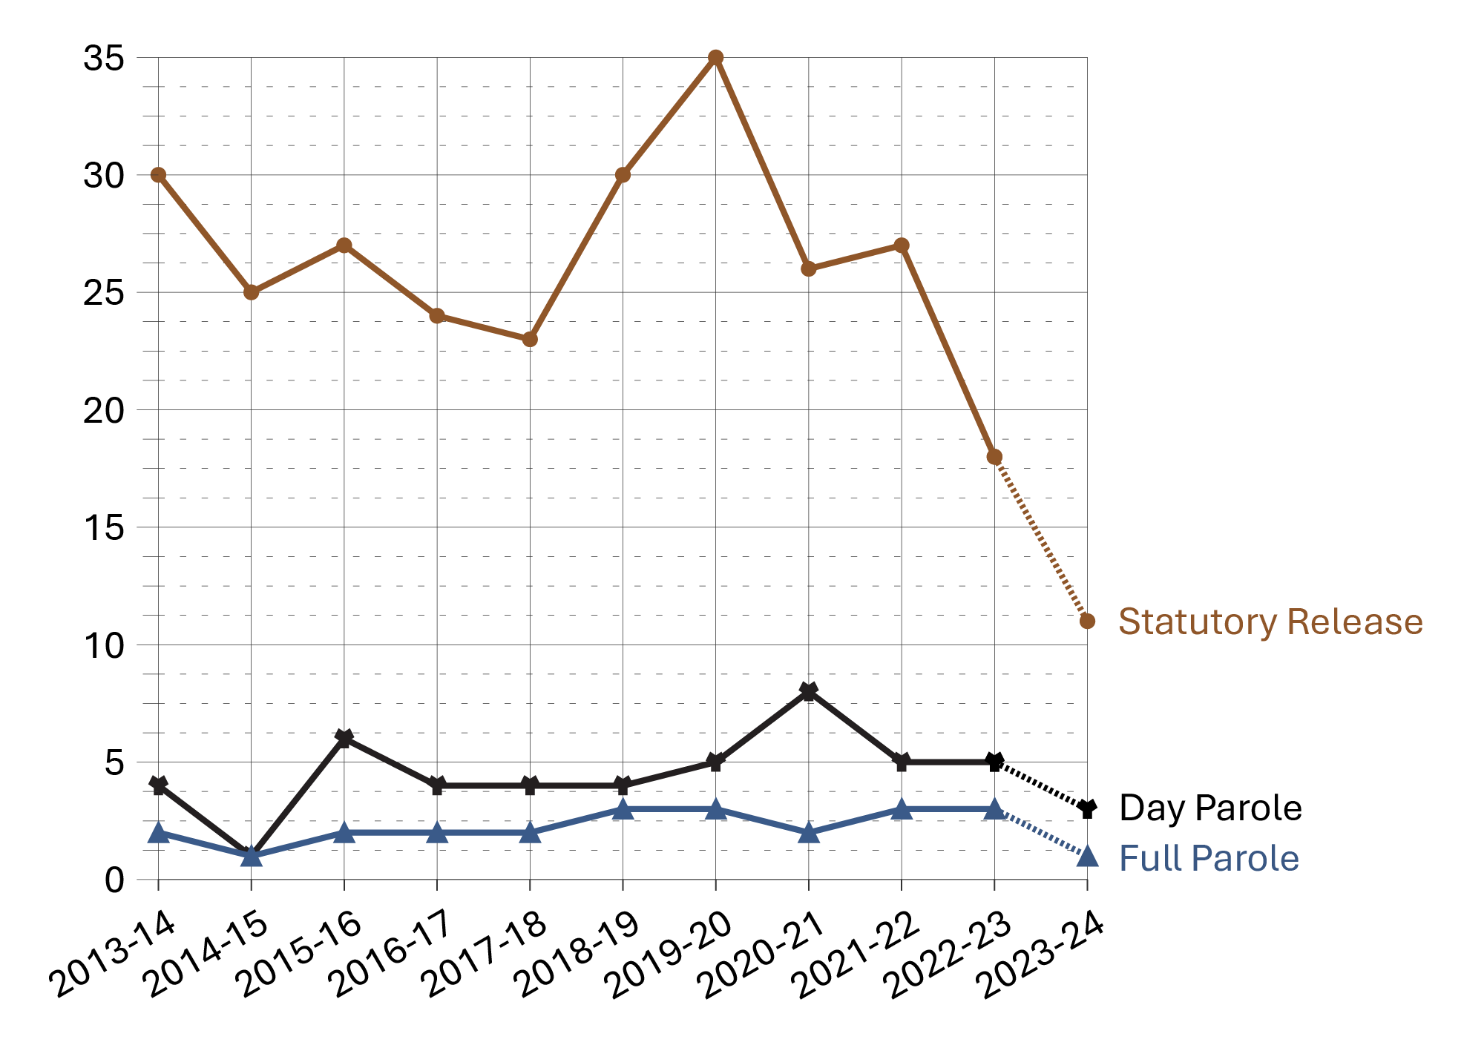
Source: Parole Board of Canada.
- During the 10-fiscal year period between 2013-14 and 2022-23*, the number of convictions for a violent offence for offenders on federal conditional release decreased 39.5% (from 119 in 2013-14 to 72 in 2022-23). Over this period, the annual average number of convictions for violent offences was 7.3 for offenders on day parole, 10.4 for offenders on full parole, and 86.9 for offenders on statutory release.
- During the 10-fiscal-year period between 2013-14 and 2022-23*, convictions for violent offences on statutory release accounted for 83.1% of all convictions by offenders on federal conditional release.
- When comparing the rates of conviction for violent offences per 1,000 supervised offenders (between 2013-14 and 2022-23*), offenders on statutory release were 11.1 times more likely to commit a violent offence during their supervision periods than offenders on full parole, and 5.7 times more likely to commit a violent offence than offenders on day parole.
Notes
*The dotted line between 2022-23 and 2023-24 is intended to signify that due to delays in the court process, these numbers under-represent the actual number of convictions, as verdicts may not have been reached by year-end.

Table D12a. Number of convictions for violent offences
Fiscal year | Day parole | Full parole | Statutory release | Total
2013-14 | 5 | 8 | 106 | 119
2014-15 | 1 | 4 | 87 | 92
2015-16 | 9 | 7 | 96 | 112
2016-17 | 7 | 8 | 85 | 100
2017-18 | 7 | 8 | 78 | 93
2018-19 | 8 | 15 | 98 | 121
2019-20 | 9 | 14 | 111 | 134
2020-21 | 12 | 11 | 81 | 104
2021-22 | 7 | 14 | 78 | 99
2022-23 | 8 | 15 | 49 | 72
2023-24 | 6 | 5 | 30 | 41
Source: Parole Board of Canada.

Table D12b. Rates of violent offence convictions per 1,000 supervised offenders
Fiscal year | Day parole | Full parole | Statutory release
2013-14 | 4 | 2 | 30
2014-15 | 1 | 1 | 25
2015-16 | 6 | 2 | 27
2016-17 | 4 | 2 | 24
2017-18 | 4 | 2 | 23
2018-19 | 4 | 3 | 30
2019-20 | 5 | 3 | 35
2020-21 | 8 | 2 | 26
2021-22 | 5 | 3 | 27
2022-23 | 5 | 3 | 18
2023-24 | 3 | 1 | 11
Source: Parole Board of Canada.
Notes
Violent offences include murder and Schedule I offences (listed in the Corrections and Conditional Release Act) such as assaults, sexual offences, arson, abduction, robbery, and some weapon offences.
Supervised offenders include offenders who are on parole and statutory release, those temporarily detained in federal institutions, and those who are deported or extradited.
Statutory release refers to a conditional release that is subject to supervision after the offender has served two-thirds of the sentence.
Day and full parole include those offenders serving determinate and indeterminate sentences.
Reported year periods reflect fiscal years. A fiscal year runs from April 1 to March 31 of the following year.

Section E:
Special Applications of Criminal Justice



Number of initial detention reviews: 10-year trend

Figure E1. Number of initial detention reviews
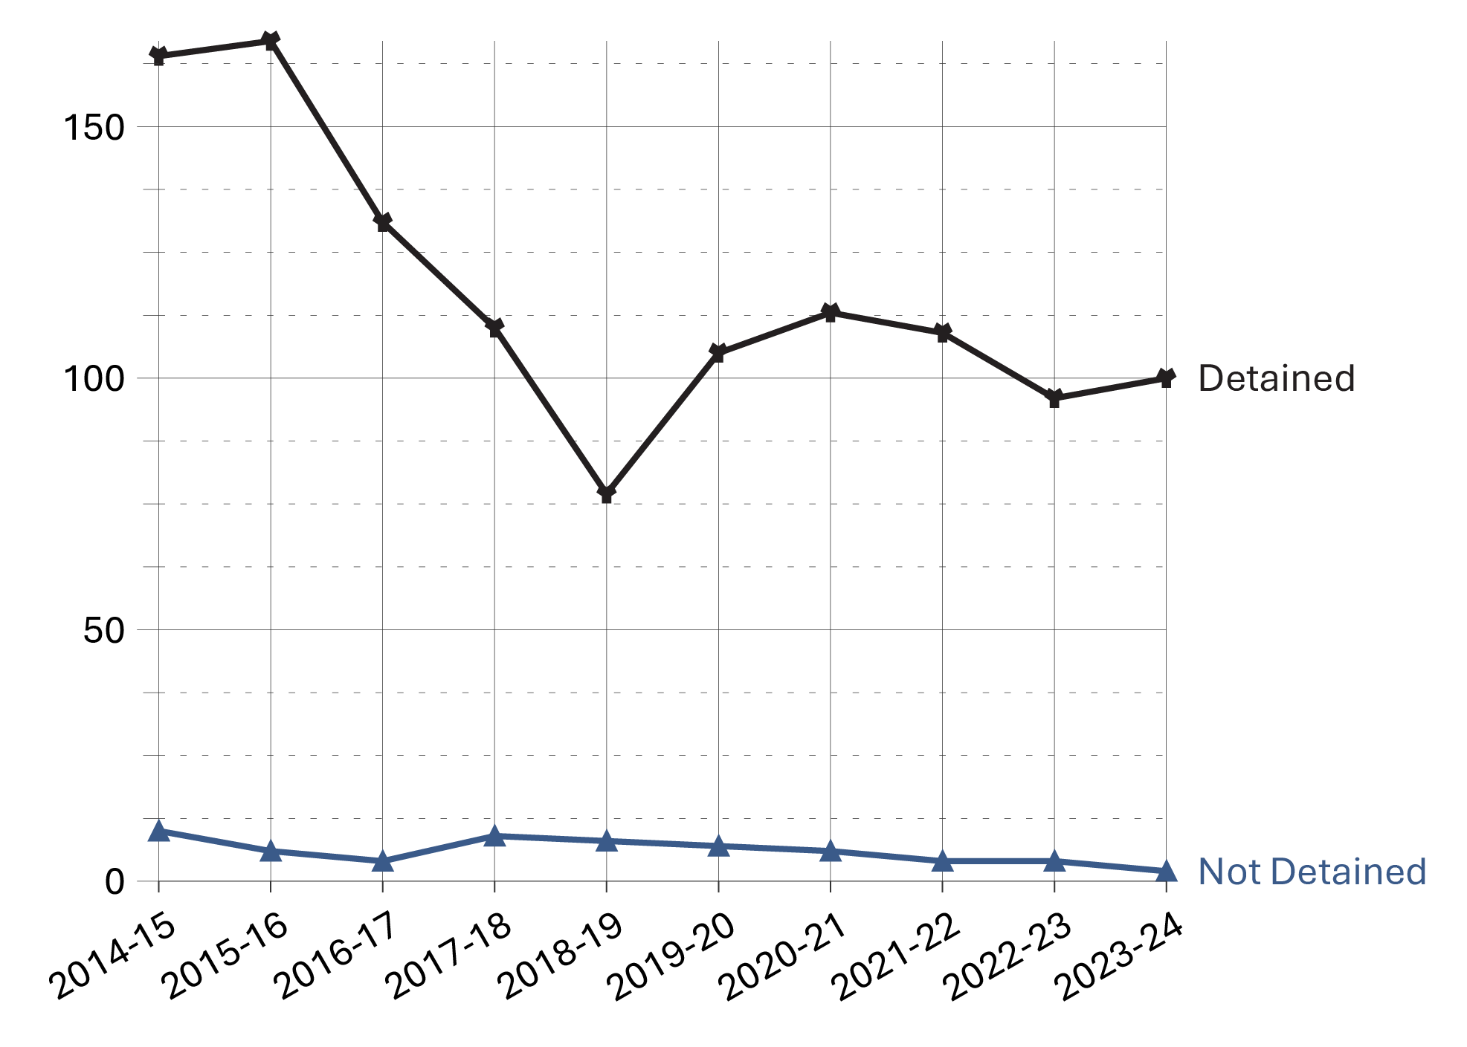
Source: Parole Board of Canada.
- In 2023-24, the number of referrals for detention increased slightly from 100 to 102 when compared to 2022-23. The detention rate was 98.0%.
- In 2023-24, the detention rate for all race groups was 100% apart from Caucasian offenders with a detention rate of 95.1%.
- As of April 7, 2024, Indigenous offenders accounted for 32.7%, Asian offenders accounted for 5.2%, Black offenders accounted for 9.2%, Caucasian offenders accounted for 44.9%, and offenders in the “Other” race group accounted for 8.0%, of the federal incarcerated offender population serving determinate sentences.
- In 2023-24, Indigenous offenders accounted for 41.2% and Caucasian offenders accounted for 40.2% of federal incarcerated offenders serving determinate sentences of offenders referred for detention. Black (9.8%), Asian (4.9%) and “Other” (3.9%) race groups accounted for the remaining proportion of federal incarcerated offenders serving determinate sentences of offenders referred for detention.

Table E1. Number of initial detention reviews by race group

Outcome: Detained
Race group | 2014-15 | 2015-16 | 2016-17 | 2017-18 | 2018-19 | 2019-20 | 2020-21 | 2021-22 | 2022-23 | 2023-24
Indigenous | 71 | 75 | 55 | 51 | 38 | 50 | 58 | 49 | 48 | 42
Asian | 7 | 2 | 1 | 1 | 2 | 2 | 3 | 6 | 3 | 5
Black | 10 | 13 | 10 | 10 | 6 | 6 | 12 | 10 | 8 | 10
Caucasian | 69 | 76 | 59 | 47 | 28 | 43 | 38 | 43 | 34 | 39
Other | 7 | 1 | 6 | 1 | 3 | 4 | 2 | 1 | 3 | 4
Total (#) | 164 | 167 | 131 | 110 | 77 | 105 | 113 | 109 | 96 | 100
Total (%) | 94.3 | 96.5 | 97.0 | 92.4 | 90.6 | 93.8 | 95.0 | 96.5 | 96.0 | 98.0

Outcome: Statutory Release
Race group | 2014-15 | 2015-16 | 2016-17 | 2017-18 | 2018-19 | 2019-20 | 2020-21 | 2021-22 | 2022-23 | 2023-24
Indigenous | 5 | 2 | 2 | 5 | 6 | 4 | 2 | 1 | 2 | 0
Asian | 0 | 1 | 1 | 0 | 0 | 0 | 0 | 0 | 0 | 0
Black | 1 | 2 | 0 | 1 | 0 | 1 | 1 | 2 | 0 | 0
Caucasian | 4 | 1 | 1 | 3 | 2 | 2 | 3 | 0 | 2 | 2
Other | 0 | 0 | 0 | 0 | 0 | 0 | 0 | 1 | 0 | 0
Total (#) | 10 | 6 | 4 | 9 | 8 | 7 | 6 | 4 | 4 | 2
Total (%) | 5.7 | 3.5 | 3.0 | 7.6 | 9.4 | 6.3 | 5.0 | 3.5 | 4.0 | 2.0

Total outcomes
Race group | 2014-15 | 2015-16 | 2016-17 | 2017-18 | 2018-19 | 2019-20 | 2020-21 | 2021-22 | 2022-23 | 2023-24
Indigenous | 76 | 77 | 57 | 56 | 44 | 54 | 60 | 50 | 50 | 42
Asian | 7 | 3 | 2 | 1 | 2 | 2 | 3 | 6 | 3 | 5
Black | 11 | 15 | 10 | 11 | 6 | 7 | 13 | 12 | 8 | 10
Caucasian | 73 | 77 | 60 | 50 | 30 | 45 | 41 | 43 | 36 | 41
Other | 7 | 1 | 6 | 1 | 3 | 4 | 2 | 2 | 3 | 4
Total (#) | 174 | 173 | 135 | 119 | 85 | 112 | 119 | 113 | 100 | 102
Total (%) | 100.0 | 100.0 | 100.0 | 100.0 | 100.0 | 100.0 | 100.0 | 100.0 | 100.0 | 100.0
Source: Parole Board of Canada.
Notes
During intake assessment, parole officers ask federal offenders to self-identify their race and this information is entered into the Correctional Service of Canada’s (CSC) Offender Management System. Parole Board of Canada (PBC) uses the term “race grouping” as this is the term used by CSC to collect the information from offenders and also reflects how the data is captured in CSC’s and PBC’s data tables.
Initial Detention Review: In accordance with subsection 130(1) of the Corrections and Conditional Release Act, a review conducted upon referral by the Correctional Service of Canada. On completion of its review, the Board may order that an individual not be released from imprisonment before the expiration of their sentence according to law – except on an escorted temporary absence for medical or administrative reasons – if it is satisfied that the individual is likely, if released, to commit an offence causing the death of or serious harm to another person, a sexual offence involving a child, or a serious drug offence before the end of their sentence. Detention orders are subject to review within 1 or 2 years, depending on the type of offence.
Reported year periods reflect fiscal years. A fiscal year runs from April 1 to March 31 of the following year.

Annual judicial review hearings

Figure E2. Judicial review hearings between fiscal year 1987-88 and fiscal year 2023-24
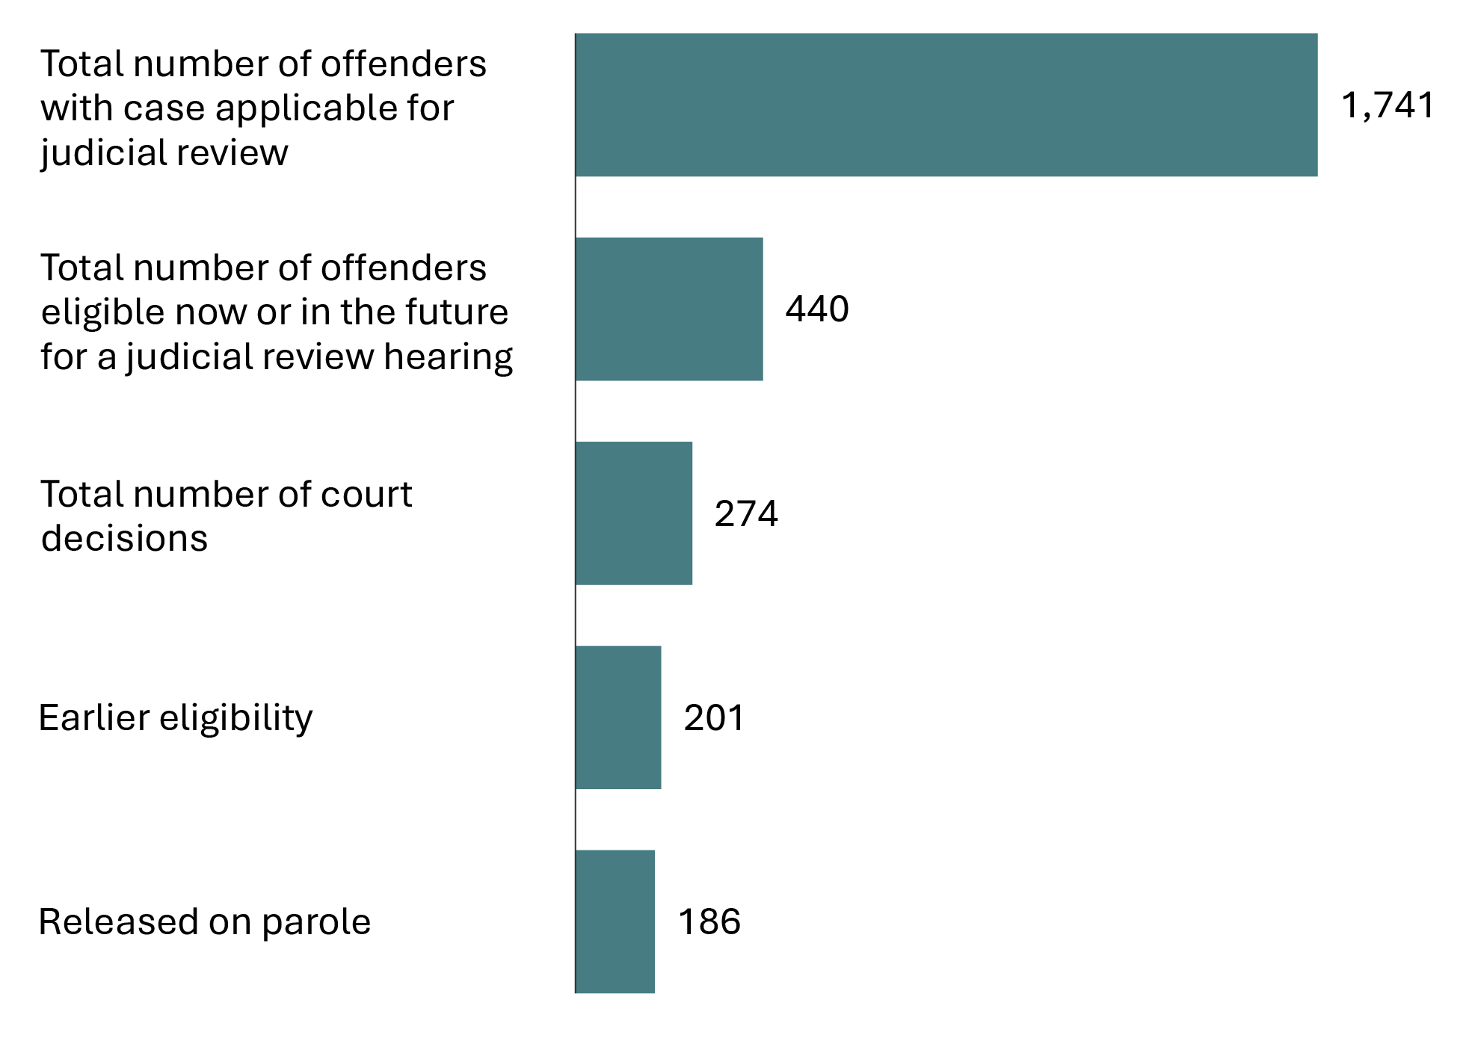
Source: Correctional Service of Canada.
- Since the first judicial review hearing in 1987, there have been a total of 274 court decisions (i.e., between fiscal year 1987-88 and the end of fiscal year 2023-24).
- Of these cases, 73.4% of the court decisions resulted in a reduction of the period that must be served before parole eligibility.
- Of the 440 offenders eligible to apply for a judicial review, 291 have already served 15 years of their sentence, whereas 149 have not.
- Of the 201 offenders who had their parole eligibility date moved closer, 197 had reached their revised Day Parole eligibility date. Of these offenders, 186 were released on parole, and 122 were being actively supervised in the community*.
- A higher percentage of second degree (81.5%) than first degree (72.5%) murder cases have resulted in a reduction of the period required to be served before parole eligibility.
Notes
* Of the 64 offenders who were no longer under active supervision, 5 were in custody, 50 were deceased, 6 were deported, and 3 were temporarily detained.

Table E2. Judicial review hearings between fiscal year 1987-88 and fiscal year 2023-24

Parole ineligibility reduced by court
Province/territory of judicial review | 1st degree murder | 2nd degree murder
Northwest Territories | 1 | 0
Nunavut | 0 | 0
Yukon | 0 | 0
Newfoundland and Labrador | 0 | 0
Prince Edward Island | 0 | 0
Nova Scotia | 1 | 1
New Brunswick | 1 | 0
Quebec | 81 | 16
Ontario | 28 | 0
Manitoba | 8 | 4
Saskatchewan | 7 | 0
Alberta | 21 | 0
British Columbia | 31 | 1
Total | 179 | 22

Reduction denied by court
Province/territory of judicial review | 1st degree murder | 2nd degree murder
Northwest Territories | 0 | 0
Nunavut | 0 | 0
Yukon | 0 | 0
Newfoundland and Labrador | 0 | 0
Prince Edward Island | 0 | 0
Nova Scotia | 1 | 0
New Brunswick | 1 | 0
Quebec | 7 | 2
Ontario | 36 | 1
Manitoba | 1 | 0
Saskatchewan | 3 | 0
Alberta | 9 | 1
British Columbia | 10 | 1
Total | 68 | 5

Total parole ineligibility reduced by court and reduction denied by court
Province/territory of judicial review | 1st degree murder | 2nd degree murder
Northwest Territories | 1 | 0
Nunavut | 0 | 0
Yukon | 0 | 0
Newfoundland and Labrador | 0 | 0
Prince Edward Island | 0 | 0
Nova Scotia | 2 | 1
New Brunswick | 2 | 0
Quebec | 88 | 18
Ontario | 64 | 1
Manitoba | 9 | 4
Saskatchewan | 10 | 0
Alberta | 30 | 1
British Columbia | 41 | 2
Total | 247 | 27
Source: Correctional Service of Canada.
Notes
Judicial review is an application to the court for a reduction in the time required to be served before being eligible for parole. Judicial review procedures apply to offenders who have been sentenced to imprisonment for life without eligibility for parole until more than 15 years of their sentence has been served. Offenders can apply when they have served at least 15 years of their sentence. Judicial reviews are conducted in the province where the conviction took place.
Reported year periods reflect fiscal years. A fiscal year runs from April 1 to March 31 of the following year.

Number of Dangerous Offender designations

Figure E3. Number of Dangerous Offenders designated
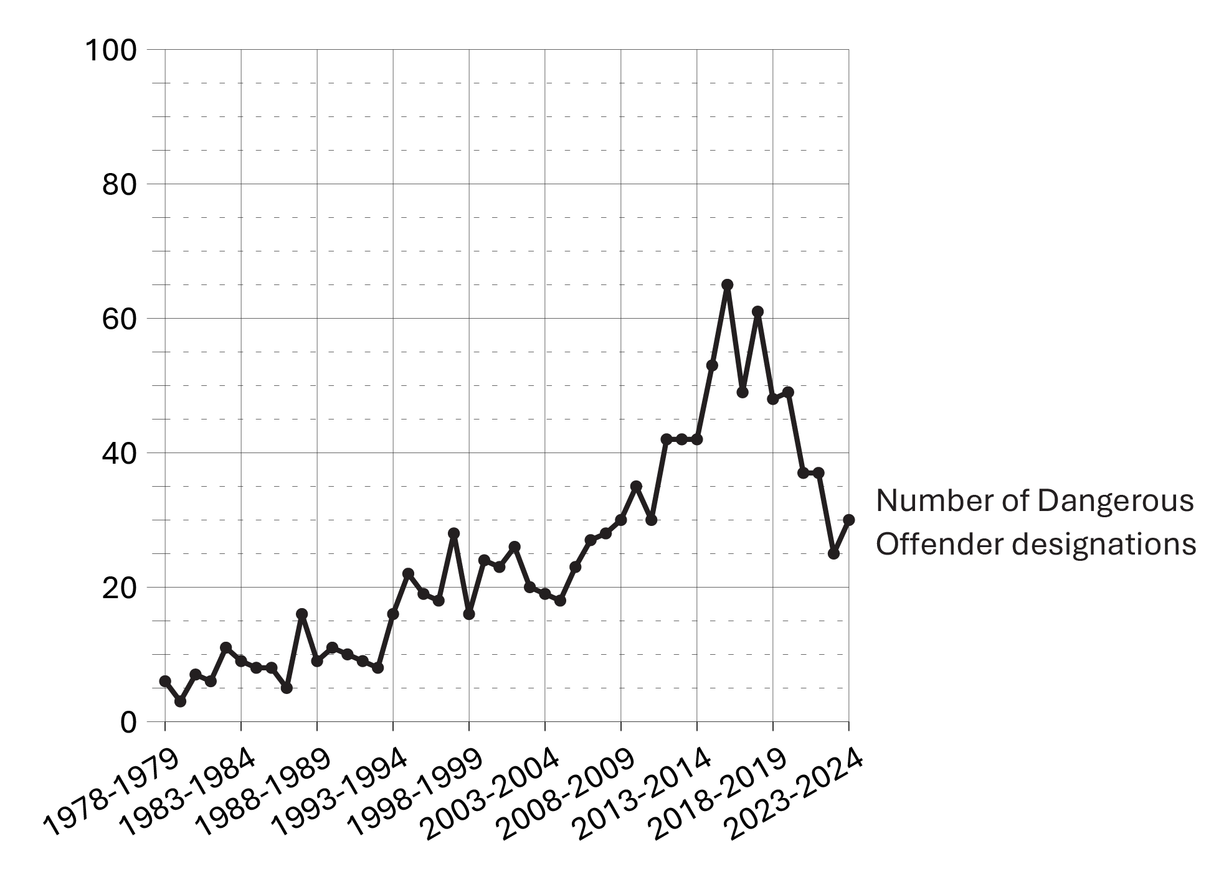
Source: Correctional Service of Canada.
- As of the end of fiscal year 2023-24, 1,128 Dangerous Offender designations were ordered by the court since 1978.
- At the end of fiscal year 2023-24 there were 909 offenders with a Dangerous Offender designation under the responsibility of Correctional Service Canada, and of those, 74.1% had indeterminate sentences.
- Of these 909 offenders with a Dangerous Offender designation, 740 were in custody (representing 5.3% of the total in-custody population) and 169 were in the community under supervision. There were 10 female offenders with a Dangerous Offender designation. Indigenous offenders accounted for 37.7% of the offenders with a Dangerous Offender designation and 29.0% of the total offender population.

Table E3a. Number of Active Dangerous Offenders designated (2023-24)
Province/territory of designation | # of indeterminate offenders | # of determinate offenders | Total
Newfoundland and Labrador | 6 | 2 | 8
Nova Scotia | 19 | 3 | 22
Prince Edward Island | 0 | 0 | 0
New Brunswick | 4 | 0 | 4
Quebec | 98 | 31 | 129
Ontario | 288 | 119 | 407
Manitoba | 27 | 4 | 31
Saskatchewan | 60 | 40 | 100
Alberta | 55 | 10 | 65
British Columbia | 107 | 20 | 127
Yukon | 2 | 3 | 5
Northwest Territories | 8 | 1 | 9
Nunavut | 0 | 2 | 2
Total | 674 | 235 | 909
Source: Correctional Service of Canada.

Table E3b. Number of designations (designated since 1978)
Province/territory of designation | All designations (designated since 1978)
Newfoundland and Labrador | 15
Nova Scotia | 29
Prince Edward Island | 0
New Brunswick | 8
Quebec | 157
Ontario | 498
Manitoba | 35
Saskatchewan | 114
Alberta | 79
British Columbia | 171
Yukon | 7
Northwest Territories | 11
Nunavut | 4
Total | 1,128
Source: Correctional Service of Canada.
Notes
The number of Dangerous Offenders designated per year does not include overturned decisions.
Offenders who have died since receiving designations are no longer classified as “active”; however, they are still represented in the above graph, which depicts the total number of offenders “designated”.
The percentage of offenders with a Dangerous Offender designation who had at least one current conviction for a sexual offence is not available.
Dangerous Offender legislation came into effect in Canada on October 15, 1977, replacing the Habitual Offender and Dangerous Sexual Offender provisions that were abolished. A Dangerous Offender is an individual given an indeterminate or a determinate sentence on the basis of a particularly violent crime or pattern of serious violent offences where it is judged that the offender’s behaviour is unlikely to be inhibited by normal standards of behavioural restraint (see Section 753 of the Criminal Code of Canada).
In addition to the offenders with a Dangerous Offender designation, there were 6 Dangerous Sexual Offenders and 1 offender with an Habitual Offender designation under the responsibility of Correctional Service Canada at the end of fiscal year 2023-24.
Determinate sentence for Dangerous Offenders must be a minimum punishment of imprisonment for a term of two years — and have an order that the offender be subject to long-term supervision for a period that does not exceed 10 years.
Reported year periods reflect fiscal years. A fiscal year runs from April 1 to March 31 of the following year.

Number of long-term supervision orders imposed

Figure E4. Number of long-term supervision orders imposed (2023-24)
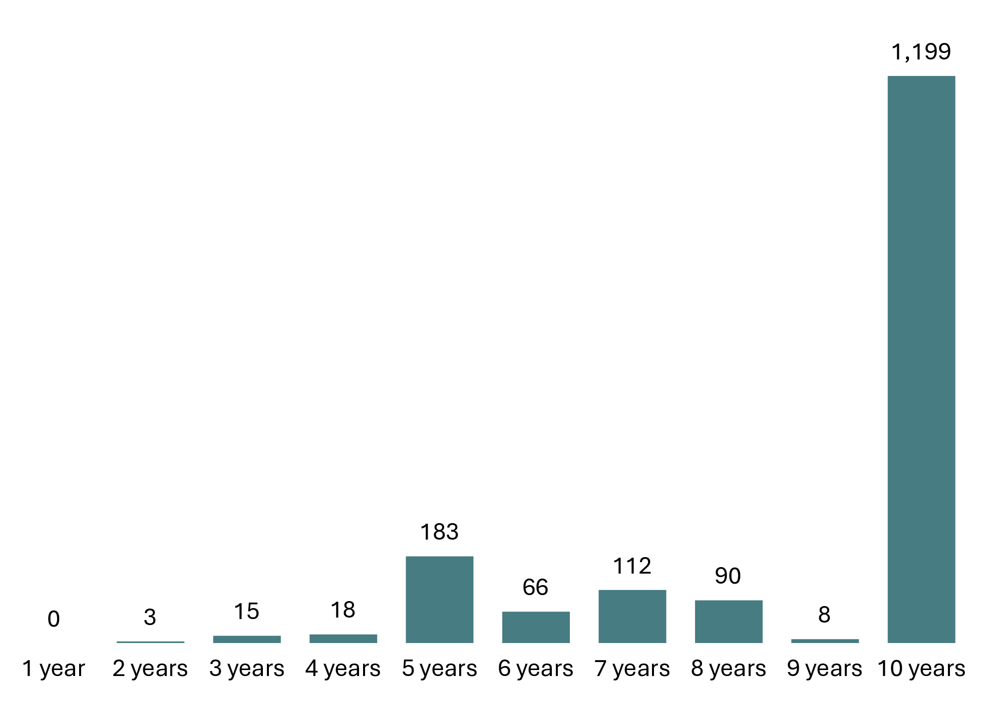
Source: Correctional Service of Canada.
- At the end of fiscal year 2023-24, the courts had imposed 1,694 long-term supervision orders since the legislation came into effect. Of these, 70.8% were for a period of 10 years.
- At the end of fiscal year 2023-24, there were 959 offenders with long-term supervision orders under the responsibility of Correctional Service Canada. There were 17 females with long-term supervision orders under the responsibility of Correctional Service Canada.
- There were 474 offenders being supervised in the community on their long-term supervision order at the end of the fiscal year 2023-24. Of these, 376 offenders were supervised in the community, 9 offenders were temporarily detained, 84 offenders were on remand, 4 offenders were unlawfully at large for less than 90 days and 1 offender was supervised and subject to an immigration hold by Canada Border Services Agency.

Table E4a. Number of long-term supervision orders imposed by length (2023-24)
Province or territory of order | 1 year | 2 years | 3 years | 4 years | 5 years | 6 years | 7 years | 8 years | 9 years | 10 years | Total
Newfoundland and Labrador | 0 | 0 | 0 | 0 | 0 | 0 | 0 | 1 | 0 | 13 | 14
Nova Scotia | 0 | 0 | 0 | 0 | 4 | 0 | 1 | 3 | 0 | 17 | 25
Prince Edward Island | 0 | 0 | 0 | 0 | 1 | 0 | 0 | 0 | 0 | 1 | 2
New Brunswick | 0 | 0 | 1 | 0 | 2 | 0 | 0 | 1 | 0 | 8 | 12
Quebec | 0 | 2 | 10 | 6 | 112 | 29 | 57 | 27 | 3 | 385 | 631
Ontario | 0 | 0 | 1 | 8 | 20 | 16 | 26 | 34 | 0 | 387 | 492
Manitoba | 0 | 0 | 0 | 0 | 1 | 2 | 3 | 2 | 0 | 39 | 47
Saskatchewan | 0 | 1 | 1 | 1 | 12 | 10 | 14 | 11 | 3 | 101 | 154
Alberta | 0 | 0 | 1 | 0 | 10 | 1 | 1 | 1 | 0 | 80 | 94
British Columbia | 0 | 0 | 0 | 2 | 14 | 4 | 7 | 8 | 0 | 140 | 175
Yukon | 0 | 0 | 0 | 0 | 2 | 1 | 3 | 1 | 1 | 19 | 27
Northwest Territories | 0 | 0 | 0 | 0 | 2 | 1 | 0 | 0 | 1 | 4 | 8
Nunavut | 0 | 0 | 1 | 1 | 3 | 2 | 0 | 1 | 0 | 5 | 13
Total | 0 | 3 | 15 | 18 | 183 | 66 | 112 | 90 | 8 | 1,199 | 1,694
Source: Correctional Service of Canada.

Table E4b. Current status of long-term supervision orders imposed (2023-24)
Province or territory of order | Incarcerated | DP, FP or SR* | LTSO period | LTSO interrupted** | Total
Newfoundland and Labrador | 1 | 1 | 6 | 1 | 9
Nova Scotia | 4 | 0 | 5 | 2 | 11
Prince Edward Island | 0 | 0 | 0 | 0 | 0
New Brunswick | 0 | 0 | 1 | 3 | 4
Quebec | 147 | 23 | 154 | 55 | 379
Ontario | 66 | 11 | 173 | 33 | 283
Manitoba | 4 | 0 | 8 | 4 | 16
Saskatchewan | 34 | 7 | 40 | 27 | 108
Alberta | 11 | 0 | 23 | 9 | 43
British Columbia | 13 | 5 | 52 | 10 | 80
Yukon | 9 | 0 | 7 | 1 | 17
Northwest Territories | 2 | 0 | 2 | 0 | 4
Nunavut | 1 | 1 | 3 | 0 | 5
Total | 292 | 48 | 474 | 145 | 959
Source: Correctional Service of Canada.
Notes
Long-Term Supervision Order (LTSO) legislation, which came into effect in Canada on August 1, 1997, allows the court to impose a LTSO which requires an offender to be supervised in the community for a period not exceeding 10 years following the warrant expiry date.
150 offenders under these provisions have died, and 486 offenders have completed their long-term supervision period.
The percentage of long term supervision orders that had at least 1 current conviction for a sexual offence is not available.
* This category includes offenders whose current status is either supervised on day parole (DP), full parole (FP), or statutory release (SR).
** This category includes offenders convicted of a new offence while on the supervision portion of an LTSO. When this occurs, the LTSO supervision period is interrupted until the offender has served the new sentence to its warrant expiry date. At that time, the LTSO supervision period resumes where it left off. From the 145, 108 offenders were in custody, 27 were supervised in the community (25 on statutory release, 1 on day parole, and 1 on a long-term supervision order), 7 offenders were temporarily detained, 2 offenders were unlawfully at large for less than 90 days, and 1 offender was on remand.
Remand is the temporary detention of a person while awaiting trial, sentencing or the commencement of a custodial disposition.
Reported year periods reflect fiscal years. A fiscal year runs from April 1 to March 31 of the following year.

Record suspensions and pardons: 5-year trend

Figure E5. Number of record suspension and pardon applications received*
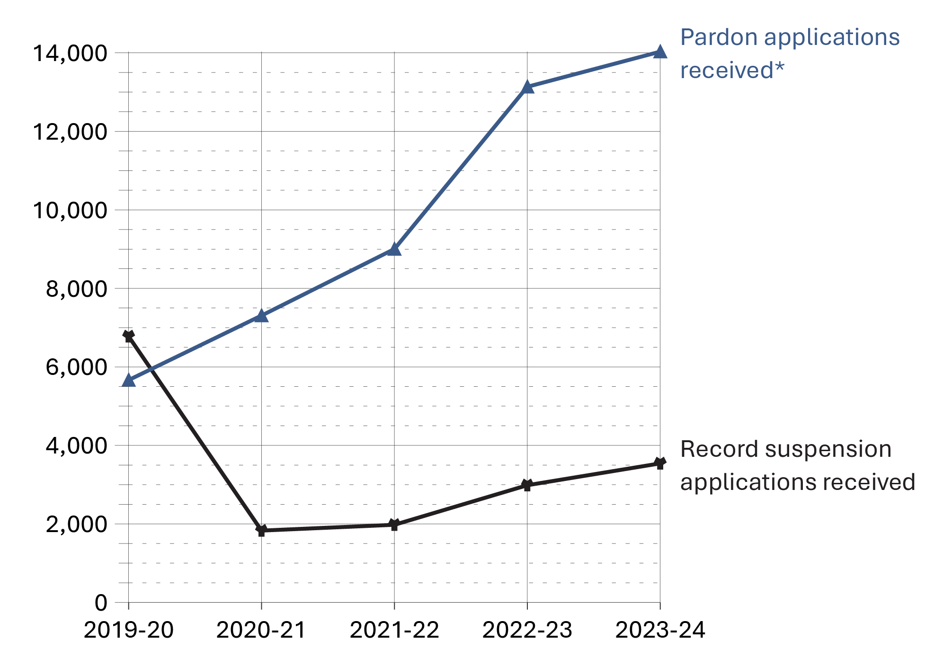
Source: Parole Board of Canada.
- In 2023-24, the Parole Board of Canada received 3,542 record suspension applications and accepted 2,483 applications for processing. The Board also received 14,030 pardon applications and accepted 10,302 applications for processing. The acceptance rate was 72.8%.
- In 2023-24, the Parole Board of Canada made 2,312 record suspension decisions; 97.3% of record suspensions were ordered and 2.7% were refused.
- In 2023-24, the Parole Board of Canada rendered 10,882 pardon decisions, granting/issuing a pardon in 98.2% of cases and denying a pardon in 1.8% of cases.
- In 2023-24, the PBC also ordered 123 Cannabis Record Suspensions.
- In the past 5 fiscal years (from 2019-20 to 2023-24), the number of record suspension and pardon applications received by the Parole Board of Canada increased by 41.2%*.
- Since 1970, when the pardon/record suspension process began, 584,754 pardons/record suspensions have been granted/issued and ordered.
Notes
*On March 13, 2012, Bill C-10 amended the Criminal Records Act (CRA) by replacing the term pardon with the term record suspension. In 2017-18, following British Columbia Supreme Court and Ontario Superior Court decisions, the application of the CRA amendments for applicants who had committed an offence prior to the implementation of these amendments were struck down and the Board resumed processing pardon cases for residents of Ontario and British Columbia based on the criteria that were in force on the day on which the offence was committed. In response to the March 2020 Federal Court of Canada decision in P.H. v. Canada (Attorney General) (P.H.), all applications are processed according to the CRA decision-making criteria that was in force at the time the first offence was committed and not the date the application was received by the PBC. Where applications span multiple legislative schemes, policy was amended to specify that the applicable version of the CRA is to be determined based on the first offence on the criminal record.

Table E5. Number of record suspension and pardon applications*, decisions and revocations/cessations

Record suspension applications processed
Record suspension applications | 2019-20 | 2020-21 | 2021-22 | 2022-23 | 2023-24
Received | 6,777 | 1,830 | 1,978 | 2,986 | 3,542
Accepted | 5,227 | 1,411 | 1,254 | 2,072 | 2,483
% accepted | 77.1 | 77.1 | 63.4 | 69.4 | 70.1

Record suspensions
Record suspension decisions | 2019-20 | 2020-21 | 2021-22 | 2022-23 | 2023-24
Ordered | 5,287 | 1,403 | 1,559 | 1,909 | 2,250
Refused | 209 | 103 | 56 | 48 | 62
Total ordered/refused | 5,496 | 1,506 | 1,615 | 1,957 | 2,312
% ordered | 96.2 | 93.2 | 96.5 | 97.5 | 97.3

Pardon applications processed
Pardon applications | 2019-20 | 2020-21 | 2021-22 | 2022-23 | 2023-24
Received | 5,664 | 7,307 | 9,003 | 13,135 | 14,030
Accepted | 4,360 | 6,032 | 6,031 | 9,545 | 10,302
% accepted | 77.0 | 82.6 | 67.0 | 72.7 | 73.4

Pardon decisions
Pardon decisions | 2019-20 | 2020-21 | 2021-22 | 2022-23 | 2023-24
Granted | 3,155 | 4,846 | 4,667 | 3,810 | 7,052
Issued | 1,552 | 2,467 | 2,053 | 3,498 | 3,629
Denied | 209 | 218 | 245 | 184 | 201
Total granted/issued/denied | 4,916 | 7,531 | 6,965 | 7,492 | 10,882
% granted/issued | 95.7 | 97.1 | 96.5 | 97.5 | 98.2
Cannabis Record Suspensions
Cannabis Record Suspensions | 2019-20 | 2020-21 | 2021-22 | 2022-23 | 2023-24
Received | 437 | 239 | 197 | 224 | 212
Accepted | 248 | 166 | 146 | 153 | 120
% accepted | 56.8 | 69.5 | 74.1 | 68.3 | 56.6
Ordered | 238 | 168 | 148 | 152 | 123

Pardon/record suspension revocations/cessations
Pardon/record suspension revocations/cessations | 2019-20 | 2020-21 | 2021-22 | 2022-23 | 2023-24
Revocations** | 410 | 314 | 250 | 232 | 284
Cessations | 439 | 270 | 306 | 343 | 349
Total revocations/cessations | 849 | 584 | 556 | 575 | 633
Cumulative # granted/issued and ordered*** | 545,611 | 554,327 | 562,606 | 571,823 | 584,754
Cumulative # revocations/cessations*** | 28,118 | 28,702 | 29,258 | 29,833 | 30,466
Source: Parole Board of Canada.
Notes
*On March 13, 2012, Bill C-10 amended the Criminal Records Act (CRA) by replacing the term pardon with the term record suspension. In 2017-18, following British Columbia Supreme Court and Ontario Superior Court decisions, the application of the CRA amendments for applicants who had committed an offence prior to the implementation of these amendments were struck down and the Board resumed processing pardon cases for residents of Ontario and British Columbia based on the criteria that were in force on the day on which the offence was committed. In response to the March 2020 Federal Court of Canada decision in P.H. v. Canada (Attorney General) (P.H.), all applications are processed according to the CRA decision-making criteria that was in force at the time the first offence was committed and not the date the application was received by the PBC. Where applications span multiple legislative schemes, policy was amended to specify that the applicable version of the CRA is to be determined based on the first offence on the criminal record.
**Revocations fluctuate due to resource re-allocation to address backlogs.
***Cumulative data reflects activity since 1970, when the pardon process was established under the Criminal Records Act.
Only includes the number of files accepted of those received in a given fiscal year. For example, the 2023-24 acceptance rate does not include the 1,237 applications that were received in 2022-2023, but not processed until 2023-2024.
Excluded are files that were accepted and subsequently discontinued.
As of March 31, 2024, the PBC has received a total of 82 expungement applications, 71 of which have been returned as ineligible (i.e., did not meet the legislated criteria), one (1) expungement was refused, nine (9) expungements were ordered, and one (1) expungement application had been received but not yet processed.
Reported year periods reflect fiscal years. A fiscal year runs from April 1 to March 31 of the following year.

Section F:
Federal Services to Registered Victims



Number of contacts with registered victims: 5-year trend

Figure F1. Number of contacts with registered victims
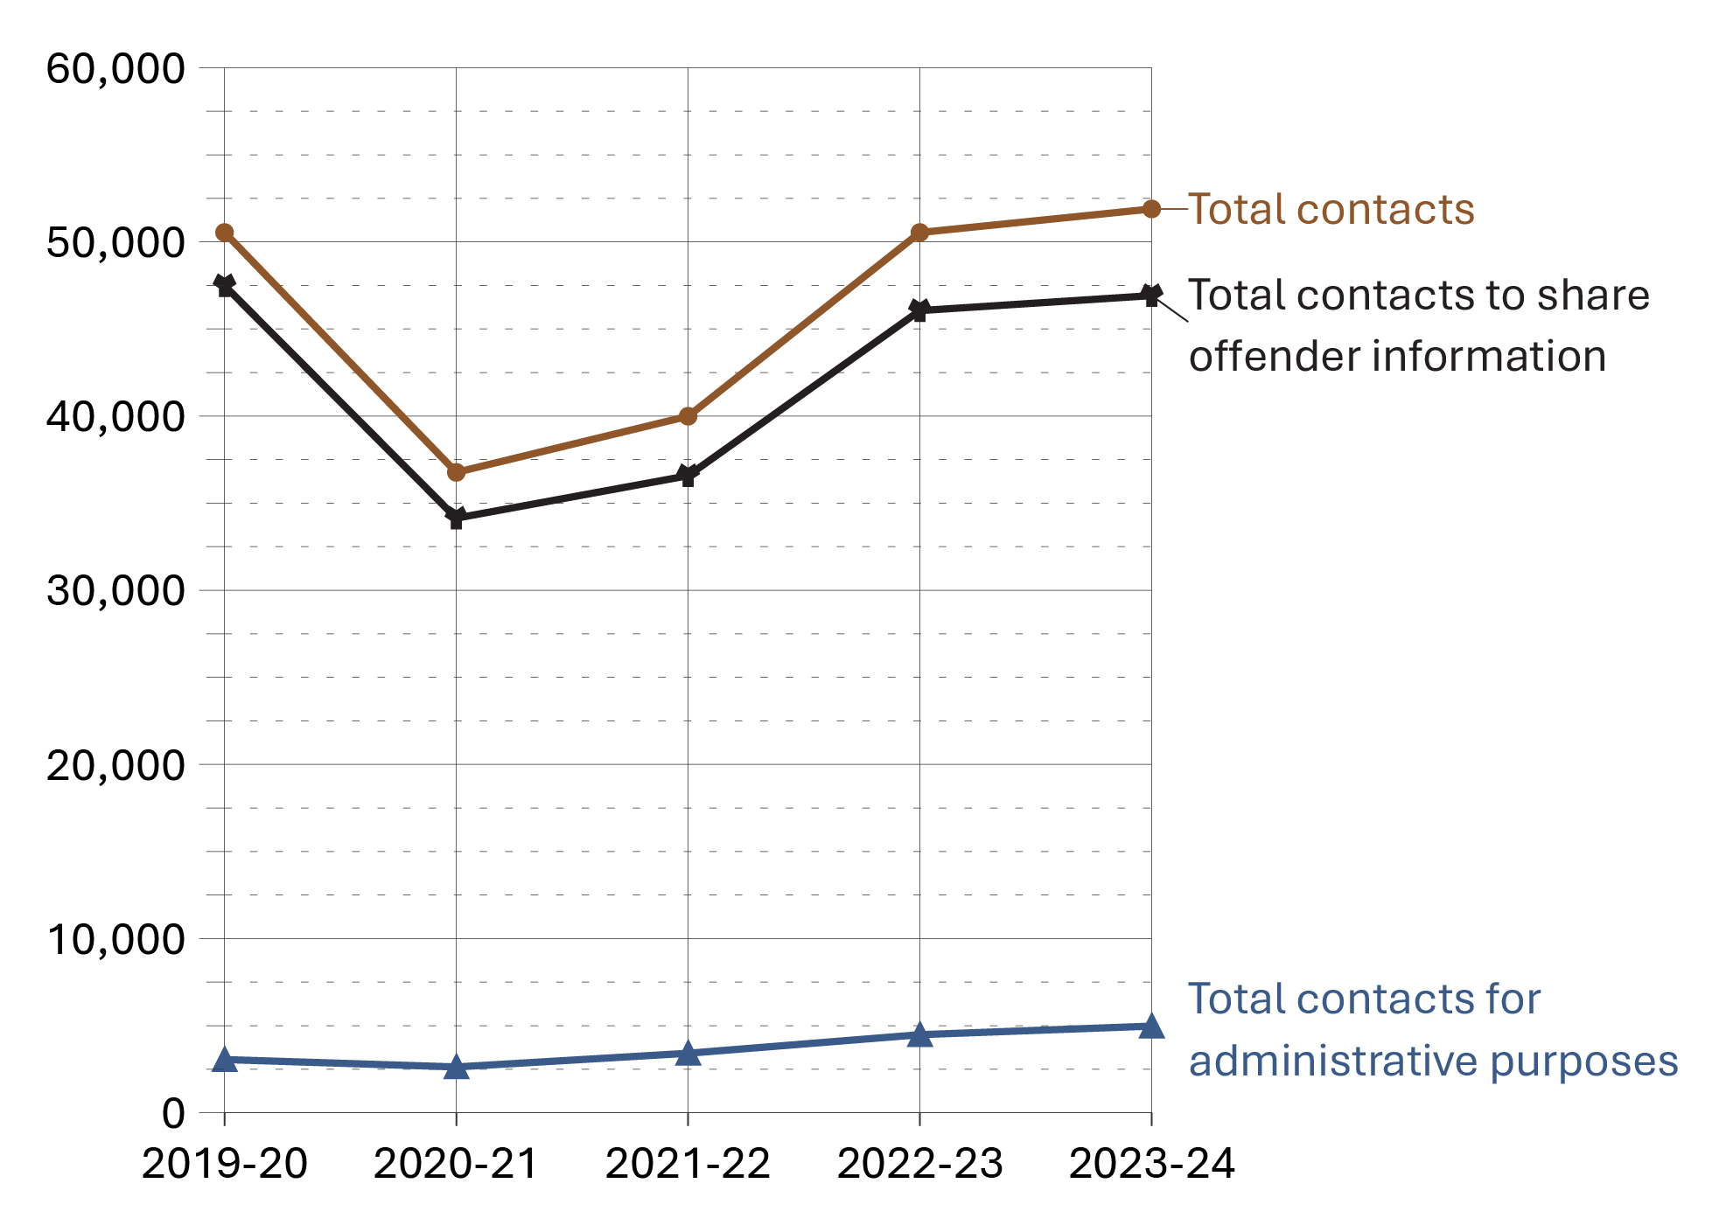
Source: Correctional Service of Canada.
- The majority of contacts with registered victims (90.4%) were to share offender information. There was a decrease from 2019-20 to 2023-24, from 94.0% to 90.4%.
- The total number of contacts with registered victims decreased by 20.9% from 2019-20 to 2021-22 (50,539 to 39,989), and then increased by 29.8% from 2021-22 to 2023-24 (39,989 to 51,889).

Table F1. Number of contacts with registered victims
Contact type | 2019-20 | 2020-21 | 2021-22 | 2022-23 | 2023-24
Total contacts to share offender information | 47,485 | 34,137 | 36,574 | 46,054 | 46,914
Total contacts for administrative purposes | 3,054 | 2,629 | 3,415 | 4,482 | 4,975
Total contacts | 50,539 | 36,766 | 39,989 | 50,536 | 51,889
Source: Correctional Service of Canada.
Notes
The Canadian Victims Bill of Rights defines a victim as an individual who has suffered physical or emotional harm, property damage, or economic loss as the result of the commission or alleged commission of an offence. The CCRA also allows a spouse, a relative or dependant, an individual who is responsible for the care or support of the victim or the care or support of a dependant of the victim, to act on behalf of a victim, if the victim cannot act on their own behalf. Victims include persons harmed as the result of an act of an offender, whether or not the offender was prosecuted or convicted for that act, as long as an official complaint has been made to the police or to the Crown.
Victims do not automatically receive information about the offender who harmed them. If they have been harmed by an offender serving a sentence of two years or more, victims are asked to register with the Correctional Service of Canada (CSC) or the Parole Board of Canada to receive information or access services. The registration process allows CSC to verify that the individual meets the definition of victim, which is required under law before sharing protected offender information.
For more information about victim registration, visit: https://www.canada.ca/en/correctional-service/services/you-csc/victims/register.html
Contacts to share offender information include those where the CSC Victim Services Unit communicates offender information to victims. This might include information such as temporary absences, transfers, travel permits, conditional release, and sentencing information. Contacts for administrative reasons include tasks such as updating contact information, discussing the Restorative Opportunities program, and referrals to provincial or community stakeholders.
The numbers above exclude internal tasks that do not involve contacting victims, and do not include task types that can be used for documenting both internal tasks or communicating with victims. They also do not count multiple attempts it may take to make contact with a victim.
Reported year periods reflect fiscal years. A fiscal year runs from April 1 to March 31 of the following year.

Number of victim statements received for consideration in release decisions: 5-year trend

Figure F2. Number of victim statements received for consideration in release decisions
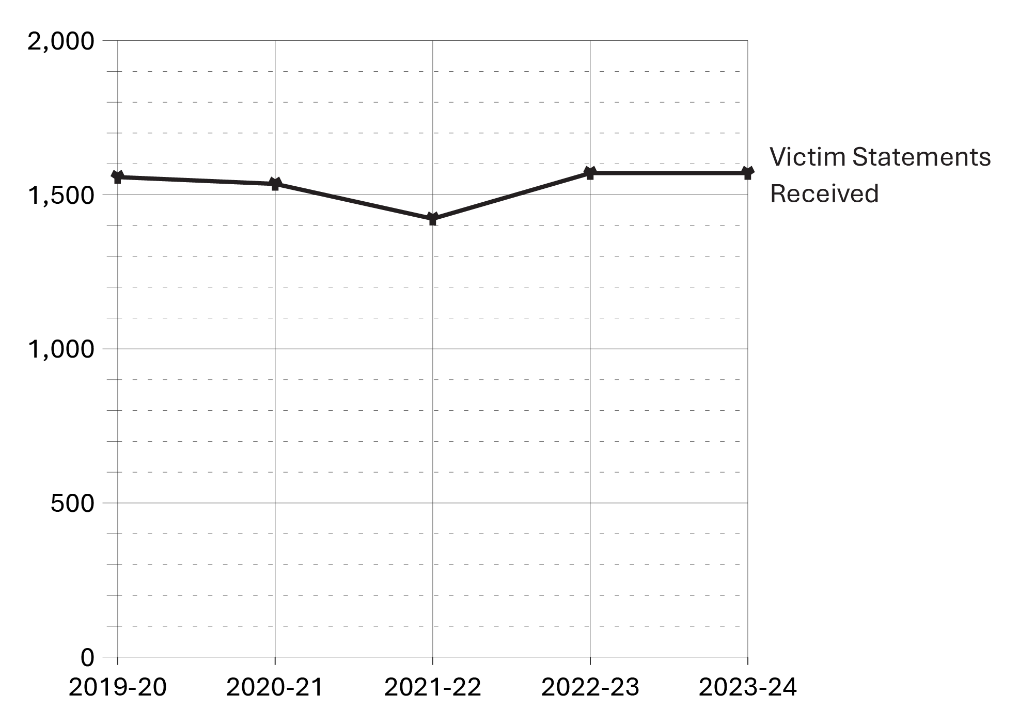
Source: Correctional Service of Canada.
- The number of victim statements received for consideration remained relatively stable for the past 5 fiscal years.
Table F2. Number of victim statements received for consideration in release decisions
Fiscal year | Number of victim statements received
2019-20 | 1,557
2020-21 | 1,535
2021-22 | 1,422
2022-23 | 1,570
2023-24 | 1,570
Source: Correctional Service of Canada.
Notes
The Canadian Victims Bill of Rights defines a victim as an individual who has suffered physical or emotional harm, property damage, or economic loss as the result of the commission or alleged commission of an offence. The CCRA also allows a spouse, a relative or dependant, an individual who is responsible for the care or support of the victim or the care or support of a dependant of the victim, to act on behalf of a victim, if the victim cannot act on their own behalf. Victims include persons harmed as the result of an act of an offender, whether or not the offender was prosecuted or convicted for that act, as long as an official complaint has been made to the police or to the Crown.
CSC will consider statements from victims who choose not to register.
Not all statements received will be considered when release decisions are made; victims may choose to withdraw their statement before it is considered. In previous years, these withdrawn statements were included in the reported totals, but they have been excluded from the totals above given they are withdrawn before being considered.
Reported year periods reflect fiscal years. A fiscal year runs from April 1 to March 31 of the following year.

Requests for financial assistance to attend parole hearings: 5-year trend

Figure F3. Number of requests for financial assistance to attend parole hearings
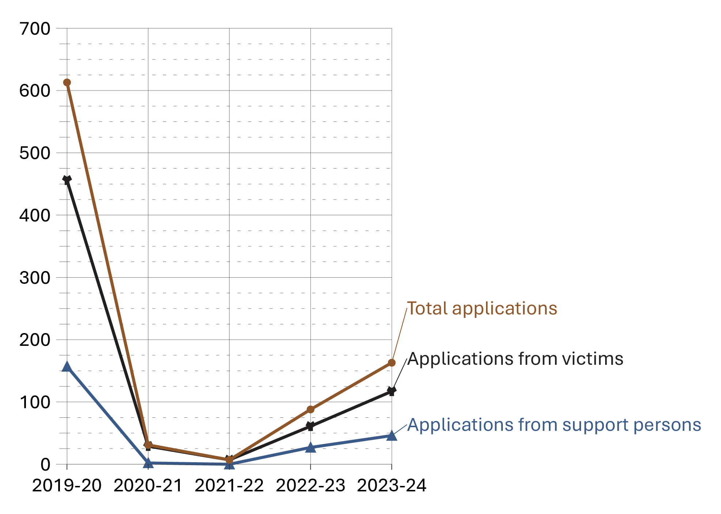
Source: Justice Canada.
- The number of victim applications for financial assistance to attend parole hearings decreased between 2019-20 and 2021-22 and then gradually increased from 2021-22 and 2023-24. Fluctuations may be due to the imposition and cessation of the COVID-19 pandemic lockdown restrictions, which began in mid-March 2020. To adapt to COVID-19, Parole Board of Canada hearings were conducted primarily by teleconference and/or video conference in 2020-21 and 2021-22.
- Between fiscal years 2022-23 and 2023-24, the total number of applications for financial assistance increased from 61 to 117. Numbers of applications have not returned to pre-pandemic levels as the Parole Board of Canada schedules virtual hearings over in-person.

Table F3. Number of requests for financial assistance to attend parole hearings
Application type | 2019-20 | 2020-21 | 2021-22 | 2022-23 | 2023-24
Number of applications for financial assistance received from victims | 456 | 29 | 7 | 61 | 117
Number of applications for financial assistance received from support persons | 157 | 2 | 0 | 27 | 46
Total number of applications | 613 | 31 | 7 | 88 | 163
Source: Justice Canada.
Notes
The number of applications in 2023-24 include applications for hearings that ended up being changed from “in person” to “virtual”, and for hearings that were postponed or cancelled altogether.
Victims can apply for financial assistance for a support person to accompany them to a parole hearing.
Reported year periods reflect fiscal years. A fiscal year runs from April 1 to March 31 of the following year.

Number of Parole Board of Canada contacts with victims: 10-year trend

Figure F4. Number of PBC contacts with victims
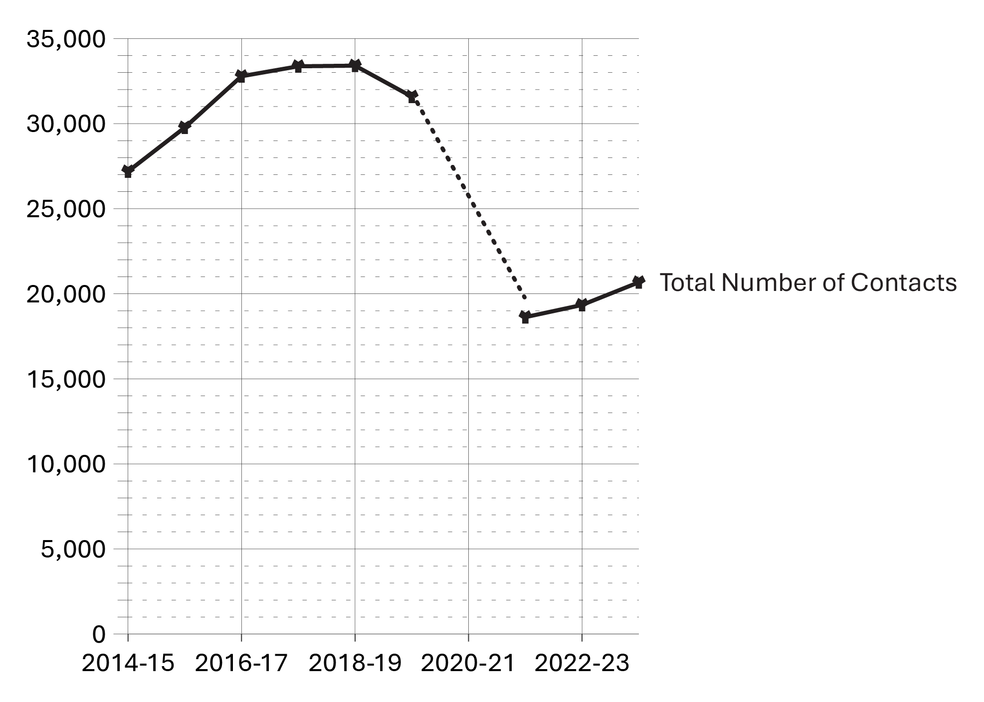
Source: Parole Board of Canada.
- In 2023-24, the Parole Board of Canada (PBC) reported 20,674 contacts with victims, an increase of 6.9% compared to 2022-23.
- In the past 10 fiscal years (from 2014-15 to 2023-24), the number of PBC contacts with victims decreased by 24.0% (6,517 fewer contacts)*.
Notes
*The dotted line in the figure indicates that data for 2020-21 are not available as the PBC transitioned from manual data collection to using an automated system, the Victims Application Module, during this timeframe. The reduction in contacts with victims between 2019-20 and 2021-22 is also the result of this transition to an automated system. A victim contact refers to each time the PBC has contact with a victim by mail, fax, telephone, in person, or through the Victims Portal.

Table F4. Number of PBC contacts with victims
Fiscal year | Number of contacts
2014-15 | 27,191
2015-16 | 29,771
2016-17 | 32,786
2017-18 | 33,370
2018-19 | 33,408
2019-20 | 31,587
2020-21* | NA**
2021-22 | 18,627
2022-23 | 19,343
2023-24 | 20,674
Source: Parole Board of Canada.
Notes
*Data for 2020-21 are not available as the PBC transitioned from manual data collection to using an automated system, the Victims Application Module, during this timeframe. The reduction in contacts with victims between 2019-20 and 2021-22 is also the result of this transition to an automated system. A victim contact refers to each time the PBC has contact with a victim by mail, fax, telephone, in person, or through the Victims Portal.
** “Not applicable” is abbreviated to “NA” in this table due to formatting.
Reported year periods reflect fiscal years. A fiscal year runs from April 1 to March 31 of the following year.

Victim presentations at PBC Hearings: 10-year trend

Figure F5. Number of victim presentations and number of hearings with victim presentations
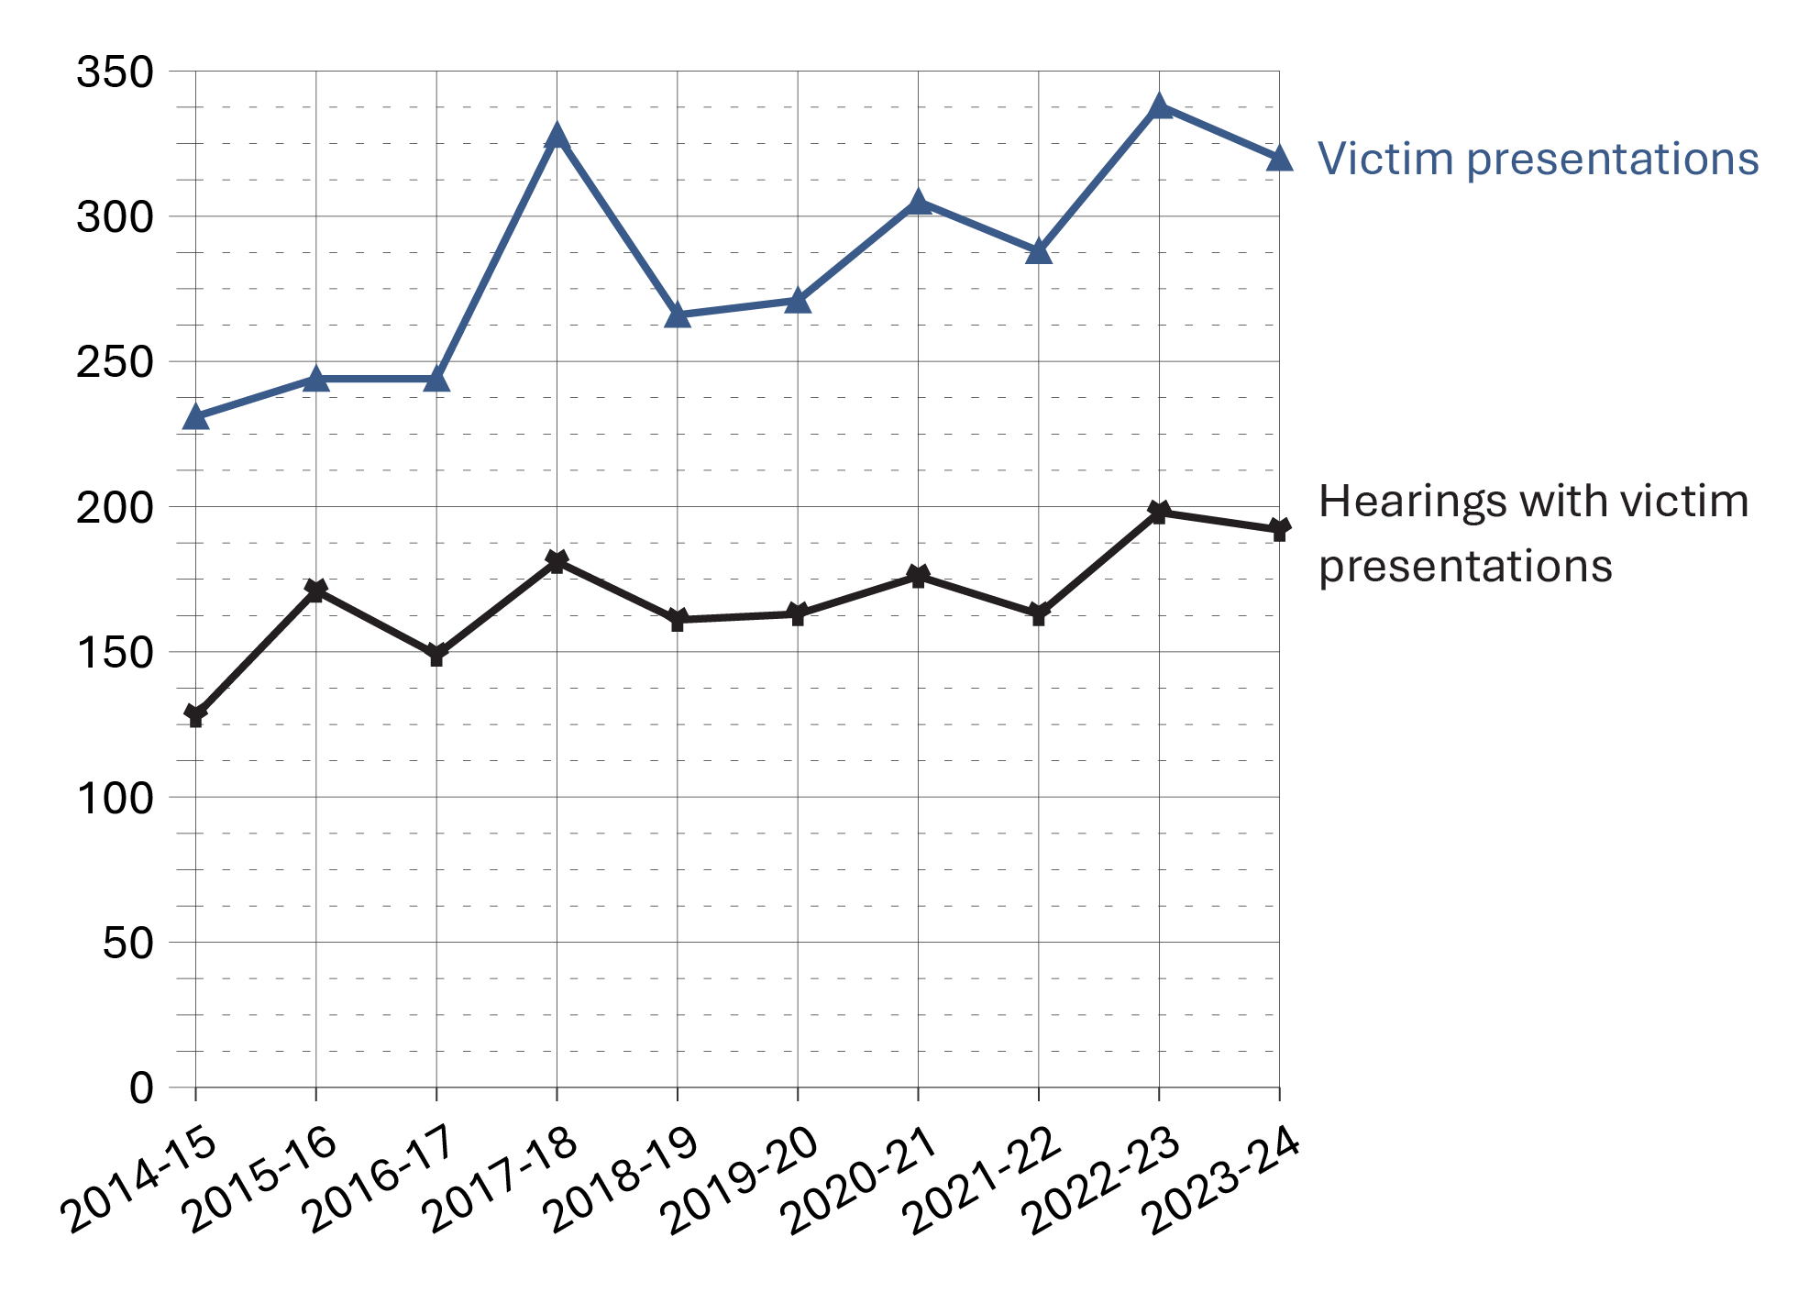
Source: Parole Board of Canada.
- In 2023-24, victims made 320 presentations (a decrease of 5.3% or 18 fewer presentations) at 192 hearings (a decrease of 3.0% or 6 fewer hearings) compared to 2022-23.
- In 2023-24, there was a 6.3% increase (346 more hearings) in the total number of Parole Board of Canada hearings (with or without victim presentations) compared to 2022-23.
- In 2023-24, 80.6% of victim presentations were delivered remotely (e.g., by video-conference) and 19.4% were presented in-person.

Table F5. Number of victim presentations and number of hearings with victim presentations
Fiscal year | Number of hearings with presentations | Victim presentations
2014-15 | 128 | 231
2015-16 | 171 | 244
2016-17 | 149 | 244
2017-18 | 181 | 328
2018-19 | 161 | 266
2019-20 | 163 | 271
2020-21 | 176 | 305
2021-22 | 163 | 288
2022-23 | 198 | 338
2023-24 | 192 | 320
Source: Parole Board of Canada.
Notes
Reported year periods reflect fiscal years. A fiscal year runs from April 1 to March 31 of the following year.

Number of decisions sent from PBC decision registry: 5-year trend

Figure F6. Total number of decisions sent from the decision registry vs. number of decisions sent to victims from the decision registry*
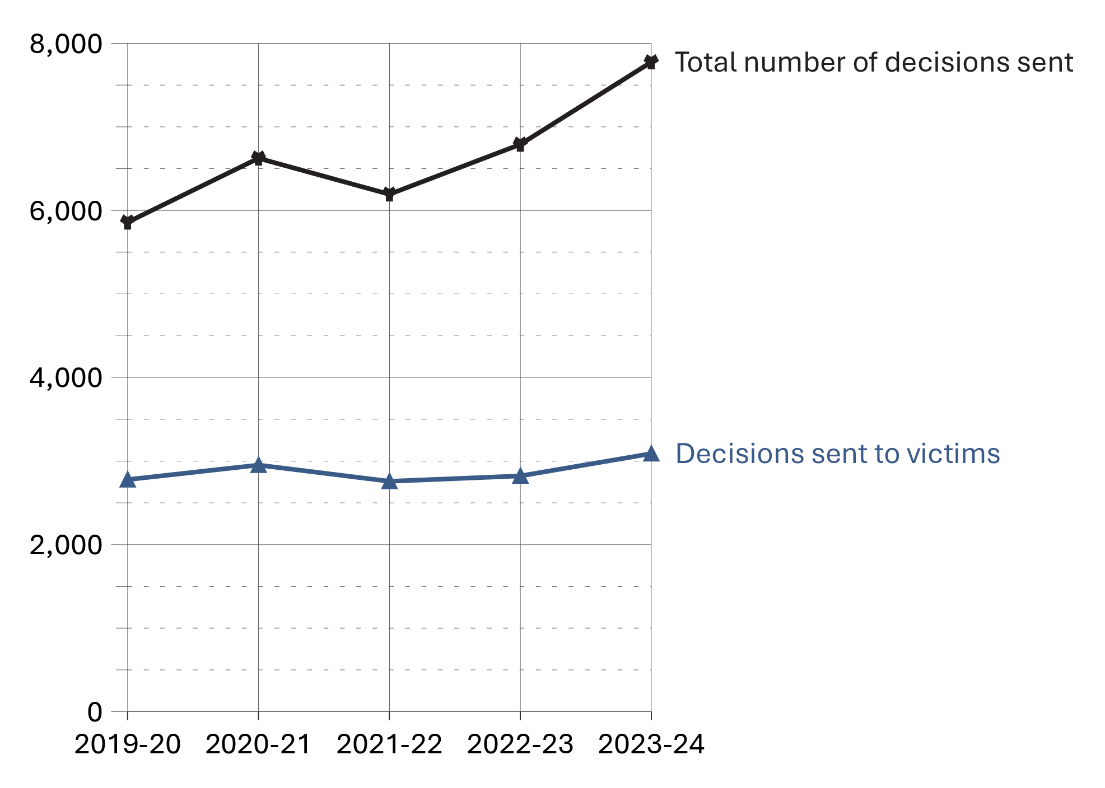
Source: Parole Board of Canada.
- In 2023-24, 7,775 decisions were sent from the Parole Board of Canada’s decision registry, an increase of 14.5% from the previous fiscal year.
- In 2023-24, the number of decisions sent to victims from the decision registry increased by 9.5% to 3,089 compared to the previous fiscal year.
- Between 2019-20 and 2023-24, the number of decisions sent from the decision registry has increased by 32.7%.
Notes
* Additional information about the decision registry can be found at: https://www.canada.ca/en/parole-board/services/decision-registry.htm
Figure F6 in the 2024 CCRSO corresponds to Figure F7 in the 2023 CCRSO.

Table F6. Total number of decisions sent from the decision registry vs. number of decisions sent to victims from the decision registry*
Fiscal year | Decisions sent to victims | % | Total number of decisions sent
2019-20 | 2,778 | 47.4 | 5,858
2020-21 | 2,952 | 44.6 | 6,624
2021-22 | 2,758 | 44.5 | 6,193
2022-23 | 2,822 | 41.6 | 6,790
2023-24 | 3,089 | 39.7 | 7,775
Source: Parole Board of Canada.
Notes
In 2020-21, the PBC transitioned from manual data collection to using an automated system, the Victims Application Module (VAM).
* Additional information about the decision registry can be found at: https://www.canada.ca/en/parole-board/services/decision-registry.htm
The Corrections and Conditional Release Act (CCRA) requires the Parole Board of Canada (PBC) to maintain a decision registry that includes the decisions made and the reasons for those decisions. The purpose of the decision registry is to contribute to public understanding of conditional release decision making and to promote openness and accountability. Anyone may request a copy of these decisions.
Victims also include victims' agents and victim organizations.
Table F6 in the 2024 CCRSO corresponds to Table F7 in the 2023 CCRSO.
Reported year periods reflect fiscal years. A fiscal year runs from April 1 to March 31 of the following year.

